#### CFO Dashboard Business scenario

Corporate currency amounts are calculated based on the base currency of each entity. If the current month is chosen, the system uses the accounting exchange rate that is valid at the period end or on the current date.

If CC=BC ,then BC

CC<>BC and CC=TC(Transaction Currency),then TC use CC

CC & BC accounting exchange rate

1.Income statement

Compare revenue by expense



Net income

Net Sales

Main categories of expense: COGS/Other OPEX/Interest paid/taxes

***Question1:What does Account Number represent?***

***Question2:Get COGS and other Account calculation method?***

2.Balance Sheet

Total Assets / Liabilities

The difference between the above two measure is a company’s net worth.

3.Metrics Summary

1.Days Sales Outstanding page320 for detail

2.Return on capital employed

If the ROCE metric is not higher than the rate at which the company borrows,

then any increase in borrowing reduces shareholders’ earnings.

ROCE=EBIT / (Total Assets - Current Liabilities)

Earnings Before Interest and Taxes(EBIT) = revenue - expense ,excluding tax and interest

Profit Before Interest & Taxes (PBIT) = net income with interest and taxes

Question: which trend represent good effiency and profitabiltiy?

3.Quick Ratio = (Current Assets -minus inventories) / current liabilities

company’s short-term liquidity.The ration measures a company's ability to meet its short-term

obligations with its liquid assets. So the higher the quick ratio, the better the position the company is in.

It's more conservative that the current ration(a more well-known liquid assets ration)

because it excludes inventory from current assets.

Inventory is excluded because some company have difficulty turning inventory into cash.

There are situations when short-term obligations must be paid off immediately that the current ratio would overestimate a company’s short-term financial strength.

4.Working Capital Turnover

5.ICT Expense

less than business growth,it can indicated economies of scale,improved efficiencies or underinvestment.

Total ICT Expense/Net Sales

6.Current ratio

current assets/current liabilities

also known as liquidity asset ratio/cash asset ratio

It give you a sense of the efficiency of a company's operating cycle or its ability to turn its product into cash.

Question3: why company have trouble getting paid on their receivables or have long inventory turnover

can run into liquidity problem?

7.Return on Working capital

1.Days Sales Outstanding page320 for detail

2.Return on capital employed

If the ROCE metric is not higher than the rate at which the company borrows,

then any increase in borrowing reduces shareholders’ earnings.

ROCE=EBIT / (Total Assets - Current Liabilities)

Earnings Before Interest and Taxes(EBIT) = revenue - expense ,excluding tax and interest

Profit Before Interest & Taxes (PBIT) = net income with interest and taxes

Question: which trend represent good effiency and profitabiltiy?

3.Quick Ratio = (Current Assets -minus inventories) / current liabilities

company’s short-term liquidity.The ration measures a company's ability to meet its short-term

obligations with its liquid assets. So the higher the quick ratio, the better the position the company is in.

It's more conservative that the current ration(a more well-known liquid assets ration)

because it excludes inventory from current assets.

Inventory is excluded because some company have difficulty turning inventory into cash.

There are situations when short-term obligations must be paid off immediately that the current ratio would overestimate a company’s short-term financial strength.

4.Working Capital Turnover

5.ICT Expense

less than business growth,it can indicated economies of scale,improved efficiencies or underinvestment.

Total ICT Expense/Net Sales

6.Current ratio

current assets/current liabilities

also known as liquidity asset ratio/cash asset ratio

It give you a sense of the efficiency of a company's operating cycle or its ability to turn its product into cash.

Question3: why company have trouble getting paid on their receivables or have long inventory turnover

can run into liquidity problem?

7.Return on Working captial

## Portal Customization

Query

1.Condition

ProductLine Range from to

Year From TO

2.Measure

Gross Margin

Invoice Amout

Sample: (Query3)

SELECT TOP 10

dim_customer_sold_to.customer_name AS 'customer_name'

,SUM(invoice_amount_base) AS 'invoice_amount_base'

FROM fact_om_invoice join dim_customer_sold_to

on fact_om_invoice.dim_customer_sold_to_key=dim_customer_sold_to.dim_customer_sold_to_key

join dim_invoice_date

on fact_om_invoice.dim_invoice_date_key=dim_invoice_date.dim_invoice_date_key

WHERE

P{GE,dim_invoice_date.cal_year, P_0, String}

and P{LE,dim_invoice_date.cal_year, P_1, String}

and P{EQ,dim_customer_sold_to.customer_type_code,P_3,String}

GROUP BY dim_customer_sold_to.customer_name

order by SUM(invoice_amount_base) desc

***Attention: X axis column must be set as correct type ,refer to below***

***Yellow rectangle :***

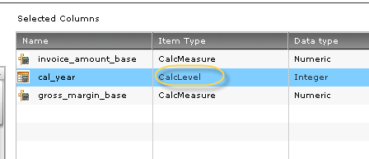

**2.the year value transferring to the target chart**

**Should be the value underlying in the Chart. Rather than the**

**Parameter bar years.**

*And the “To” column in Bottom-right will list the parameter resided*

*in target Query.*

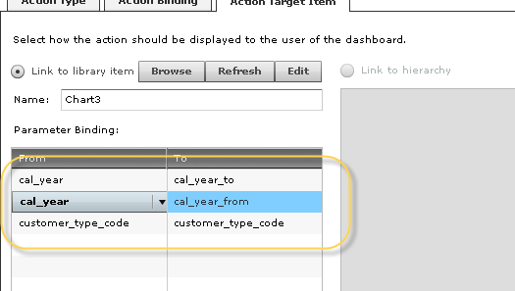

3.Design Query derived SQL Script

--Query1 sum of gross marign

SELECT dim_invoice_date.cal_year AS 'cal_year',

SUM(fact_om_invoice.gross_margin_base) AS 'gross_margin_base' ,

SUM(fact_om_invoice.invoice_amount_base) AS 'invoice_amount_base'

FROM fact_om_invoice join dim_customer_sold_to

on fact_om_invoice.dim_customer_sold_to_key=dim_customer_sold_to.dim_customer_sold_to_key

join dim_invoice_date

on fact_om_invoice.dim_invoice_date_key=dim_invoice_date.dim_invoice_date_key

WHERE dim_invoice_date.cal_year between 2008 and 2012

and dim_customer_sold_to.customer_type_code between 'DIST' and 'ENDU'

GROUP BY dim_invoice_date.cal_year

--Query2 InvoiceAmount rank of customer

SELECT TOP 10

dim_customer_sold_to.customer_name AS 'customer_name'

,SUM(invoice_amount_base) AS 'invoice_amount_base'

FROM fact_om_invoice join dim_customer_sold_to

on fact_om_invoice.dim_customer_sold_to_key=dim_customer_sold_to.dim_customer_sold_to_key

join dim_invoice_date

on fact_om_invoice.dim_invoice_date_key=dim_invoice_date.dim_invoice_date_key

WHERE

dim_invoice_date.cal_year = '2010'

and dim_customer_sold_to.customer_type_code between 'INTC' and 'OTH'

GROUP BY dim_customer_sold_to.customer_name

order by SUM(invoice_amount_base) desc

SELECT TOP 10

dim_customer_sold_to.customer_name AS 'customer_name'

,SUM(gross_margin_base) AS 'gross_margin_base'

FROM fact_om_invoice join dim_customer_sold_to

on fact_om_invoice.dim_customer_sold_to_key=dim_customer_sold_to.dim_customer_sold_to_key

join dim_invoice_date

on fact_om_invoice.dim_invoice_date_key=dim_invoice_date.dim_invoice_date_key

WHERE

dim_invoice_date.cal_year = '2010'

and dim_customer_sold_to.customer_type_code between 'INTC' and 'OTH'

GROUP BY dim_customer_sold_to.customer_name

order by SUM(invoice_amount_base) desc

--Query3 Buttom layer

select

customer_name,

cal_month,

order_number,

invoice_number,

quantity_invoiced,

quantity_ordered,

quantity_shipped,

quantity_returned,

extended_cost_base,

gross_margin_base

FROM fact_om_invoice join dim_customer_sold_to

on fact_om_invoice.dim_customer_sold_to_key=dim_customer_sold_to.dim_customer_sold_to_key

join dim_invoice_date

on fact_om_invoice.dim_invoice_date_key=dim_invoice_date.dim_invoice_date_key

WHERE

dim_invoice_date.cal_year = '2010'

and dim_customer_sold_to.customer_name = 'MediLogic'

SELECT TOP 20

customer_name as 'Sold to Customer'

,sum(curr_invoice_amount_base) as 'Current Year Invoice Amount'

,sum(prev_invoice_amount_base) as 'Last Year Invoice Amount'

,sum(curr_invoice_amount_base) - sum(prev_invoice_amount_base) as 'Difference'

, case when SUM(curr_invoice_amount_base) = 0 then 0 else

((sum(curr_invoice_amount_base) - sum(prev_invoice_amount_base)) / SUM(curr_invoice_amount_base)) * 100 end as '%'

from (

SELECT dim_customer_sold_to.customer_name AS 'customer_name',0 as 'prev_invoice_amount_base', SUM(invoice_amount_base) AS 'curr_invoice_amount_base'

FROM fact_om_invoice join dim_customer_sold_to on fact_om_invoice.dim_customer_sold_to_key=dim_customer_sold_to.dim_customer_sold_to_key

join dim_invoice_date on fact_om_invoice.dim_invoice_date_key=dim_invoice_date.dim_invoice_date_key

WHERE ( ( P{IN, dim_invoice_date.cal_year+1, P_1, String} ) ) GROUP BY dim_customer_sold_to.customer_name

UNION

SELECT dim_customer_sold_to.customer_name AS 'customer_name',SUM(invoice_amount_base) AS 'prev_invoice_amount_base',0 as 'curr_invoice_amount_base'

FROM fact_om_invoice join dim_customer_sold_to on fact_om_invoice.dim_customer_sold_to_key=dim_customer_sold_to.dim_customer_sold_to_key

join dim_invoice_date on fact_om_invoice.dim_invoice_date_key=dim_invoice_date.dim_invoice_date_key

WHERE ( ( P{IN, dim_invoice_date.cal_year, P_1, String} ) ) GROUP BY dim_customer_sold_to.customer_name

) foo

GROUP BY customer_name

ORDER BY 2 DESC

********************************************************************

--Month Level

SELECT

dim_customer_sold_to.customer_name AS 'customer_name',

0 as 'prev_invoice_amount_base',

dim_invoice_date.cal_month,

SUM(invoice_amount_base) AS 'curr_invoice_amount_base'

FROM

fact_om_invoice join dim_customer_sold_to

on fact_om_invoice.dim_customer_sold_to_key=dim_customer_sold_to.dim_customer_sold_to_key

join dim_invoice_date

on fact_om_invoice.dim_invoice_date_key=dim_invoice_date.dim_invoice_date_key

WHERE dim_invoice_date.cal_year = '2010' and dim_customer_sold_to.customer_name = 'MediLogic'

GROUP BY dim_customer_sold_to.customer_name,dim_invoice_date.cal_month

********************************************************************

--Report Level

SELECT

dim_customer_sold_to.customer_name AS 'customer_name',

dim_invoice_date.cal_month,

fact_om_invoice.*

FROM

fact_om_invoice join dim_customer_sold_to

on fact_om_invoice.dim_customer_sold_to_key=dim_customer_sold_to.dim_customer_sold_to_key

join dim_invoice_date

on fact_om_invoice.dim_invoice_date_key=dim_invoice_date.dim_invoice_date_key

WHERE dim_invoice_date.cal_month = '201007' and dim_customer_sold_to.customer_name = 'MediLogic'

Next To-Do Item

**1.Organize Load Table as chained job flow and execute by schedule.**

**This process preprocess**

1. **Truncate …. Table**

**2.Design Dashboard KPI**

*Column property “Business Key” number represent what?*

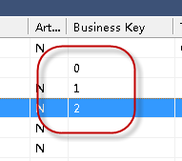

3.what’s filter used for?

How to use filter in Query?

Associate with Parameter?

## DW related objects

### 1.Rollup fact table

Create a roll-up fact table allows user to see budgeted . forecast and actual sales amounts and quantities broken down by customer. product and month.

Create separate aggregate tables that summarize data in rollup tables by x,y

### 2.Aggregrate table

An aggregate is typically created by the deletion of items that don't make sense when summarized and by deleting one or more of the dimension keys.

Tips: it is common practice to make two or more aggregate tables for a large fact table.

Drag fact table into the middle pane of Aggregrate

Delete the key of fact tables

So that it can summarize from various fact tables

Dss_fact_table_key : automatically built during the fact table process

Create table and build procedure

Tip: The dimension key is the relationship column between

Fact table and aggregrate table.



Creating aggregrate from version of other aggregrate table

Complex dimension and hierarchy

Slowly changing dimension

reset the procedure option as (build)

change dimension in table properties

add dimension slowly changing column

alter/recreate physical database tables for additional columns working for slowing changing dimensions

as we have the fact tables that use the dimension we cannot re-create dimension table .To do so would make all the joins in fact tables to dimension invalid. Therefore we choose alter the dimension rather than re-create.

What’s the usage of slowly changing dimension?

Business prospective:

If a customer has a name change a new version of the customer record will be created to allow the tracking of both the old name and new name.

null value is forbidden in the slowly changing dimension

Make all the dependent changes

Rebuild the update procedure of stage table

Tracking the slowly changing dimension

Tip:

What is the columns related to track changes in stage table ?

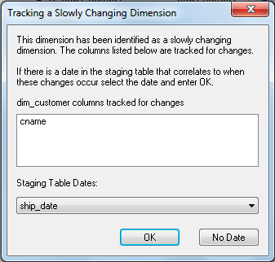

Multiple Source Table Dimension

because this dimension acquire more columns , we establish more load tables.

Tip: we can position the mouse in the right hand pane and click the right menu option “filter_load”To restrict the display to just load tables.

2. drag the descriptive column “xx description” into dimension table.

3.use “validate against database” to alter the physical database table construct.

4.rebuild and recompile the update procedure of dimension table

choose primary source load table/switch join to lookup

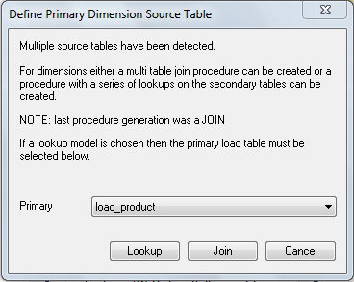

switch a join to a lookup has been detected automatically and the join syntax will be removed

7. Dimension lookup definition

other points worth to note

This would be used where a generic code table was used to lookup descriptions and we would need to make multiple lookups on the same table to get different descriptions.

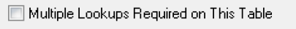

The second is that procedure variables are available in the drop down list of the primary load table. Using this feature it is possible to make lookups that are dependent on the results from previous lookups. This is done by selecting the columns that would have been populated by the earlier lookups.

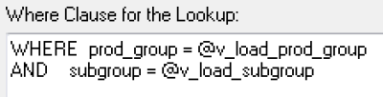

Creating a dimension hierarchy

These dimension hierarchies are used in the generation of Analysis Services cubes. Every dimension in a cube must have a hierarchy with at least one element in it.

### 3.Analysis service cubes

Premise:

This process need to have access to microsoft analysis services server with appropriate rights to create a OLAP Database.

This analysis functionality is supplied with Microsoft SQL server.

1/create a cube from fact table

Cycly each dimension associated with the fact tables



adding a measure group object

**Manage cube measures** dialog is displayed next. Remove all non-measure columns (that is, columns that cannot be aggregated) from

based on a fact table

## Fact_om_invoice chapter

Metadata list

|  |
| --- |
| **QAD Source Table** |
| load_ar_mstr |
| load_cc_mstr |
| load_cu_mstr |
| load_dom_mstr |
| load_ee_BudgetGroup |
| load_ee_BusinessRelation |
| load_ee_CashGroup |
| load_ee_company |
| load_ee_CostCentre |
| load_ee_currency |
| load_ee_dinvoice |
| load_ee_domainproperty |
| load_ee_domains |
| load_ee_DomainSharedSet |
| load_ee_Unit |
| load_ee_Usr |
| load_en_mstr |
| load_idh_hist |
| load_ih_hist |
| load_si_mstr |
| load_tr_hist |
| load_tr_hist_history |

Connection Information

QAD Data Source is located in RH6 64bit Linux

Account Info : sysprogress/sysprogress

Installation

Appendix

1.check the log file to search the essential procedure of jobs?

Load Table

Appendix

**1. log and result status**

property “Work Directory” of QAD Source Connection

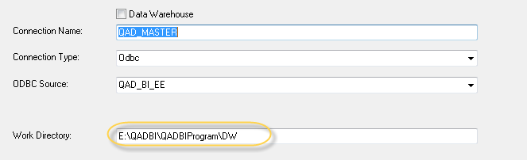

Four kinds of file will be generated throughout load action process.

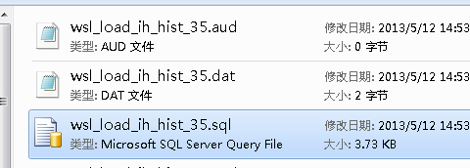

***Note:***

***1.How to troubleshoot problem running load action***

1)open aud file to view error log detail

C:\Program Files (x86)\QAD>sqlcmd –

S2013-0415-0433 -U2013-0415-0433\Administrator -Pqadbi

-dQAD_BI_DW2 -i "xx\input.ctl" -o "xxx\output.log"

*消息 18456，级别 14，状态 1，服务器 2013-0415-0433，第 1 行*

*用户 '2013-0415-0433\Administrator' 登录失败。*

2）the red highlight text is insufficient specific , we can check

SQL Server internal log to view the essential reason.

(http://msdn.microsoft.com/zh-cn/library/ms187109.aspx)



2.Parameter Variable

Start with ‘$P’ plus Parameter Name and trailing ‘$’

3.Load Action process

Execute pre-load Action if existed

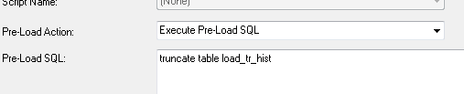

Load Action essential process

**Invocation of windows program command to execute the specific command string**

**The log and callable script will be generated in the Work directory.**

C:\Program Files (x86)\QAD>sqlcmd -S2013-0415-0433 -E -dQAD_BI_SS -i "E:\QADBI\QADBIProgram\DW\wsl_load_tr_hist_60.ctl" -o "E:\QADBI\QADBIProgram\DW\wsl_load_tr_hist_60.load.log"

4.Load_ih_hist duplicated rows .

This table doesn’t have pre-load action. If the schedule executed twice time ,

Then duplicated rows exists.

select * from load_ih_hist

where

source_system_code='QADDB' and

ih_domain = '10USA' and

ih_inv_nbr = '2010/CINV000000123' and

ih_nbr = 'SO091020'

load_cu_mstr OK

cu_mstr

load_si_mstr OK

ok

ODBC is not stable and consolidated

Can’t open log life

load_en_mstr OK

ok

load_ih_hist OK

1.Load Action

Load customization script:

WHERE substr('$**PSALES_PROCESS_RUNNING_JOB_NAME**$',1,4) != 'DAIL'

OR

(substr('$**PSALES_PROCESS_RUNNING_JOB_NAME**$',1,4) = 'DAIL'

AND ih_inv_date > sysdate() - $**PSALES_LOOKBACK_DAYS**$*)*

Parameter:

**SALES_LOOKBACK_DAYS**:60 => 700

Desc:

The number of days to look back in the ih_hist and idh_hist tables to pick up changed records.

Remark:

In order to in accord with the tr_hist data, we reassign the value to 700 days.

Refer to TR_HIST_PROCESS_DAYS value.

**2.SALES_PROCESS_RUNNING_JOB_NAME**:HIST_PREPROCESS_OM_TRUNCATE



load_tr_hist OK(Important)

1.Load Action (Modify)

WHERE tr_domain IN ($PTR_HIST_DOMAIN$)

AND tr_trnbr > $PTR_HIST_TRAN_MAX$

AND tr_date > sysdate - $PTR_HIST_PROCESS_DAYS$

AND tr_trnbr IS NOT NULL

Parameter:

**1.TR_HIST_DOMAIN: empty**

Desc:

DONT UPDATE MANUALLY. Domain to extract this iteration

WHERE tr_domain IN ***(‘$PTR_HIST_DOMAIN$’)***

Cause of fatal error always occurred

when running Fact_om_invoce -related job.

***2.TR_HIST_TRAN_MAX:0=>13000***

Desc:

DONT UPDATE MANUALLY. Maximum Transaction Id to extract this iteration.

***3.TR_HIST_PROCESS_DAYS:5=>700***

Desc:

Number of look back days when extracting data from tr_hist. The records being extracted are tr_trnbr records that are > than the highest transaction_number records already extracted for that source except for tr_nbr rollover where dates come into play.

Remark:

Reassign value to 700 days.

Load Action : failed

Solution: modify default condition

***tr_date > (select max(tr_date)-25 from PUB.tr_hist )***

The reason maybe is empty value of Parameter.

So I assign a parameter value manually and modify the condition script with Load action cause i suppose it lack ‘ symbol to identify the String variable.

Modification as below diagram:

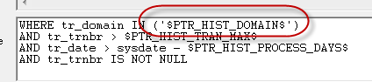

After this manual modification , load action succeed.

load_tr_hist_history

OK

Load Action:

TRUNCATE TABLE load_tr_hist_history;

Fetch the dataset restrict by condition

…

WHERE tr_domain = '$***PTR_HIST_DOMAIN***$'

AND tr_trnbr BETWEEN $***PTR_HIST_TRAN_MIN***$ AND $***PTR_HIST_TRAN_MAX***$

AND tr_trnbr IS NOT NULL

Parameter Info:

1.TR_HIST_TRAN_MIN

DONT UPDATE MANUALLY. Minimum Transaction Id to extract this iteration.

2. TR_HIST_TRAN_MAX

DONT UPDATE MANUALLY. Maximum Transaction Id to extract this iteration.

Default is 0 , modify to maximum value of table ,132813

load_idh_hist OK

Load Action

Here use multiple tables condition:

, **PUB.IH_HIST** ih_hist

WHERE ih_hist.ih_domain = idh_hist.idh_domain

AND ih_hist.ih_inv_nbr = idh_hist.idh_inv_nbr

AND ih_hist.ih_nbr = idh_hist.idh_nbr

AND (substr('$PSALES_PROCESS_RUNNING_JOB_NAME$',1,4) != 'DAIL'

OR (substr('$PSALES_PROCESS_RUNNING_JOB_NAME$',1,4) = 'DAIL'

AND ih_hist.ih_inv_date > sysdate()-$PSALES_LOOKBACK_DAYS$

)

)

load_ee_dinvoice OK

Pre-Load :

WHERE substr('$PCOM_PROCESS_RUNNING_JOB_NAME$',1,4) != 'DAIL'

OR (substr('$PCOM_PROCESS_RUNNING_JOB_NAME$',1,4) = 'DAIL'

AND LastModifiedDate > sysdate() - $PAR_PAYMENT_PROCESS_DAYS$

)

Reassign parameter value to 700 in order to in accord with tr_hist look back days.

load_ar_mstr OK(DS is empty)

Pre-Load:

WHERE substr('$PCOM_PROCESS_RUNNING_JOB_NAME$',1,4) != 'DAIL'

OR

(

substr('$PCOM_PROCESS_RUNNING_JOB_NAME$',1,4) = 'DAIL'

AND (ar_open='1'

OR (ar_open='0'

AND ar_type <> 'P'

AND ar_paid_date > sysdate() - $PAR_PAYMENT_PROCESS_DAYS$

)

OR (ar_type = 'P'

AND ar_date > sysdate() - $PAR_PAYMENT_PROCESS_DAYS$

)

)

)

)

load_ee_company OK

load_ee_currency OK

load_ee_domainproperty OK

load_ee_domains OK

load_ee_BudgetGroup OK

load_ee_CashGroup OK(DS is empty)

load_ee_DomainSharedSet OK

load_ee_Unit OK

load_ee_BusinessRelation OK

load_ee_GL OK

load_ee_SharedSet Failed

Source column “SharedSet_ID” contents:

[DataDirect][ODBC Progress OpenEdge Wire Protocol driver][OPENEDGE]Column %s in table %s has value exceeding its max length or

Select SharedSet_ID from PUB.SharedSet;

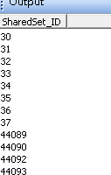

Load_ac_mstr oK

load_code_mstr OK

load_ee_CostCentre OK

load_ee_Usr OK

load_cc_mstr OK

load_dom_mstr ok

Columns contains Parameter probable restrict the data being load is derived from

Different QAD Domain or DB?

|  |  |  |
| --- | --- | --- |
| process_batch_id | $PJOB_COM_PROCESS_BATCH_ID$ | The batch id of the data loaded sourced from the job sequence number. |
| source_system_code | '$PCOM_PROCESS_CONNECTION_NAME$' | The source system of the data loaded sourced from the connection name. |

Stage Table

Appendix (Important)

Build process:

Refer to QAD generated Doc to establish physical table

Column rename / transformation /Data type changes

/***Business Key(Primary Key Setup)***

**Important:**

***We should use third option to review the dimension dependency reference as below red rectangle :***

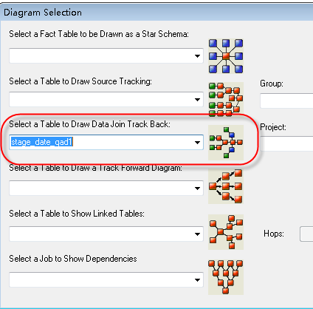

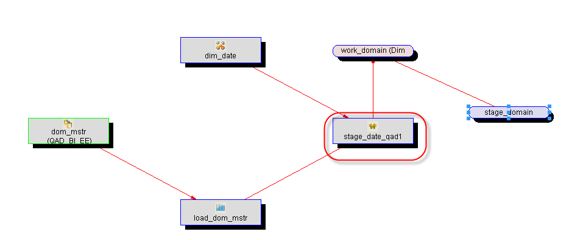

Validation

Verify the column name change.

Compare column quantity and data type difference.

SELECT COLUMN_NAME, DATA_TYPE, CHARACTER_MAXIMUM_LENGTH

FROM information_schema.columns y

WHERE y.TABLE_NAME = 'stage_xx_currency'

and

not exists

(

SELECT COLUMN_NAME, DATA_TYPE, CHARACTER_MAXIMUM_LENGTH

FROM information_schema.columns x

WHERE x.TABLE_NAME = 'stage_currency' and x.COLUMN_NAME = y.COLUMN_NAME

);

*SELECT COLUMN_NAME, DATA_TYPE, CHARACTER_MAXIMUM_LENGTH*

*FROM information_schema.columns y*

*WHERE y.TABLE_NAME = 'stage_xx_account'*

*and exists*

*(SELECT COLUMN_NAME, DATA_TYPE, CHARACTER_MAXIMUM_LENGTH*

*FROM information_schema.columns x*

*WHERE x.TABLE_NAME = 'stage_account' and x.COLUMN_NAME = y.COLUMN_NAME and y.DATA_TYPE<>x.DATA_TYPE);*

3)Build procedure

Choose Procedure Type (normally choose Set)

**Set parameters(This doesn’t refer in QAD Doc??)**

The utilization of Parameter is frequently used in column transformation matter.

Insert into target_tab(dss_update_time…)

SELECT ISNULL(Col,@v_DEFAULT_COST_CENTER) col from src_tab

It is assigned by dbo system level procedure as belows:

SELECT @v_default_cost_center = dbo.WsParameterReadF('DEFAULT_COST_CENTER')

**Dimension reference dependency (If dimension join exists)**

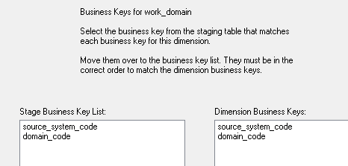

1.Stage Table doesn’t contains any primary constraint or check ?

How to avoid duplicated ?

Actually it has business key sometime.

Such as “stage_domain”

1.Stage table no constraint or check ,how to avoid duplicated row inserting.

2.when populate the Procedure type Selection page ,the purpose of the checked option ?

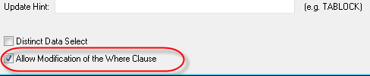

3.what’s the usage of the below procedure?

dbo.ConvertCurrencyValueTrans

4.What the option “Additive” functionality?

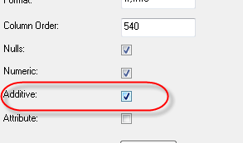

5. Array type column need to transfer?

Un-do columns:

Derive from stage_xx_om_invoice2 table.

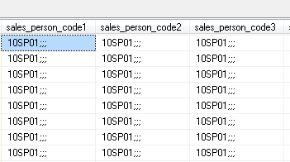

**6. how to verify the column between QAD original table and our customization table?**

**Check out the lack columns ?**

**SELECT COLUMN_NAME, DATA_TYPE, CHARACTER_MAXIMUM_LENGTH**

**FROM information_schema.columns y**

**WHERE y.TABLE_NAME = 'stage_ee_account'**

**and**

**not exists**

**(**

**SELECT COLUMN_NAME, DATA_TYPE, CHARACTER_MAXIMUM_LENGTH**

**FROM information_schema.columns x**

**WHERE x.TABLE_NAME = 'stage_xx_ee_account' and x.COLUMN_NAME = y.COLUMN_NAME**

**);**

7.The purpose of extra layer table ,for instance as below describe:???

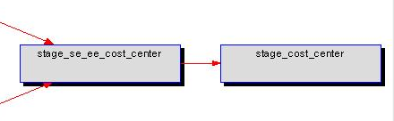

8.The cross join usage?

stage_date_qad1

stage_transaction_hist OK

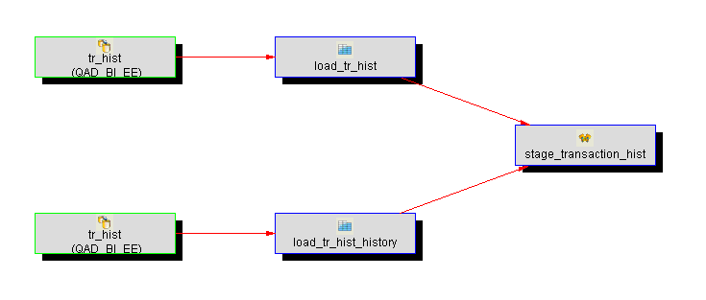(stage_xx_tr_hist)

Business Metrics:

Merge tr_hist(the data look back N days before sysdate)

And tr_hist_history(the data < max transaction number)

together

Columns:

load_tr_hist

load_tr_hist_history source column : source_system_code

same name column from load_tr_hist has been removed .

use one table to build two load_tab

Procedure:

1. built was a Type 5 Set Merge

stage_om_invoice_header OK

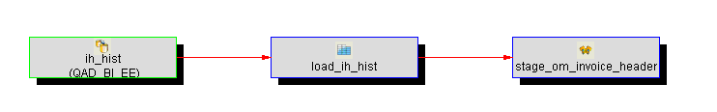

1.Columns

Attention: one columns make five alias columns

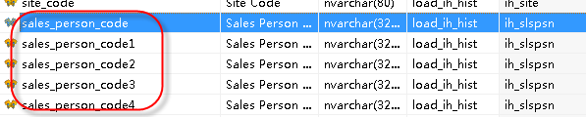

2.procedure

Type is 3.Set

stage_om_invoice_line OK

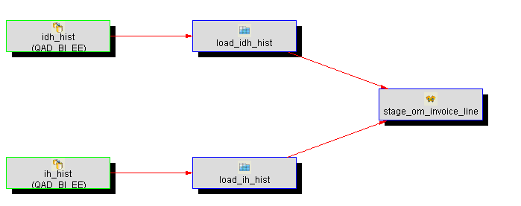

1.columns

load_ih_hist:

Sold_to_code | ih_cust

Invoice_date | ih_inv_date

load_idh_hist:

Other columns

Idh_comm_pct expand five alias columns.

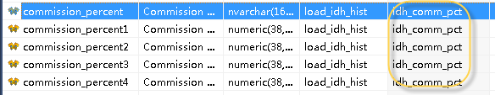

Transformation:

In order to process the array type column of Progress column ,

divide the commission_percent column into four columns as following:

commission_percent1 : (Numbered from 1 upward to 4)

**CONVERT(NUMERIC(38,10),ISNULL(NULLIF(dbo.SubstrPartN(load_idh_hist.idh_comm_pct,';',1),''),'0'))**

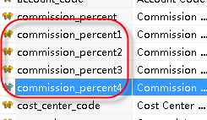

Currently cause of the misunderstanding process , I populate this process

In extract_xx_om_invoice_line table.

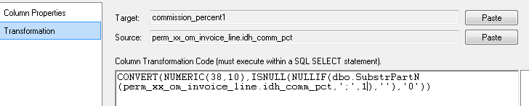

2.Procedure

**Column properties within transformation.**

Suggest that you can view the procedure block within insert/update append

The transformation located in insert SQL. As below diagram:

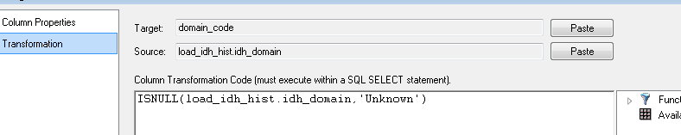

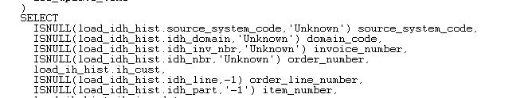

procedure

is a type 3.Set

**The join type consist of outer join plus simple join**

The join relationship built in DWD will generate essentially below SQL scripts:

FROM load_idh_hist

JOIN load_ih_hist

ON load_idh_hist.source_system_code = load_ih_hist.source_system_code

AND load_idh_hist.idh_domain = load_ih_hist.ih_domain

AND load_idh_hist.idh_nbr = load_ih_hist.ih_nbr

AND load_idh_hist.idh_inv_nbr = load_ih_hist.ih_inv_nbr

stage_ee_entity OK

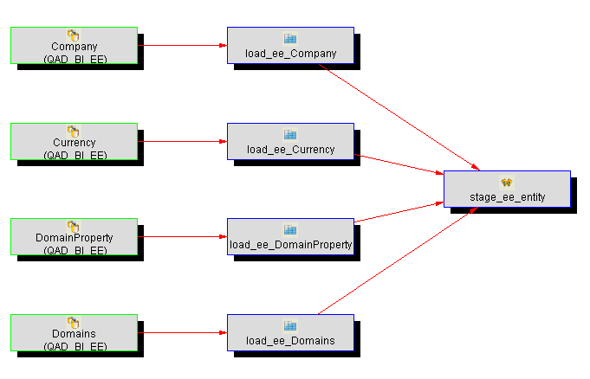

1 load table

Problem1) entity_statutory_currency_code column is source from

CurrencyCode / load_ee_Currency_Statutory

This table doesn’t display on the diagram?

Issuing SQL to validate this load table doesn’t exists.

2 procedure

Procedure type is 3.Set.

Parameter choose:

Unknown value

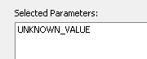

Table relationship:

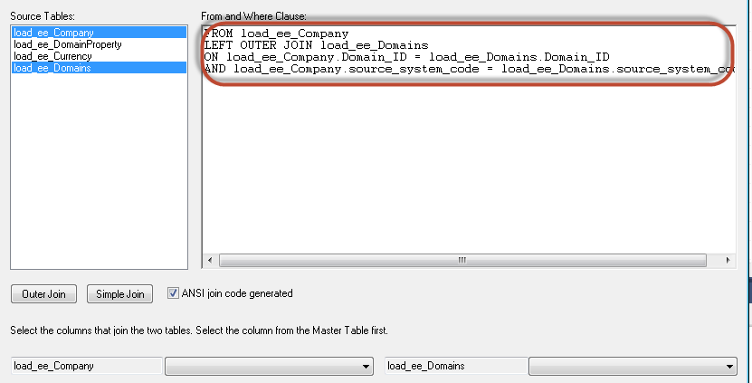

You can also type sql script directly. The same effect:

**FROM load_ee_Company**

**LEFT OUTER JOIN load_ee_Domains**

**ON load_ee_Company.Domain_ID = load_ee_Domains.Domain_ID**

**AND load_ee_Company.Source_System_Code = load_ee_Domains.Source_System_Code**

LEFT OUTER JOIN load_ee_DomainProperty

ON **load_ee_Domains**.Domain_ID = load_ee_DomainProperty.Domain_ID

AND **load_ee_Domains**.Source_System_Code = load_ee_DomainProperty.Source_System_Code

LEFT OUTER JOIN load_ee_Currency

ON load_ee_DomainProperty.Currency_ID = load_ee_Currency.Currency_ID

AND load_ee_DomainProperty.Source_System_Code = load_ee_Currency.Source_System_Code

LEFT OUTER JOIN load_ee_CompanyProperty

ON load_ee_Company.Company_ID = load_ee_CompanyProperty.company_id

AND load_ee_Company.Source_System_Code = load_ee_CompanyProperty.Source_System_Code

LEFT OUTER JOIN load_ee_currency load_ee_currency_statutory

ON load_ee_DomainProperty.StatutoryCurrency_ID = load_ee_currency_statutory.currency_id

AND load_ee_DomainProperty.Source_System_Code = load_ee_currency_statutory.Source_System_Code

**Problem1)load_ee_currency_statutory is alias table,**

**but how to update this artifilate column data ?**

stage_ee_ar_master OK

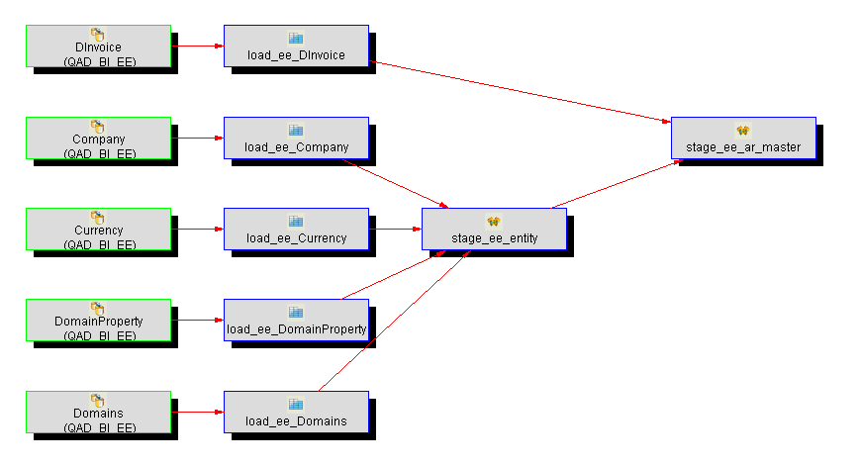

1.Columns

1) ar_domain is derived from load_ee_Domains\DomainCode

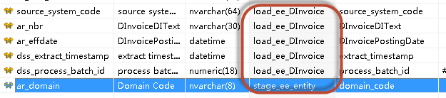

2) column transformation and Aggregation

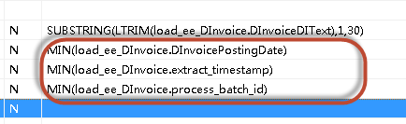

Column expression transformation as below rounded rectangle:

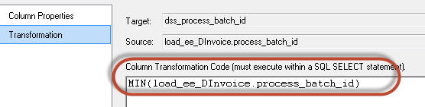

**3.artificial column without source table and assign null value in procedure**

**In order to acquire the identical columns with stage_xx_se_ar_master ,**

**When the more higher layer stage_ar_master’s procedure merge type.**

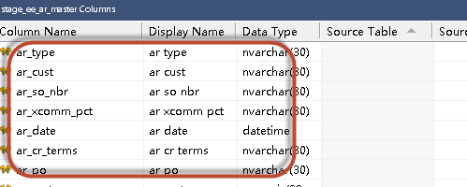

2.Procedure

1)Built as a type 3.SET

2)Procedure Cursor Mapping ( Multiple Tables Relationship):

FROM load_ee_DInvoice

LEFT OUTER JOIN stage_ee_entity

ON load_ee_DInvoice.source_system_code = stage_ee_entity.source_system_code

AND ***load_ee_DInvoice.Company_ID = stage_ee_entity.entity_id***

***(Remarkable condition the relative column***

***entity_id is derived from stage_xx_entity/load_ee_Company/Company_ID)***

GROUP BY

load_ee_DInvoice.source_system_code

,stage_ee_entity.domain_code

,SUBSTRING(LTRIM(load_ee_DInvoice.DInvoiceDIText),1,30)

**? option shaped in cycle is checked? What’s the usage?**

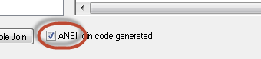

stage_se_ar_master OK(Data is empty)

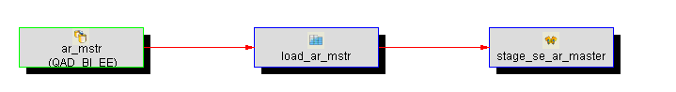

Rename or Transformation columns:



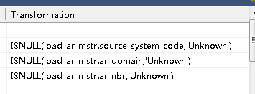

Procedure Type is 3.Set

ee

stage_ar_master OK

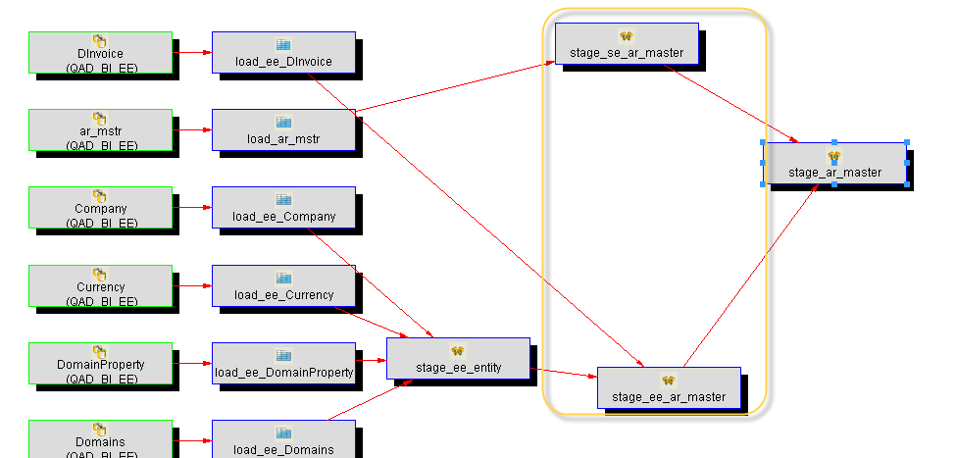

Columns

Ar_domain,duplicated column, is derived from stage_ee_ar_master.

One column is sourced from “stage_ee_ar_master” ,

others comes from “stage_se_ar_master”.

Attention: ar_domain column is contained in two tables. Here choose ar_domain from

“stage_ee_ar_master” , not duplicated column .



2.Procedure

***Current build was a Type 5.SET MERGE***

**???Cursor Mapping was form of only one table?**

**The table typed in the blank of bottom right hander will be firstly inserted in procedure script.**

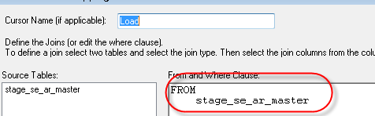

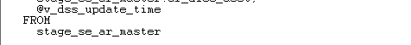

**Important:**

**Merge Type is to restrict two source table must have the same quantity of columns.**

**So this reason why need to establish the artificial key in Table**

**Stage_xx_ee_ar_master.**

stage_om_invoice_transaction1 OK

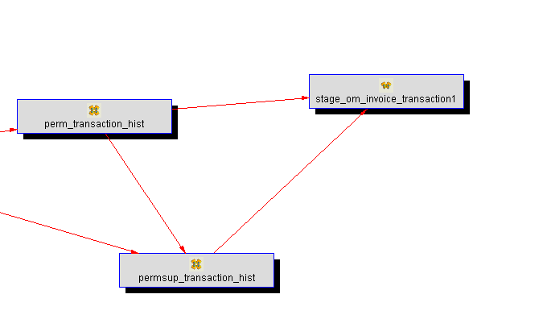

***Table functionality description:***

***Temporary staging table for fact_om_order_history containing tr_hist rows (type of ISS-SO and ORD-SO) ranked by transaction rank and number (descending). ORD-SO rows have rank 0. The last row on a particular date or date range has a transaction_rank of 1.***

1.Columns

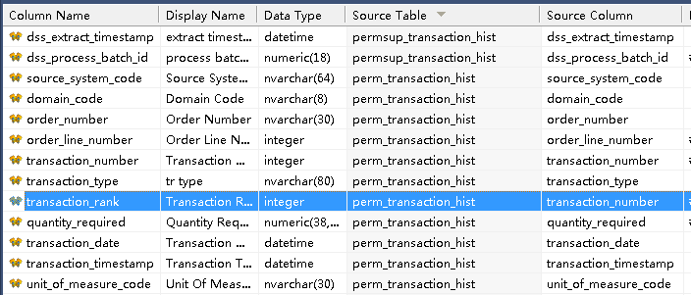

perm_transaction_hist/transaction_number:

RANK() OVER (

PARTITION BY perm_transaction_hist.source_system_code

, perm_transaction_hist.domain_code

, perm_transaction_hist.order_number

, perm_transaction_hist.order_line_number

ORDER BY perm_transaction_hist.transaction_timestamp ASC,

perm_transaction_hist.transaction_number ASC

)

2.Procedure

1)Type is 3.set / Allow modification of The where clause

2)Parameter

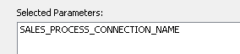

3)Cursor Mapping

FROM perm_transaction_hist

JOIN permsup_transaction_hist

ON perm_transaction_hist.source_system_code = permsup_transaction_hist.source_system_code

AND perm_transaction_hist.domain_code = permsup_transaction_hist.domain_code

AND perm_transaction_hist.transaction_number = permsup_transaction_hist.transaction_number

AND perm_transaction_hist.transaction_date = permsup_transaction_hist.transaction_date

WHERE perm_transaction_hist.source_system_code = @v_sales_process_connection_name

AND perm_transaction_hist.transaction_type IN ('ORD-SO')

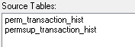

stage_om_ar_master_extract OK

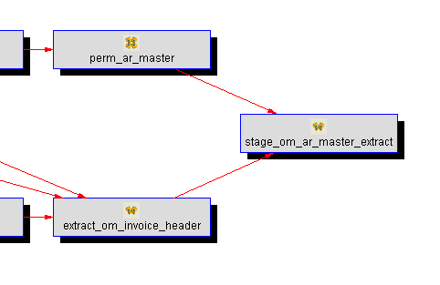

1.Columns

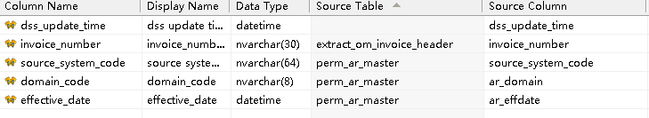

Transforamtion : ***aggregation express***

effective_date =〉MIN(perm_ar_master.ar_effdate)

2.Procedure

1)Type is 3.set

2)Cursor Mapping

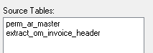

FROM perm_ar_master

JOIN extract_om_invoice_header

ON perm_ar_master.source_system_code = extract_om_invoice_header.source_system_code

AND perm_ar_master.ar_domain = extract_om_invoice_header.domain_code

AND perm_ar_master.ar_nbr = extract_om_invoice_header.invoice_number

GROUP BY perm_ar_master.source_system_code

, perm_ar_master.ar_domain

, extract_om_invoice_header.invoice_number

stage_om_invoice_transaction OK

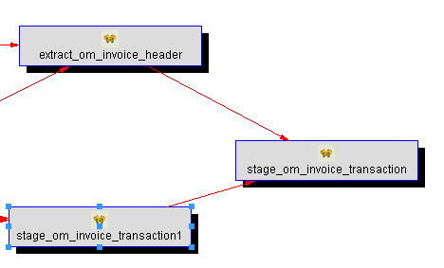

1.Columns

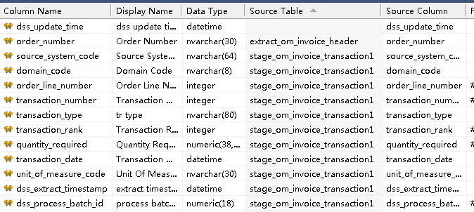

2.Procedure

1)Type is 3.Set/Distinct Data

2)Cursor Mapping

FROM stage_om_invoice_transaction1

JOIN extract_om_invoice_header

ON stage_om_invoice_transaction1.source_system_code = extract_om_invoice_header.source_system_code

AND stage_om_invoice_transaction1.domain_code = extract_om_invoice_header.domain_code

AND stage_om_invoice_transaction1.order_number = extract_om_invoice_header.order_number

WHERE stage_om_invoice_transaction1.transaction_rank = 1

**??Important Puzzle:**

What’s the usage of the below sentence:

***WHERE stage_om_invoice_transaction1.transaction_rank = 1***

stage_om_invoice1 OK

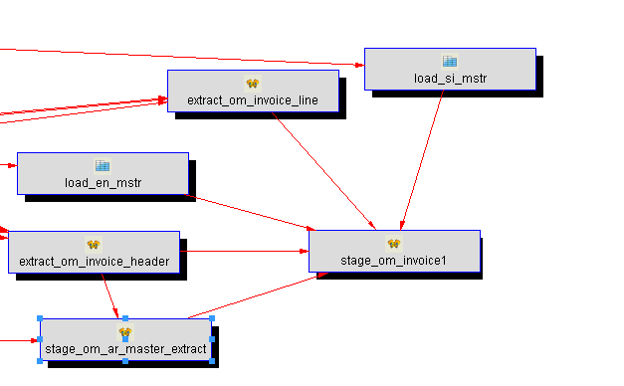

***Table Notion:***

***Temporary staging table for fact_om_invoice***

***containing data from perm_om_invoice_heade and perm_om_invoice_line. Data change in either perm table in the last SALES_PROCESS_DAYS only is included.***

1.Columns

Corporate_currency_code is artificial column.

**How to process the array type column of Progress DB**

**commission_percent1**

**This column value is String cause following expression failed.**

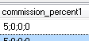

--stage_xx_om_invoice1.net_price_trans

-- *stage_xx_om_invoice1.quantity_invoiced

-- *stage_xx_om_invoice1.commission_percent1

-- /100 commission_amount1_trans

Solved method & Process Analysis:

1.stage_om_invoice1

commission_percent1:ISNULL(extract_om_invoice_line.commission_percent1,0)

2.extract_om_invoice_line

perm_om_invoice_line/commission_percent1

3.perm_om_invoice_line

stage_om_invoice_line/commission_percent1

4.Stage Table

**CONVERT(NUMERIC(38,10),ISNULL(NULLIF(dbo.SubstrPartN(load_idh_hist.idh_comm_pct,';',1),''),'0'))**

load_idh_hist.idh_comm_pct

**Remark:**

*Use split function to separate the array string delimiter throughout this process ,*

*We transform this in Stage Table step.*

2.Procedure

1)Type is 3.Set

2)Parameter

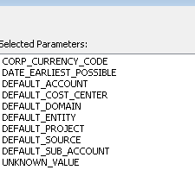

3)Cursor Mapping

FROM extract_om_invoice_header

JOIN extract_om_invoice_line

ON extract_om_invoice_header.source_system_code = extract_om_invoice_line.source_system_code

AND extract_om_invoice_header.domain_code = extract_om_invoice_line.domain_code

AND extract_om_invoice_header.order_number = extract_om_invoice_line.order_number

AND extract_om_invoice_header.invoice_number = extract_om_invoice_line.invoice_number

LEFT OUTER JOIN load_si_mstr

ON extract_om_invoice_line.source_system_code = load_si_mstr.source_system_code

AND extract_om_invoice_line.domain_code = load_si_mstr.si_domain

AND ISNULL(NULLIF(extract_om_invoice_line.site_code,''),extract_om_invoice_header.site_code) = load_si_mstr.si_site

LEFT OUTER JOIN load_en_mstr

ON load_si_mstr.source_system_code = load_en_mstr.source_system_code

AND load_si_mstr.si_domain = load_en_mstr.en_domain

AND load_si_mstr.si_entity = load_en_mstr.en_entity

LEFT OUTER JOIN stage_om_ar_master_extract

ON extract_om_invoice_header.source_system_code = stage_om_ar_master_extract.source_system_code

AND extract_om_invoice_header.domain_code = stage_om_ar_master_extract.domain_code

AND extract_om_invoice_header.invoice_number = stage_om_ar_master_extract.invoice_number

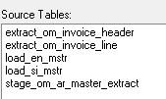

stage_om_invoice2 OK

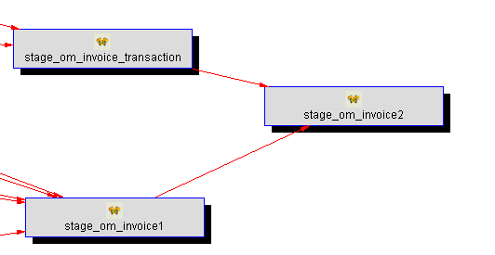

1.Columns

Source column “unit_cost_base” expand :

unit_cost_trans\ unit_cost_corp\ unit_cost_base\ extended_cost_base

“net_price_trans” expand:

net_price_trans\ net_price_corp\ net_price_base\

invoice_amount_trans\ gross_margin_trans

**“net_price_corp”:?**

**invoice_amount_corp\ gross_margin_corp**

**“net_price_base”:?**

**invoice_amount_base\ gross_margin_base**

“list_price_trans”:

list_price_extended_trans\ list_price_corp\

list_price_base\ discount_amount_trans

**“list_price_corp”:??**

**list_price_extended_corp\ discount_amount_corp**

**“list_price_base”:??**

**list_price_extended_base\ discount_amount_base**

“commission_percent4”: (numbered from 1 upward to 4)

commission_percent4\ commission_amount4_trans\

commission_amount4_corp\ commission_amount4_base

Transformation:

List price relative

1)list_price_base

dbo.ConvertCurrencyValueTrans

( stage_om_invoice1.source_system_code

, stage_om_invoice1.domain_code

, stage_om_invoice1.transaction_currency_code

, stage_om_invoice1.base_currency_code

, stage_om_invoice1.base_currency_code

, stage_om_invoice1.effective_date

, stage_om_invoice1.list_price_trans

, 0

, stage_om_invoice1.exchange_rate

, stage_om_invoice1.exchange_rate2

, 6)

2) list_price_corp

dbo.ConvertCurrencyValueTrans

( stage_om_invoice1.source_system_code

, stage_om_invoice1.domain_code

, stage_om_invoice1.transaction_currency_code

, stage_om_invoice1.base_currency_code

, stage_om_invoice1.corporate_currency_code

, stage_om_invoice1.effective_date

, stage_om_invoice1.list_price_trans

--Derive list_price_base for use in deriving corp_currency when corp_currency doesn't match transaction or base currency.

, dbo.ConvertCurrencyValueTrans

( stage_om_invoice1.source_system_code

, stage_om_invoice1.domain_code

, stage_om_invoice1.transaction_currency_code

, stage_om_invoice1.base_currency_code

, stage_om_invoice1.base_currency_code

, stage_om_invoice1.effective_date

, stage_om_invoice1.list_price_trans

, 0

, stage_om_invoice1.exchange_rate

, stage_om_invoice1.exchange_rate2

, 6) -- list_price_base

, stage_om_invoice1.exchange_rate

, stage_om_invoice1.exchange_rate2

, 6)

**Net price relative ? lack columns**

1)net_price_base

dbo.ConvertCurrencyValueTrans

( stage_om_invoice1.source_system_code

, stage_om_invoice1.domain_code

, stage_om_invoice1.transaction_currency_code

, stage_om_invoice1.base_currency_code

, stage_om_invoice1.base_currency_code

, stage_om_invoice1.effective_date

, stage_om_invoice1.net_price_trans

, 0

, stage_om_invoice1.exchange_rate

, stage_om_invoice1.exchange_rate2

, 6)

2)net_price_corp

dbo.ConvertCurrencyValueTrans

( stage_om_invoice1.source_system_code

, stage_om_invoice1.domain_code

, stage_om_invoice1.transaction_currency_code

, stage_om_invoice1.base_currency_code

, stage_om_invoice1.corporate_currency_code

, stage_om_invoice1.effective_date

, stage_om_invoice1.net_price_trans

-- Next input is net_price_base and needs to be derived using the net_price_trans by using ConvertCurrencyValueTrans to get the base.

, dbo.ConvertCurrencyValueTrans

( stage_om_invoice1.source_system_code

, stage_om_invoice1.domain_code

, stage_om_invoice1.transaction_currency_code

, stage_om_invoice1.base_currency_code

, stage_om_invoice1.base_currency_code

, stage_om_invoice1.effective_date

, stage_om_invoice1.net_price_trans

, 0

, stage_om_invoice1.exchange_rate

, stage_om_invoice1.exchange_rate2

, 6) --net_price_base

, stage_om_invoice1.exchange_rate

, stage_om_invoice1.exchange_rate2

, 6)

Unit cost relative

1) unit_cost_trans

dbo.ConvertCurrencyValueTrans

( stage_om_invoice1.source_system_code

, stage_om_invoice1.domain_code

, stage_om_invoice1.transaction_currency_code

, stage_om_invoice1.base_currency_code

, stage_om_invoice1.transaction_currency_code

, stage_om_invoice1.effective_date

, 0

, stage_om_invoice1.unit_cost_base

, stage_om_invoice1.exchange_rate

, stage_om_invoice1.exchange_rate2

, 6)

2)unit_cost_corp

dbo.ConvertCurrencyValueTrans

( stage_om_invoice1.source_system_code

, stage_om_invoice1.domain_code

, stage_om_invoice1.transaction_currency_code

, stage_om_invoice1.base_currency_code

, stage_om_invoice1.corporate_currency_code

, stage_om_invoice1.effective_date

, 0

, stage_om_invoice1.unit_cost_base

, stage_om_invoice1.exchange_rate

, stage_om_invoice1.exchange_rate2

, 6)

**Commission Amount Relative:**

***\*\*\*\*\*\*\*Remark: red highlighted numbered from 1 upward to 4\*\*\*\*\*\****

***Commission_persentX column***

1)commission_amount1_trans

stage_om_invoice1.net_price_trans

*stage_om_invoice1.quantity_invoiced

*stage_om_invoice1.commission_percent***1***

/100

2) commission_amount1_base

dbo.ConvertCurrencyValueTrans

( stage_om_invoice1.source_system_code

, stage_om_invoice1.domain_code

, stage_om_invoice1.transaction_currency_code

, stage_om_invoice1.base_currency_code

, stage_om_invoice1.base_currency_code

, stage_om_invoice1.effective_date

, (stage_om_invoice1.net_price_trans

*stage_om_invoice1.quantity_invoiced

*stage_om_invoice1.commission_percent***1***

/100)

, 0

, stage_om_invoice1.exchange_rate

, stage_om_invoice1.exchange_rate2

, 6)

3) commission_amount1_corp

dbo.ConvertCurrencyValueTrans

( stage_om_invoice1.source_system_code

, stage_om_invoice1.domain_code

, stage_om_invoice1.transaction_currency_code

, stage_om_invoice1.base_currency_code

, stage_om_invoice1.corporate_currency_code

, stage_om_invoice1.effective_date

, (stage_om_invoice1.net_price_trans

*stage_om_invoice1.quantity_invoiced

*stage_om_invoice1.commission_percent***1***

/100)

, dbo.ConvertCurrencyValueTrans --Include net_price_base here.

( stage_om_invoice1.source_system_code

, stage_om_invoice1.domain_code

, stage_om_invoice1.transaction_currency_code

, stage_om_invoice1.base_currency_code

, stage_om_invoice1.base_currency_code

, stage_om_invoice1.effective_date

, (stage_om_invoice1.net_price_trans

*stage_om_invoice1.quantity_invoiced

*stage_om_invoice1.commission_percent***1***

/100)

, 0

, stage_om_invoice1.exchange_rate

, stage_om_invoice1.exchange_rate2

, 6) --net_price_base

, stage_om_invoice1.exchange_rate

, stage_om_invoice1.exchange_rate2

, 6)

**List price extended Relative:**

1)list_price_extended_trans

stage_om_invoice1.list_price_trans

*stage_om_invoice1.quantity_invoiced

**2)list_price_extended_base ? Lack column**

dbo.ConvertCurrencyValueTrans

( stage_om_invoice1.source_system_code

, stage_om_invoice1.domain_code

, stage_om_invoice1.transaction_currency_code

, stage_om_invoice1.base_currency_code

, stage_om_invoice1.base_currency_code

, stage_om_invoice1.effective_date

, (stage_om_invoice1.list_price_trans

*stage_om_invoice1.quantity_invoiced)

, 0

, stage_om_invoice1.exchange_rate

, stage_om_invoice1.exchange_rate2

, 6)

**3) list_price_extended_corp ? Lack column**

dbo.ConvertCurrencyValueTrans

( stage_om_invoice1.source_system_code

, stage_om_invoice1.domain_code

, stage_om_invoice1.transaction_currency_code

, stage_om_invoice1.base_currency_code

, stage_om_invoice1.corporate_currency_code

, stage_om_invoice1.effective_date

, (stage_om_invoice1.list_price_trans

*stage_om_invoice1.quantity_invoiced)

, dbo.ConvertCurrencyValueTrans --list_price_extended_base needed here.

( stage_om_invoice1.source_system_code

, stage_om_invoice1.domain_code

, stage_om_invoice1.transaction_currency_code

, stage_om_invoice1.base_currency_code

, stage_om_invoice1.base_currency_code

, stage_om_invoice1.effective_date

, (stage_om_invoice1.list_price_trans

*stage_om_invoice1.quantity_invoiced)

, 0

, stage_om_invoice1.exchange_rate

, stage_om_invoice1.exchange_rate2

, 6) --list_price_extended_base

, stage_om_invoice1.exchange_rate

, stage_om_invoice1.exchange_rate2

, 6)

**Discount Amount Relative:**

**1)discount_amount_trans ? Lack Column**

(stage_om_invoice1.list_price_trans

*stage_om_invoice1.quantity_invoiced)

-(stage_om_invoice1.net_price_trans

*stage_om_invoice1.quantity_invoiced)

**2)discount_amount_base ? Lack Column**

(dbo.ConvertCurrencyValueTrans

( stage_om_invoice1.source_system_code

, stage_om_invoice1.domain_code

, stage_om_invoice1.transaction_currency_code

, stage_om_invoice1.base_currency_code

, stage_om_invoice1.base_currency_code

, stage_om_invoice1.effective_date

, (stage_om_invoice1.list_price_trans

*stage_om_invoice1.quantity_invoiced)

, 0

, stage_om_invoice1.exchange_rate

, stage_om_invoice1.exchange_rate2

, 6))

-

(dbo.ConvertCurrencyValueTrans

( stage_om_invoice1.source_system_code

, stage_om_invoice1.domain_code

, stage_om_invoice1.transaction_currency_code

, stage_om_invoice1.base_currency_code

, stage_om_invoice1.base_currency_code

, stage_om_invoice1.effective_date

, (stage_om_invoice1.net_price_trans

*stage_om_invoice1.quantity_invoiced)

, 0

, stage_om_invoice1.exchange_rate

, stage_om_invoice1.exchange_rate2

, 6))

**3)discount_amount_corp ? Lack Column**

(dbo.ConvertCurrencyValueTrans

( stage_om_invoice1.source_system_code

, stage_om_invoice1.domain_code

, stage_om_invoice1.transaction_currency_code

, stage_om_invoice1.base_currency_code

, stage_om_invoice1.corporate_currency_code

, stage_om_invoice1.effective_date

, (stage_om_invoice1.list_price_trans

*stage_om_invoice1.quantity_invoiced)

, dbo.ConvertCurrencyValueTrans

( stage_om_invoice1.source_system_code

, stage_om_invoice1.domain_code

, stage_om_invoice1.transaction_currency_code

, stage_om_invoice1.base_currency_code

, stage_om_invoice1.base_currency_code

, stage_om_invoice1.effective_date

, (stage_om_invoice1.list_price_trans

*stage_om_invoice1.quantity_invoiced)

, 0

, stage_om_invoice1.exchange_rate

, stage_om_invoice1.exchange_rate2

, 6) --discount_amount_list_base

, stage_om_invoice1.exchange_rate

, stage_om_invoice1.exchange_rate2

, 6))

-

(dbo.ConvertCurrencyValueTrans

( stage_om_invoice1.source_system_code

, stage_om_invoice1.domain_code

, stage_om_invoice1.transaction_currency_code

, stage_om_invoice1.base_currency_code

, stage_om_invoice1.corporate_currency_code

, stage_om_invoice1.effective_date

, (stage_om_invoice1.net_price_trans

*stage_om_invoice1.quantity_invoiced)

, dbo.ConvertCurrencyValueTrans

( stage_om_invoice1.source_system_code

, stage_om_invoice1.domain_code

, stage_om_invoice1.transaction_currency_code

, stage_om_invoice1.base_currency_code

, stage_om_invoice1.base_currency_code

, stage_om_invoice1.effective_date

, (stage_om_invoice1.net_price_trans

*stage_om_invoice1.quantity_invoiced)

, 0

, stage_om_invoice1.exchange_rate

, stage_om_invoice1.exchange_rate2

, 6) --discount_amount_net_base

, stage_om_invoice1.exchange_rate

, stage_om_invoice1.exchange_rate2

, 6))

**Invoice Amount Relative:**

1) invoice_amount_trans

stage_om_invoice1.net_price_trans

*stage_om_invoice1.quantity_invoiced

**2) invoice_amount_base ?Lack Column**

dbo.ConvertCurrencyValueTrans

( stage_om_invoice1.source_system_code

, stage_om_invoice1.domain_code

, stage_om_invoice1.transaction_currency_code

, stage_om_invoice1.base_currency_code

, stage_om_invoice1.base_currency_code

, stage_om_invoice1.effective_date

, (stage_om_invoice1.net_price_trans

*stage_om_invoice1.quantity_invoiced)

, 0

, stage_om_invoice1.exchange_rate

, stage_om_invoice1.exchange_rate2

, 6)

**3) invoice_amount_corp ?Lack Column**

dbo.ConvertCurrencyValueTrans

( stage_om_invoice1.source_system_code

, stage_om_invoice1.domain_code

, stage_om_invoice1.transaction_currency_code

, stage_om_invoice1.base_currency_code

, stage_om_invoice1.corporate_currency_code

, stage_om_invoice1.effective_date

, (stage_om_invoice1.net_price_trans

*stage_om_invoice1.quantity_invoiced)

, dbo.ConvertCurrencyValueTrans

( stage_om_invoice1.source_system_code

, stage_om_invoice1.domain_code

, stage_om_invoice1.transaction_currency_code

, stage_om_invoice1.base_currency_code

, stage_om_invoice1.base_currency_code

, stage_om_invoice1.effective_date

, (stage_om_invoice1.net_price_trans

*stage_om_invoice1.quantity_invoiced)

, 0

, stage_om_invoice1.exchange_rate

, stage_om_invoice1.exchange_rate2

, 6) --invoice_amount_base

, stage_om_invoice1.exchange_rate

, stage_om_invoice1.exchange_rate2

, 6)

**Extended cost Relative:**

**1)extended_cost_trans ?Lack Column**

dbo.ConvertCurrencyValueTrans

( stage_om_invoice1.source_system_code

, stage_om_invoice1.domain_code

, stage_om_invoice1.transaction_currency_code

, stage_om_invoice1.base_currency_code

, stage_om_invoice1.transaction_currency_code

, stage_om_invoice1.effective_date

, 0

, (stage_om_invoice1.unit_cost_base

*stage_om_invoice1.quantity_invoiced)

, stage_om_invoice1.exchange_rate

, stage_om_invoice1.exchange_rate2

, 6)

2) extended_cost_base

stage_om_invoice1.unit_cost_base

*stage_om_invoice1.quantity_invoiced

**3) extended_cost_corp ?Lack Column**

dbo.ConvertCurrencyValueTrans

( stage_om_invoice1.source_system_code

, stage_om_invoice1.domain_code

, stage_om_invoice1.transaction_currency_code

, stage_om_invoice1.base_currency_code

, stage_om_invoice1.corporate_currency_code

, stage_om_invoice1.effective_date

, 0

, (stage_om_invoice1.unit_cost_base

*stage_om_invoice1.quantity_invoiced)

, stage_om_invoice1.exchange_rate

, stage_om_invoice1.exchange_rate2

, 6)

**Gross margin Relative: ? Lack Column**

1) gross_margin_trans

(stage_om_invoice1.net_price_trans

*stage_om_invoice1.quantity_invoiced)

-

(dbo.ConvertCurrencyValueTrans

( stage_om_invoice1.source_system_code

, stage_om_invoice1.domain_code

, stage_om_invoice1.transaction_currency_code

, stage_om_invoice1.base_currency_code

, stage_om_invoice1.transaction_currency_code

, stage_om_invoice1.effective_date

,0

, (stage_om_invoice1.unit_cost_base

*stage_om_invoice1.quantity_invoiced)

, stage_om_invoice1.exchange_rate

, stage_om_invoice1.exchange_rate2

, 6))

2) gross_margin_base

(dbo.ConvertCurrencyValueTrans

( stage_om_invoice1.source_system_code

, stage_om_invoice1.domain_code

, stage_om_invoice1.transaction_currency_code

, stage_om_invoice1.base_currency_code

, stage_om_invoice1.base_currency_code

, stage_om_invoice1.effective_date

, (stage_om_invoice1.net_price_trans

*stage_om_invoice1.quantity_invoiced)

, 0

, stage_om_invoice1.exchange_rate

, stage_om_invoice1.exchange_rate2

, 6))

-(stage_om_invoice1.unit_cost_base

*stage_om_invoice1.quantity_invoiced)

3) gross_margin_corp

(dbo.ConvertCurrencyValueTrans

( stage_om_invoice1.source_system_code

, stage_om_invoice1.domain_code

, stage_om_invoice1.transaction_currency_code

, stage_om_invoice1.base_currency_code

, stage_om_invoice1.corporate_currency_code

, stage_om_invoice1.effective_date

, (stage_om_invoice1.net_price_trans

*stage_om_invoice1.quantity_invoiced)

, dbo.ConvertCurrencyValueTrans

( stage_om_invoice1.source_system_code

, stage_om_invoice1.domain_code

, stage_om_invoice1.transaction_currency_code

, stage_om_invoice1.base_currency_code

, stage_om_invoice1.base_currency_code

, stage_om_invoice1.effective_date

, (stage_om_invoice1.net_price_trans

*stage_om_invoice1.quantity_invoiced)

, 0

, stage_om_invoice1.exchange_rate

, stage_om_invoice1.exchange_rate2

, 6) --net_price_base

, stage_om_invoice1.exchange_rate

, stage_om_invoice1.exchange_rate2

, 6))

-

(dbo.ConvertCurrencyValueTrans

( stage_om_invoice1.source_system_code

, stage_om_invoice1.domain_code

, stage_om_invoice1.transaction_currency_code

, stage_om_invoice1.base_currency_code

, stage_om_invoice1.corporate_currency_code

, stage_om_invoice1.effective_date

, 0

, (stage_om_invoice1.unit_cost_base

*stage_om_invoice1.quantity_invoiced)

, stage_om_invoice1.exchange_rate

, stage_om_invoice1.exchange_rate2

, 6))

2.Procedure

1)Type is 3.Set

2)Cursor Mapping

FROM stage_om_invoice1

LEFT OUTER JOIN stage_om_invoice_transaction

ON stage_om_invoice1.source_system_code = stage_om_invoice_transaction.source_system_code

AND stage_om_invoice1.domain_code = stage_om_invoice_transaction.domain_code

AND stage_om_invoice1.order_number = stage_om_invoice_transaction.order_number

AND stage_om_invoice1.order_line_number = stage_om_invoice_transaction.order_line_number

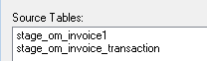

stage_om_invoice3

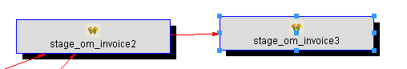

This table had already dimension dependency link.

Temporary staging table for final result table named “fact_om_invoice”

Containing data from table “stage_om_invoice2” established in previous step

With most dimension keys add.

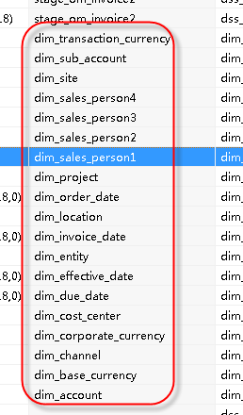

1.Columns

2.Procedure

1)Type is 3.set

2)Dimension key dependency

Dim_account:

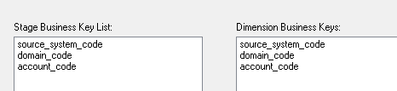

Dim_base_concurrency:

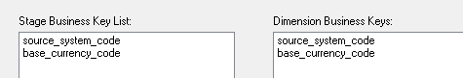

Dim_channel:

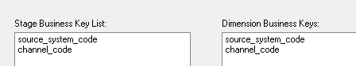

Dim_customer_center:

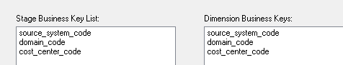

Dim_corporate_currency:

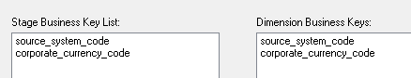

Dim_due_date:

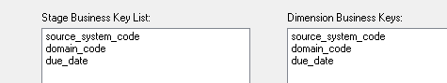

Dim_entity:

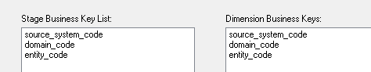

Dim_effective_date:

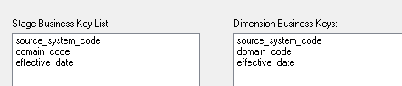

Dim_invoice_date:

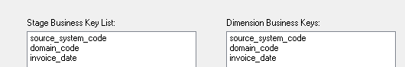

Dim_location:

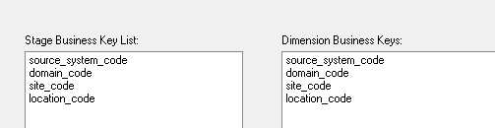

Dim_order_date:

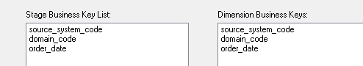

Dim_project:

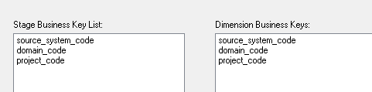

Dim_sales_person1:

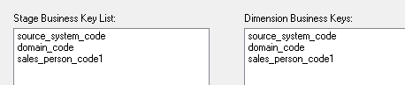

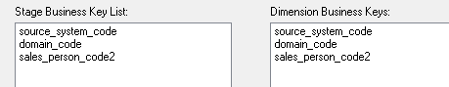

Dim_site:

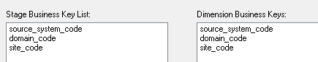

Dim_sub_account:

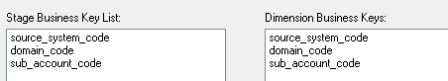

Dim_transaction_concurrency:

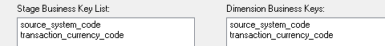

stage_om_invoice

stage_ee_account OK

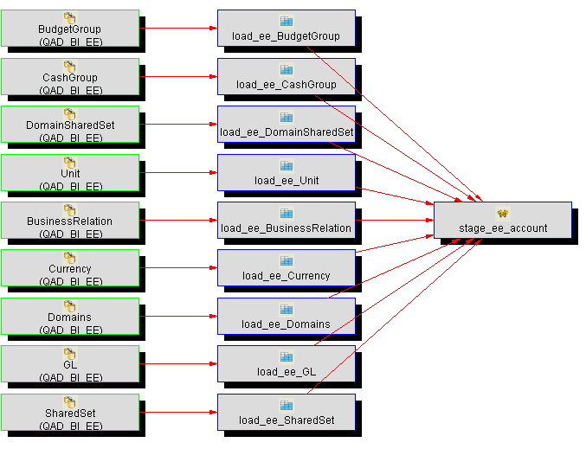

Columns

Artificial columns (for the next Merge stage operation)

Important:

This artificial column need to transform

It not then it will produce the following errors:

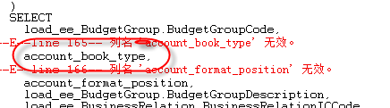

As below diagram(whether null or transformation expression):

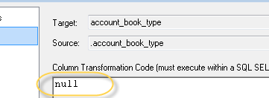 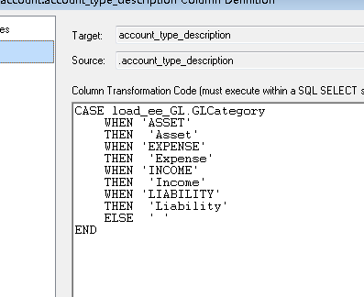

In order to make the above process go through , “nulls” need to be checked .

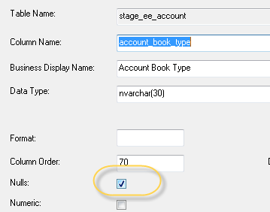

Transformation:

1)account_system_type_description (Artificial Column)

fillled with translatable value of the GL.GLSystemTypeCode

CASE load_ee_GL.GLSystemTypeCode

WHEN 'CIREC'

THEN 'Unmatched Invoices'

WHEN 'CONVERSION'

THEN 'Conversion'

WHEN 'CROSSCOMP'

THEN 'Cross Company To Allocate'

WHEN 'EXCHANGEREALLOSS'

THEN 'Realized Exchange Loss'

WHEN 'EXCHANGEREALPROFIT'

THEN 'Realized Exchange Gain'

WHEN 'EXCHANGEUNREALLOSS'

THEN 'Unrealized Exchange Loss'

WHEN 'EXCHANGEUNREALPROFIT'

THEN 'Unrealized Exchange Gain'

WHEN 'RESULTCURRENTYEAR'

THEN 'Result of the current year'

WHEN 'RESULTPREVIOUSYEAR'

THEN 'Result of previous year'

WHEN 'ROUND'

THEN 'Rounding Differences'

WHEN 'VOUPAY'

THEN 'Purchase Order Receipts'

ELSE 'NONE'

END

2)account_type_description (Artificial Column)

CASE load_ee_GL.GLCategory

WHEN 'ASSET'

THEN 'Asset'

WHEN 'EXPENSE'

THEN 'Expense'

WHEN 'INCOME'

THEN 'Income'

WHEN 'LIABILITY'

THEN 'Liability'

ELSE ' '

END

3) account_type_code<=load_ee_GL/GLCategory

UPPER(LEFT(load_ee_GL.GLCategory,1))

4) account_gl_type_description<=load_ee_GL/GLTypeCode

CASE load_ee_GL.GLTypeCode

WHEN 'BANK'

THEN 'Bank Account'

WHEN 'CASH'

THEN 'Cash Account'

WHEN 'CREDITORDOCUMENT'

THEN 'Supplier Document Account'

WHEN 'CREDITORCONTROL'

THEN 'Supplier Control Account'

WHEN 'CROSSCOMPANY'

THEN 'Cross-Company Account'

WHEN 'DEBTORDOCUMENT'

THEN 'Customer Document Account'

WHEN 'DEBTORCONTROL'

THEN 'Customer Control Account'

WHEN 'FIXEDASSET'

THEN 'Fixed Assets Account'

WHEN 'INVENTORYCONTROL'

THEN 'Inventory Control Account'

WHEN 'OPENITEM'

THEN 'Open Items Account'

WHEN 'PERSONNEL'

THEN 'Personnel Control Account'

WHEN 'STANDARD'

THEN 'Standard Account'

WHEN 'SYSTEM'

THEN 'System Account'

WHEN 'VAT'

THEN 'Tax Account'

WHEN 'WIPCONTROL'

THEN 'WIP Control Account'

WHEN 'YEARCLOSING'

THEN 'Closing Account'

ELSE 'NONE'

END

5) account_is_active_flag<=load_ee_GL\GLIsActive

CASE load_ee_GL.GLIsActive

WHEN 0 THEN 'N'

WHEN 1 THEN 'Y'

ELSE 'U'

END

6) account_master_oid<=load_ee_GL\GL_ID

CONVERT(numeric(38,10), load_ee_GL.GL_ID)

7) account_is_project_flag<=load_ee_GL\GLIsProjectAccount

CASE load_ee_GL.GLIsProjectAccount

WHEN 0 THEN 'N'

WHEN 1 THEN 'Y'

ELSE 'U'

END

8) account_is_balance_sheet_flag<=load_ee_GL\GLIsBalanceAccount

CASE load_ee_GL.GLIsBalanceAccount

WHEN 0 THEN 'N'

WHEN 1 THEN 'Y'

ELSE 'U'

END

9) account_is_division_flag<=load_ee_GL\GLIsDivisionAccount

CASE load_ee_GL.GLIsDivisionAccount

WHEN 0 THEN 'N'

WHEN 1 THEN 'Y'

ELSE 'U'

END

10) account_is_cost_centre_flag<=load_ee_GL\GLIsCostCentreAccount

CASE load_ee_GL.GLIsCostCentreAccount

WHEN 0 THEN 'N'

WHEN 1 THEN 'Y'

ELSE 'U'

END

11) account_is_saf_flag<=load_ee_GL\GLIsSafAccount

CASE load_ee_GL.GLIsSafAccount

WHEN 0 THEN 'N'

WHEN 1 THEN 'Y'

ELSE 'U'

END

2.Procedure

1) Type is 3.Set

2)Parameter

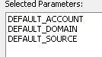

Cursor Mapping

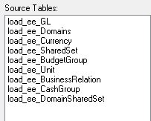

FROM load_ee_GL

LEFT OUTER JOIN load_ee_DomainSharedSet

ON load_ee_DomainSharedSet.SharedSet_ID = load_ee_GL.SharedSet_ID

LEFT OUTER JOIN load_ee_Domains

ON load_ee_Domains.Domain_ID = load_ee_DomainSharedSet.Domain_ID

LEFT OUTER JOIN load_ee_SharedSet

ON load_ee_SharedSet.SharedSet_ID = load_ee_GL.SharedSet_ID

LEFT OUTER JOIN load_ee_BudgetGroup

ON load_ee_BudgetGroup.BudgetGroup_ID = load_ee_GL.BudgetGroup_ID

LEFT OUTER JOIN load_ee_Unit

ON load_ee_Unit.Unit_ID = load_ee_GL.Unit_ID

LEFT OUTER JOIN load_ee_Currency

ON load_ee_Currency.Currency_ID = load_ee_GL.Currency_ID

LEFT OUTER JOIN load_ee_BusinessRelation

ON load_ee_BusinessRelation.BusinessRelation_ID = load_ee_GL.BusinessRelation_ID

LEFT OUTER JOIN load_ee_CashGroup

ON load_ee_CashGroup.CashGroup_ID = load_ee_GL.CashGroup_ID

stage_se_account OK

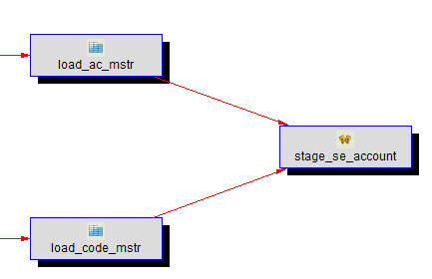

1.Columns

Refer to Excel/sheet

2.Procedure

1)type is 3.Set

2)Parameter

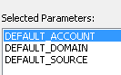

3)Cursor Mapping

FROM load_ac_mstr

LEFT OUTER JOIN load_code_mstr

ON load_ac_mstr.ac_type = load_code_mstr.code_value

AND load_ac_mstr.ac_domain = load_code_mstr.code_domain

AND load_ac_mstr.source_system_code = load_code_mstr.source_system_code

AND load_code_mstr.code_fldname = 'ac_type'

ORDER BY load_ac_mstr.ac_code, load_ac_mstr.ac_domain

stage_account (For Dim) OK

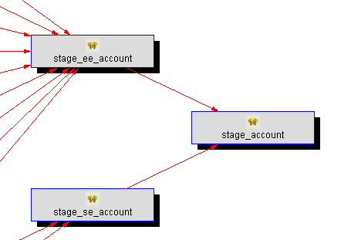

1.Columns

Two columns were not derived from stage_ee_account or stage_se_account.

gl_id

domain_id

***account_master_oid date type should modify as “numeric(38,10)”***

2.Procedure

1) Type is 3.Set

Why use union functionality in this procedure

You can check in the next section.

***Rather than use 5.Merge?***

***Merge is to use two complete insert scripts***

***Insert into tab1 …***

***Insert into tab2…***

Ascertain Reason:

The where clause within stage_ee_account

Alternatively stage_se_account doesn’t contain this where clause.

Cursor Mapping

stage_se_account/ stage_ee_account

FROM **stage_se_account**

LEFT OUTER JOIN **stage_ee_account**

ON stage_se_account.source_system_code = stage_ee_account.source_system_code

AND stage_se_account.account_domain_code = stage_ee_account.account_domain_code

AND stage_se_account.account_code = stage_ee_account.account_code

WHERE stage_ee_account.account_code IS NULL

UNION

SELECT

stage_ee_account.account_code,

stage_ee_account.account_domain_code,

stage_ee_account.source_system_code,

stage_ee_account.account_description,

stage_ee_account.account_book_type,

stage_ee_account.account_format_position,

stage_ee_account.account_type_code,

stage_ee_account.account_type_description,

stage_ee_account.account_type_description_other,

stage_ee_account.account_gl_type_code,

stage_ee_account.account_gl_type_description,

stage_ee_account.account_currency_code,

stage_ee_account.account_is_active_flag,

stage_ee_account.account_fx_translation_index,

stage_ee_account.account_user1,

stage_ee_account.account_user2,

stage_ee_account.account_stat_acc_code,

stage_ee_account.account_stat_cctr_code,

stage_ee_account.account_sub_module_only_flag,

stage_ee_account.account_matching_sequence,

stage_ee_account.account_master_oid,

stage_ee_account.account_system_type_code,

stage_ee_account.account_system_type_description,

stage_ee_account.account_shared_set_code,

stage_ee_account.account_budget_group_code,

stage_ee_account.account_budget_group_description,

stage_ee_account.account_unit_of_measure_code,

stage_ee_account.account_unit_of_measure_description,

stage_ee_account.account_intercompany_code,

stage_ee_account.account_cash_group_code,

stage_ee_account.account_cash_group_description,

stage_ee_account.account_is_project_flag,

stage_ee_account.account_is_balance_sheet_flag,

stage_ee_account.account_is_division_flag,

stage_ee_account.account_is_cost_centre_flag,

stage_ee_account.account_is_saf_flag,

stage_ee_account.account_last_modified_date,

stage_ee_account.account_last_modified_time,

stage_ee_account.account_last_modified_user,

stage_ee_account.dss_extract_timestamp,

stage_ee_account.dss_process_batch_id,

@v_dss_update_time

FROM

stage_ee_account

Procedure has been modified manually in SQL Server management studio.

The DWW will save the version.

stage_se_currency OK

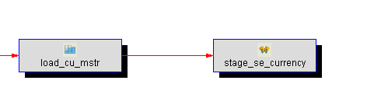

1.Columns

2.Procedure

1)Type is 3.Set

stage_ee_currency OK

Procedure

1)Type is 3.Set

stage_currency (For Dim) OK

stage_channel OK

stage_cost_center OK

just derived from stage_se_ee_cost_center.

stage_se_ee_cost_center OK

stage_se_cost_center & stage_ee_cost_center

stage table that contains both se and ee data, done by starting from SE and joining to EE

1.Columns Rename

|  |  |  |  |  |  |
| --- | --- | --- | --- | --- | --- |
| domain_code | Domain Code | nvarchar(8) |  | stage_se_cost_center | cost_center_domain_code |

stage_se_cost_center OK

1)The alias name ‘s data type has been modified from bit to nvarchar(1)

|  |  |  |  |  |  |
| --- | --- | --- | --- | --- | --- |
| cost_center_active_flag | Cost Center Active Flag | nvarchar(1) |  | load_cc_mstr | cc_active |

2)Procedure->Parameter

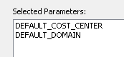

Otherwise the following error will be occurred.

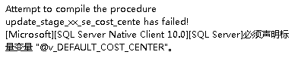

stage_ee_cost_center OK

1.Data type has been modified from bit to nvarchar(1)

|  |  |  |  |  |  |
| --- | --- | --- | --- | --- | --- |
| cost_center_with_saf_flag | With Saf Flag | nvarchar(1) |  | load_ee_CostCentre | CostCentreIsWithSaf |
| cost_center_struct_from_gl_flag | Struct From GL Flag | nvarchar(1) |  | load_ee_CostCentre | CostCentreIsStructFromGL |

2.Procedure/Parameters

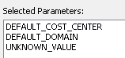

stage_date_qad

stage_date_qad1

**ER Diagram is different from QAD Doc**



stage_date_qad3

stage_date_qad_trade

stage_date_qad2 process

Temporary table for dim_date_qad. Contains most columns, but not the two trading days in month and so far columns

stage_eam_date_qad3

stage_domain OK (Executive Customization by Mark)

Purpose:

Final staging table for domain data. Merges SE, EE and EAM

Procedure

1)Type is 5.Merge

***Cust:***

***1.change procedure type to 3.Set which means only derive from “Stage_domain_std”***

stage_domain_std OK

1.Columns essential alias column ‘s data type was changed from bit to nvarchar(1)

|  |  |  |  |  |  |
| --- | --- | --- | --- | --- | --- |
| domain_active_flag | Domain Active Flag | nvarchar(1) |  | load_dom_mstr | dom_active |

stage_eam_domain (EAM Module Postpone)

Source Table load_eam_domain is not been setup.

Dimension Table

Appendix

1.Build Dimension Table FLOW

1) Refer to QAD Doc

Confirm Object type whether a table or view

Column Rename/Transformation

Business Key

Dimension Type (Very important) according to real business scenario [sɪˈneəri:ˌəʊ]

2)build table

Validation columns and data type by SQL utilization script

“…FROM information_schema.columns y”

***Tip: build physical table must in front of procedure establish step***

***In order that the primary key can be effective .***

3)Build Procedure

Set type(cursor/set)

Set business key / ***Select options as below***

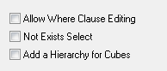

4)Execute procedure

Check data result by launching select inquiry in DW Database

select * from xx

2.Build View Flow

1)Choose Source Table

2)Choose Columns and Business key

***Remember that View doesn’t generate artificial key but use***

***Artificial key in source dimension table.***

2.The essential process program of Dimension Type ??

Normal

Changed …

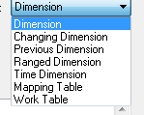

***What’s the usage of this accessory option when remapping source ?***

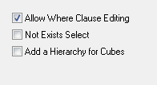

3.Get_dimxx_key procedure / update_dim_procedure usage?

**4.essential program script**

Not exists select type:

0)Fetch dataset by excluding no changed data

from source tables

This will fetch the record within any bit changness.

Insert into a 0 record

Loop through the dataset ,normally is cursor

Update the record based by Equivalent the business key.

If the record was not being lookup ,

then insert the record

5.What’s snowflake?

6.Why need Dimension Table and View?

***In particular, the dimension view ‘s usage?***

7.Modify Dimension View’s business key method

1) position on the column and right click to choose to populate the

Column property page .

check the check-box to enable this option

8.Dimension View ‘s get_dim_key function ?

Is empty?

dim_xx_corporate_currency

9.What’s dimension table “” source table?

Dim_account OK

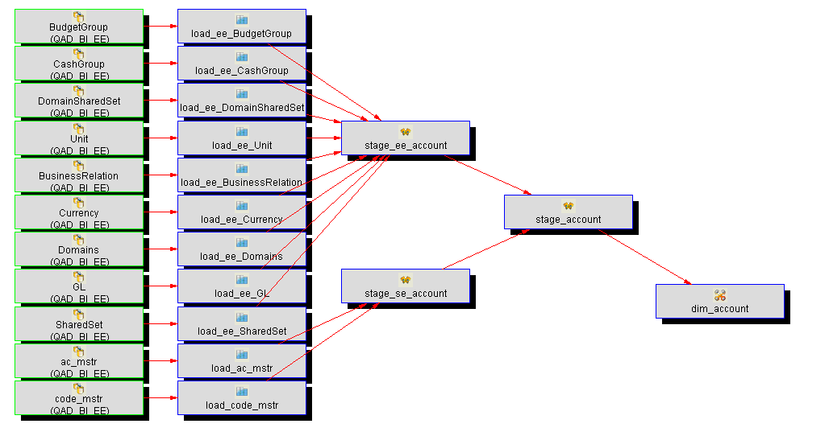

1.Columns

Process contains rename or filter of columns derived from original table

Refer to **DataDictionary.xls**

2.Procedure

1) Type is Cursor

BK

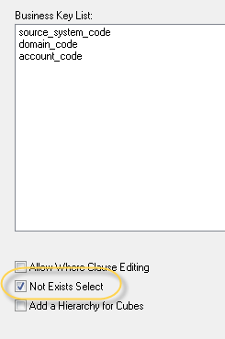

Dim_base_concurrency View OK

Dim_currency OK

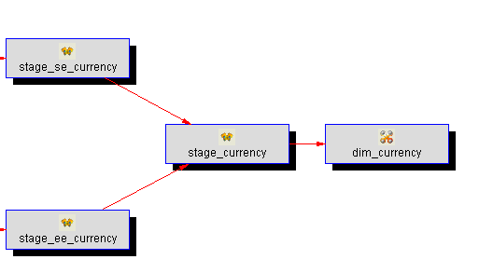

Procedure

1)Dimension Type

Normal

2)Business key definition

Not exists select

Dim_channel (Last layer Object) OK



Stage_channel is empty cause of where clause retrieved empty data.

select distinct code_fldname from load_code_mstr

where code_fldname like 'so%'

code_mstr of Progress table is empty.

Dim_cust_center OK

Procedure

Not exists select

Dim_corporate_currency View ok

Holds information about corporate currencies. Corporate currencies are the standardized currencies used to facilitate reporting between different sites that might have different base currencies between them. Reporting in corporate currency allows the reports to be normalized to one specific unit.

1.Columns rename

|  |  |  |  |  |  |
| --- | --- | --- | --- | --- | --- |
| corporate_currency_code | Corporate Currency Code | nvarchar(30) |  | dim_currency | currency_code |

Work_domain OK with puzzle

Procedure:

1.Business Key Accessory option



2.Source Map

FROM stage_domain

ORDER BY source_system_code

, domain_code

Problem1 : The business key had been setup and we can lookup the

Business key usage in procedure .

“ , dss_update_time = GETDATE()

WHERE domain_code = @v_dim_domain_code

AND source_system_code = @v_dim_source_system_code”

But DB table metadata primary key seems to be not activate .

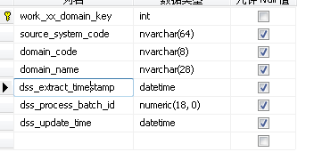

Dim_due_date

Dim_date OK but puzzled?

System automatically initialize data?

Dim_date_qad

Dim_entity

Dim_effective_date

Dim_invoice_date

Dim_location

Dim_order_date

Dim_project

Dim_sales_person1

Dim_sales_person 2

Dim_sales_person 3

Dim_sales_person 4

Dim_site

Permanent Table

1.Procedure Type

Initial insert : insert into perm_tab select columns from stage_table

Included update statement : update perm_tabs …select columns from stage table except (select columns from perm_tabs)

2.

perm_om_invoice_header OK

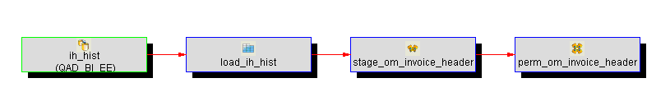

procedure

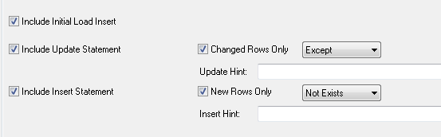

Check whether current table is empty or not .

if empty then Run 1)initial load

Insert into perm_table select columns from stage_tab

If not empty then run 2) update statement (changed Rows Only)

Update perm_tables set … select columns from stage_tab

excpet（select * from perm_tables ...）

Attention that the business key is used in the where clause:

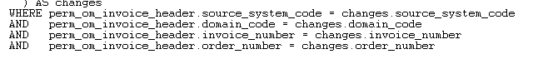

Business Key:

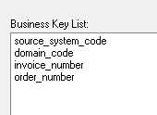

This step will generate unique index in db:

CREATE UNIQUE NONCLUSTERED INDEX [perm_om_invoice_header_idx_A] ON [dbo].[perm_om_invoice_header]

(

[source_system_code] ASC,

[domain_code] ASC,

[invoice_number] ASC,

[order_number] ASC

)WITH (PAD_INDEX = OFF, STATISTICS_NORECOMPUTE = OFF, SORT_IN_TEMPDB = OFF, IGNORE_DUP_KEY = OFF, DROP_EXISTING = OFF, ONLINE = OFF, ALLOW_ROW_LOCKS = ON, ALLOW_PAGE_LOCKS = ON) ON [PRIMARY]

GO

Domain_code is sourced from ih_domain

Ih_inv_nbr

Ih_nbr

**？？ why I verify Source table ,stage_om_invoice_header, which doesn’t contain any Business key ?**

perm_transaction_hist OK

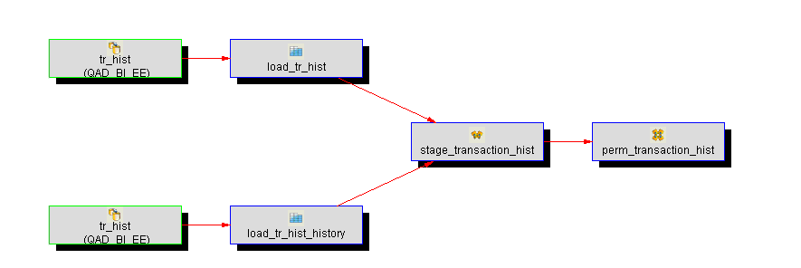

Customization

Stage table is stage_xx_tr_hist

Procedure apply two

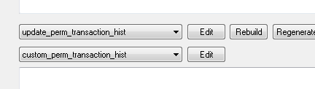

BK:

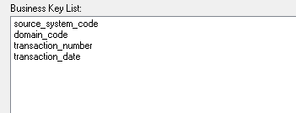

Tr_domain

Tr_trnbr

Tr_date

perm_om_invoice_line OK

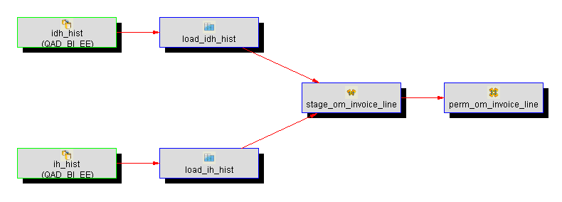

Procedure Type :

**Option shaped: Include initial load insert \ Changed Rows Only**

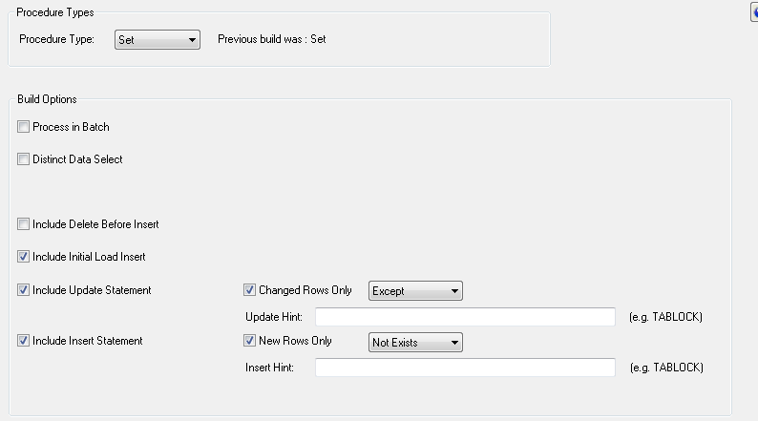

**Include initial load insert option is checked to generate below script block :**

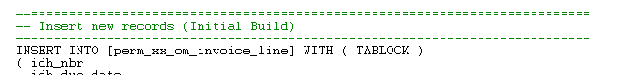

**Changed Rows Only option is checked to generate below script block :**



BK:

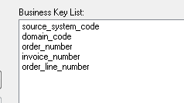

Idh_domain

Idh_nbr

Idh_inv_nbr

Idh_line

perm_ar_master OK

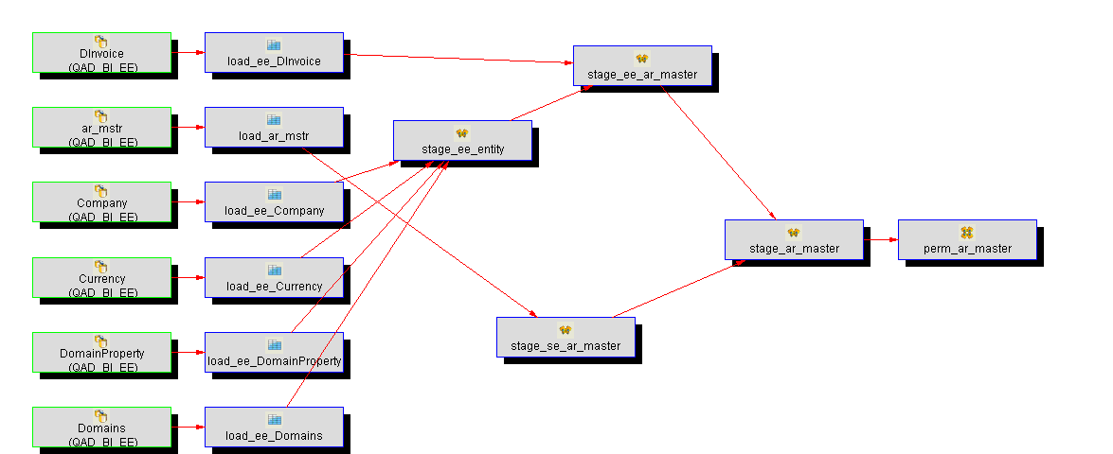

After finished processing **stage_ar_master**, we can proceed to process this permanent table.

Columns:

Transformation has been carry on of “dss_update_time” stage system own column.

Processing as below script:

*CASE*

*WHEN @p_job_name LIKE @v_perm_hist_prefix + '%'*

*THEN @v_perm_hist_date*

*ELSE @v_current_datetime*

*END*

Procedure Type:

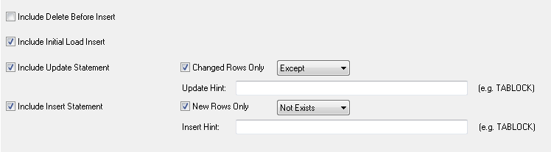

Parameter choosed

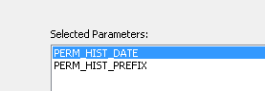

BK

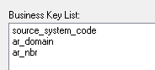

permsup_om_invoice_line OK Temp

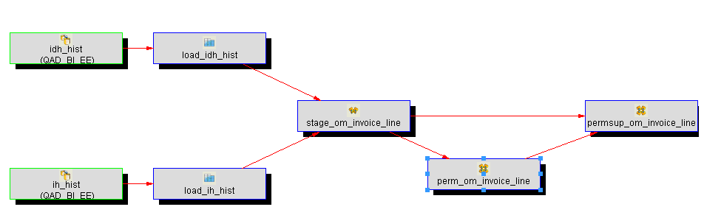

1.columns

Perm_update_date transformation :

**MARK: Temporary comment out this transformation**

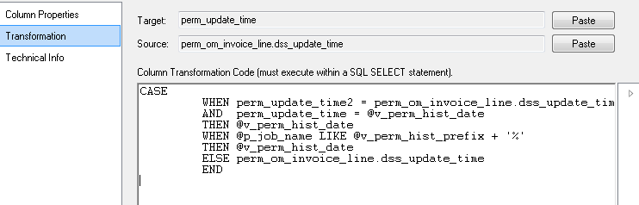

2.Procedure

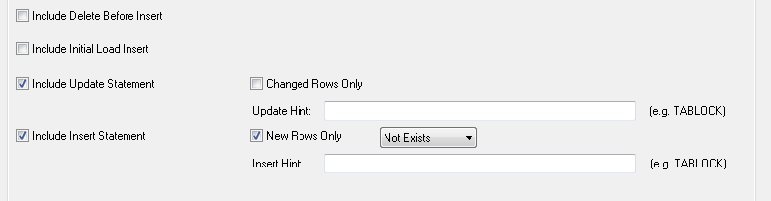

***Attention: New Rows Only option was assigned to NotExist***

Parameter :

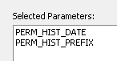

BK:

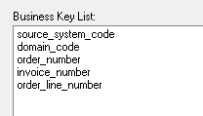

Source Talbe Mapping:

FROM [stage_om_invoice_line] stage_om_invoice_line

JOIN [perm_om_invoice_line] perm_om_invoice_line

ON stage_om_invoice_line.source_system_code = perm_om_invoice_line.source_system_code

AND stage_om_invoice_line.domain_code = perm_om_invoice_line.domain_code

AND stage_om_invoice_line.invoice_number = perm_om_invoice_line.invoice_number

AND stage_om_invoice_line.order_number = perm_om_invoice_line.order_number

AND stage_om_invoice_line.order_line_number = perm_om_invoice_line.order_line_number

permsup_om_invoice_header OK Temp

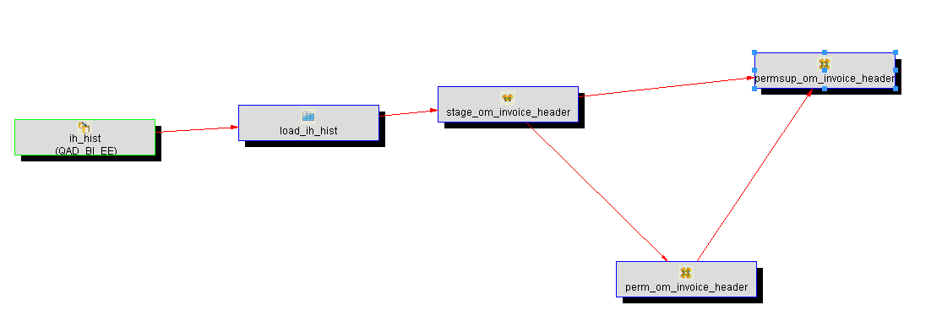

1.Columns

Several alias column based on one individual column “dss_update_time”



One column **“perm_update_time”** within transformation as below script:

**CASE**

**WHEN perm_update_time2 = perm_om_invoice_header.dss_update_time**

**AND perm_update_time = @v_perm_hist_date**

**THEN @v_perm_hist_date**

**WHEN @p_job_name LIKE @v_perm_hist_prefix + '%'**

**THEN @v_perm_hist_date**

**ELSE perm_om_invoice_header.dss_update_time**

**END**

**The above transformation code will generate below script in procedure ,but it doesn’t work :**

/***

perm_update_time = CASE

WHEN perm_update_time2 = perm_xx_om_inovice_header.dss_update_time

AND perm_update_time = @v_perm_hist_date

THEN @v_perm_hist_date

WHEN @p_job_name LIKE @v_perm_hist_prefix + '%'

THEN @v_perm_hist_date

ELSE perm_xx_om_inovice_header.dss_update_time

END

FROM [stage_xx_om_inovice_header] stage_xx_om_inovice_header

JOIN [perm_xx_om_inovice_header] perm_xx_om_inovice_header

ON stage_xx_om_inovice_header.source_system_code =

……****/

**MARK: Temporary comment out this transformation.**

CASE

WHEN perm_update_time2 = perm_xx_om_inovice_header.dss_update_time

AND perm_update_time = @v_perm_hist_date

THEN @v_perm_hist_date

WHEN @p_job_name LIKE @v_perm_hist_prefix + '%'

THEN @v_perm_hist_date

ELSE perm_xx_om_inovice_header.dss_update_time

END

Source column list as below table:

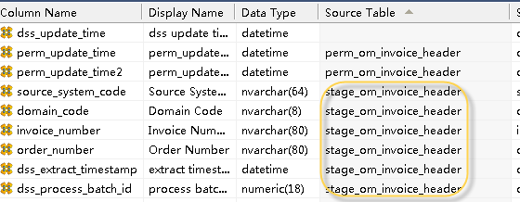

domain_code => load_ih_hist/ih_domain

invoice_number=>load_ih_hist/ih_inv_nbr

order_number=>load_ih_hist/ih_nbr

dss_extract_timestamp=>load_ih_hist/extract_timestamp

dss_process_batch_id=>load_ih_hist/process_batch_id

2.Procedure

Procedure type:

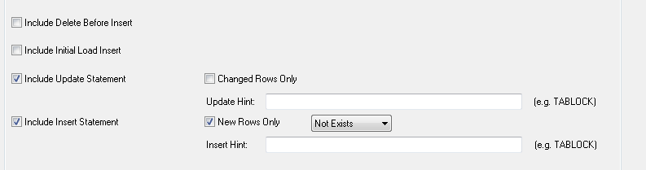

Parameter:

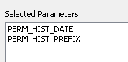

The values are assigned as 1900-1-1 and HIST.

BK:

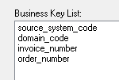

Source Table Mapping:

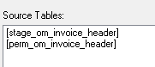

Multiple tables relationship where clause as below :

(where clause blank is used to add where conditions)

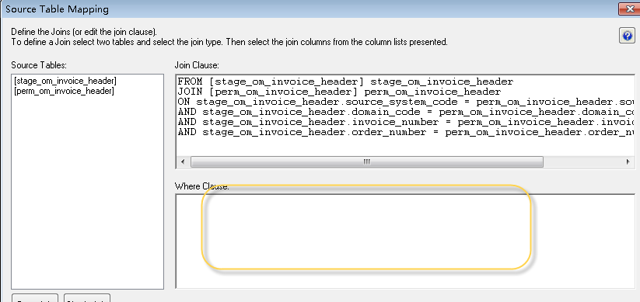

FROM [stage_om_invoice_header] stage_om_invoice_header

JOIN [perm_om_invoice_header] perm_om_invoice_header

ON stage_om_invoice_header.source_system_code = perm_om_invoice_header.source_system_code

AND stage_om_invoice_header.domain_code = perm_om_invoice_header.domain_code

AND stage_om_invoice_header.invoice_number = perm_om_invoice_header.invoice_number

AND stage_om_invoice_header.order_number = perm_om_invoice_header.order_number

FROM [stage_xx_om_invoice_header] stage_om_invoice_header

JOIN [perm_xx_om_invoice_header] perm_om_invoice_header

ON stage_om_invoice_header.source_system_code =

perm_om_invoice_header.source_system_code

AND stage_om_invoice_header.domain_code =

perm_om_invoice_header.domain_code

AND stage_om_invoice_header.invoice_number =

perm_om_invoice_header.invoice_number

AND stage_om_invoice_header.order_number = perm_om_invoice_header.order_number

permsup_transaction_hist OK

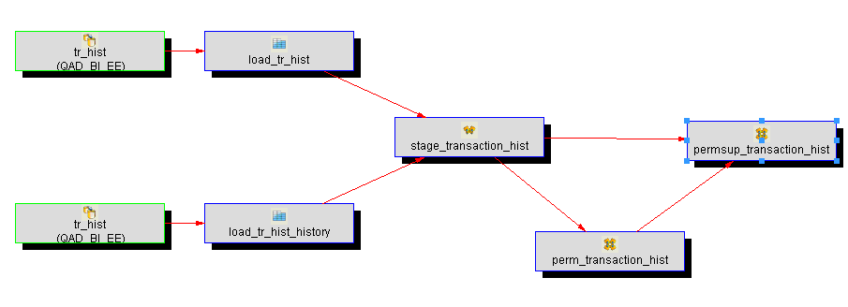

Columns

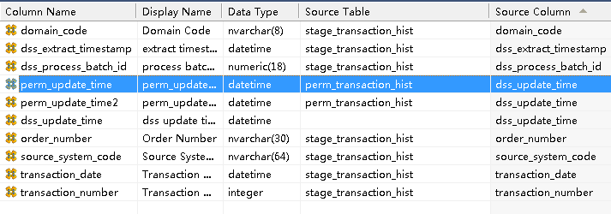

Columns Transfomation:

CASE

WHEN perm_update_time2 = perm_transaction_hist.dss_update_time

AND perm_update_time = @v_perm_hist_date

THEN @v_perm_hist_date

WHEN @p_job_name LIKE @v_perm_hist_prefix + '%'

THEN @v_perm_hist_date

ELSE perm_transaction_hist.dss_update_time

END

2.Procedure

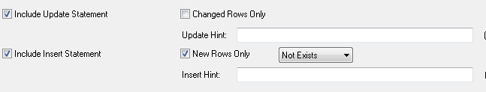

Parameter:

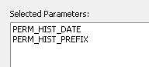

BK:

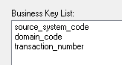

Source Map:

FROM [stage_transaction_hist] stage_transaction_hist

JOIN [perm_transaction_hist] perm_transaction_hist

ON stage_transaction_hist.source_system_code = perm_transaction_hist.source_system_code

AND stage_transaction_hist.domain_code = perm_transaction_hist.domain_code

AND stage_transaction_hist.transaction_number = perm_transaction_hist.transaction_number

ISSUE

**permsup_xx_om_invoice_header table columns transformation**

**The procedure insert block failed caused by suspect transformation?**

**Look all over to figure out this functionality ?**

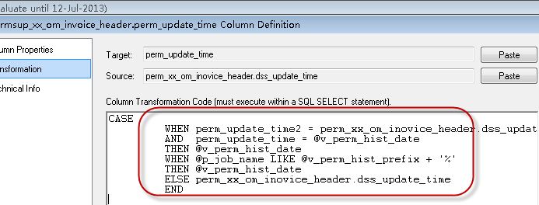

CASE

WHEN perm_update_time2 = perm_xx_om_inovice_header.dss_update_time

AND perm_update_time = '1900-1-1'

THEN '1900-1-1'

--WHEN @p_job_name LIKE @v_perm_hist_prefix + '%'

--THEN @v_perm_hist_date

ELSE perm_xx_om_inovice_header.dss_update_time

END

Work Table

1.What’s the usage of Work Table?

work_om_change_hist_list

work_om_change_list

work_om_change_list1 OK

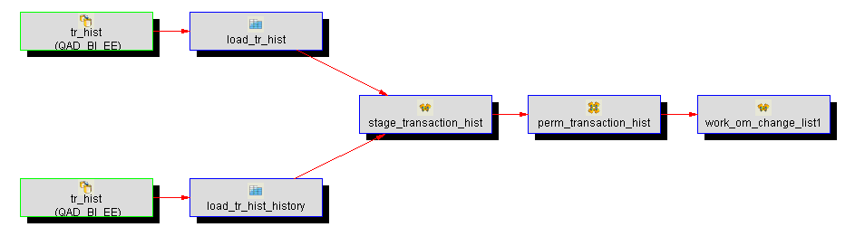

Columns

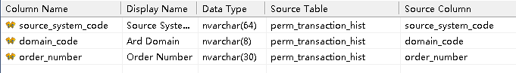

Domain_code => load_tr_hist\tr_domain

Order_number => load_tr_hist\tr_nbr

2.Procedure

It’s built as Type 3.SET.

Parameters:

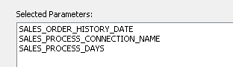

Cursor Mapping & Table Relationship :

WHERE perm_transaction_hist.source_system_code = @v_SALES_PROCESS_CONNECTION_NAME

AND perm_transaction_hist.dss_update_time >= GETDATE() - CONVERT(INTEGER,@v_SALES_PROCESS_DAYS)

work_om_change_list2 OK

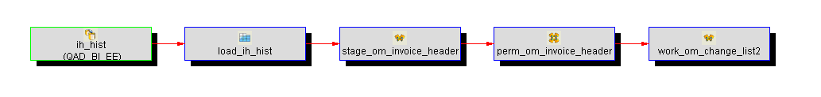

1.Columns

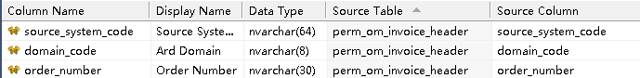

2.Procedure

Is built Type 3.SET

Parameter:

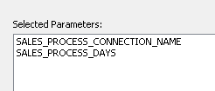

Cursor setting :

Where clause contains exists condition which is partly form of table ” work_om_change_list1”

***Fetch the data no exist in work_om_change_list1.***

**WHERE perm_om_invoice_header.source_system_code = @v_SALES_PROCESS_CONNECTION_NAME**

**AND perm_om_invoice_header.dss_update_time >= GETDATE() - CONVERT(INTEGER,@v_SALES_PROCESS_DAYS)**

**AND NOT EXISTS**

**( SELECT 1**

**FROM work_om_change_list1**

**WHERE work_om_change_list1.source_system_code = perm_om_invoice_header.source_system_code**

**AND work_om_change_list1.domain_code = perm_om_invoice_header.domain_code**

**AND work_om_change_list1.order_number = perm_om_invoice_header.order_number**

**)**

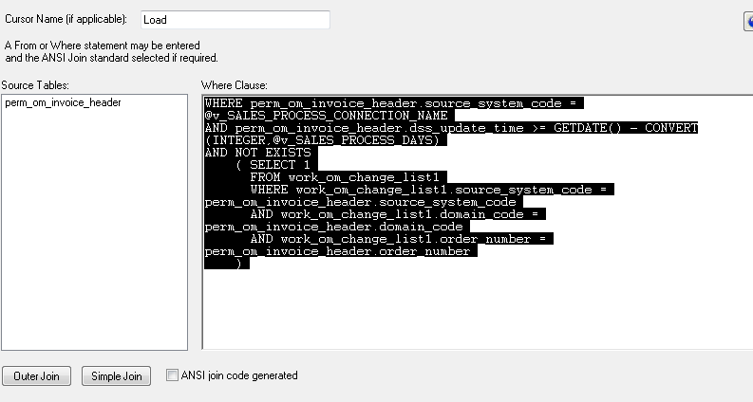

work_om_change_list3 OK

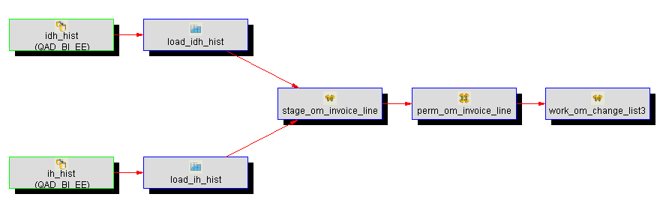

1.Columns

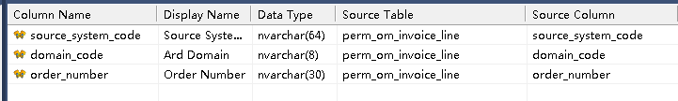

2.Procedure

Type 3.Set / Distinct option had been turn on.

Parameter:

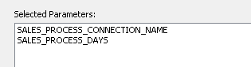

Source Tables Mapping:

Fetch the data which isn’t belong to work_om_change_list1 and

Work_om_change_list2.

**WHERE perm_om_invoice_line.source_system_code = @v_SALES_PROCESS_CONNECTION_NAME**

**AND perm_om_invoice_line.dss_update_time >= GETDATE() - CONVERT(INTEGER,@v_SALES_PROCESS_DAYS)**

**AND NOT EXISTS**

**( SELECT 1**

**FROM work_om_change_list1**

**WHERE work_om_change_list1.source_system_code = perm_om_invoice_line.source_system_code**

**AND work_om_change_list1.domain_code = perm_om_invoice_line.domain_code**

**AND work_om_change_list1.order_number = perm_om_invoice_line.order_number**

**)**

**AND NOT EXISTS**

**( SELECT 1**

**FROM work_om_change_list2**

**WHERE work_om_change_list2.source_system_code = perm_om_invoice_line.source_system_code**

**AND work_om_change_list2.domain_code = perm_om_invoice_line.domain_code**

**AND work_om_change_list2.order_number = perm_om_invoice_line.order_number**

**)**

work_om_change_hist_list OK

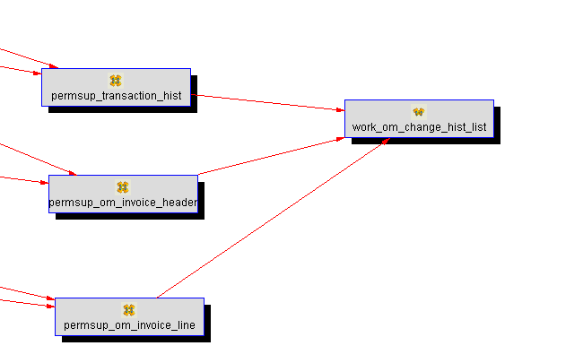

1.Columns

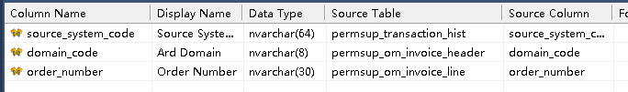

***Attention: The column named “dss_update_time”***

***established by system automatically***

***Must be removed for the compile procedure later.***

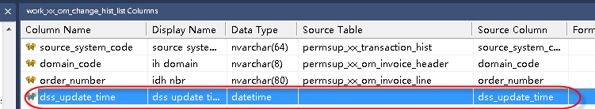

1)The below transformation is used to make the select clause in procedure script.

1)permsup_om_invoice_header/ domain_code

Transformation expression:

permsup_transaction_hist.domain_code

2)permsup_om_invoice_line/ order_number

permsup_transaction_hist.order_number

**this transformation purpose is to generate the insert clause identified as**

**below red rectangle . The other select clause within the union part is generated in Procedure/Cursor Mapping part.**

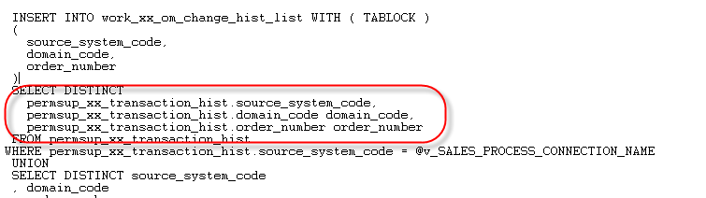

2.Procedure

1)Type is 3.set/Distinct Data is turned on

2)Parameter

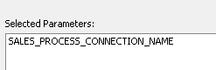

3) Mapping

Merge these three tables data together using Union functionality.

FROM permsup_transaction_hist

WHERE permsup_transaction_hist.source_system_code = @v_SALES_PROCESS_CONNECTION_NAME

UNION

SELECT DISTINCT source_system_code

, domain_code

, order_number

FROM permsup_om_invoice_header

WHERE permsup_om_invoice_header.source_system_code = @v_SALES_PROCESS_CONNECTION_NAME

UNION

SELECT DISTINCT source_system_code

, domain_code

, order_number

FROM permsup_om_invoice_line

WHERE permsup_om_invoice_line.source_system_code = @v_SALES_PROCESS_CONNECTION_NAME

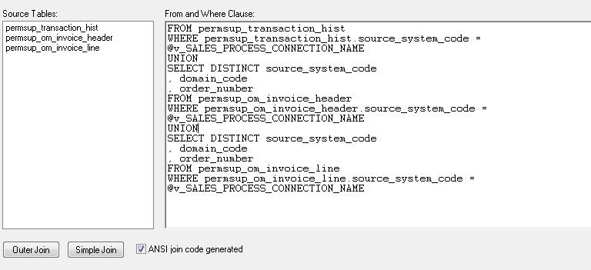

work_om_change_list OK

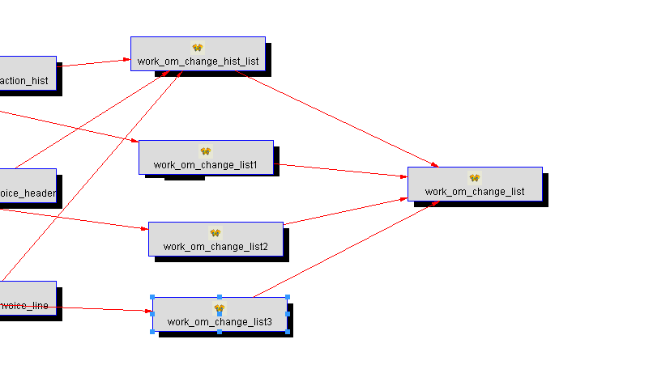

1.Columns

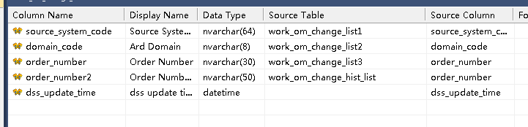

2.Procedure

1) Type is 5.Merge

2)Cursor Mapping

FROM

work_om_change_list1

Extract Table

extract_om_invoice_header OK

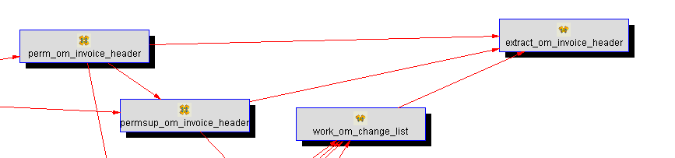

1.Columns

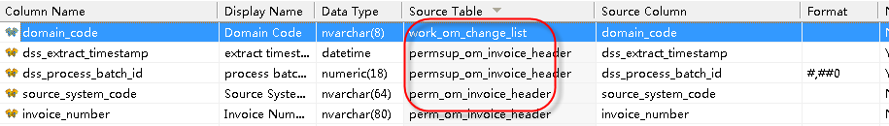

1)Transformation

work_om_change_list/ domain_code

perm_om_invoice_header.domain_code

2.Procedure

1) Type is 3.Set/Distinct Data is turned on

2) Cursor Mapping

FROM perm_om_invoice_header

JOIN work_om_change_list

ON perm_om_invoice_header.source_system_code = work_om_change_list.source_system_code

AND perm_om_invoice_header.domain_code = work_om_change_list.domain_code

AND perm_om_invoice_header.order_number = work_om_change_list.order_number

JOIN permsup_om_invoice_header

ON perm_om_invoice_header.source_system_code = permsup_om_invoice_header.source_system_code

AND perm_om_invoice_header.domain_code = permsup_om_invoice_header.domain_code

AND perm_om_invoice_header.order_number = permsup_om_invoice_header.order_number

AND perm_om_invoice_header.invoice_number = permsup_om_invoice_header.invoice_number

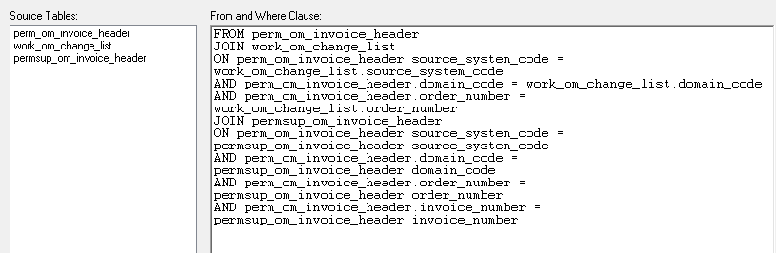

***Attention :***

***The restriction length of SQL Server cause the procedure name is been***

***Shorten as update_extract_xx_om_invoice***

extract_om_invoice_line OK

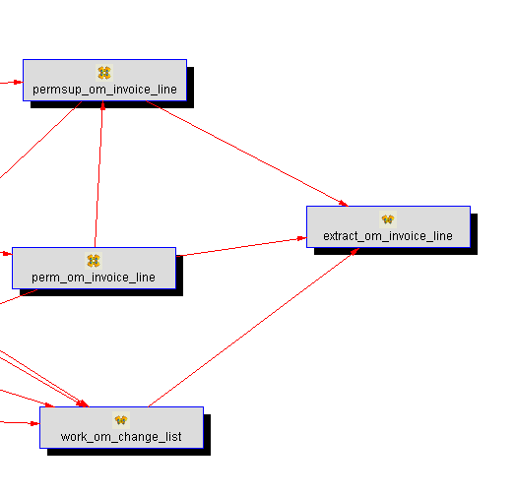

1.Columns

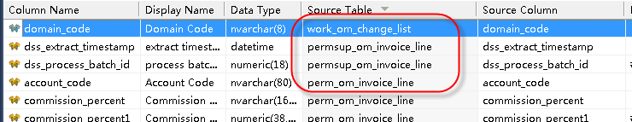

Transforamtion:

work_om_change_list/ domain_code

perm_om_invoice_line.domain_code

2.Procedure

1)Type is 3.Set/Distinct data functionality is enabled.

2)Cursor Mapping

FROM perm_om_invoice_line

JOIN work_om_change_list

ON perm_om_invoice_line.source_system_code = work_om_change_list.source_system_code

AND perm_om_invoice_line.domain_code = work_om_change_list.domain_code

AND perm_om_invoice_line.order_number = work_om_change_list.order_number

JOIN permsup_om_invoice_line

ON perm_om_invoice_line.source_system_code = permsup_om_invoice_line.source_system_code

AND perm_om_invoice_line.domain_code = permsup_om_invoice_line.domain_code

AND perm_om_invoice_line.order_number = permsup_om_invoice_line.order_number

AND perm_om_invoice_line.invoice_number = permsup_om_invoice_line.invoice_number

AND perm_om_invoice_line.order_line_number = permsup_om_invoice_line.order_line_number

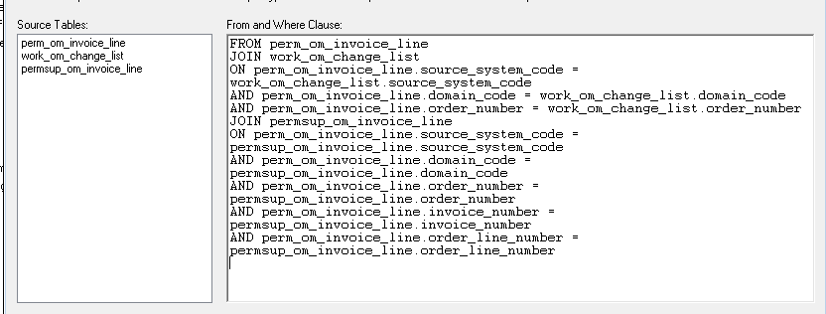

Fact Table

fact_om_invoice

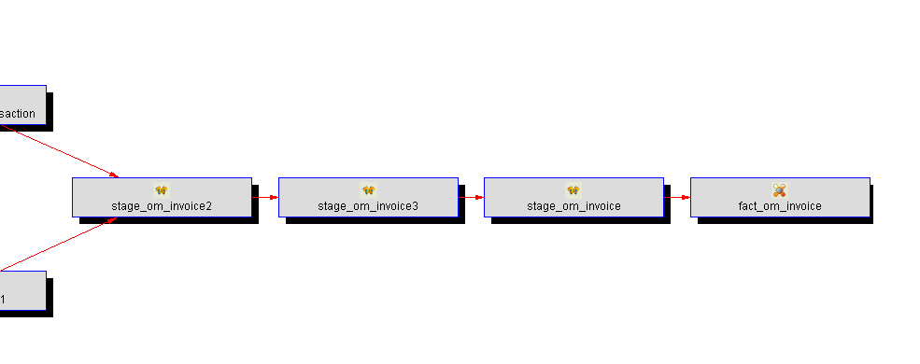

ETL Status

Summary

1.Global parameter variable setting for load table action

*SALES_LOOKBACK_DAYS:60 => 700*

*TR_HIST_PROCESS_DAYS:5=>700*

*TR_HIST_DOMAIN => 11CAN*

*TR_HIST_TRAN_MAX:0=>13000*

**27.the function / usage of Table Load_syscolumn**

**Resolution:**

Currently running this syscolumn appears OK by attempting several times.

And it’s purpose is mentioned as below:

About this procedure. It's purpose is for us to be able to have load tables that dynamically change to accomodate differences between EE and SE environments. Columns that don't exist in SE get populated with a static dummy value, columns that exist only in EE get referenced normally. This accomplished by

referencing the syscolumn data dictionary from QAD and setting relevant parameters accordingly.

***Currently look up in one procedure pre_load_ee_journal***

--

-- Set the value of parameters, which is used to determine

-- if the consigned value amount is a valid column in this schema

--

SET @v_step = 2100

SET @v_role_id = ( select count(*) from load_SYSCOLUMNS where TBL = 'Journal'

and COL = 'Role_ID'

and source_system_code = @v_connection_name )

## Customer Account

GZSHOWA:昭和

219.137.239.236:3380

administrator / plan

BI: admin/GSAPLAN

# PROGRESS

## Installation&Setup

1.Install 10.2B in Windows Server2008 64bit

1) Prerequisites

.net framework 3.0 +

Windows server2008(install .net framework3.5 firstly)

2)install openedge10.2B

3)install openedge service pack5.0

2.Several features after installation completion successfully for JDBC

成功安装后，有几个特点

1）JDBC连接

SQL Explorer Tool 该工具是数据库内置的JDBC连接

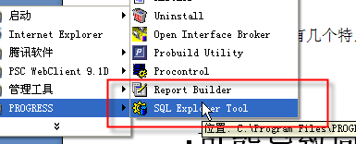

2）JdbcProgress.dll 文件

该文件是JDBC连接的关键

\PROGRESS\bin\JdbcProgress.dll

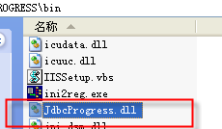

3.lanuch progress own client util and type script as below to validate connection (PROGRESS测试语句)

FOR EACH po_mstr NO-LOCK:

DISPLAY po_nbr .

END.

## Lanuch&Configue

1.Create User Step

1)Logon QAD

Choose Menu 36.25.80 to login Progress UI

CD /app/mfgpro/eb21sp6

./Client.Demonstration

the accout is mfg and password is null.

Input numeric value of menu id in the red rectangle as below ,then populate Progress menu:

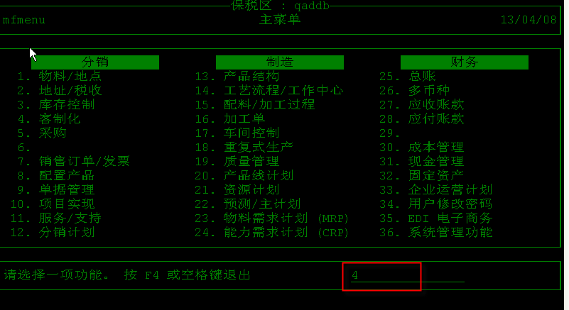

2)Choose Tools-> Data dictionary->Security

3)Enter the administrative account sysprogress/sysprogess

4)Create a user and grant the privilege/permission.

Alternativley logon Progress config page:

1)在服务器PROGRESS数据库安装目录下的bin

# cd app/mfg/91d/bin

# PRO

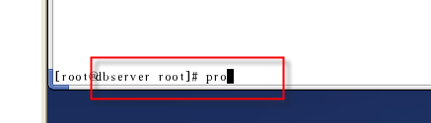

2.Login Progress in Back-end way

Login the command windows connect to Linux

Type the command to switch to the database loacation file path

Such as CD/app/2011.1ee/mfgpro/db

Then enter “pro mfgpro(dbinstance)”

2.写BI For Liux

1、启动MFG/PRO

**A、QAD/Progress 在VMW的Linux系统（路径：H:\VM-eb2sp7）**

Progress Version 9.1D

（启动VMW的Progress数据命令

cd /app/mfgpro/eb2sp7 (该数据是昭和/BI为6.X版本)  
./start.Demonstation (运行start.Demonstation文件。该文件为自定义数据库启动文件)  
./stop.Demonstation

cd /app/mfgpro/eb21sp3 (该数据是敏实/BI为5.X版本)  
./start.Demo  
./stop.Demo ）

cd /app/mfgpro/eb21sp6

./start.Demo  
./stop.Demo ）

**B、Startup environment of eb21sp6**

1. The physical location is H:\eb21sp6

2. Set the host-only network

3. Use netTerm software to access the VMW of Linux server

The account is **mfg/mfg.**

We can save the connection shortcut.

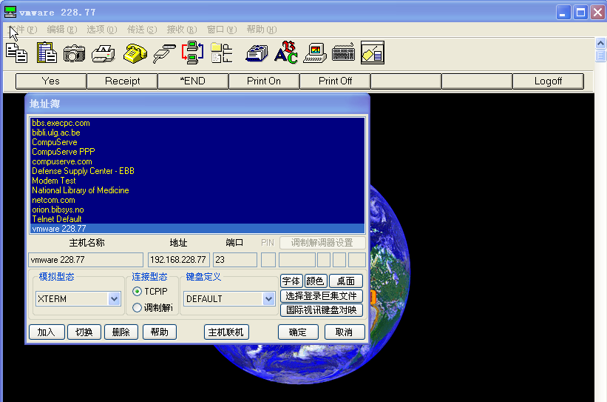

set the basic configuration for desktop as following diagram:

选项Option->设置Setting->桌面设置Desktop Property

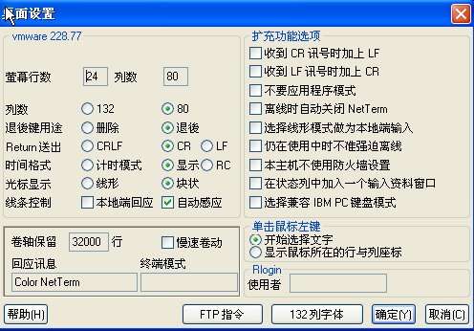

set the printer protocol as the customized file.

It is vital to make the above option that the data will display in BI Report

选项Option->设置Setting->综合设置General

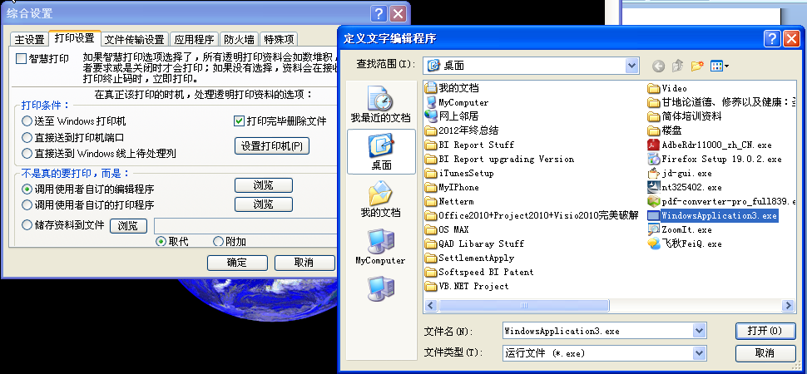

4. Compile the .p program source code

5. Login in QAD and access menu report to open BI Report

Tap the following command to switch to QAD main page:

CD /app/mfgpro/eb21sp6

./Client.Demonstration

the accout is mfg and password is null.

Hot Key :

F1 directly jump to the next page

F4 quit

Enter confirm and execute

6. launch the new menu related to the .p program .

Input the numeric value of 4 then enter to the customized maintenance menu.



Input the report id number to enter the report runtime page.

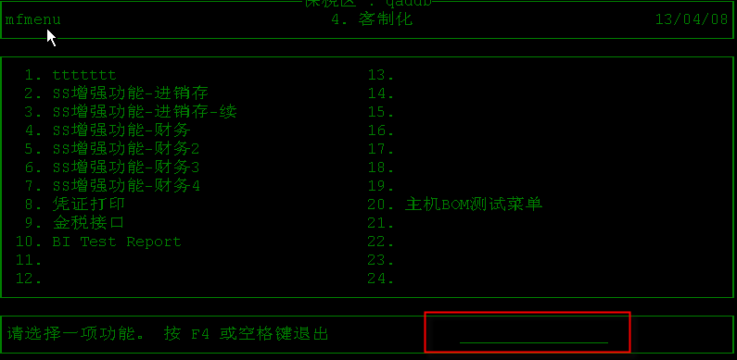

Choose the optional value to Printer which will invoke

the customized executable file.

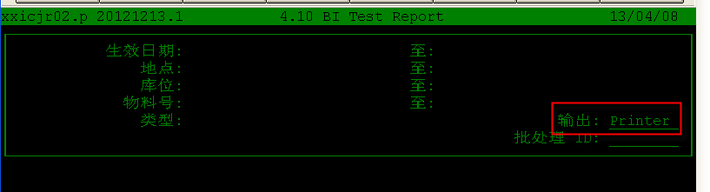

When the process is finished ok then the output temp file will occurred in the specified location.

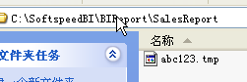

Check Progress Version

1、在服务器PROGRESS数据库安装目录下的bin

# cd app/mfg/91d/bin

# PRO



如果安装了PROGRESS，将出现以下提示：

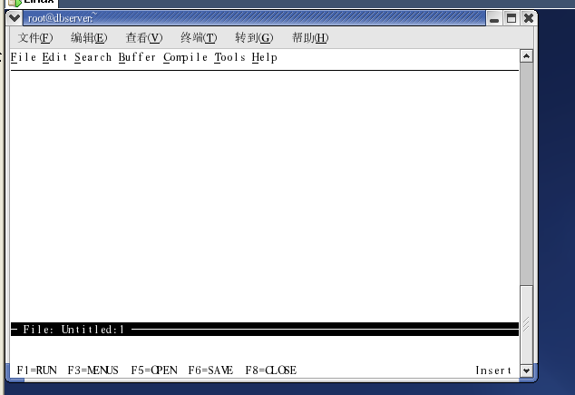

按F3 通过鼠标移动，照看Help

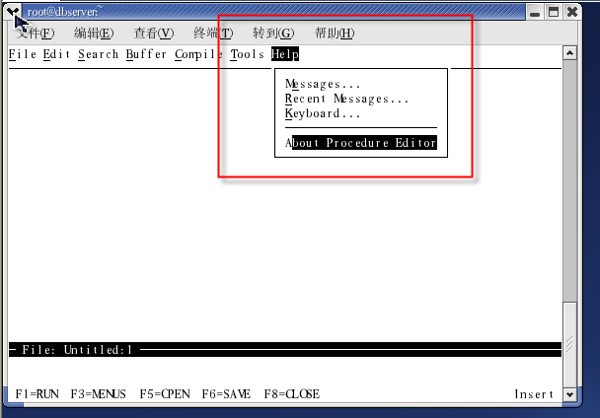

版本信息如下：

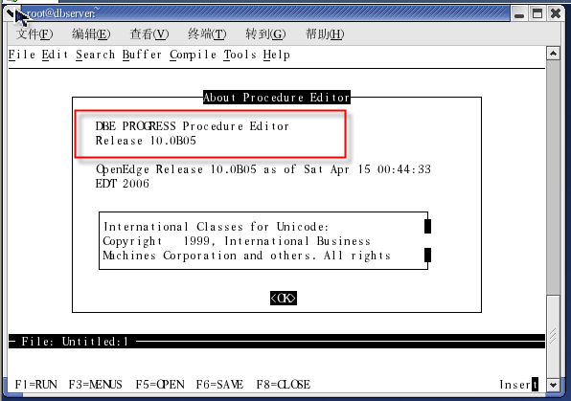

按回车、F3 选择FILE-EXIT 可回到SHELL命令窗口

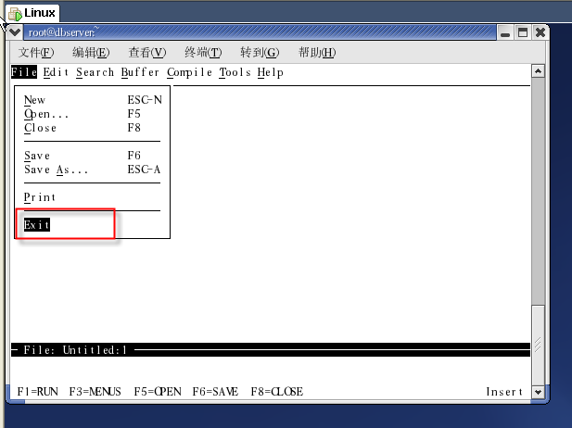

公司光盘 I

|  |  |  |
| --- | --- | --- |
| 虚拟机 | eb21sp5 | vm eb21sp5 /10.0B05 |
| 虚拟机 | eb21sp3 | vm-eb21sp3 /10.0B05 |

公司光盘 J

|  |  |  |  |  |
| --- | --- | --- | --- | --- |
| 虚拟机 | eb21sp6 | EB21SP5-WHTS  (Mark  C:\03 NBTS-WM-eb21sp6\VMX.eB21.SP6) | 10.1B03 | 192.168.228.77 root[123456] mfg[空] |
| 虚拟机 | eb21sp5 | loncin Vmare | 10.0B05 | 192.168.8.91 root[123] mfg[空] |
| 虚拟机 | QAD2007.1 | NBTS-WM-eb21sp6 | 10.1B03 | 192.168.228.77 root[123456] mfg[空] |
| 虚拟机 | eb2sp11 | vm-eb2sp11/10 | 10.0B05 | 192.168.0.11 root[123456] mfg[空] |

公司光盘 K

|  |  |  |  |  |
| --- | --- | --- | --- | --- |
| Roger20110628-VM | |  |  |  |
|  | vm_chui_eb21sp5_Jonyang | eb21sp5 | 10.1B03 | root[123456],mfg[mfg] |
|  | vm_eb21sp6_with_gui | qad2007.1 | 10.1B03 | root[123456], mfg[空] |
| vm-eb2sp11 | | eb2sp11 | 10.0B05 | root[123456], mfg[空] |
| VM-EB21SP3 | | eb21sp3 | 10.0B05 | root[123456], mfg[空] |

2、查看数据库启动文件

在app/mfgpro/eb2sp7目录下，执行CAT命令查看

cat ./start.Demonstation(查看该数据库启动文件)

启动QAD/Progress : Terminal => 输入下图红色命令

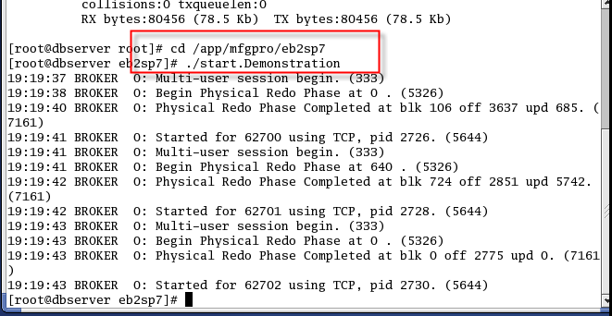

查看Progress数据库、端口：输入cat ./start.Demonstration

下图红色处为数据库、端口 [http://192.168.0.55:](http://192.168.0.55:62700:mfgdemosp7)**[62700](http://192.168.0.55:62700:mfgdemosp7)**[:mfgdemosp7](http://192.168.0.55:62700:mfgdemosp7)

Sysprogress /123456

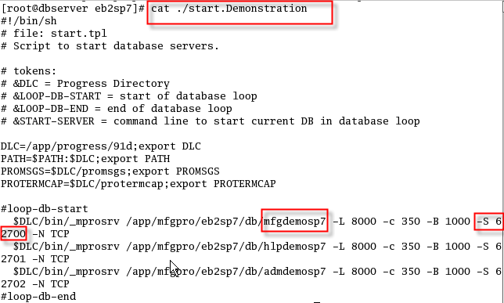

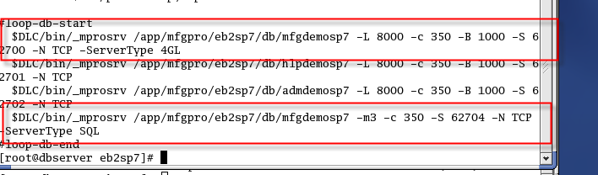

FTP访问VMW的LINUX文件夹

Root/123456

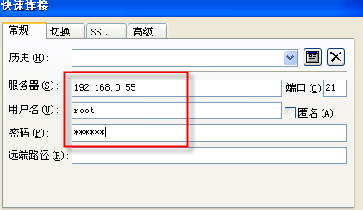

Open Progress ServerType

1、修改Progress的SQL模式

QAD默认的是4GL模式，需要改成4GL、SQL两种模式

修改成功后，SQL端口就是提供给JDBC的端口。我们可以在查看端口，如下图：

62704 就是 ServerType SQL(For JDBC)的端口。

设置4GL、ServerType SQL 模式的方法：

 $DLC/bin/_mprosrv/app/mfgpro/eb21sp6/db/mfgdemo -S 25005 -N TCP -n 61   
 -Mn 8 - Ma 5 -L8000  -B 100 -ServerType 4GL  
 $DLC/bin/_mprosrv/app/mfgpro/eb21sp6/db/mfgdemo -S 25008 -N TCP -m3 –c 350

-ServerType SQL

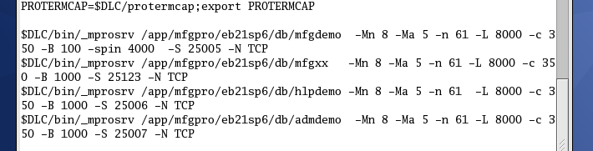

  说明：  
              * 首先启动4GL服务器，附加启动SQL服务器，-ServerType为服务器类型  
              * 4GL服务器的-n参数包括4GL服务器启动的用户数，所以是150+12 = 162  
              * 附加启动服务器必须使用-m3,另外需指明端口，此处为-S 9010  
              * 其他参数可以按照各自数据库情况自行设定

2、服务器开启SQL服务模式

使用VI命令修改数据库启动文件

启动文件路径通常是: /app/mfgpro/eb2sp7/start.xxx

(xxx could be Demonstration、Training… )

将需要使用JDBC访问的DB的服务模式修改成4GL、ServerType SQL两种：

$DLC/bin/_mprosrv /app/mfgpro/eb2sp7/db/mfgdemosp7 -L 8000 -c 350 -B 1000 -S 62700 -N TCP **-ServerType 4GL**

$DLC/bin/**proserver** /app/mfgpro/eb2sp7/db/mfgdemosp7 **-m3** -c 350 -S 62704 -N TCP **-ServerType SQL**

**(注意：ServerType SQL语句中第二个参数要改成proserver，不要用原来的_mprosrv)**

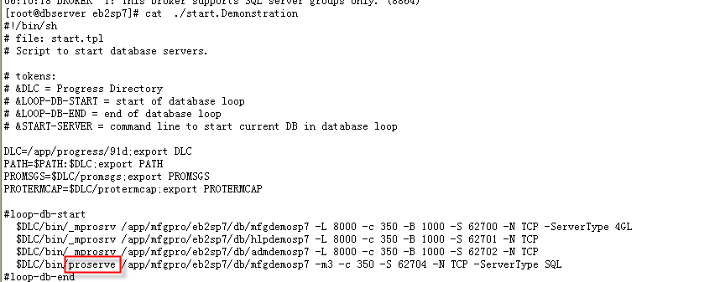

**Progress9.1D Configuration as follows:**



**Progress10.1B03 Configuration take effect as below diagram:**

Important Tip:

**–ServerType 4GL**

**–ServerType SQL**

**–m3**

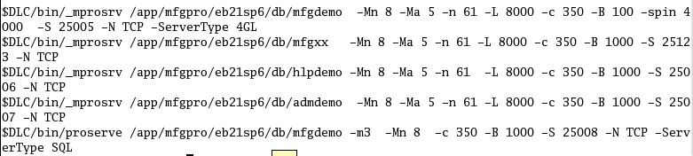

WINDOWS版本下设置：

REM tokens:

REM &DLC = Progress Directory

REM &LOOP-DB-START = start of database loop

REM &LOOP-DB-END = end of database loop

REM &START-SERVER = command line to start current DB in database loop

SET DLC=d:\eb21sp3\91d

SET PATH=%PATH%;%DLC%

SET PROMSGS=%DLC%\promsgs

SET PROTERMCAP=%DLC%\protermcap

REM loop-db-start

REM %DLC%\bin\_mprosrv d:\eb21sp3\eb21\db\mfgtrain -L 8000 -c 350 -B 1000

%DLC%\bin\_mprosrv d:\eb21sp3\eb21\db\hlptrain -L 8000 -c 350 -B 1000

%DLC%\bin\_mprosrv d:\eb21sp3\eb21\db\admtrain -L 8000 -c 350 -B 1000

%DLC%\bin\_mprosrv d:\eb21sp3\eb21\db\mfgtrain -L 8000 -c 350 -B 1000 -S 62700 -N TCP -ServerType 4GL

**%DLC%\bin\_mprosrv** d:\eb21sp3\eb21\db\mfgtrain -m3 -c 350 -S 62704 -N TCP -ServerType SQL

QAD

Check QAD Version

type the following command to switch to QAD main page:

CD /app/mfgpro/eb21sp6

./Client.Demonstration

Then will populate QAD Version information page.



QAD2011.1EE Setup

注：拷贝完2011.1EE文件夹之后，用VMware打开Red Hat 6.3 64-bit.vmx，看到系统提示请选择“I moved it”。

登录Linux：

Linux login: mfg

Password: mfg

Root password: 123456

服务命令：

启动或停止服务：

#cd /home/mfg 用mfg用户登录

#./callmenu 执行callmenu

或

启动服务：/app/2011.1ee/qdt/envs/demo/scripts/startall.sh

停止服务：/app/2011.1ee /qdt/envs/demo/scripts/stopall.sh

启动QAD字符界面命令：./client-us.demo（同在scripts下）

本地虚拟网卡设置：

VMware Network Adapter VMnet1 setup:

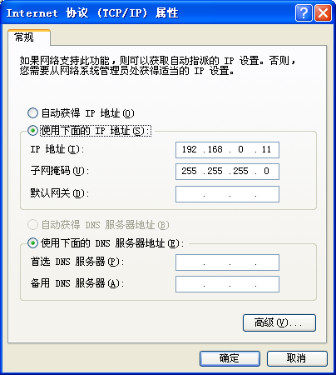

登录QAD系统：

EA2008 USER: mfg, ch, us

Pwd: 空白

5.1 How to observe ODBC ServerType?

Locate the startall.sh file which is placed in startup path

/app/2011.1ee/….

Open this file to check the port.

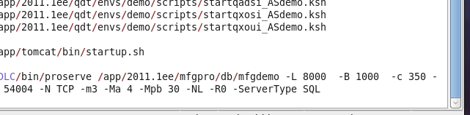

本地host文件修改：

C:\Windows\System32\drivers\etc路径下hosts文件，

添加: 192.168.0.55 dbserver

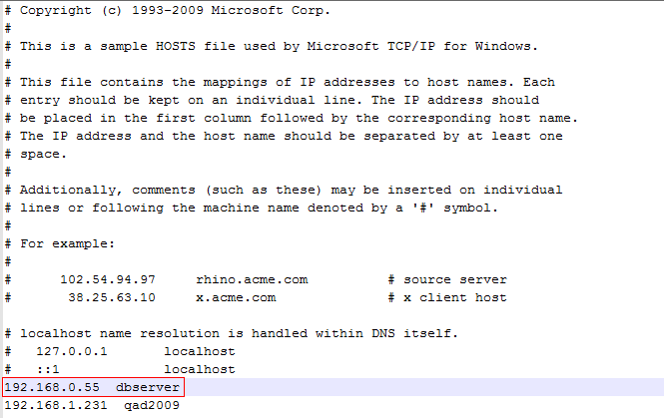

.Net下载地址：

<http://192.168.0.55:8080/qadhome/>

**本机WINDOW和VMW的LINUX连通**

保证WINDOW和LINUX在一个HOST-ONLY网段内。

Linux网络配置如下：

查看IP 方式 1）点击桌面Terminal 2）输入ipconfig 3）查看信息

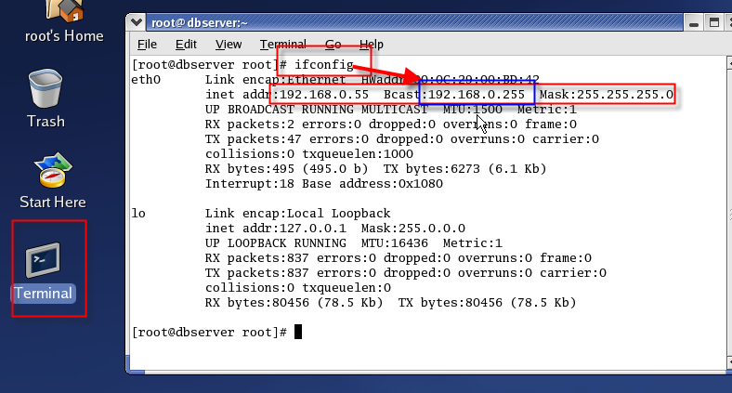

WINDOW配置：

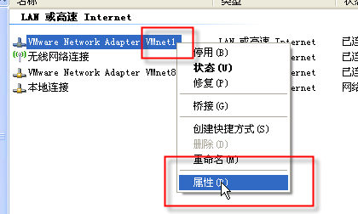

注意WINDOW的VWM-NETWORK的默认网关需要设置成和LINUX一样。

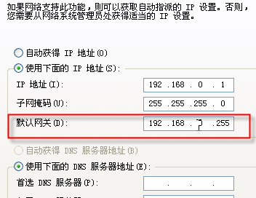

Step2、通过CMD PING测试

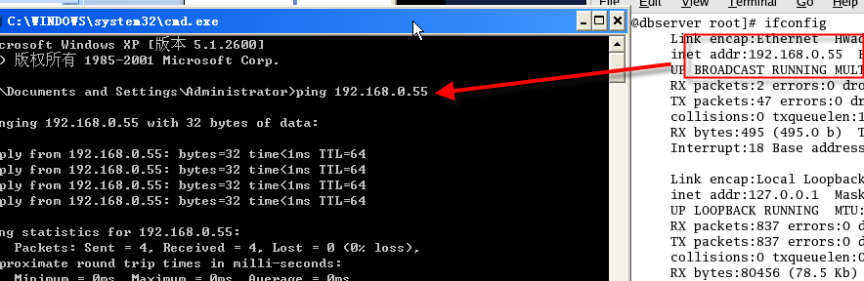

查看VMW的网络设置方法：

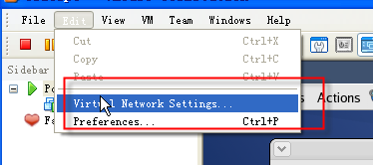

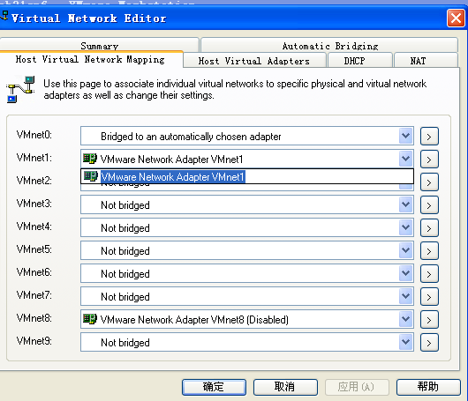

Step4、本机JAVA程序通过JDBC测试访问Progress

1）将2个DLL复制到 C:\WINDOWS\system32文件夹

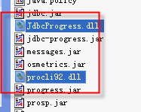

2）将2个JAR复制到JDBC的LIB目录下

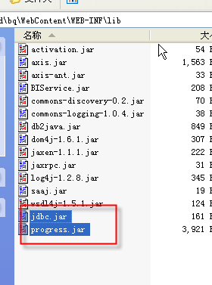

3）

String url = "jdbc:JdbcProgress:T:192.168.0.55:62700:mfgdemosp7";

String userid= "sysprogress";

String passwd= "123456";

Class.*forName* ("com.progress.sql.jdbc.JdbcProgressDriver");

192.168.0.55 Progress数据库IP

62700 端口

mfgdemosp7 数据库名

com.progress.sql.jdbc.JdbcProgressDriver

JDBC驱动类名

卸载Progress数据库

1）Progress安装完后，会有JAVA.exe进程。

需要先结束后，在uninstall.

2、progress需开启JDBC服务才能访问？

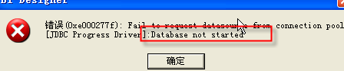

直接在VMW环境中通过JDBC方式访问PROGRESS 也报错。提示驱动不存在？

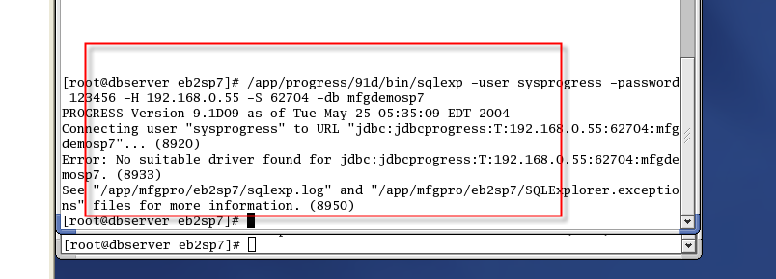

3、驱动不正确

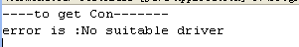

在JDBC连接代码的URL需要做相应改动：



其他脚本：

一、LINUX1

Red Hat Enterprise Linux ES release 3 (Taroon)

Kernel 2.4.21-4.ELsmp on an i686

login: root

Password:

Last login: Thu Feb 23 17:04:24 from 192.168.0.1

You have new mail.

[root@dbserver root]# sqlexp -user sysprogress -password 123456 -db mfgprod -H

192.168.0.55 -S 62704

OpenEdge Release 10.0B05 as of Sat Apr 15 00:44:33 EDT 2006

Progress sqlexp Messages:

Java Virtual Machine could not be found.

JREHOME environment variable may not be set correctly.

Set JREHOME variable to a valid directory.

JREHOME setting: /app/tool/jdk1.5

[root@dbserver root]# cd /app/mfgpro/eb2sp7

[root@dbserver eb2sp7]# cd ../..

[root@dbserver app]# cd progress/

[root@dbserver progress]# ls

10b 91d 91e lost+found

[root@dbserver progress]# cd 91d/bin

[root@dbserver bin]# ./sqlexp -user sysprogress -password 123456 -db mfgprod -H

192.168.0.55 -S 62704

PROGRESS Version 9.1D09 as of Tue May 25 05:35:09 EDT 2004

Progress sqlexp Messages:

Java Virtual Machine could not be found.

JREHOME environment variable may not be set correctly.

Set JREHOME variable to a valid directory.

JREHOME setting: /app/tool/jdk1.3

[root@dbserver bin]# java

-bash: java: command not found

[root@dbserver bin]#

二、LINUX

Red Hat Enterprise Linux ES release 3 (Taroon)

Kernel 2.4.21-4.ELsmp on an i686

login: root

Password:

Last login: Thu Feb 23 17:04:24 from 192.168.0.1

You have new mail.

[root@dbserver root]# sqlexp -user sysprogress -password 123456 -db mfgprod -H

192.168.0.55 -S 62704

OpenEdge Release 10.0B05 as of Sat Apr 15 00:44:33 EDT 2006

Progress sqlexp Messages:

Java Virtual Machine could not be found.

JREHOME environment variable may not be set correctly.

Set JREHOME variable to a valid directory.

JREHOME setting: /app/tool/jdk1.5

[root@dbserver root]# cd /app/mfgpro/eb2sp7

[root@dbserver eb2sp7]# cd ../..

[root@dbserver app]# cd progress/

[root@dbserver progress]# ls

10b 91d 91e lost+found

[root@dbserver progress]# cd 91d/bin

[root@dbserver bin]# ./sqlexp -user sysprogress -password 123456 -db mfgprod -H

192.168.0.55 -S 62704

PROGRESS Version 9.1D09 as of Tue May 25 05:35:09 EDT 2004

Progress sqlexp Messages:

Java Virtual Machine could not be found.

JREHOME environment variable may not be set correctly.

Set JREHOME variable to a valid directory.

JREHOME setting: /app/tool/jdk1.3

[root@dbserver bin]# java

-bash: java: command not found

[root@dbserver bin]#

3、WINDOW环境变量配置PATH的作用

或者将文件放在下面的目录下是一样的效果。

%PATH% 代表的是可执行文件的搜索路径，默认为 Windows 目录(C:\windows)和系统目录(C:\windows\system32)

BI6.2测试路径

[http://amy-pc/default.htm](qq://txfile/platformres:MsgMgr/msgmgr.htm)

SQL Server2005测试环境

192.168.1.104

用户名Administrator / pass@word1

Progress

1.1、测试SQL SERVER TYPE 端口/服务

客户端使用

1.5、TELNET命令

0）测试端口服务

1）可以直接访问LINUX

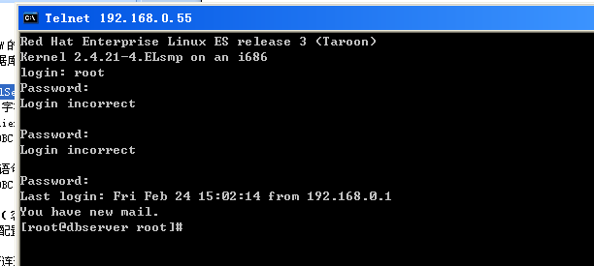

1、修改progress字符集

利用ODBC工具 CLIENT连接报错:

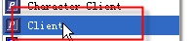

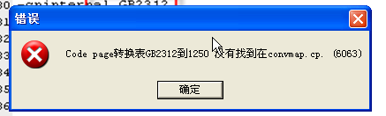

解决方案：

WINDOW安装的progress连接VMW的progress方法

修改\PROGRESS\startup.pf 文件的5个参数需要进行修改.如下图红色处

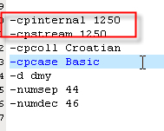 改成： 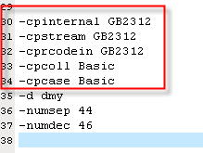

2、Progress的Client连接

1、打开PROGRESS开始程序的Client

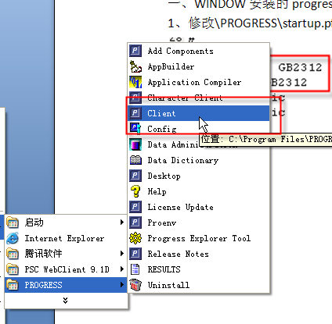

2、

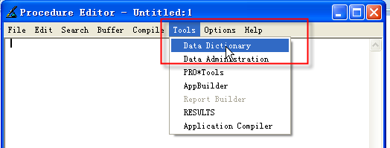

4、

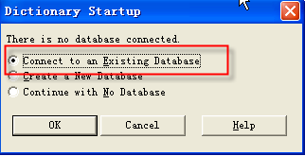

数据库mfgdemosp7(QAD Demo progress数据库名)

数据库IP 192.168.0.55 (VMW Linux的IP)

62700 数据库端口号码(注意FOR JDBC的端口不一样)

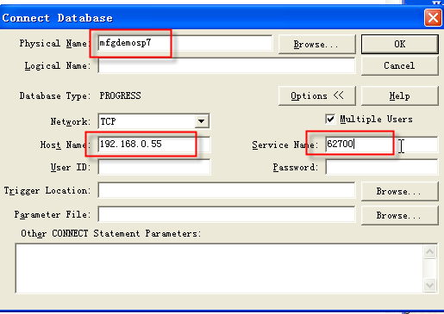

5、成功后，可以看到以下图片

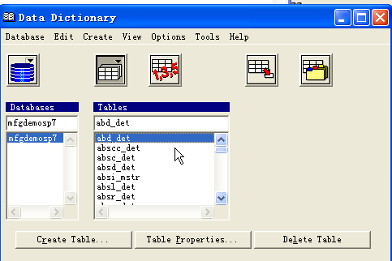

6、查看本地PROGRESS版本

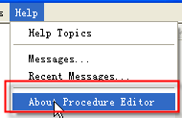

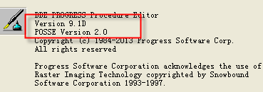

3、Progress的JDBC连接

3.0、Sqlexp命令测试JDBC连接(PROGRESS命令)

3.1、连接该VMW可行JDBC

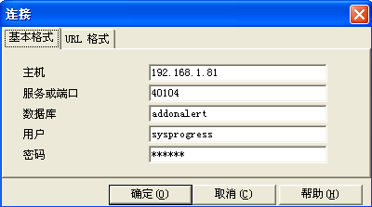

#  sqlexp -user sysprogress -password 123456 -db mfgdemo -H localhost  -S 25009

select * from sysprogress.systables;

连接配置如下：

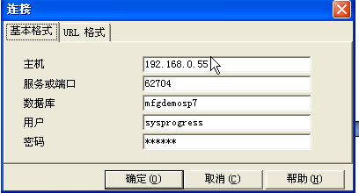

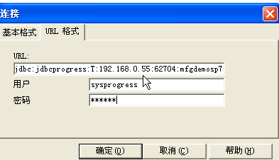

6、PROGRESS的ODBC连接

客户端、服务器端版本需要一致。

可能导致问题的情况

测试步骤：

1、确保QAD PROGRESS打开

2、确保本地能访问VWM的PROGRESS

3、确保PROGRESS开启JDBC端口服务

利用ODBC连接PROGRESS

4、确保JDBC能连接PROGRESS

利用PROGRESS WINDOW客户端访问

0、VMW安装JDK

是由于从Windows往LINUX上传文件的时候，模式不是二进制导致的文件破坏。在DOS命令下，登录FTP，用二进制方式传，就不会有问题了。

修改环境变量：

KAINE

Restrictions of these Supplemental Terms, Sun grants you a

non-exclusive, non-transferable, limited license without

fees to reproduce and distribute the Software, provided

that (i) you distribute the Software complete and

unmodified and only bundled as part of, and for the sole

purpose of running, your Programs, (ii) the Programs add

significant and primary functionality to the Software,

(iii) you do not distribute additional software intended to

replace any component(s) of the Software, (iv) you do not

remove or alter any proprietary legends or notices

contained in the Software, (v) you only distribute the

Software subject to a license agreement that protects Sun's

interests consistent with the terms contained in this

Agreement, and (vi) you agree to defend and indemnify Sun

and its licensors from and

C. License to Distribute Redistributables. Subject to the

terms and conditions of this Agreement and restrictions and

exceptions set forth in the Software README file, including

but not limited to the Java Technology Restrictions of

these Supplemental Terms, Sun grants you a non-exclusive,

non-transferable, limited license without fees to reproduce

and distribute those files specifically identified as

redistributable in the Software "README" file

("Redistributables") provided that: (i) you distribute the

Redistributables complete and unmodified, and only bundled

as part of Programs, (ii) the Programs add significant and

primary functionality to the Redistributables, (iii) you do

not distribute additional software intended to supersede

any component(s) of the Redistributables (unless otherwise

specified in the applicable README file), (iv) you do not

remove or alter any proprietary legends or notices

contained in or on the Redistributables, (v) you only

distribute the Redistributables pursuant to a license ag

D. Java Technology Restrictions. You may not create,

modify, or change the behavior of, or authorize your

licensees to create, modify, or change the behavior of,

classes, interfaces, or subpackages that are in any way

identified as "java", "javax", "sun" or similar convention

as specified by Sun in any naming convention designation.

E. Distribution by Publishers. This section pertains to

your distribution of the Software with your printed book or

magazine (as those terms are commonly used in the industry)

relating to Java technology ("Publication"). Subject to and

conditioned upon your compliance with the restrictions and

obligations contained in the Agreement, in addition to the

license granted in Paragraph 1 above, Sun hereby grants to

you a non-exclusive, nontransferable limited right to

reproduce complete and unmodified copies of the Software on

electronic media (the "Media") for the sole purpose of

inclusion and distribution with your Publication(s),

subject to the following terms: (i) You may not distribute

the Software on a stand-alone basis; it must be distributed

with your Publication(s); (ii) You are responsible for

downloading the Software from the applicable Sun web site;

(iii) You must refer to the Software as JavaTM SE

Development Kit 6; (iv) The Software must be reproduced in

its entirety and without any modification what

F. Source Code. Software may contain source code that,

unless expressly licensed for other purposes, is provided

solely for reference purposes pursuant to the terms of this

Agreement. Source code may not be redistributed unless

expressly provided for in this Agreement.

G. Third Party Code. Additional copyright notices and

license terms applicable to portions of the Software are

set forth in the THIRDPARTYLICENSEREADME.txt file. In

addition to any terms and conditions of any third party

opensource/freeware license identified in the

THIRDPARTYLICENSEREADME.txt file, the disclaimer of

warranty and limitation of liability provisions in

paragraphs 5 and 6 of the Binary Code License Agreement

shall apply to all Software in this distribution.

H. Termination for Infringement. Either party may terminate

this Agreement immediately should any Software become, or

in either party's opinion be likely to become, the subject

of a claim of infringement of any intellectual property

right.

I. Installation and Auto-Update. The Software's

installation and auto-update processes transmit a limited

amount of data to Sun (or its service provider) about those

specific processes to help Sun understand and optimize

them. Sun does not associate the data with personally

identifiable information. You can find more information

about the data Sun collects at http://java.com/data/.

For inquiries please contact: Sun Microsystems, Inc., 4150

Network Circle, Santa Clara, California 95054, U.S.A.

Do you agree to the above license terms? [yes or no]

yes

Unpacking...

Checksumming...

The download file appears to be corrupted. Please refer

to the Troubleshooting section of the Installation

Instructions on the download page for more information.

Please do not attempt to install this archive file.

[root@dbserver java]# cd /app/tool/java/

[root@dbserver java]# rpm -ivh jdk-6u2-linux-i586-rpm.bin

jdk-6u2-linux-i586-rpm.bin: not an rpm package (or package manifest):

[root@dbserver java]# /app/tool/java/

-bash: /app/tool/java/: is a directory

[root@dbserver java]# cd /app/tool/java/

[root@dbserver java]# chmod a+x jdk-6u2-linux-i586-rpm.bin

[root@dbserver java]# ./jdk-6u2-linux-i586-rpm.bin

Sun Microsystems, Inc. Binary Code License Agreement

for the JAVA SE DEVELOPMENT KIT (JDK), VERSION 6

SUN MICROSYSTEMS, INC. ("SUN") IS WILLING TO LICENSE THE

SOFTWARE IDENTIFIED BELOW TO YOU ONLY UPON THE CONDITION

THAT YOU ACCEPT ALL OF THE TERMS CONTAINED IN THIS BINARY

CODE LICENSE AGREEMENT AND SUPPLEMENTAL LICENSE TERMS

(COLLECTIVELY "AGREEMENT"). PLEASE READ THE AGREEMENT

CAREFULLY. BY DOWNLOADING OR INSTALLING THIS SOFTWARE, YOU

ACCEPT THE TERMS OF THE AGREEMENT. INDICATE ACCEPTANCE BY

SELECTING THE "ACCEPT" BUTTON AT THE BOTTOM OF THE

AGREEMENT. IF YOU ARE NOT WILLING TO BE BOUND BY ALL THE

TERMS, SELECT THE "DECLINE" BUTTON AT THE BOTTOM OF THE

AGREEMENT AND THE DOWNLOAD OR INSTALL PROCESS WILL NOT

CONTINUE.

1. DEFINITIONS. "Software" means the identified above in

binary form, any other machine readable materials

(including, but not limited to, libraries, source files,

header files, and data files), any updates or error

corrections provided by Sun, and any user manuals,

programming guides and other documentation provided to you

by Sun under this Agreement. "Programs" mean Java applets

and applications intended to run on the Java Platform,

Standard Edition (Java SE) on Java-enabled general purpose

desktop computers and servers.

2. LICENSE TO USE. Subject to the terms and conditions of

this Agreement, including, but not limited to the Java

Technology Restrictions of the Supplemental License Terms,

Sun grants you a non-exclusive, non-transferable, limited

license without license fees to reproduce and use

internally Software complete and unmodified for the sole

purpose of running Programs. Additional licenses for

developers and/or publishers are granted in the

Supplemental License Terms.

3. RESTRICTIONS. Software is confidential and copyrighted.

Title to Software and all associated intellectual property

rights is retained by Sun and/or its licensors. Unless

enforcement is prohibited by applicable law, you may not

modify, decompile, or reverse engineer Software. You

acknowledge that Licensed Software is not designed or

intended for use in the design, construction, operation or

maintenance of any nuclear facility. Sun Microsystems, Inc.

disclaims any express or implied warranty of fitness for

such uses. No right, title or interest in or to any

trademark, service mark, logo or trade name of Sun or its

licensors is granted under this Agreement. Additional

restrictions for developers and/or publishers licenses are

set forth in the Supplemental License Terms.

4. LIMITED WARRANTY. Sun warrants to you that for a period

of ninety (90) days from the date of purchase, as evidenced

by a copy of the receipt, the media on which Software is

furnished (if any) will be free of defects in materials and

workmanship under normal use. Except for the foregoing,

Software is provided "AS IS". Your exclusive remedy and

Sun's entire liability under this limited warranty will be

at Sun's option to replace Software media or refund the fee

paid for Software. Any implied warranties on the Software

are limited to 90 days. Some states do not allow

limitations on duration of an implied warranty, so the

above may not apply to you. This limited warranty gives you

specific legal rights. You may have others, which vary from

state to state.

5. DISCLAIMER OF WARRANTY. UNLESS SPECIFIED IN THIS

AGREEMENT, ALL EXPRESS OR IMPLIED CONDITIONS,

REPRESENTATIONS AND WARRANTIES, INCLUDING ANY IMPLIED

WARRANTY OF MERCHANTABILITY, FITNESS FOR A PARTICULAR

PURPOSE OR NON-INFRINGEMENT ARE DISCLAIMED, EXCEPT TO THE

EXTENT THAT THESE DISCLAIMERS ARE HELD TO BE LEGALLY

INVALID.

6. LIMITATION OF LIABILITY. TO THE EXTENT NOT PROHIBITED BY

LAW, IN NO EVENT WILL SUN OR ITS LICENSORS BE LIABLE FOR

ANY LOST REVENUE, PROFIT OR DATA, OR FOR SPECIAL, INDIRECT,

CONSEQUENTIAL, INCIDENTAL OR PUNITIVE DAMAGES, HOWEVER

CAUSED REGARDLESS OF THE THEORY OF LIABILITY, ARISING OUT

OF OR RELATED TO THE USE OF OR INABILITY TO USE SOFTWARE,

EVEN IF SUN HAS BEEN ADVISED OF THE POSSIBILITY OF SUCH

DAMAGES. In no event will Sun's liability to you, whether

in contract, tort (including negligence), or otherwise,

exceed the amount paid by you for Software under this

Agreement. The foregoing limitations will apply even if the

above stated warranty fails of its essential purpose. Some

states do not allow the exclusion of incidental or

consequential damages, so some of the terms above may not

be applicable to you.

7. TERMINATION. This Agreement is effective until

terminated. You may terminate this Agreement at any time by

destroying all copies of Software. This Agreement will

terminate immediately without notice from Sun if you fail

to comply with any provision of this Agreement. Either

party may terminate this Agreement immediately should any

Software become, or in either party's opinion be likely to

become, the subject of a claim of infringement of any

intellectual property right. Upon Termination, you must

destroy all copies of Software.

8. EXPORT REGULATIONS. All Software and technical data

delivered under this Agreement are subject to US export

control laws and may be subject to export or import

regulations in other countries. You agree to comply

strictly with all such laws and regulations and acknowledge

that you have the responsibility to obtain such licenses to

export, re-export, or import as may be required after

delivery to you.

9. TRADEMARKS AND LOGOS. You acknowledge and agree as

between you and Sun that Sun owns the SUN, SOLARIS, JAVA,

JINI, FORTE, and iPLANET trademarks and all SUN, SOLARIS,

JAVA, JINI, FORTE, and iPLANET-related trademarks, service

marks, logos and other brand designations ("Sun Marks"),

and you agree to comply with the Sun Trademark and Logo

Usage Requirements currently located at

http://www.sun.com/policies/trademarks. Any use you make of

the Sun Marks inures to Sun's benefit.

10. U.S. GOVERNMENT RESTRICTED RIGHTS. If Software is being

acquired by or on behalf of the U.S. Government or by a

U.S. Government prime contractor or subcontractor (at any

tier), then the Government's rights in Software and

accompanying documentation will be only as set forth in

this Agreement; this is in accordance with 48 CFR 227.7201

through 227.7202-4 (for Department of Defense (DOD)

acquisitions) and with 48 CFR 2.101 and 12.212 (for non-DOD

acquisitions).

11. GOVERNING LAW. Any action related to this Agreement

will be governed by California law and controlling U.S.

federal law. No choice of law rules of any jurisdiction

will apply.

12. SEVERABILITY. If any provision of this Agreement is

held to be unenforceable, this Agreement will remain in

effect with the provision omitted, unless omission would

frustrate the intent of the parties, in which case this

Agreement will immediately terminate.

13. INTEGRATION. This Agreement is the entire agreement

between you and Sun relating to its subject matter. It

supersedes all prior or contemporaneous oral or written

communications, proposals, representations and warranties

and prevails over any conflicting or additional terms of

any quote, order, acknowledgment, or other communication

between the parties relating to its subject matter during

the term of this Agreement. No modification of this

Agreement will be binding, unless in writing and signed by

an authorized representative of each party.

SUPPLEMENTAL LICENSE TERMS

These Supplemental License Terms add to or modify the terms

of the Binary Code License Agreement. Capitalized terms not

defined in these Supplemental Terms shall have the same

meanings ascribed to them in the Binary Code License

Agreement . These Supplemental Terms shall supersede any

inconsistent or conflicting terms in the Binary Code

License Agreement, or in any license contained within the

Software.

A. Software Internal Use and Development License Grant.

Subject to the terms and conditions of this Agreement and

restrictions and exceptions set forth in the Software

"README" file incorporated herein by reference, including,

but not limited to the Java Technology Restrictions of

these Supplemental Terms, Sun grants you a non-exclusive,

non-transferable, limited license without fees to reproduce

internally and use internally the Software complete and

unmodified for the purpose of designing, developing, and

testing your Programs.

B. License to Distribute Software. Subject to the terms and

conditions of this Agreement and restrictions and

exceptions set forth in the Software README file,

including, but not limited to the Java Technology

Restrictions of these Supplemental Terms, Sun grants you a

non-exclusive, non-transferable, limited license without

fees to reproduce and distribute the Software, provided

that (i) you distribute the Software complete and

unmodified and only bundled as part of, and for the sole

purpose of running, your Programs, (ii) the Programs add

significant and primary functionality to the Software,

(iii) you do not distribute additional software intended to

replace any component(s) of the Software, (iv) you do not

remove or alter any proprietary legends or notices

contained in the Software, (v) you only distribute the

Software subject to a license agreement that protects Sun's

interests consistent with the terms contained in this

Agreement, and (vi) you agree to defend and indemnify Sun

and its licensors from and

C. License to Distribute Redistributables. Subject to the

terms and conditions of this Agreement and restrictions and

exceptions set forth in the Software README file, including

but not limited to the Java Technology Restrictions of

these Supplemental Terms, Sun grants you a non-exclusive,

non-transferable, limited license without fees to reproduce

and distribute those files specifically identified as

redistributable in the Software "README" file

("Redistributables") provided that: (i) you distribute the

Redistributables complete and unmodified, and only bundled

as part of Programs, (ii) the Programs add significant and

primary functionality to the Redistributables, (iii) you do

not distribute additional software intended to supersede

any component(s) of the Redistributables (unless otherwise

specified in the applicable README file), (iv) you do not

remove or alter any proprietary legends or notices

contained in or on the Redistributables, (v) you only

distribute the Redistributables pursuant to a license ag

D. Java Technology Restrictions. You may not create,

modify, or change the behavior of, or authorize your

licensees to create, modify, or change the behavior of,

classes, interfaces, or subpackages that are in any way

identified as "java", "javax", "sun" or similar convention

as specified by Sun in any naming convention designation.

E. Distribution by Publishers. This section pertains to

your distribution of the Software with your printed book or

magazine (as those terms are commonly used in the industry)

relating to Java technology ("Publication"). Subject to and

conditioned upon your compliance with the restrictions and

obligations contained in the Agreement, in addition to the

license granted in Paragraph 1 above, Sun hereby grants to

you a non-exclusive, nontransferable limited right to

reproduce complete and unmodified copies of the Software on

electronic media (the "Media") for the sole purpose of

inclusion and distribution with your Publication(s),

subject to the following terms: (i) You may not distribute

the Software on a stand-alone basis; it must be distributed

with your Publication(s); (ii) You are responsible for

downloading the Software from the applicable Sun web site;

(iii) You must refer to the Software as JavaTM SE

Development Kit 6; (iv) The Software must be reproduced in

its entirety and without any modification what

F. Source Code. Software may contain source code that,

unless expressly licensed for other purposes, is provided

solely for reference purposes pursuant to the terms of this

Agreement. Source code may not be redistributed unless

expressly provided for in this Agreement.

G. Third Party Code. Additional copyright notices and

license terms applicable to portions of the Software are

set forth in the THIRDPARTYLICENSEREADME.txt file. In

addition to any terms and conditions of any third party

opensource/freeware license identified in the

THIRDPARTYLICENSEREADME.txt file, the disclaimer of

warranty and limitation of liability provisions in

paragraphs 5 and 6 of the Binary Code License Agreement

shall apply to all Software in this distribution.

H. Termination for Infringement. Either party may terminate

this Agreement immediately should any Software become, or

in either party's opinion be likely to become, the subject

of a claim of infringement of any intellectual property

right.

I. Installation and Auto-Update. The Software's

installation and auto-update processes transmit a limited

amount of data to Sun (or its service provider) about those

specific processes to help Sun understand and optimize

them. Sun does not associate the data with personally

identifiable information. You can find more information

about the data Sun collects at http://java.com/data/.

For inquiries please contact: Sun Microsystems, Inc., 4150

Network Circle, Santa Clara, California 95054, U.S.A.

Do you agree to the above license terms? [yes or no]

yes

Unpacking...

Checksumming...

The download file appears to be corrupted. Please refer

to the Troubleshooting section of the Installation

Instructions on the download page for more information.

Please do not attempt to install this archive file.

[root@dbserver java]# cd ..

[root@dbserver tool]# CD..

-bash: CD..: command not found

[root@dbserver tool]#

[root@dbserver tool]# java -version

-bash: java: command not found

[root@dbserver tool]# rpm -qa|grep jdk

[root@dbserver tool]# rpm -q jdk

package jdk is not installed

[root@dbserver tool]# cd ..

[root@dbserver app]# vi /etc/profile

USER="`id -un`"

LOGNAME=$USER

MAIL="/var/spool/mail/$USER"

HOSTNAME=`/bin/hostname`

HISTSIZE=1000

if [ -z "$INPUTRC" -a ! -f "$HOME/.inputrc" ]; then

INPUTRC=/etc/inputrc

fi

JAVAHOME=/app/jdk1.6.0_07

export JAVAHOME

JREHOME=/app/jdk1.6.0_07/jre

export JREHOME

PATH=$PATH:/app/jdk1.6.0_07/bin

export PATH USER LOGNAME MAIL HOSTNAME HISTSIZE INPUTRC

for i in /etc/profile.d/*.sh ; do

if [ -r "$i" ]; then

. $i

fi

done

unset i

"/etc/profile" 57L, 963C 57,1 Bot

HISTSIZE=1000

if [ -z "$INPUTRC" -a ! -f "$HOME/.inputrc" ]; then

INPUTRC=/etc/inputrc

fi

JAVAHOME=/app/tool/jdk1.3

export JAVAHOME

JREHOME=/app/tool/jdk1.3/jre

export JREHOME

PATH=$PATH:/app/jdk1.6.0_07/bin

export PATH USER LOGNAME MAIL HOSTNAME HISTSIZE INPUTRC

for i in /etc/profile.d/*.sh ; do

if [ -r "$i" ]; then

. $i

fi

done

unset i

"/etc/profile" 57L, 963C written

[root@dbserver app]# vi /etc/profile

[root@dbserver app]# JAVAHOME=/app/tool/jdk1.3

[root@dbserver app]# export JAVAHOME

[root@dbserver app]# JREHOME=/app/tool/jdk1.3/jre

[root@dbserver app]# export JREHOME

[root@dbserver app]#

[root@dbserver app]#

[root@dbserver app]#

[root@dbserver app]#

[root@dbserver app]#

1、PROGRESS版本（客户端与服务器端）

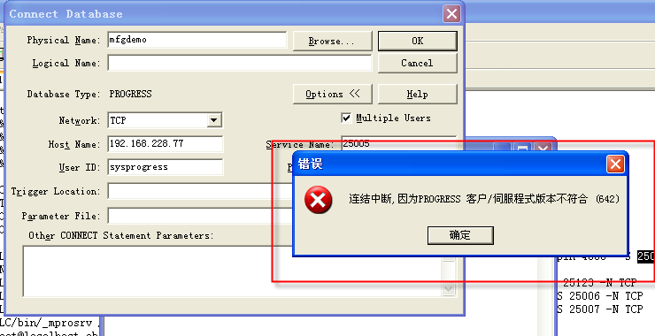

客户端与服务器端版本必须一致。才能通过CLIENT、ODBC、JDBC连通。

2、PROGRESS本地配置 (possible)

2.1、关于PROGRESS的JRE配置

利用每个PROGRESS版本/bin下面的sqlexp访问localhost的数据库

每个progress版本都是用自己的JRE环境

Sqlexp –H localhost –S -db

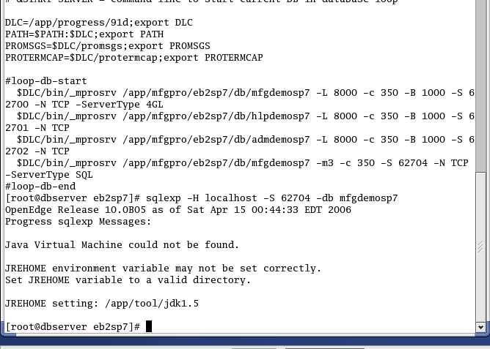

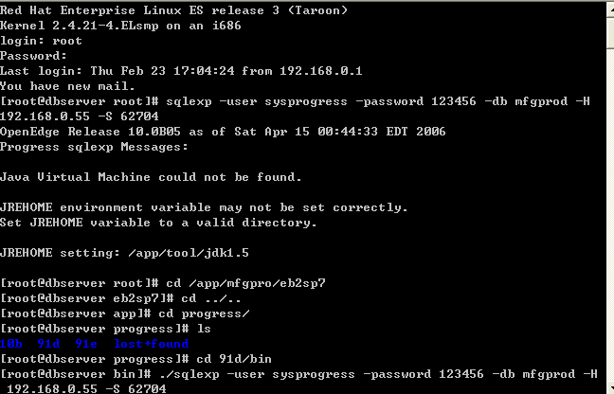

可以通过下面命令进入Progress目录：

[root@dbserver /]# cd /app/progress/

[root@dbserver progress]# cd 91d/bin

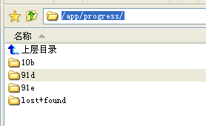

使用PROGRESS自带的JDBC连接工具命令：

./sqlexp -user sysprogress -password 123456 –db mfgdemosp7 –H localhost –S 62704

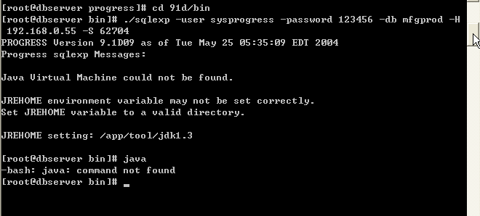

3、本地环境变量

4、测试JDBC能否连通VMW

1）通过PROGRESS的JDBC连接数据库

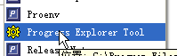

5、VMW环境问题

1) 换一个VMW

用VMW

2) 找一个纯净的机器来测试JDBC

6、升级建议及方案

1）找一个QAD顾问、不同版本数据库的JDBC需要协助

将3K切出1K。

2）按客户分个数测试JDBC连接

每个客户测试通过后，在进行BI的升级工作

3）

7、没有合适的驱动No suitable driver

1、问题1

[root@dbserver jdk1.3]# cd bin

[root@dbserver bin]# ./java -version

java version "1.3.1_15"

Java(TM) 2 Runtime Environment, Standard Edition (build 1.3.1_15-b01)

Java HotSpot(TM) Client VM (build 1.3.1_15-b01, mixed mode)

[root@dbserver bin]# /app/progress/91d/bin/sqlexp -user sysprogress -password 123456 -H 192.168.0.55 -S 62704 -db mfgdemosp7

PROGRESS Version 9.1D09 as of Tue May 25 05:35:09 EDT 2004

Connecting user "sysprogress" to URL "jdbc:jdbcprogress:T:192.168.0.55:62704:mfgdemosp7"... (8920)

**Error: No suitable driver. (8933)**

See "/app/tool/jdk1.3/bin/sqlexp.log" and "/app/tool/jdk1.3/bin/SQLExplorer.exceptions" files for more information. (8950)

[root@dbserver bin]#

当前VMW的JDK版本是1.3

可能是JDK版本太低了？

通过以下命令查看JDK版本：

[root@dbserver bin]# cd /app/tool/jdk1.3/

[root@dbserver jdk1.3]# ./bin/java -version

**java version "1.3.1_15"**

Java(TM) 2 Runtime Environment, Standard Edition (build 1.3.1_15-b01)

Java HotSpot(TM) Client VM (build 1.3.1_15-b01, mixed mode)

Linux Command

ls

su-

Use “ls” command to visit files

vi

执行VI命令修改

根目录输入 vi /etc/profile

按insert 开始修改文件内容：

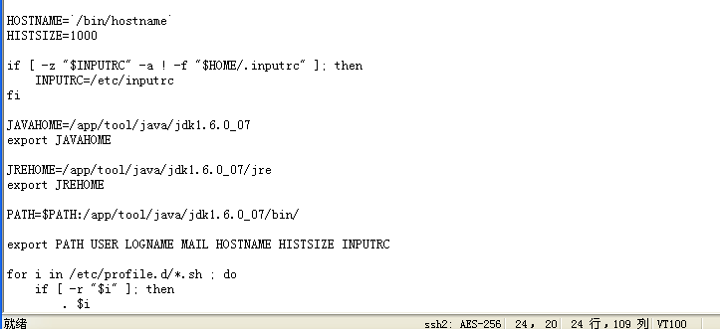

完成后，先按ESC

**然后按:w (保存修改) 注意要大小写敏感。需要小写**

**然后按:q（退出）**

To-do Items

1、VMW挂不同的DATA文件（AMY）

2、PERVSER参数 保证开另一个SQL服务，提示性能？

2013-2-5

PROGRESS环境变量、LINUX环境变量

1）注意客户端和服务器端都要设置

如果通过LINUX工具访问81服务器，输入SQLEXP

实际上是81作为Client访问自己Server。81必须配置client环境变量。

2）检查55VMW的服务器端环境变量设置，对比81

3）查看81的progress版本

S1、使用91D07目录的BIN命令测试：

# cd /app/progress/91d07

# cd ./bin

[root@dbserver bin]# **sqlexp -user sysprogress -password 123456 -db addonalert -H 192.168.1.81 -S 40104**

PROGRESS Version 9.1D07 as of Wed Sep 24 09:04:41 EDT 2003

Connecting user "sysprogress" to URL "jdbc:jdbcprogress:T:192.168.1.81:40104:addonalert"... (8920)

Error: No suitable driver. (8933)

See

"/app/progress/91d07/bin/sqlexp.log" and "/app/progress/91d07/bin/SQLExplorer.exceptions" files for more information. (8950)

[root@dbserver bin]#

S2、本地WINDOWS客户端访问VMW81的Progress服务器端

C:\Program Files\PROGRESS\bin\ sqlexp.bat 即SQLEXP工具

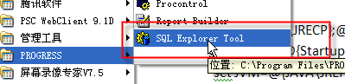

该文件中对客户端的JRE是进行设定了的，将PROGRESS的LIB增加到了客户端环境变量中的。

:SETJVM

REM if Java environment variables set, use them

REM otherwise use the registry

if "%JREHOME%"=="" goto USEREG

:USEREG

set JCP=@{JAVA\JRECP};@{JAVA\PROGRESSCP};@{Startup\DLC}\java\rmi.zip;@{Startup\DLC}\java\messages.jar;@{Startup\DLC}\java\prowin.jar;@{Startup\DLC}\java\jdbc.jar

set JVM=@{JAVA\JREHOME}\bin\@{JAVA\JVMEXE}

set WRK=@{WorkPath}

set ARGS=@{JAVA\JVMARGS}

set POLICY=@{JAVA\JAVAPOLICY}

goto SETPARAMS

WINDOWS客户端访问成功。

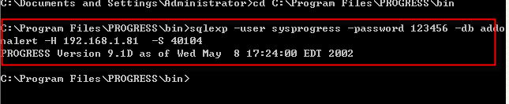

终于搞定了。在PROGRESS服务器端的启动文件。



JDBC访问流程总结(Very Important)

一、客户端安装和服务器端一致的PROGRESS版本

1、Client环境变量

Windows的progress client JDBC 工具

CLASSPATH 需增加progress的JDBC驱动

C:\Program Files\PROGRESS\java\jdbc.jar;

C:\Program Files\PROGRESS\java\progress.jar

PATH需增加JDBC的DLL文件

(将文件JdbcProgress.dll拷贝到C:\WINDOWS\system32 也是同样道理)

C:\Program Files\PROGRESS\bin\JdbcProgress.dll

JAVA驱动文件路径：

C:\Program Files\PROGRESS\java

jdbc.jar、progress.jar

JAVA DLL文件路径:

C:\Program Files\PROGRESS\bin\JdbcProgress.dll

（测试后发现procli92.dll该文件可以不用配置到PATH环境变量中）

BQ Client

配置PATH

将JDBC JAR文件拷贝至BQ目录\webapps\BIService\WEB-INF\lib下

注意:

1、客户端和服务器端都要设置

2、如果没有设置环境变量，使用PROGRESS的SQL工具是可以访问的。

因为sqlexp命令中发现如果没有设置JDBC驱动到classpath中,progress的sqlexp文件中

会自动将C:\Program Files\PROGRESS\java的JDBC驱动注册到环境变量中。

3、直接将PROGRESS的JDBC驱动拷贝至BQ 目录BIService\WEB-INF\lib下，无法直接生效。

3.1)可能是BQ路径中存在中文,JAR文件无法被指定

3.2)另外配置CLASSPATH环境变量指向BIService\WEB-INF\lib的2个JAR

3.3)

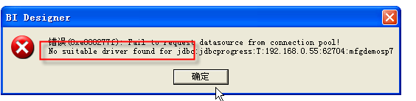

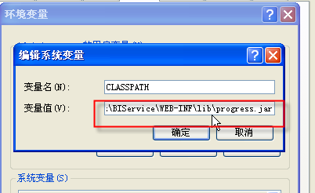

2、服务器开启SQL服务模式

使用VI命令修改数据库启动文件

启动文件路径通常是: /app/mfgpro/eb2sp7/start.xxx

(xxx could be Demonstration、Training… )

将需要使用JDBC访问的DB的服务模式修改成4GL、ServerType SQL两种：

$DLC/bin/_mprosrv /app/mfgpro/eb2sp7/db/mfgdemosp7 -L 8000 -c 350 -B 1000 -S 62700 -N TCP -ServerType 4GL

$DLC/bin/**proserver** /app/mfgpro/eb2sp7/db/mfgdemosp7 -m3 -c 350 -S 62704 -N TCP -ServerType SQL

**(注意：ServerType SQL语句中第二个参数要改成proserver，不要用原来的_mprosrv)**



WINDOWS版本下设置：

REM tokens:

REM &DLC = Progress Directory

REM &LOOP-DB-START = start of database loop

REM &LOOP-DB-END = end of database loop

REM &START-SERVER = command line to start current DB in database loop

SET DLC=d:\eb21sp3\91d

SET PATH=%PATH%;%DLC%

SET PROMSGS=%DLC%\promsgs

SET PROTERMCAP=%DLC%\protermcap

REM loop-db-start

REM %DLC%\bin\_mprosrv d:\eb21sp3\eb21\db\mfgtrain -L 8000 -c 350 -B 1000

%DLC%\bin\_mprosrv d:\eb21sp3\eb21\db\hlptrain -L 8000 -c 350 -B 1000

%DLC%\bin\_mprosrv d:\eb21sp3\eb21\db\admtrain -L 8000 -c 350 -B 1000

%DLC%\bin\_mprosrv d:\eb21sp3\eb21\db\mfgtrain -L 8000 -c 350 -B 1000 -S 62700 -N TCP -ServerType 4GL

**%DLC%\bin\_mprosrv** d:\eb21sp3\eb21\db\mfgtrain -m3 -c 350 -S 62704 -N TCP -ServerType SQL

PROGRESS-BQ Repository测试流程

1、智能查询

1、使用聚合函数的查询报错

BQ将别名解析成了COL AS AXIS_COL

原解析的语法：

GROUP BY tr_hist.tr_part AS COL1_CHAR18,

解决方案：建一个查询（不含聚合），然后基于查询的查询在求sum()

2、设置Schema

1、能直接在Progress永久设定一次即可吗？

2、BQ

修改所有已做报表、查询。增加一个刷新前的set schema操作

Option Explicit

'#Uses "*$/MARK/AviodPUBSchemaForProgress"

Public Sub Query_BeforeRefreshData(nMaxRows As Long, bCancel As Boolean)

Call modifyProgressSchema

End Sub

注意：在参数输入前事件也需要调用。因为用户定义的参数可能增加了数据来源。

Query_BeforeInputParams

3、Progress的数组类型字段在BQ如何处理？

设置Progress默认Schema

F:\工作\项目\QAD（快意）\Progress\ProgressJDBC\ Progress SQL-92 guide and reference.pdf

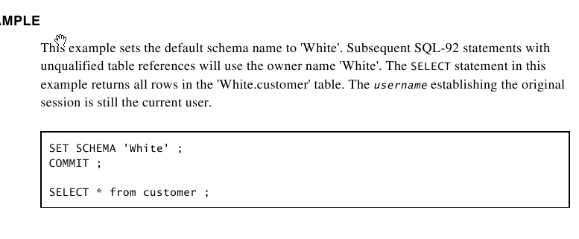

1）通过progress的sqlexp 访问。

首先需要执行 set schema 'pub';commit;

但每次打开都需要设置一次。

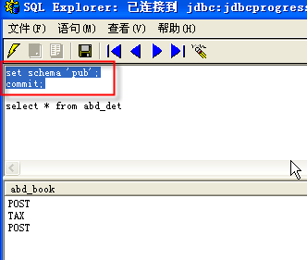

2）BQ 需要手工设置执行脚本。

**问题：每个查询刷新前都需要设置？**

**还是设置一次后，只要BQ服务器不重启，就一直生效？**

**Possible1：每个查询刷新前，都必须运行一次？**

AviodPUBSchemaForProgress脚本内容如下：

Option Explicit

Sub Main

On Error GoTo err_p

Dim db As New SunDatasource

db.Open "mfgprod",dbReadWrite

db.Execute "set schema 'pub'",-1

db.Execute "commit",-1

Call queryDS

Exit Sub

err_p:

If Err.Number <> 0 Then

Err.Description

End If

End Sub

Sub queryDS

Dim ds As New SunDataset

Dim cmdStr As String

Dim i As Integer

cmdStr = "SELECT abd_type AS COL1_CHAR60 FROM {mfgprod}.abd_det"

ds.CreateDataset cmdStr,-1

If ds.RowCount > 0 Then

For i = 1 To ds.RowCount

App.ShowMsg 0,i & ":" & ds.CellData(1,1)

Next

End If

End Sub

在VMW的服务器端访问Progress

1、进行eb2sp7

2、./client.Demonstration

用户名 mfg/

按F4(退出)

再按P

登入Progress

PROGRESS的4GL和SQL92对比函数

Day(Date_col) => dayofmonth(Date_col)

EMAIL-JOB1 Progress 4GL调用BQ页面

Progress 4GL生成报表所需数据文件 => 打开BQ报表

Progress10 JDBC连接

1、VMW

eb21sp6

10.1B03

http://www.yellowfinbi.com/YFForum-Connecting-to-10-x-Progress-OpenEdge-?thread=97599

第一步、配置服务器

第二步、配置Client

CLASSPATH环境变量配置：

openedge.jar

util.jar

base.jar

pool.jar

spy.jar

同时将上述5个JAR拷贝到BQ的lib目录下

PATH环境变量配置：

Xx:\progress\OpenEdge

Xx:\progress\OpenEdge\jre\bin\client

第三步、

JDBC驱动类名：

com.ddtek.jdbc.openedge.OpenEdgeDriver

URL：

jdbc:datadirect:openedge://<IP>:<Port>;databaseName=dbname

XIEXING BI Testing ( BI6.X Accessing Progress10.2B)

Progress Version

Openedge 10.2B

1．License code is on the list of below diagram:

2．QAD EE on demand

File location is E:\Softspeed BI Team\Mark\VMW

## ODBC 配置手册

大家好，这个手册是我自己写的，如在配置中遇到什么问题请直接在群里问我，本人不才，如那些写的不好请多多包涵。

配置声明：

首先你必须有一定权限，例如你要有权限进入 progress 数字辞典 ，知道你们LINUX 服务器IP 地址。

如果QAD版本较新，你的电脑上必须安装progress(版本和你公司版本必须一样)

老版本QAD好像自己带的有ODBC驱动（本人不清楚听说）有条件也安装一下progress很简单的。

1. 首先你必须确定你们公司的QAD系统里PROGRESS 是什么版本的，初学者请看你必须有（方法如下：在字符界面下进入编辑界面

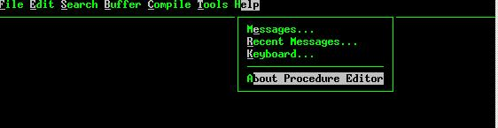

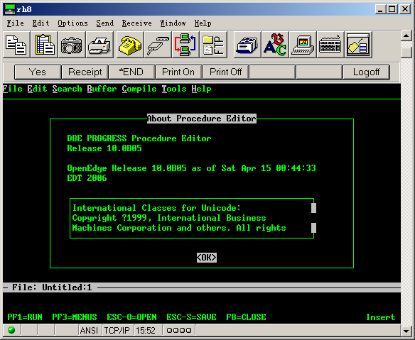

里面 10.0B 就是版本号。

线面就是安装progress 了。

这个是傻瓜安装，只要安装 Client 的 licence 就OK 了，详细的就不说了。

2.然后就是在里的QAD 系统progress 里设置一个用户名，和密码。

如果进入出现如下画面恭喜你你不用设置了，直接找IT 要用户名和密码就好了。

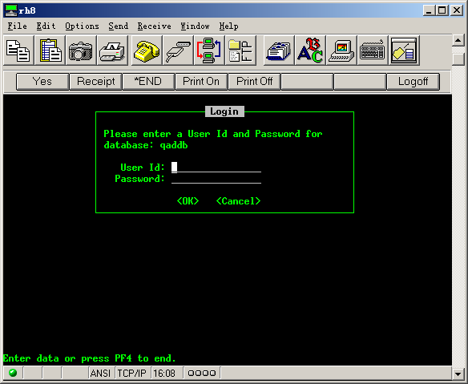

如果出现下面画面你就要创建了。（也就是没有用户名，密码提示）

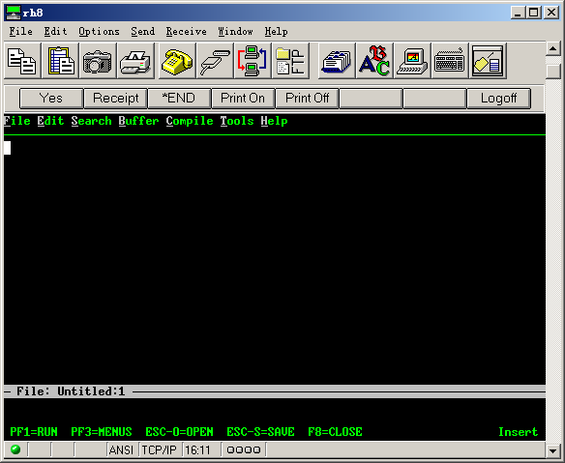

操作如下：

进入数字字典

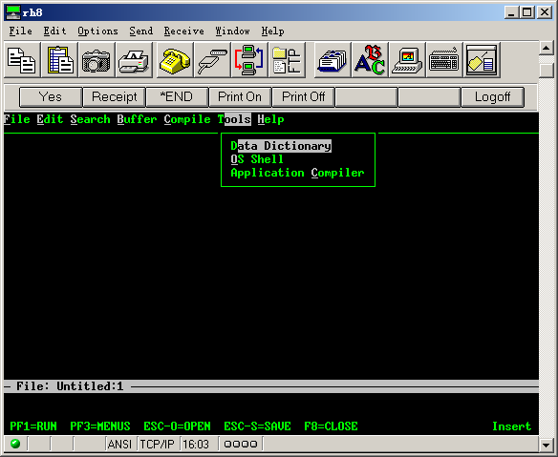

选择 Security----Edit User List

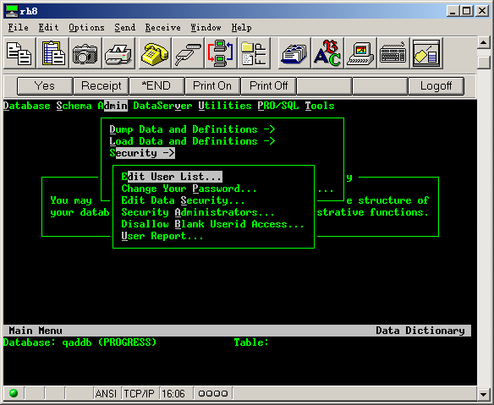

进入后加入用户名，密码

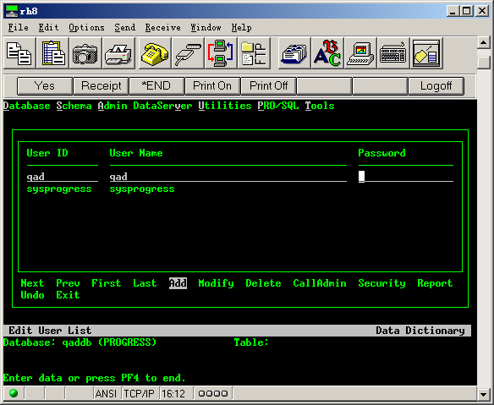

确认后退出。

1. 加入一个环境变量。

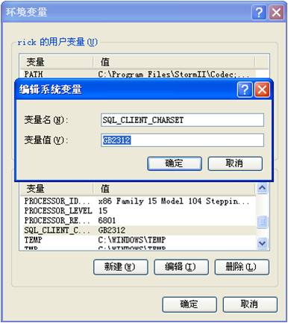

3.还要改一下启动脚本。（start.eb21spxxxxx）

**把_mproserv 改成 preserve（注意：一定要修改，否则不行）**

在加一行

$DLC/bin/**proserve** /db/eb21sp4/mfgdemo -m3 -Ma 6 -Mpb 5 -N tcp -S 50110 -ServerType SQL

记住加入的这行你要修改，端口号 。因为这是我的启动脚本。（红色为要修改的）

要注意，你在连接ODBC 时这个必须必须启动。（别看简单，好多人就是这里没有改，出现连接不上的错误）。

4.在Windows 下找到 odbc 配置窗口：

打开方法 控制面板------管理工具-----数据源（ODBC）

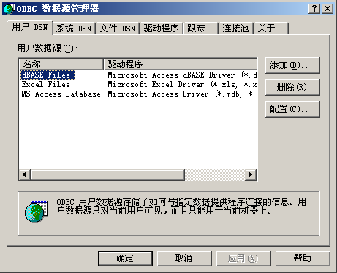

选择 系统DSN，在选择 添加：

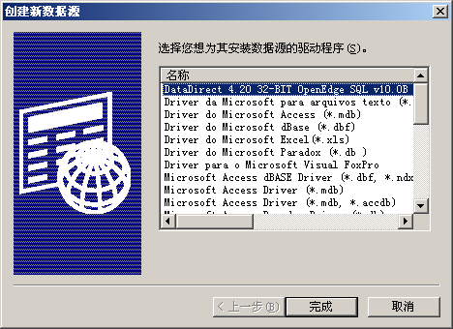

一定要选择 OpenEdge SQL (这个就是你安装的progress的odbc 的驱动)

然后出现下面的界面：记住只修改 General 里面的信息。

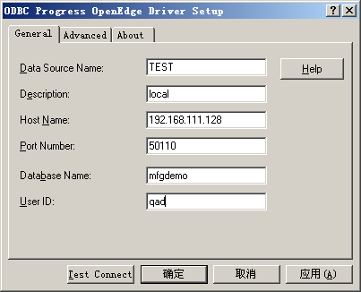

详解：

Data Source Name： 这个是数据来源的名称一般为你公司数据库的名字（可以随便填写，主要输区分数据来源的）；

Description: 描述，之歌就不多说了；

Host Name: 你们Linux 服务器的IP .

Port Number: 输入你的端口号

Database Name: 数据库名 （一定要填对）

User ID : 就是你在progress 里设置的 。



然后你确定你刚才改的脚本启动了，也就是数据库启动了（例如启动脚本 start.eb21spxxxxx）：

点击TEST Connect . 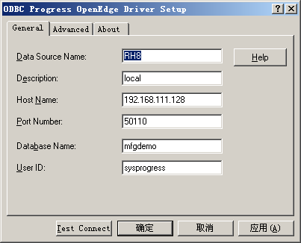

出现输入密码的界面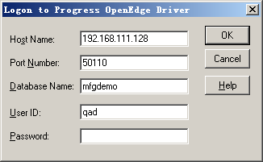

输入密码 ，

出现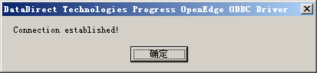

就OK

## License Information

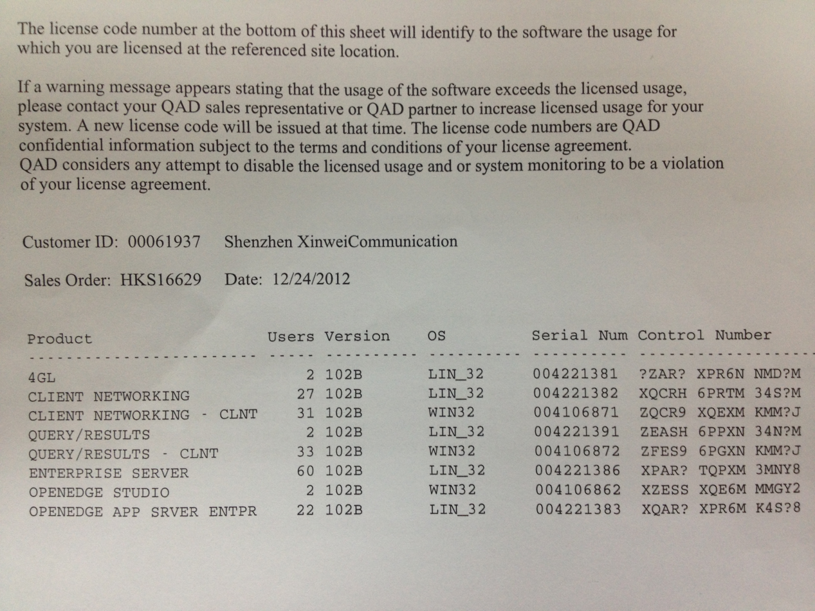

This progress openedge version is within Windows XP

The operating system requires Microsoft .Net Framework3.0

Need install Progress service pak

Solution:

Problem is progress10.2B enclose the port so BI6.X can access it directly.

Currently BI6.X use ODBC connection access to Progress10.2

BI Migration 6.x or below to 7.x

PROGRESS10安装

安装光盘

017 Win32 Intel 10.1B

Karrie P00700 60R

Includes OpenEdge Replication

111008 Batch#6

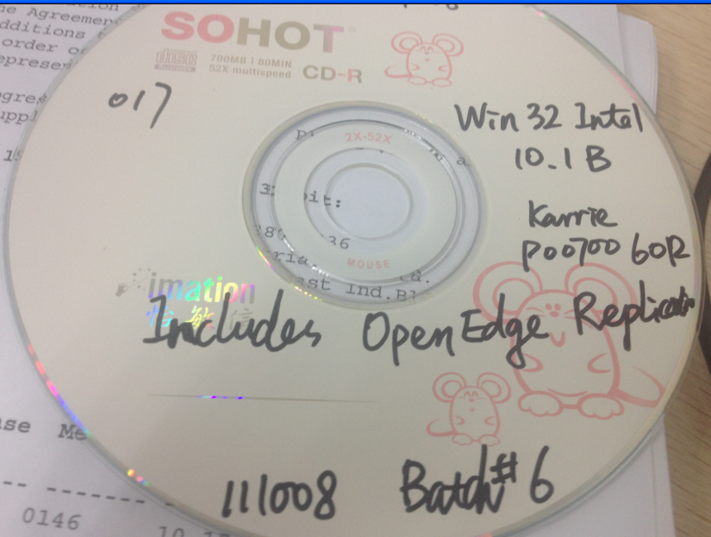

License for win32 intel

Client Networking

Serial : 003850558

Control Number: Z8GR9 6PGTM 5MCYJ

Application

Serial :003850562

Control Number: X9ASS 6PEJM 5MRY6

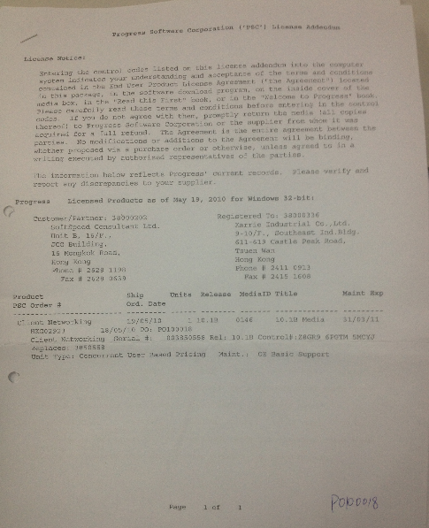

# VMW

1.How to configurate multiply VMW interact each other

  在主机方式下，windows主机操作系统不需要配置什么了，我们打开cmd.exe，输入ipconfig，就知道VMnet1的ip地址是什么了，因为这个ip就是VMWare虚拟机上的客户操作系统的网关ip地址。我的VMWare虚拟机上一般装的是redhat，因为linux系列里redhat是最常见的，公司用的有suse, slaceware，unix使用solaris，freeBSD。那么我们在客户操作系统上配置网络，主要注意的是，**网关的IP就是你在windows主机操作系统里用ipconfig命令查看到的VMnet1的ip地址。**

MARK summary:

* 1. VMW use Host-only network mode
  2. ***VMW gateway should be set up as Host operating system’s IP***

# Operation System

## Linux

### How to set user account

Application->System Setting->Users&Group

### Modify startup mode of Linux

1.locate in etc directory by type command “cd /etc”

2.use “vi inittab” command to edit the file

3.assign the value highlighten to 3

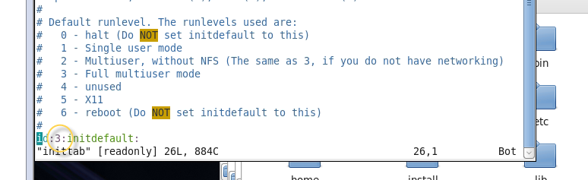

### Modify QADEE VM to Bridge Mode and Change IP address

VM file is located in 152 server

(E:\QADBI\VMW\VM-2011.1EE-Demo)

1.choose network and change IP

Optional change host operating system file :

“C:\Windows\System32\drivers\etc\Hosts”

Modify the former Ip to current bridge IP.

Such as “192.168.0.55 dbserver”

2.reboot

3.use ping and telnet to test

***Important: firewall of Linux should be turned off.***

***The problem present as ping succeed but telnet failed.***

4.start QAD

Optional:

Check the startup information in order to ensure that SQLServer Type running OK.

If not then launch the below command manually:

***proserve /app/2011.1ee/mfgpro/db/mfgdemo -L 8000 -B 1000 -c 350 -S 54***

***004 -N TCP -m3 -Ma 4 -Mpb 30 -NL -R0 -ServerType SQL***

# DATABASE

## SQL Server

**1、How to find the instance name in SQL Server?**

In SQL Server Management Studio->RegisterServers->double click your server to open the Object Explorer -> right click to select the properties window ->General Tab - to see the ServerName

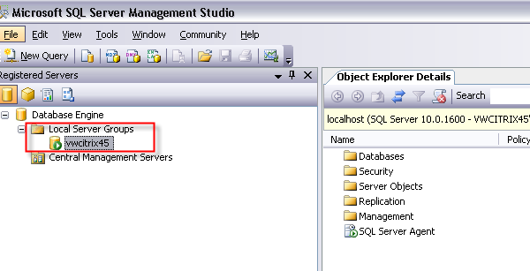

**2、Modify Database in windows Authentication type?**

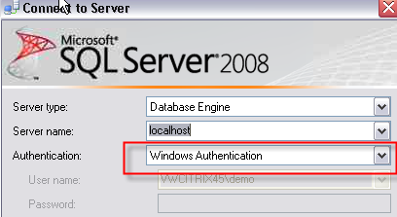

http://blog.csdn.net/qishuangquan/article/details/6024767

**3、Create an new user by SqlServer management studio?**

## ORACLE

# Printer (how to use flip on both sides)

1.Choose the right printer from the drap-down list

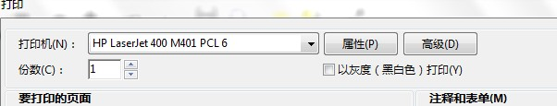

2.Set the configuration below

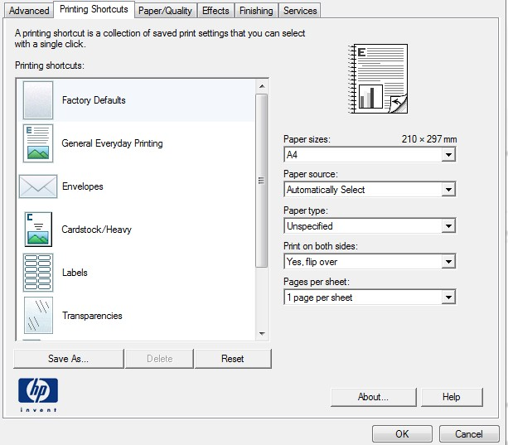

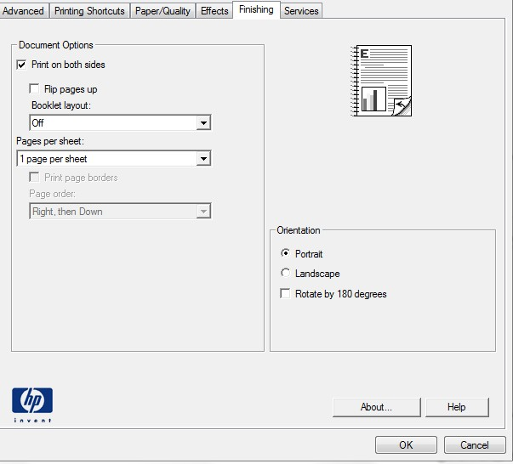

# Softspeed BI

## 第一章关系数据源

### （一）功能概述

1、设计者可根据需要建立所需要的关系数据源

2、建立好的数据源中的数据表可供设计者及用户使用

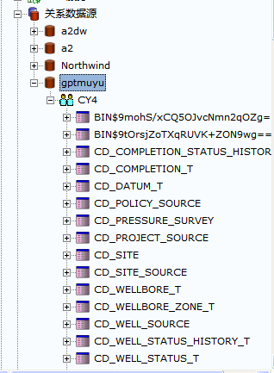

### （二）新建关系数据源

一、新建数据源

选择关系数据源->右键->新建数据源

二、配置数据源

1、基本配置信息

1）数据源名称

2）数据库驱动程序（JDBC）

3）类型（Oracle）

4）列出对象（默认只是将数据库的表和字段显示出来）

5）最大连接数（并发访问DB的个数，即：同一时刻可以有多少个用户同时连接数据库）

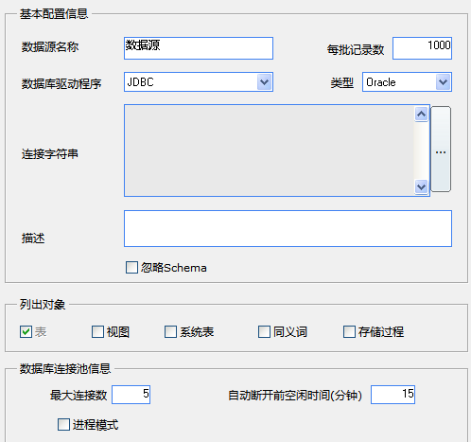

2、JDBC连接配置

1）JDBC驱动程序

2）数据库URL（选择jdbc:oracle:thin:@localhost:1521:DemoDB，把localhost的位置改为主机IP地址，DemoDB改为SID名）

3）填写相应的用户名和密码

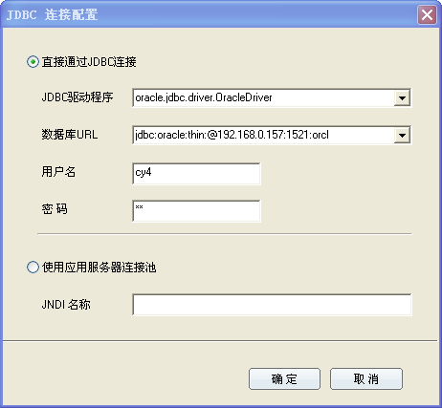

## 第二章信息域

### （一）信息域概述

一、信息域概念

信息域也叫语意层或业务视图，是对数据源中数据结构的面向业务的映射，是数据库的语意层。具体是指从业务数据源中挑选出与某项业务相关的信息，并对其进行重新分类及命名。它将您同数据库及查询语言的技术细节隔离开来，使用您熟悉的业务语言重新管理和命名数据库里的数据。

二、信息域作用

1、将数据中的表及字段改为有意义的业务术语，从而使最终用户不需要依赖IT人员即可轻松构建查询和表。

2、能按用户习惯，对数据库信息进行分类管理。

3、预建表关联

4、将复杂统计表达式作为单个对象，像使用字段一样方便查询和做报表。

5、实现单点更新，修改一处更新全部。

三、信息域实现功能

1、我们可以通过信息域利用相应的表以及表中的字段建立我们所需要的新表

2、能够为新表增加新的字段

3、当新组建的表使用了多个已存在的表时我们可以为使用到的表建立新的连接

4、为表建立别名表

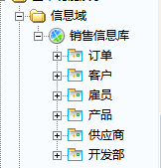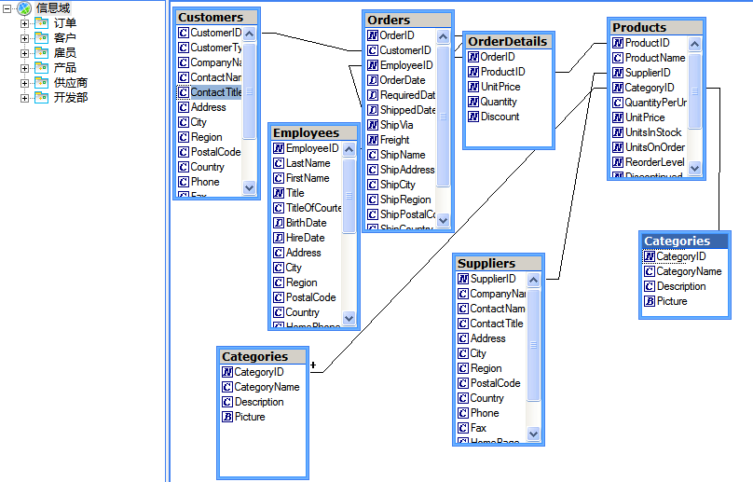（二）建立信息域

一、新建信息域

1、选择相应的目录->右键->新建->信息域

2、把相应的表拖拽到信息域中

二、信息域的相关操作

1、新建表连接

选中原表连接按Delete可删除原表连接，连接表关系中要建立连接的字段即可为表建立新的表连接，同时选中表连接右键还可设计连接的方式，例如：左连接、右连接。

2、新建用户使用的类（按业务逻辑来命名）

选择信息域->右键->新建类

3、自定义数据对象（选择位置->右键->新建数据对象）

1）数据转换

对象(新建一个智能查询，查询对象为转换目标和转换目的值)

SQL（填写相应的SQL语句）

注意：数据转换如果是ID转换成其它，第一列一定是ID，第二列是要转换的内容。

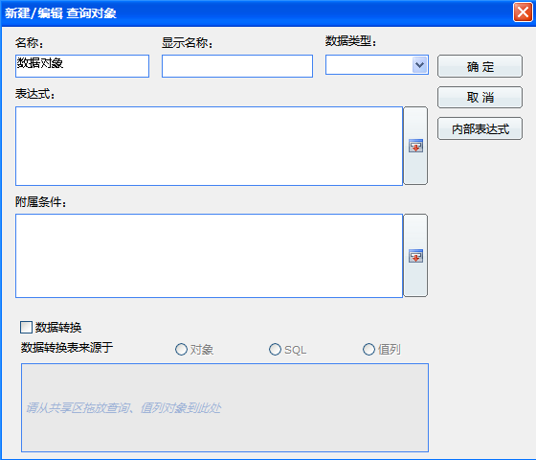

3、扩展

SQL的别名表：

1）别名表的建立

选择表右键->添加该表的别名表

2）别名表要实现的SQL查询

Select col from tab1 a left join Tab2 b on b.col1 = a.col1 Left

join Tab2 c on c.col2 = a.col2 Left join Tab2 d on d.col3 = a.col3

3）别名表效果SQL

SELECTCY4.CD_WELL_SOURCE.WELL_ID,

CY4.CD_WELL_SOURCE.SITE_ID, CY4.CD_WELL_SOURCE.WELL_LEGAL_NAME,

CY4.PC_WELL_PRO_MONTHLY.WELL_ID,

CY4.PC_WELL_PRO_MONTHLY.YEAR_MON, CY4.PC_WELL_PRO_MONTHLY.PROD_DAYS, CY4.PC_WELL_PRO_MONTHLY.OIL_PRES, CY4.PC_WELL_PRO_MONTHLY.CASING_PRES,

PC_WELL_PRO_MONTHLY2.WELL_ID

FROM

CY4.CD_WELL_SOURCE,CY4.PC_WELL_PRO_MONTHLY,CY4.PC_WELL_PRO_MONTHLY PC_WELL_PRO_MONTHLY2

WHERE

CY4.PC_WELL_PRO_MONTHLY.YEAR_MON = '200205'

AND

PC_WELL_PRO_MONTHLY2.WELL_ID = CY4.CD_WELL_SOURCE.WELL_ID

AND CY4.CD_WELL_SOURCE.WELL_ID = CY4.PC_WELL_PRO_MONTHLY.WELL_ID

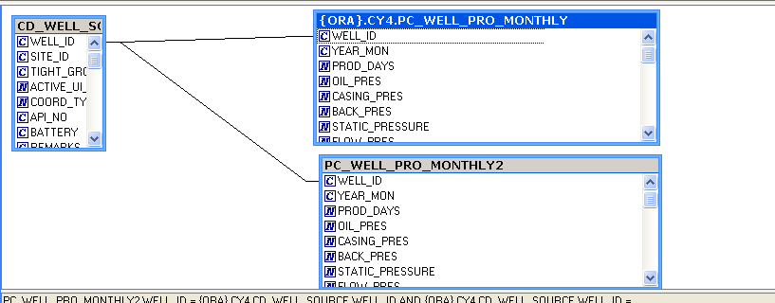

## 第三章窗体开发（订单维护）

### （一）功能概述

1、用户可根据个人需求查看相应的订单信息。

2、将符合用户需求的订单数据抽拽出来。

3、插入新订单，将订单信息保存到数据库。

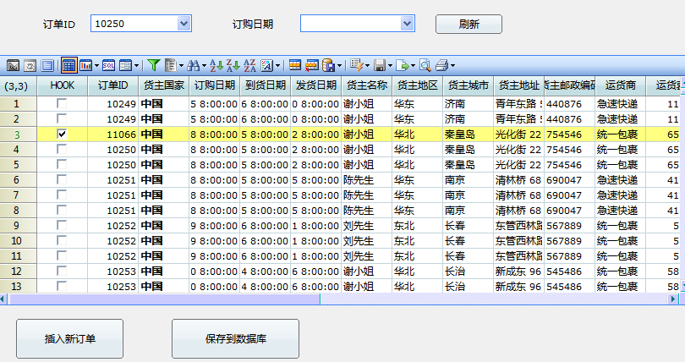

### （二）窗体开发过程

## 第五章数据泵出（ETL）

### （一）功能概述

1、 ETL是一个实现数据的抽取、转换、加载的过程。

2、GPTDex ETL就是通过查询定义数据仓库表，利用查询的强大功能做数据抽取（Extraction）（从不同数据源取数、跨数据源取数）、生成计算字段（自定义计算项）、转换类型和数据清洗（Transformation）,并通过数据泵出加载到数据仓库（Load）。

### （二）数据泵出

1、在安装了GPTDex的服务器或客户端的机器上，以Admin用户的身份登录 GPTDex Designer，点击快捷菜单中的“数据泵出”按钮，弹出以下界面：

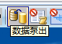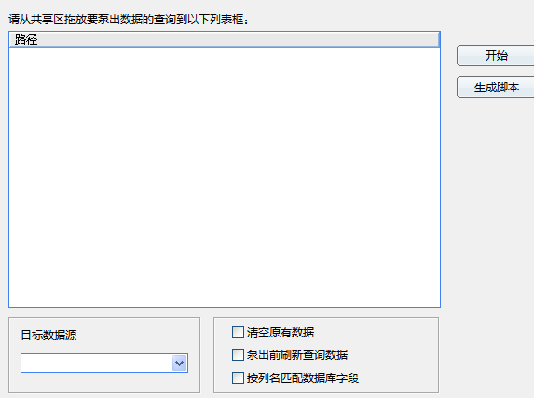

2、从系统共享区将你计划要泵出的查询文件拖到图中空白处

3、点击“目录数据源”下拉框，选择要泵出到的目标数据源

4、点击“开始”按钮即会自动泵出数据到所选择的目标数据源中，完成后会在目标数据源中自动生成一个表，这个表的名称和你选择泵出的查询的名称相同

泵出成功后，系统会自动弹出数据泵出日志，如下图：

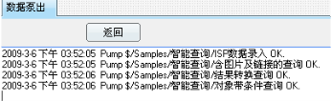

## 第六章采出井_投产初值

### （一）概述

通过采出井_投产初值窗体用户能实现以下操作

1、查询出全部关注的井投产初期情况

2、根据井名查询到选择的这口井的井史月数据

3、将选择某个月的数据保存到该井的投产初期情况表里，并且保存到数据库

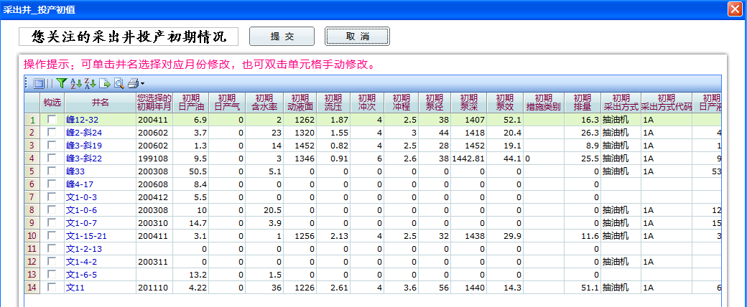

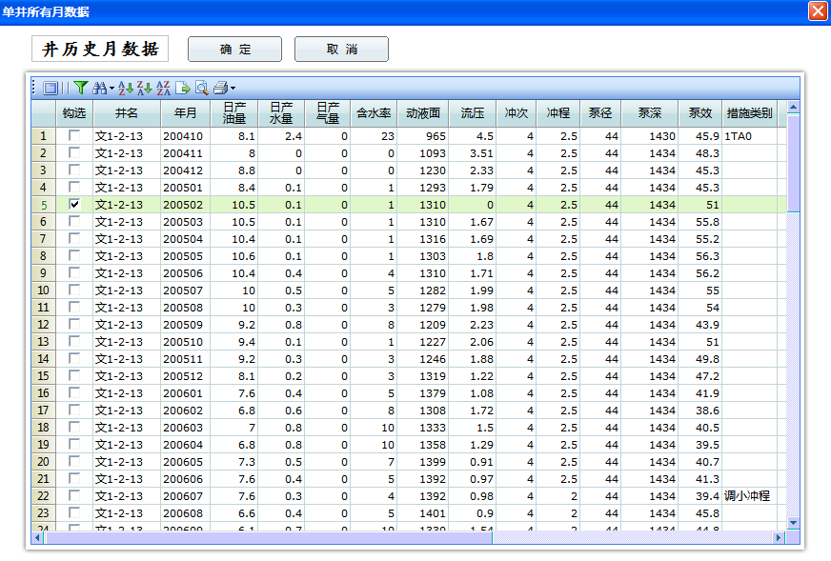

图2.井文1-2-13井史月数据

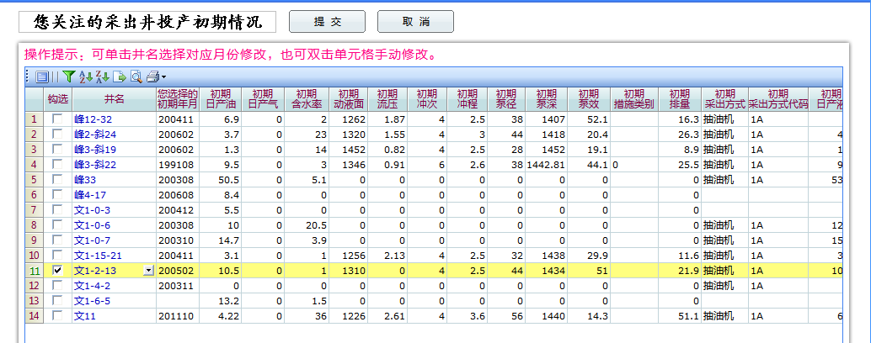

图3.将选择的井史月数据回写到投产初期情况

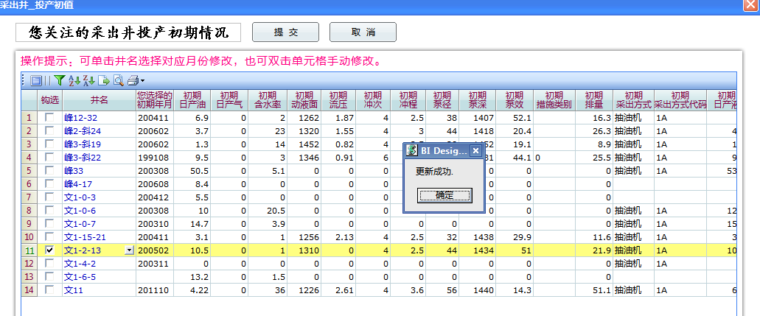

图4.提交保存到数据库中

### （二）简述建立采出井_投产初值过程

一、建立相关查询

1、主查询（sub）

查询字段参考下图

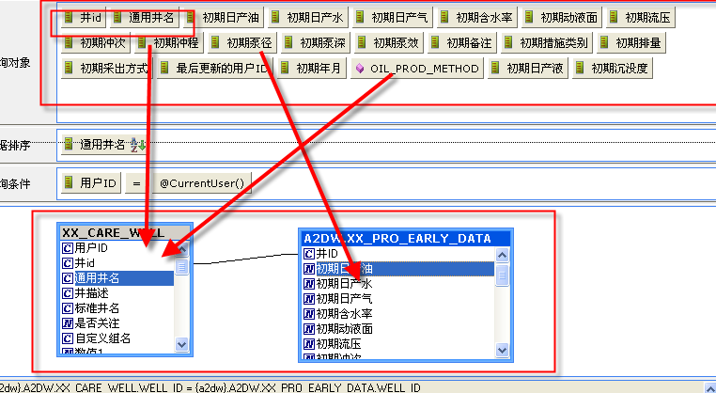

2、主窗体查询（CARE_WELL_EARLY_DATA）

查询字段参考下图

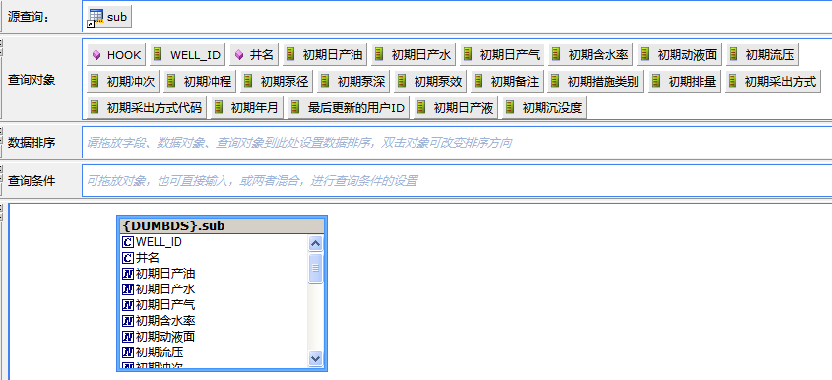

要点（1）使用源查询（sub）

（2）设置勾选列HOOK只能勾选一行

（3）设置写入数据库设置

（4）编写查询的LinkTo事件代码

具体设置代码如下所示：

设置勾选列HOOK只能勾选一行

Public Sub DataGrid_RequestCellFormat(ByValnRow As Long, ByValnCol As Long, pdispCellFormat As SUNDATAGRIDLib.CellFormat)

If nCol<>Query.ColumnIndex(HOOK) And nCol<>Query.ColumnIndex(WELL_COMMON_NAME) Then

pdispCellFormat.ReadOnly = True

End If

End Sub

编写查询的LinkTo事件代码

If nHitCol = Query.ColumnIndex(WELL_COMMON_NAME) Then

Dim wellId,yearMon,wellCommonName As String

Dim iAs Long

wellId = Query.CellData(nHitRow,Query.ColumnIndex(WELL_ID))

yearMon = Query.CellData(nHitRow,Query.ColumnIndex(YEAR_MON))

wellCommonName = Query.CellData(nHitRow,Query.ColumnIndex(WELL_COMMON_NAME))

App.FireContainerEvent "LinkTo",wellId,wellCommonName,yearMon,nHitRow

End If

3、子窗体查询（CARE_WELL_PRO_MONTHLY）

查询字段参考下图

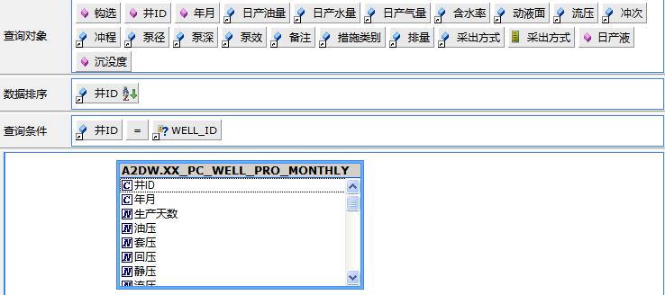

要点：

（1）设置勾选列HOOK只能勾选一行

（2）设置写入数据库设置

（3）利用查询做数据转换，转换查询对象井ID，参数WELL_ID

查询路径：$/a2dw/09DataTranslation/井ID转换井名查询

二、主窗体（采出井_投产初值）

1、主窗体的简易界面如下图所示：

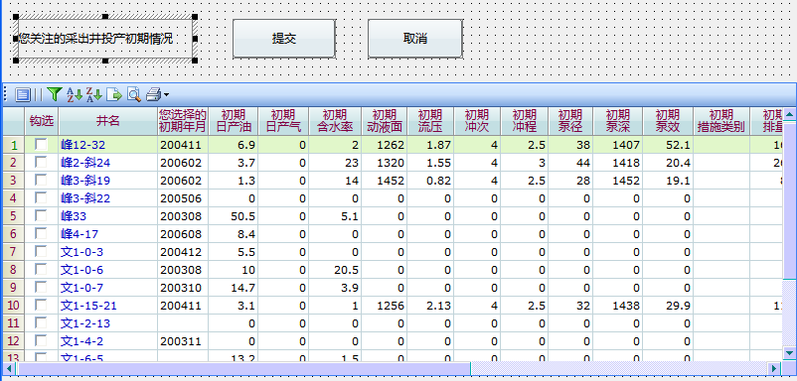

2、功能点描述

1）通过井名链接到子窗体

2）获得子窗体传递过来的值

3）通过提交按钮将记录保存到数据库

3、具体脚本代码分析

1）引入ExecuteSql，GlobalFunction（具体方法如窗体开发中介绍）

2）定义全局变量（这里不做具体说明）

3）获得子窗体传过来的数值并做出相应的动作（Form_Load()事件）

Form.EnvVar ("?CurrentUser") = App.CurrentUser

App.ShowWaitMsgPROMPT_MSG_REFRESH,False

QryCtrl.IObject.RefreshData False,-1

App.HideWaitMsg

4）弹出子窗体并且把主窗体的参数传递到子窗体，同时获得子窗体传出的值（ DO_EVENT事件）

If Trim(varID) = "LinkTo" Then

Dim frm As New SunContainer

Dim QryNameAs String

Dim szRow As Long

Dim qry As Query

frm.ObjectFile = App.BaseUrl& "单井所有月数据"

frm.EnvVar("?WELL_ID") = pvarParamArray(0)

frm.EnvVar("?WELL_COMMON_NAME") = pvarParamArray(1)

szRow = pvarParamArray(3)

App.ShowMsg 0,"----------You click Row[" &szRow& "]-------------"

‘以上代码是弹出子窗体并且把主窗体的参数传递到子窗体

5）通过提交按钮将数据更新到数据库

If MsgBox("您确定提交吗？",vbOkCancel,"提交提示") = vbCancel Then Exit Sub

If judgeHook(QryCtrl) = False Then

MsgBox UNHOOK_ERROR

Exit Sub

End If

If saveToDB(QryCtrl) = True Then

MsgBox PROMPT_MSG_UPDATE_SUCCESS

App.ShowWaitMsgPROMPT_MSG_REFRESH,False

QryCtrl.IObject.RefreshData False,-1

App.HideWaitMsg

Else

MsgBox PROMPT_MSG_UPDATE_FAIL

End

''将钩选记录更新到数据库

Function saveToDB(ByValqueryCtrl As SunContainer) As Boolean

On Error Resume Next

Dim i,j,curIndex As Long

Dim fields(22) As String,szErrMsg As String,transactionSql As String

定义一个数组用于存放所选行的各个字段

Dim conditions(1) As String

Dim nWellID,nYearMon As String

Dim cmdstr As String,operType As Long

Dim ds As New SunDataset

Dim selectedWell As String

App.ShowWaitMsgPROMPT_MSG_UPDATE,False

transactionSql = ""

用一个for循环将勾选记录的各个字段的值拼接起来

Form.EnvVar("?selectedWell") = ""

saveToDB = True

For i = START_ROW ToQryCtrl.IObject.RowCount

If queryCtrl.IObject.CellData(i,queryCtrl.IObject.ColumnIndex("HOOK")) = 1

Then

fields(2) = "YEAR_MON:" &queryCtrl.IObject.CellData(i,queryCtrl.IObject.ColumnIndex("初期年月"))

fields(3) = "OIL_PROD_DAILY:" &queryCtrl.IObject.CellData(i,queryCtrl.IObject.ColumnIndex("初期日产油"))

fields(4)="WATER_PROD_DAILY:"&queryCtrl.IObject.CellData(i,queryCtrl.IObject.ColumnIndex("初期日产水"))

……(其他类似)

fields(20) = "SUBMERGE:" &queryCtrl.IObject.CellData(i,queryCtrl.IObject.ColumnIndex("初期沉没度"))

nWellID = queryCtrl.IObject.CellData(i,queryCtrl.IObject.ColumnIndex(WELL_ID))

conditions(1) = "WELL_ID:" &nWellID

transactionSql = transactionSql&GetUpdateSql(PRO_EARLY_DATA,fields,conditions)

End If

Next I

App.ShowMsg 0,“current transaction:” &transactionSql输出拼接的SQL语句

If ExecuteSQL(transactionSql, szErrMsg)= False Then

将拼接出来的SQL语句传给方法（发送到DB执行）

MsgBox "维护井失败，更多信息：" &szErrMsg,vbCritical ,"提示信息"

App.HideWaitMsg

saveToDB = False

Exit Function

End If

App.HideWaitMsg

End Function

三、子窗体（单月所有月数据）

1、设计效果简图如下图所示

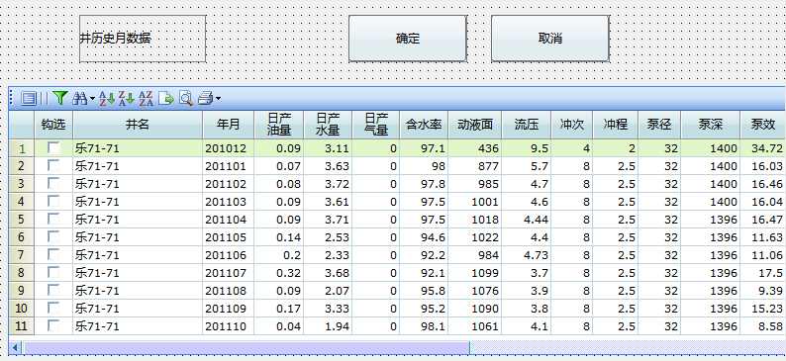

2、基本功能点描述

1）接收主窗体传过来的参数，根据参数显示数据

2）通过确定按钮将勾选列内容传到主窗体

3、具体脚本说明

1)定义全局变量

Const HOOK As String = "HOOK"

Const HOOK_SUB As String = "HOOK_SUB"

Const DISCHARGE_CAPACITY As String = "DISCHARGE_CAPACITY"

Const CHEM_VISCOSITY_WH As String = "CHEM_VISCOSITY_WH"

Const CHEM_CONC_WH As String = "CHEM_CONC_WH"

Const UNHOOKED_WELLS_ERROR As String = "请您选择一口井！"

Const NOT_EXISTS_WELL_ERROR As String = "您当前的条件下,不存在任何井！"

Const TRACE_YEAR_NUM_INIT As Long = 2

Const REFRESH_WAITING_PROMPT As String = "正在刷新,请稍候..."

……

2、取得勾选记录内容，并保存到数据库

Dim resultCode As Long

Dim entireRow,partRow As Long

If QryCtrl.IObject.RowCount<= 0 Then 如果行数小于0

MsgBox NOT_EXISTS_WELL_ERROR 输出错误信息

Exit Sub

End If

entireRow = getSelectedWell(HOOK)

If entireRow< 0 Then

MsgBox UNHOOKED_WELLS_ERROR

Exit Sub

End If

Form.EnvVar("初期含水率") = QryCtrl.IObject.CellData(entireRow,QryCtrl.IObject.ColumnIndex("含水率"))

Form.EnvVar("初期动液面") = QryCtrl.IObject.CellData(entireRow,QryCtrl.IObject.ColumnIndex("动液面"))

……..

Form.ClosevbOK

'判断当前是否选择记录,返回钩选的行号

Function getSelectedWell(ByValcolName As String) As Long

Dim i As Long,hookFlag As Long

Dim nMaxRow As Long

nMaxRow = QryCtrl.IObject.RowCount统计记录行数赋值给nMaxRow

For i = START_ROW To nMaxRow由第一行到最后一行做一个FOR循环

If QryCtrl.IObject.CellData(i,QryCtrl.IObject.ColumnIndex(colName)) = HOOK_FLAG Then

判断是否勾选

getSelectedWell = I 取得勾选记录的行号

Exit For

End If

Next i

If i = nMaxRow + 1 Then

getSelectedWell = -1

End If

End Function

四、查看保存结果

登录PLsql运行以下SQL语句，查看数据库中是否存在保存的记录

selectb.well_common_name,a.* from xx_pro_early_data a

inner join xx_care_well b

ona.well_id = b.well_id

whereb.user_id = 'ADMIN'

五、示例参考

1、三个查询的目录

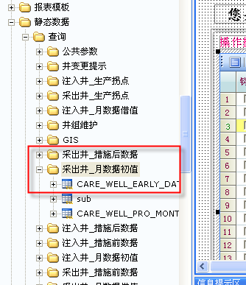

2、查询所用到的表

1）$/Datasources/a2dw/A2DW/XX_CARE_WELL

2）$/Datasources/a2dw/A2DW/XX_INJ_EARLY_DATA

3） $/Datasources/a2dw/A2DW/XX_PC_WELL_PRO_MONTHLY

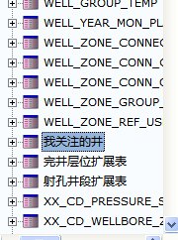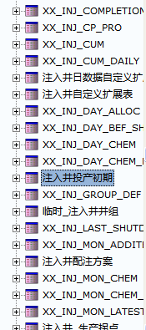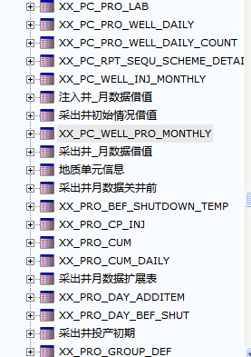

3、页面路径：

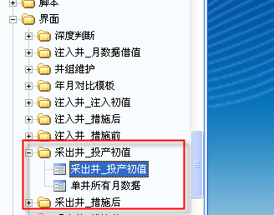

## BQ使用

若不启动oracle的相关进程，在服务中更改oracle services sid 为手动，oracle DBConsoleorcl为手动

**注意**

* **参考文档**

\\服务器IP(192.168.0.157)\gptdex\培训\Doc目录下

BIStar报表设计案例.doc

BIStar用户参考手册_include_SOA.doc

* **视频路径**

\\服务器IP(192.168.0.157)\gptdex\培训\ UF-Video目录下

## 第一节智能查询

以下查询参考视频1、2

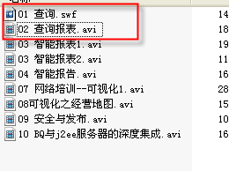

1. **销售清单查询**

要求：

* + SQL对产品ID字段进行数据转换
  + 参数

数据来源使用对象、SQL方式)

参数数据转换（SQL、查询两种方式）

参数数据转换：（第一列必须是id第二列必须是名称）

（1）SQL：（select id，name from 表（查询对象））优点：数据可以随数据库内容实时更新。缺点：操作耗费时间长。慢。

（2）查询：（新建一个智能查询产品id转换数据源，查询对象为id，name。把查询条件中产品对象的参数来源选择产品id转换数据源，选择数据转换。）用查询做参数，数据不是及时更新的。

解决利用查询做参数数据不是及时更新DEX的设计：

1. 建立参数查询。
2. 建立脚本（把所有查询刷新并保存）
3. 通过系统任务计划（Windows P处理文件）调用BQ脚本。
   * 数据排序
4. **地区金额按月统计**

要求：

* + 1、“华北”、“华南”、“华东” 3个地区的金额
  + 提供按年份选择的参数

查询对象：月份（month），华北金额，华南金额。。。

查询条件：year（orderdate）=年

1. **快速发布查询**

要求：

* 试用TOP_N

刷新选项TOPn/BOTTON n

发布模式首页可以自己进行设置；设置方法：把Default文件的文件名更改为你所要显示的首页名称即可。如下图所示：

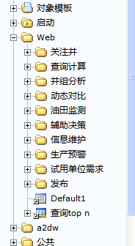

* 发布的查询不保留上次刷新的数据

点击刷新按钮的下拉菜单选择按指定行数刷新，选择取回限定记录数0

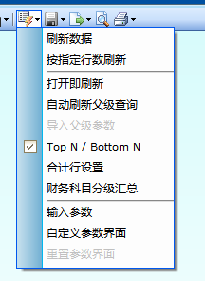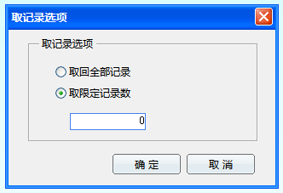

1. **查询结果格式设置**

要求：

* 数值格式（在表格视图下右键->格式设置）
* 行列表头、背景色
* 背景

在表格视图下->在格式设置的下拉菜单->选择显示/修改表格属性，即可修改相应的行列表头背景色等内容。如下图所示。BackGradien Start/end (修改背景色)

Showrowheaders(是否显示行数，即表格的第一列)

CoHeaderGradienstart/end(设置行标题颜色)

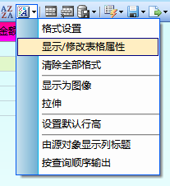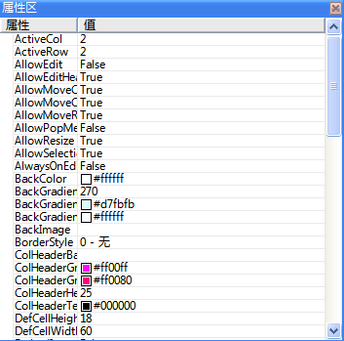

* 自定义工具栏

1. **库存预警查询**

要求：

* + 示警器使用(发送系统消息，邮件功能暂不使用)

**6、查询单元格内容使用图片**

图片路径记得加双引号

**7、查询钻取**

要求：

* + refresh方式钻取、弹出方式钻取
  + 多个链接目标钻取

以下查询参考BQ样例，在下图“查询”目录下。

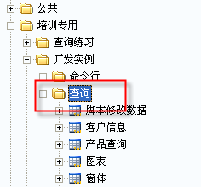

**8、脚本修改数据**

路径：$/培训专用/Developer/Query/ModifyDataByScript

**9、树型参数**

$/培训专用/Developer/Query/CustomParamDlg

**10、参数嵌套**

$/培训专用/Samples/智能查询/含嵌套参数的查询

**以下查询参考GPTDEX培训过程**

**11、基于本地文件**

**12、基于SQL查询**

**13、基于查询的查询**

**14、关注井流程**

**15、日期对比**

**16、队累计查询**

**17、区块统计**

**18、含水率分级**

**19、年月对比**

## 第二节智能报表

参考视频 03智能报表1.avi、03智能报表2.avi

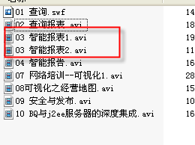

1、清单式报表

新建-智能报表（表格式）

2、销售月报表

正确使用计算域

3、费用分析报表

正确设置行列扩展

4、各地区销售一览表

正确设置行列扩展

## 第三节智能报告

参考视频04 智能报告.avi

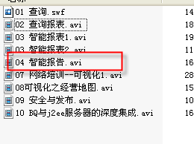

1、销售月报表

WORD中动态刷新数据

表格和图形

使用“公式”

## 第四节窗体编程

以下窗体参考视频07 网络培训--可视化1.avi、08可视化之经营地图.avi

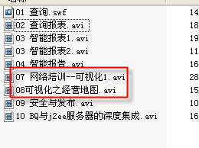

**1、中国销售经营地图**

要求：

* 用户选择年月刷新整个图表

**2、制作地图控件（蜂窝图、地理地图）**

图片文件参考\\192.168.0.157\gptdex\培训\练习素材

以下窗体参考BQ例子。

**1、销售订单维护**

**2、销售订单维护改进版**

主界面说明：  
用户钩选几条记录，点击保存，写入数据库。

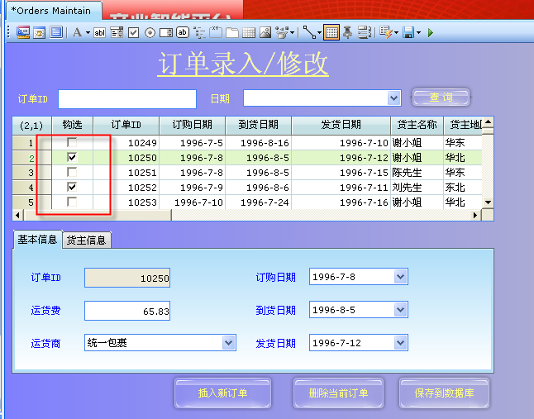

点击订单ID列，弹出子窗体。例如点击“10251”行，弹出窗体的查询刷新出所有

OrderID等于10251的记录。

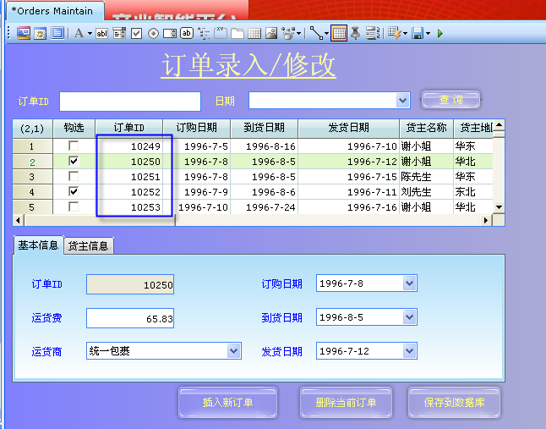

在子窗体中钩选一条记录，点击“保存”。将该行的“订货日期”、“到货日期”等红色框

内的字段的内容，传递到主界面。

同时OrderID等于10251的记录的对应字段

“订货日期”、“到货日期”等字段值被修改。

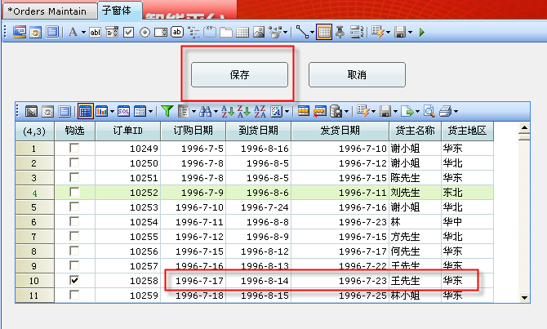

**3、采出井_措施前**

路径：$/a2dw/19RandomTime/1904Interface/XX_INJ_STIM_DATA_BEFORE/注入井_措施前

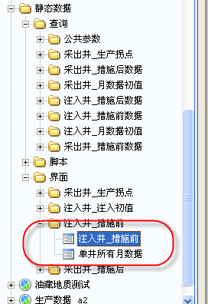

主要功能点：

写数据库操作

1、点击“提交”，将表格钩选的数据写入表。

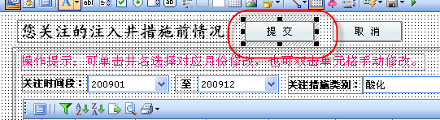

自定义的写数据库的方法

Function saveToDB(ByVal queryCtrl As SunContainer) As Boolean

原理：

遍历表格的每一个钩选的行。

将需要写入

字段名:实际值(查询表格单元格内容):字段的类型

公共脚本：

$/a2dw/10BasicModule/1006GlobalComScript/ExecuteSql

GetInsertSql \ GetUpdateSql方法。

ExecuteSQL方法过程如下：

1、定义一个数据源

Dim db As New SunDatasource

2、执行DML操作或数据库事务

db.execute sql

sql 可以是delete 、truncate、update、insert 或者一个完整的ORACLE事务。

BQ中几种操作数据库的方法

1、通过BQ的sundataset 从数据库取数

Sub main

Dim param As String,orgID As String

param = "1000"

orgID = "ITC"

App.Cookie("orgID") = orgID

Call debugDS(4)

End Sub

Sub debugDS(ByVal categoryID As Integer)

Dim ds As New SunDataset

Dim resultStr As String

Dim cmdStr As String

'STEP1)写SQL

cmdStr = "SELECT CategoryName FROM {Northwind}.Categories " _

& "where CategoryID = " & categoryID

Debug.Print cmdStr

'STEP2)基于SQL创建数据集

ds.CreateDataset cmdStr,-1

If ds.RowCount > 0 Then

resultStr = ds.CellData(1,1)

MsgBox resultStr

End If

End Sub

2、通过open 打开系统共享区的查询

Sub openQuery(ByVal path As String)

Dim ds As New SunDataset

Dim i As Integer

Dim qryCellData As String

ds.Open path,True

For i = 1 To ds.RowCount

qryCellData = ds.CellData(i,2)

Debug.Print qryCellData

Next

End Sub

3、新增异常处理的DS操作

Sub openQuery(ByVal path As String,ByVal param As String)

On Error GoTo process

Dim ds As New SunDataset

Dim i As Integer

Dim qryCellData As String

ds.Open path,False

ds.Param("城市") = param

ds.RefreshData -1

ds.Save

Exit Sub

process:

If Err.Number<>0 Then

MsgBox "information:" & Err.Number & Err.Description

End If

End Sub

## GPTDex系统使用

系统使用说明书见

## 数据库服务器部署

**一、安装操作系统**

建议安装windows2003以上操作系统

**二、部署数据仓库**

2.1、安装数据库

建议安装oracle10g R2版本，安装路径为F盘根目录(例如F:\oracle\....)。

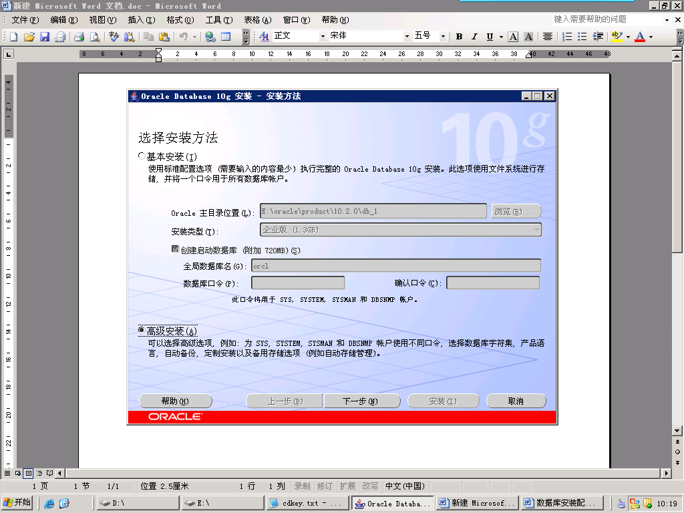

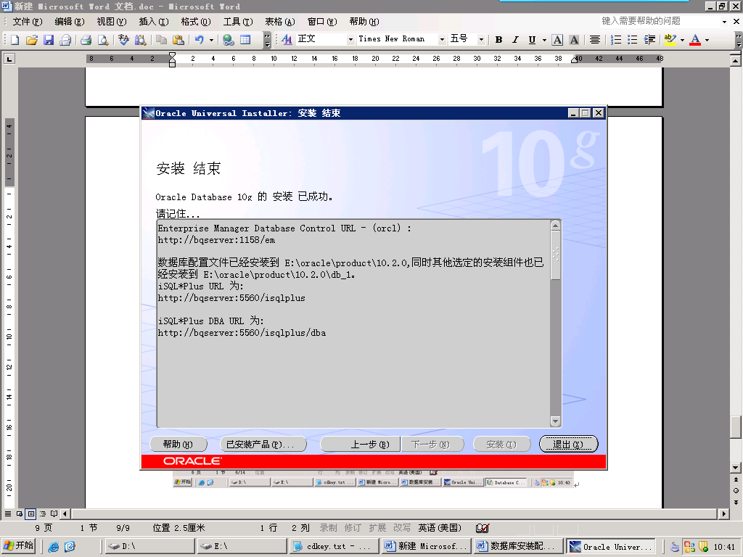

**注意：**

1）ORACLE安装路径建议不要出现中文(不推荐F:\甲骨文\oracle\...)

2）Oracle的安装文件建议放在磁盘根目录下。然后点击其中的setup文件进行安装

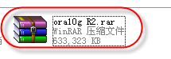

**2.2、构建数据仓库**

2.21、数据准备

1、将GPTDexDW.zip文件复制至磁盘根目录，并解压该文件。

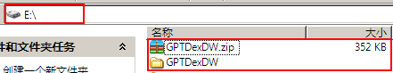

2、修改数据库路径（可选）

如2.1数据库安装中没有使用文档建议的安装目录**，需进行本步操作。**

用文本编辑器打开解压后的文件夹内的DBEnvInit.bat文件；

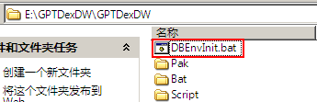

修改批处理文件，将其中如下图红框处的值改为实际ORACLE安装目录。

例如ORACLE装在E盘，则路径可能是**E:\oracle\product\10.2.0\oradata\orcl\**

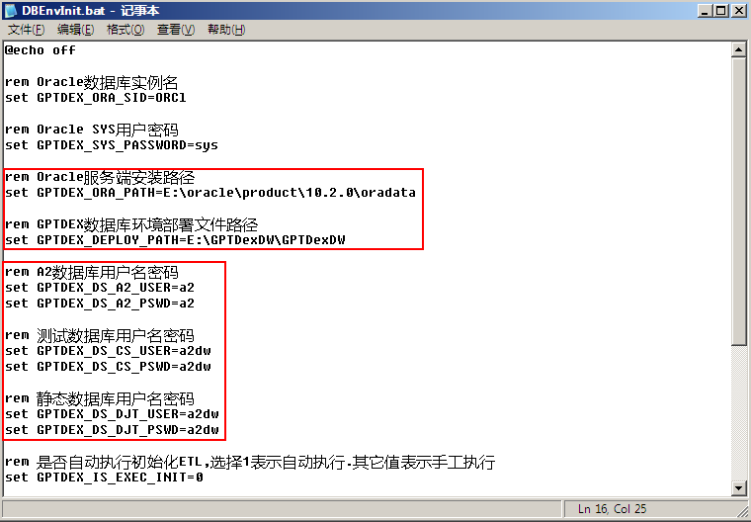

数据库环境部署文件路径就是压缩后的文件夹所在的路径；

另外配置A2,、测试以及动静态三个数据库的SID和密码；

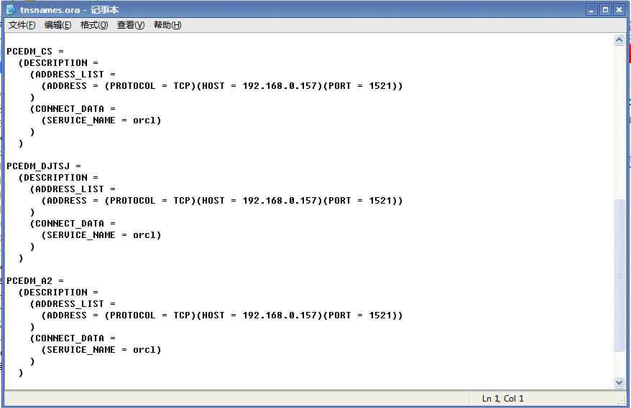

2.22、生成数据环境

双击运行修改后的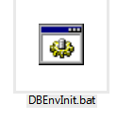文件，按照提示运行即可；

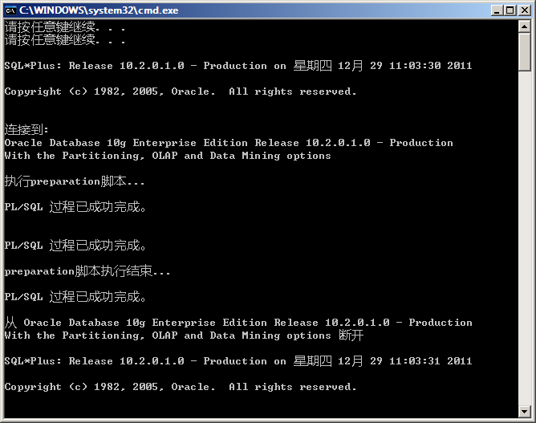

**注意：**

如果提示检查A2数据检查结果码不是0，即表示A2的数据库连接存在错误，请检查数据服务器的TSN文件中的PCEDM_A2连接是否正常。

如果报错，重启oracle服务

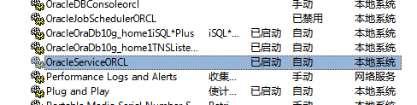

2.23、初始化数据

TO-DO：

执行BAT文件夹下的GenDW.bat文件，进行数据初始化工作；

**注意：**

数据初始化工作大概需要2-3小时，期间数据服务器不能重启；

2.24、测试部署是否成功

1、登陆PL/SQL

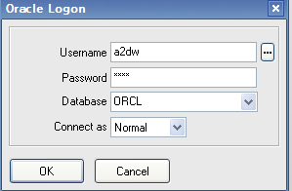

2、选择登陆用户的对象（My objects）

3、打开包体文件，右键->edit spec &body

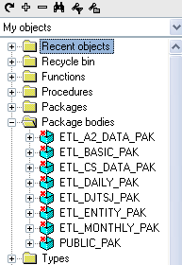

4、查看包体是否能够成功执行

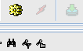

2.25、大庆研究院部署

针对用户只能开出ORACLE内的用户并且只能用视图方式访问A2原表的情况，采用如下部署数据仓库：

2.26、用户以及数据链创建

进入手工部署文件说明内找到数据链.sql、用户授权.sql文件，

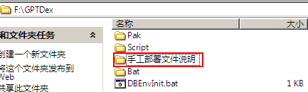

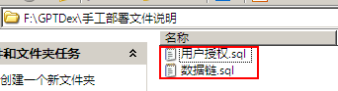

数据服务器管理员内用sys用户登陆，执行用户授权脚本，创建GPTDEX数据仓库的用户；

创建用户完毕以后，用创建完的用户登陆数据服务器，执行数据链脚本，创建linka2,linkcs,linkdjt三个数据链；

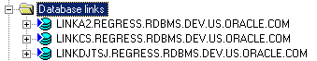

2.27、用户以及数据链创建

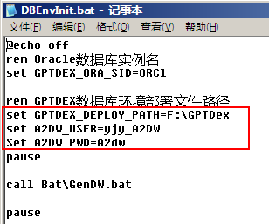

修改压缩包下DBEnvInit.bat文件，更改压缩包所在路径（压缩包解压缩至磁盘根目录）；

修改刚才创建的用户名和密码；保存文件并双击执行DBEnvInit.bat文件；

**三、部署Web服务器**

**3.1、数据迁移**

1、将WEB-STUFF.rar文件复制到本地任意磁盘的**根目录**，并解压该文件。

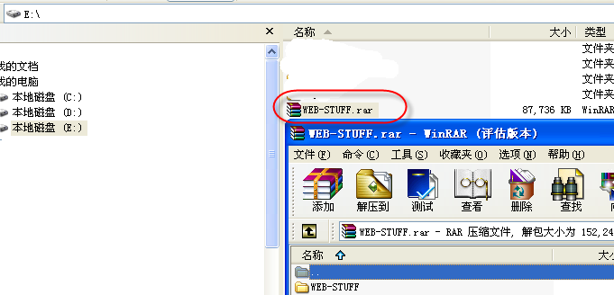

2、（可选）修改web.xml文件(JServer\webapps\bq\WEB-INF\web.xml)里的BasePath路径，修改默认的Web服务器数据文件目录，如下图蓝色字体所注：

<init-param>

<param-name>BasePath</param-name>

<param-value>**F:\ JServer\BIData**</param-value>

</init-param>然后把许可证文件(JServer.lic)复制到JServer\BIData目录下。

3、（可选）如果本地的8080端口被占用，用户可以在产品安装目录的\JServer\conf\server.xml文件中的以下位置更改端口：

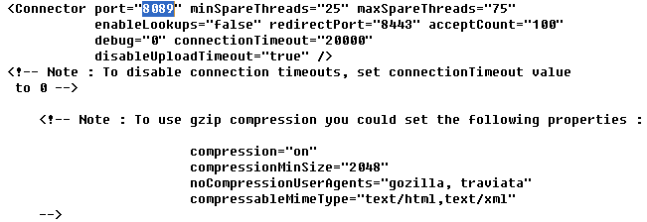

4、删除已存在Web服务插件。

通过双击\DW-STUFF\DW-STUFF\DelBIPlug.bat文件进行删除。

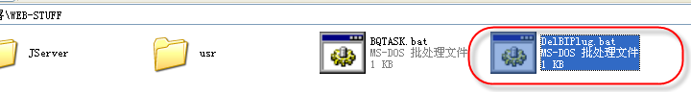

5、启动JServer。

通过双击\DW-STUFF\DW-STUFF\JServer\bin\ startup.bat文件启动Web服务器。

**提示：可以将该startup.bat文件发送到桌面，方便使用。**

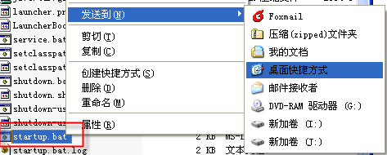

命令窗口出现类似下图提示时，服务器即启动成功。

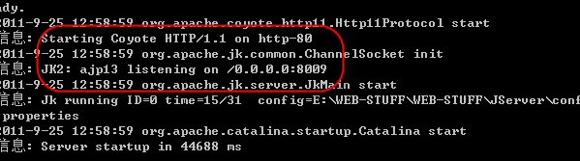

1. 打开IE浏览器，输入以下地址<http://127.0.0.1/GPTDex>
2. 如果服务器端口默认不是80则需要输入<http://127.0.0.1:端口号/GPTDex>

第一次访问系统，会提示下载插件。点击“下载并安装”，进行插件下载。

提示：IE的安全设置可能会弹出下载提示框，选择允许安装ActiveX插件即可。

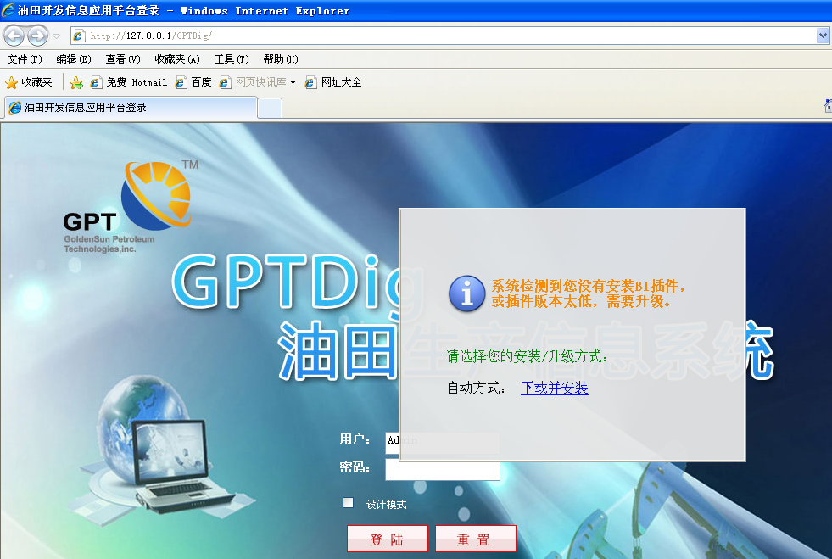

在插件下载成功后，即可以登录系统了。



**注意：**

* **系统管理员帐号名： Admin 无密码**
* **公共用户(1个): GG001 无密码**
* **动态用户(1个): DT001 无密码**
* **帐号名不区分大小写，密码区分大小写**

**3.2、配置数据源(可选)**

**可选：如果数据仓库服务器和Web服务器不是同一台机器，则需要进行以下操作。**

1、访问登陆首页，使用系统管理员帐号(**钩选“设计模式”)**登入设计器。

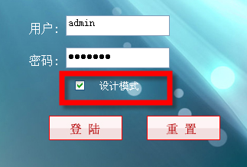

2、在设计器的系统共享区配置数据库连接。修改a2dw数据源的连接信息。

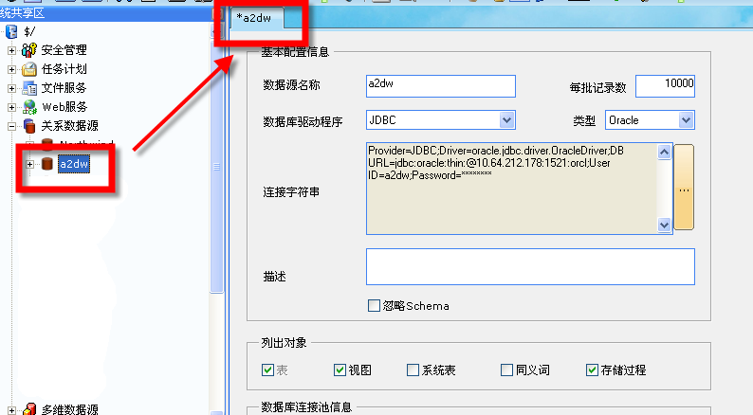

**3.3、执行WEB数据更新**

双击运行\DW-STUFF\DW-STUFF\ BQTASK.bat文件执行Web数据更新。

提示：整个过程大约需2-3分钟左右。更新成功后，打开的命令窗口会自动关闭。

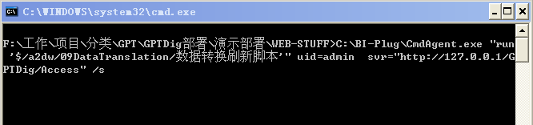

在执行更新的过程中， WEB服务器的命令窗口会不断出现更新提示信息。

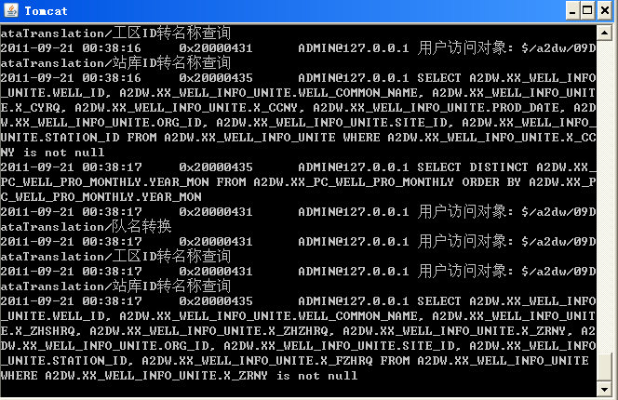

**3.4、修改JServer内存（可选）**

如果访问Web服务器对象速度慢，可以修改JServer\bin\Catalina.bat 文件。  
在166行左右

rem Added by Sunnet

SET CATALINA_OPTS=**-Xms256m -Xmx512m**

修改-xms和-xmx的值，根据本机内存情况修改。例如：

SET CATALINA_OPTS=-Xms512m –Xmx768m

**四、部署常见问题**

**4.1、部署问题**

I．增加常见问题部分

TOMCAT 开始、关闭、端口被占用。

记录到部署文档中。

错误过程记录:

LOCAL机器被设置了IP限制。

VMW中远程连接，导致其实TOMCAT是开着的，查看PID也是开着的。

误以为是VMW所在服务器开着另一个TOMCAT。

于是修改VMW的TOMCAT端口。

导致VMW开了2个TOMCAT。

2、部署DB 空格导致TNS配置失败

<http://topic.csdn.net/u/20100831/11/9d653996-7bf0-4972-a610-417273006924.html>

首先conn 用户名/密码@IP:端口号/server-name  
看能连通吗，如果能，则tns配置有问题。

结果发现是空格问题。

Quote to：

前者可以，后者SLAMPERF 有两个空格就有问题，所以要顶格写，汗。这个问题折磨人啊。 tnsnames.ora一定要主意格式，在linux/unix下还需要主意空格问题。

3、如何将TOMCAT设置为开机自动启动

TOMCAT开机启动

答：在WINDOW启动中，增加一个快捷方式。引用到STARTUP.BAT

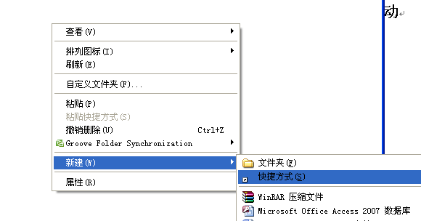

4、如何修改TOMCAT服务器端口。

如果发现TOMCAT服务器启动时发现严重错误，此错误主要是TOMCAT服务器默认80端口被占用。修改其默认端口重新启动服务器即可。在WEB-STUFF\WEB-STUFF\JServer\conf

下打开server.xml文件，找到如下代码：  
<Connector port="80" minSpareThreads="25" maxSpareThreads="75"

enableLookups="false" redirectPort="8443" acceptCount="100"

debug="0" connectionTimeout="20000"

disableUploadTimeout="true" />

修改port="80"为port="8081"保存文件，重新启动服务器；在浏览器内输入<http://127.0.0.1:8081/GPTDex>查询是否能正常访问。

**oracle完全卸载**

ORACLE安装路径为：C:\ORACLE   
  
**实现方法**：

运行完卸载程序后：

1、开始－＞设置－＞控制面板－＞管理工具－＞服务停止所有Oracle服务。  
2、开始－＞程序－＞Oracle - OraHome81－＞Oracle Installation Products－＞ Universal Installer 卸装所有Oracle产品，但Universal Installer本身不能被删除。  
3、运行regedit，选择HKEY_LOCAL_MACHINE\SOFTWARE\ORACLE，按del键删除这个入口。  
4、运行regedit，选择HKEY_LOCAL_MACHINE\SYSTEM\CurrentControlSet\Services，滚动这个列表，删除所有Oracle入口。  
5、运行refedit， HKEY_LOCAL_MACHINE\SYSTEM\CurrentControlSet\Services\Eventlog\Application，删除所有Oracle入口。  
6、开始－＞设置－＞控制面板－＞系统－＞高级－＞环境变量删除环境变量CLASSPATH和PATH中有关Oracle的设定。  
7、从桌面上－＞STARTUP（启动）组－＞程序菜单中，删除所有有关Oracle的组和图标。  
8、删除\Program Files\Oracle目录。  
9、重新启动计算机，重起后才能完全删除Oracle所在目录。  
10、删除与Oracle有关的文件，选择Oracle所在的缺省目录C:\Oracle，删除这个入口目录及所有子目录，并从Windows 2000目录（一般为C:\WINNT）下删除以下文件ORACLE.INI、oradim73.INI、oradim80.INI、oraodbc.ini等等。  
11、 WIN.INI文件中若有[ORACLE]的标记段，删除该段。  
12、如有必要，删除所有Oracle相关的ODBC的DSN。  
13、到事件查看器中，删除Oracle相关的日志。  
  
**说明**：如果有个别DLL文件无法删除的情况，则不用理会，重新启动，开始新的安装。安装时选择一个新的目录，则安装完毕并重新启动后，老的目录及文件就可以删除掉了。

2、BQ服务器部署

**create table DAA05_tab as select * from DAA05@linkdjtsj;**

**create table DAA051_tab as select * from DAA051@linkdjtsj;**

**create table DAA052_tab as select * from DAA052@linkdjtsj;**

**create table DAA054_tab as select * from DAA054@linkdjtsj;**

**create table DAA06_tab as select * from DAA06@linkdjtsj;**

**create table DAA07_tab as select * from DAA07@linkdjtsj;**

**create table DAA071_tab as select * from DAA071@linkdjtsj;**

**create table DAA072_tab as select * from DAA072@linkdjtsj;**

**create table DAA073_tab as select * from DAA073@linkdjtsj;**

**create table DAA074_tab as select * from DAA074@linkdjtsj;**

**create table DAA08_tab as select * from DAA08@linkdjtsj;**

**create table DAA091_tab as select * from DAA091@linkdjtsj;**

**create table DAA01_tab as select * from DAA01@linkdjtsj;**

**create table DAA02_tab as select * from DAA02@linkdjtsj;**

**create table DAA04_tab as select * from DAA04@linkdjtsj;**

**create table DDA02_tab as select * from DDA02@linkdjtsj;**

**create table dca04_tab as select * from dca04@linkcs;**

**create table dca05_tab as select * from dca05@linkcs;**

**create table dcb01_tab as select * from dcb01@linkcs;**

**create table dcb02_tab as select * from dcb02@linkcs;**

## 向数据库中导入表

第一步:创建目录

用sys登录plsql 密码是sys

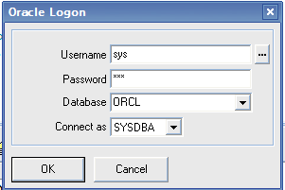

在my objects 的directories文件夹上点击右键🡪new

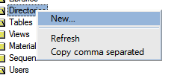

建立如下图所示的文件名称和路径：

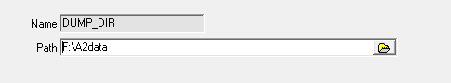

点击左下方的apply 然后点击close如图

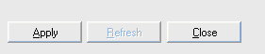

文件名称(name)可以自定义，文件路径（path）是要导入数据库的文件在本机存放的路径

文件格式为.dmp如右图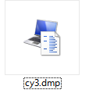

第二步：创建用户

新建SQL window 输入以下代码

-- Create the user

create user CY6

identified by a2

profile DEFAULT;

-- Grant/Revoke object privileges

-- Grant/Revoke role privileges

grant connect to CY6;

grant resource to CY6;

-- Grant/Revoke system privileges

grant alter any sequence to CY6;

grant alter any table to CY6;

grant alter any trigger to CY6;

grant alter any type to CY6;

grant create any index to CY6;

grant create any job to CY6;

grant create any procedure to CY6;

grant create any synonym to CY6;

grant create any view to CY6;

grant create public database link to CY6

grant debug any procedure to CY6;

grant debug connect session to CY6;

grant drop public database link to CY6;

grant unlimited tablespace to CY6with admin option;

然后执行如下图

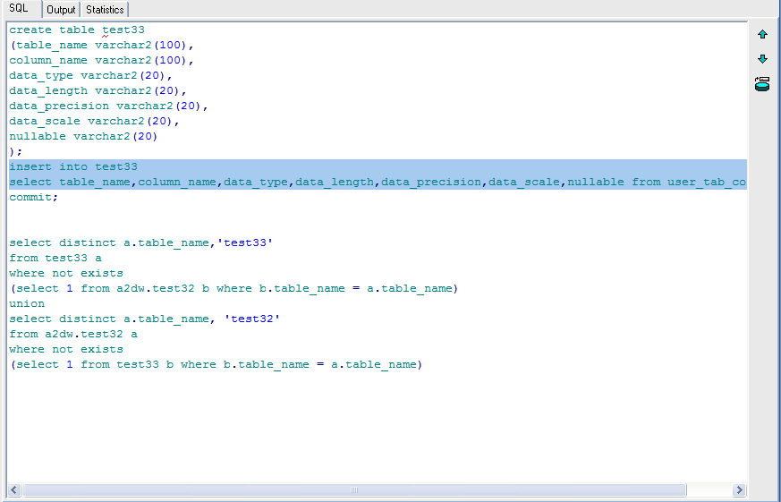

第三步：在sys中给新创建的用户授权目录读写权限

grant read,write on directory DUMP_DIR to +用户名;

如下图

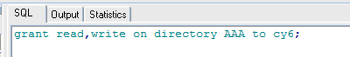

查看创建的用户，看是否有读写权限

以CY6为例子见下图

如果读写权限已经被写入会出现下图所示的read和write 注：如果缺少写权限，导入时会报错

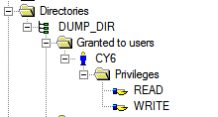

*第三步：开始导入数据*

过程如下：开始🡪运行🡪cmd🡪impdp 用户名/密码@orcl directory=创建的目录名称 dumpfile=表名.DMP parallel=4—>回车

出现如下图：

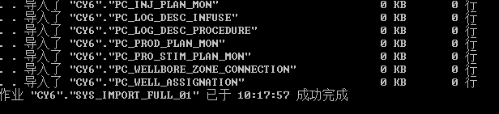

成功导入

最后检查下是否导入成功

进入你创建的用户：新建sql窗体

输入代码：select * from pc_organization_t

如果出现表，证明已经导入成功

如下图: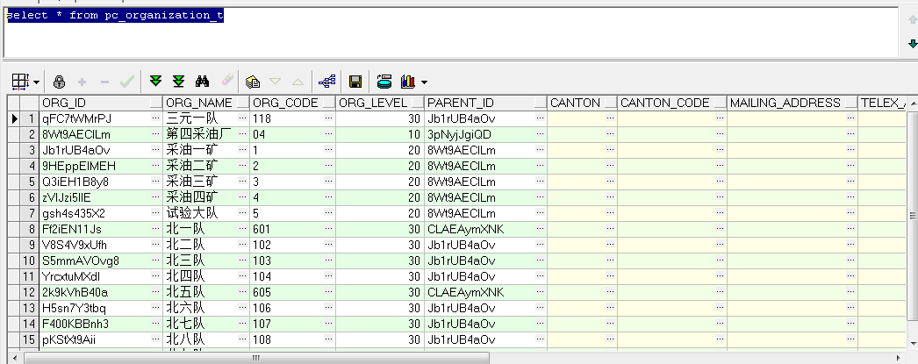

**注:1.在**IMPDP**导入数据中出现的错误如下图**

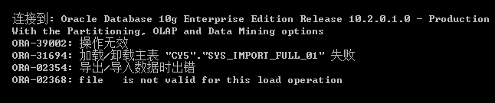

**解决方法:重新复制表到根目录下,把原来的表删除**

**2.**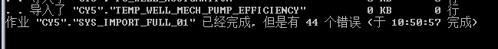

**有可能是系统表空间不足：暂未解决**

## GPTDex所需要数据库源表列表

|  |
| --- |
| **视图名称** |
| **静态** |
| **DAA01** |
| DAA05 |
| DAA052 |
| DAA051 |
| DAA054 |
| DAA06 |
| DAA07 |
| DAA071 |
| DAA072 |
| DAA073 |
| DAA074 |
| DAA08 |
| DAA091 |
| **测试** |
| dca04 |
| dca05 |
| dcb01 |
| dcb02 |
| **A2数据表** |
| PC_PRO_STIM_PLAN_MON |
| PC_PRO_WELL_HOT_WASHING |
| PC_PRO_WELL_MAINTAIN |
| PC_PRO_WELL_METER_DAILY |
| PC_PRO_WELL_METER_META |
| PC_PRO_WELL_SHUT_CLASS_DAILY |
| PC_PRO_WELL_SHUT_CLASS_MON |
| PC_PRO_WELL_STATUS_DAILY |
| PC_PRO_WELL_STIM_EFFCT_MON |
| PC_PRO_WELL_STIM_MON |
| PC_PRO_WELL_SURVEY |
| PC_PRO_WELL_VOLFACTOR_DAILY |
| PC_PRO_WELL_VOL_DAILY |
| PC_RPT_SEQU_SCHEME |
| PC_RPT_SEQU_SCHEME_DETAILS |
| PC_STATION |
| PC_STIM_INJ_ENHANCE_MON |
| PC_STIM_PRO_ENHANCE_MON |
| PC_TOR_CHEM_INJ_MONTHLY |
| PC_TOR_CHEM_PRO_MONTHLY |
| PC_TOR_INDEX_MON |
| PC_TOR_INJ_MONTHLY |
| PC_TOR_PRO_MONTHLY |
| PC_TRAN_PRO_DAILY |
| PC_VERIFY_PROD_TEN_DAYS |
| PC_WELLBORE_ZONE_CONNECTION |
| PC_WELL_ASSIGNATION |
| PC_WELL_DATA_AUDIT |
| PC_WELL_DOWNTIME |
| PC_WELL_INFO_DAILY |
| PC_WELL_INJ_CHEM_MON |
| PC_WELL_INJ_MONTHLY |
| PC_WELL_NUM_UNCONSTRUCTE |
| PC_WELL_PRO_CHEM_MON |
| PC_WELL_PRO_MECH_MONTHLY |
| PC_WELL_PRO_MONTHLY |
| PC_WELL_PRO_VERI_MONTHLY |
| PK_MUDTYPE |
| PK_PERFREASON |
| PK_PERFTYPE |
| PK_PRFCARMN |
| PK_PRFCARPH |
| PK_PRFCHGDS |
| PK_PRFCHGMN |
| PK_PRFCONV |
| PK_PRFFLD |
| PK_PRFJOB |
| PK_STMADDNM |
| PK_STMADUNT |
| PK_STMASS |
| PK_STMPROP |
| PK_STMSTAG |
| PK_STMTYPE |
| PK_STMUNIT |
| PK_WELLTYPE |
| SALGRADE |
| SYS_IMPORT_FULL_01 |
| TEMP_WELL_MECH |
| TEMP_WELL_MECH_CAPACITY |
| TEMP_WELL_MECH_DIAGRAM |
| TEMP_WELL_MECH_LIQ_LEV |
| TEMP_WELL_MECH_PRESSURE |
| TEMP_WELL_MECH_PUMP |
| TEMP_WELL_MECH_PUMP_DEPTH |
| TEMP_WELL_MECH_PUMP_EFFICIENCY |
| TEMP_WELL_MECH_ROTATE |
| TEMP_WELL_MECH_STROKE |
| TEMP_WELL_MECH_SUSP |
| CD_COMPLETION_T |
| CD_COMPLETION_STATUS_HISTORY_T |
| CD_DATUM_T |
| CD_POLICY_SOURCE |
| CD_PRESSURE_SURVEY |
| CD_PROJECT_SOURCE |
| CD_SITE |
| CD_SITE_SOURCE |
| CD_WELLBORE_T |
| CD_WELLBORE_ZONE_T |
| CD_WELL_SOURCE |
| CD_WELL_STATUS_HISTORY_T |
| CD_WELL_STATUS_T |
| PC_COMPLETION_INJ_MON |
| PC_DEV_WELL_ATTR |
| PC_FIELD_BASEDATA |
| PC_FIELD_NEWCONV_INJ_WELL_MON |
| PC_GROUP_UNIT_ITEM |
| PC_GROUP_UNIT_SOURCE |
| PC_INJECTION_MONTHLY |
| PC_INJ_CHEM_PLAN_MON |
| PC_INJ_COMPLETION_DAILY |
| PC_INJ_COMP_STATUS_DAILY |
| PC_INJ_INSPECTION_MON |
| PC_INJ_PLAN_MON |
| PC_INJ_PRO_DAILY |
| PC_INJ_VOL_CHAN_FACTOR_DAILY |
| PC_INJ_WELL_ALLOC_ZONE_PLAN |
| PC_INJ_WELL_CHEM_ZONE_PLAN |
| PC_INJ_WELL_DOWN_CLASS_DAILY |
| PC_INJ_WELL_STATUS_DAILY |
| PC_INJ_WELL_STIM_EFFE_MON |
| PC_INJ_WELL_STIM_MON |
| PC_INJ_WELL_VOLFACTOR_DAILY |
| PC_INJ_WELL_VOL_DAILY |
| PC_LOG_DESC_INFUSE |
| PC_LOG_DESC_PROCEDURE |
| PC_METWATER_WELL_GRADE_MON |
| PC_NEWCONV_INJ_WELL_MON |
| PC_NEW_WELL_PROD_MON |
| PC_OIL_PROD_DAILY |
| PC_ORGANIZATION_T |
| PC_PK_BLOCK_TYPE |
| PC_PK_COMPLETION_STATUS |
| PC_PK_CONNECT_STATUS |
| PC_PK_CONNECT_TYPE |
| PC_PK_DRIVER_TYPE |
| PC_PK_ELECTRIC_LOG_EXPLAIN |
| PC_PK_GROUP_UNIT_SOURCE |
| PC_PK_HOLE_PATTERN |
| PC_PK_INJ_METHOD |
| PC_PK_NEW_OLD_WELL_SYMBOL |
| PC_PK_ORG_LEVEL |
| PC_PK_PERFORATE_DESC |
| PC_PK_PRODUCT_CLASS |
| PC_PK_PROD_METHOD |
| PC_PK_PROJ_SOURCE_TYPE |
| PC_PK_PUMP_INDICATOR_CODE |
| PC_PK_SHUTIN_TYPE |
| PC_PK_STATION_TYPE |
| PC_PK_STIMU_TYPE |
| PC_PK_TERTIARY_OIL |
| PC_PK_THICKNESS_TYPE |
| PC_PK_TOUCH_RELATION |
| PC_PK_WATER_CUT_GRADE |
| PC_PK_WELL_TESTING_TYPE |
| PC_PRESSURE_INJ_FLOW_WATER |
| PC_PRESSURE_INJ_WATER |
| PC_PRODUCTION_ASSIGN_MONTHLY |
| PC_PRODUCTION_MONTHLY |
| PC_PROD_CHANGE_FACTOR_DAILY |
| PC_PROD_PLAN_MON |
| PC_PROD_VERI_MON |
| PC_PROJECT_ASSOC |
| PC_PRO_LAB_ANALYSIS |
| PC_PRO_LAB_ITEM |
| PC_PRO_LAB_SAMPLE |
| PC_PRO_METHOD_MON |

ExecuteSQL说明

Option Explicit

Const DB_NAME = "a2dw"

Const FIELD_CHAR = "CHAR"

Const FIELD_NUM = "NUMBER"

Const FIELD_DATE = "DATE"

'合成INSERT SQL

'szTableName目的表名称

'fileds为数组，数据类型为String ，格式为FieldName:FieldValue:[DataType] ；[DataType]默认值为:CHAR

'fields的有效值从1开始

Function GetInsertSql(ByValszTableName As String , ByVal fields As Variant) As String

If IsEmpty(fields) = True Then如果数组fields为空

GetInsertSql = ""

Exit Function

Variant 是一种特殊的数据类型，除了定长 String 数据及用户定义类型外，可以包含任何种类的数据。Variant 也可以包含 Empty、Error、Nothing 及 Null等特殊值。  
变体类型Variant，能够在运行期间动态的改变类型。变体类型能支持所有简单的数据类型，如整型、浮点、字符串、布尔型、日期时间、货币及OLE自动化对象等，不能够表达Object Pascal对象。

End If

Dim szFieldType As String

Dim i As Integer ,var As Variant

Dim strFields As String ,strValues As String

For i = 1 To UBound(fields)

UBound(fields)获得数组fields最大上标

lbound最小下标

If IsEmpty(fields(i)) Or fields(i) = "" Then如果数组中某一个值为空

'Exit For

GoTo continue

End If

var = Split(fields(i),":")将数组fields的内容，用：进行[分割](http://wenwen.soso.com/z/Search.e?sp=S%E5%88%86%E5%89%B2&ch=w.search.yjjlink&cid=w.search.yjjlink)，分割的字段放在var里

If IsEmpty(var) = True Then

'Exit For

GoTo continue

End If

If UBound(var) < 1 Then

' Exit For

GoTo continue

ElseIfUBound(var) > 1 Then

szFieldType = var(2)

Else

szFieldType = FIELD_CHAR

End If

If strFields = "" Then

strFields = var(0)

获得字段名

Else

strFields = strFields& "," &var(0)

End If

Select Case szFieldType

Case FIELD_CHAR

If strValues = "" Then

strValues = "'" &var(1) & "'"

Else

strValues = strValues& ",'" &var(1) & "'"

End If

Case FIELD_NUM

If strValues = "" Then

获得字段值

strValues = var(1)

Else

strValues = strValues& "," &var(1)

End If

Case FIELD_DATE

If strValues = "" Then

strValues = "{d '" &var(1) & "'}"

Else

strValues = strValues& ", {d '" &var(1) & "'}"

End If

End Select

continue:

Next

GetInsertSql = "INSERT INTO "&szTableName& "(" &strFields& ") VALUES(" &strValues& ");"

End Function

'合成UPDATE SQL

'szTableName目的表名称

'fileds为数组，数据类型为String ，格式为FieldName:FieldValue:[DataType] ；[DataType]默认值为:CHAR

'fields的有效值从1开始

Function GetUpdateSql(ByValszTableName As String , ByVal fields As Variant , ByVal conditions As Variant) As String

If IsEmpty(fields) = True Or IsEmpty(conditions) = True Then

如果值和类型都为空则SQL语句为空

GetUpdateSql = ""

Exit Function

End If

Dim szFieldType As String

Dim i As Integer ,var As Variant

Dim strSql As String ,strWhere As String

For i = 1 To UBound(fields)名字和值循环

If IsEmpty(fields(i)) Or fields(i) = "" Then

'Exit For

GoTo continue

End If

var = Split(fields(i),":")

If IsEmpty(var) = True Then

'Exit For

GoTo continue

End If

If UBound(var) < 1 Then

'Exit For

GoTo continue

ElseIfUBound(var) > 1 Then

szFieldType = var(2)

Else

szFieldType = FIELD_CHAR

End If

Select Case szFieldType

Case FIELD_CHAR

If strSql = "" Then

strSql = var(0) & " = '" &var(1) & "'"

Else

strSql = strSql& "," &var(0) & " = '" &var(1) & "'"

End If

Case FIELD_NUM

If strSql = "" Then

strSql = var(0) & " = " &var(1)

Else

strSql = strSql& "," &var(0) & " = " &var(1)

End If

Case FIELD_DATE

If strSql = "" Then

strSql = var(0) & " = {d '" &var(1) & "'}"

Else

strSql = strSql& "," &var(0) & " = {d '" &var(1) & "'}"

End If

End Select

continue:

Next

For i = 1 To UBound(conditions)类型循环

If IsEmpty(conditions(i)) Or conditions(i) = "" Then

Exit For

End If

var = Split(conditions(i),":")

If IsEmpty(var) = True Then

Exit For

End If

If UBound(var) < 1 Then

Exit For

ElseIfUBound(var) > 1 Then

szFieldType = var(2)

Else

szFieldType = FIELD_CHAR

End If

Select Case szFieldType

Case FIELD_CHAR

If strWhere = "" Then

strWhere = var(0) & " = '" &var(1) & "'"

Else

strWhere = strWhere& " AND " &var(0) & " = '" &var(1) & "'"

End If

Case FIELD_NUM

If strWhere = "" Then

strWhere = var(0) & " = " &var(1)

Else

strWhere = strWhere& " AND " &var(0) & " = " &var(1)

End If

Case FIELD_DATE

If strWhere = "" Then

strWhere = var(0) & " = {d '" &var(1) & "'}"

Else

strWhere = strWhere& " AND " &var(0) & " = {d '" &var(1) & "'}"

End If

End Select

Next

If strWhere = "" Or IsEmpty(strWhere) Then

GetUpdateSql = "UPDATE "&szTableName& " SET " &strSql

Exit Function

End If

GetUpdateSql = "UPDATE " &szTableName& " SET " &strSql& " WHERE " &strWhere& ";"拼接sql语句

End Function

'合成DELETE SQL

'szTableName目的表名称

'fileds为数组，数据类型为String ，格式为FieldName:FieldValue:[DataType] ；[DataType]默认值为:CHAR

'fields的有效值从1开始

Function GetDeleteSql(ByValszTableName As String , ByVal conditions As Variant) As String

If IsEmpty(conditions) = True Then

GetDeleteSql = ""

Exit Function

End If

Dim szFieldType As String

Dim i As Integer ,var As Variant

Dim strWhere As String

For i = 1 To UBound(conditions)

If IsEmpty(conditions(i)) Or conditions(i) = "" Then

Exit For

End If

var = Split(conditions(i),":")

If IsEmpty(var) = True Then

Exit For

End If

If UBound(var) < 1 Then

Exit For

ElseIfUBound(var) > 1 Then

szFieldType = var(2)

Else

szFieldType = FIELD_CHAR

End If

Select Case szFieldType

Case FIELD_CHAR

If strWhere = "" Then

strWhere = var(0) & " = '" &var(1) & "'"

Else

strWhere = strWhere& " AND " &var(0) & " = '" &var(1) & "'"

End If

Case FIELD_NUM

If strWhere = "" Then

strWhere = var(0) & " = " &var(1)

Else

strWhere = strWhere& " AND " &var(0) & " = " &var(1)

End If

Case FIELD_DATE

If strWhere = "" Then

strWhere = var(0) & " = {d '" &var(1) & "'}"

Else

strWhere = strWhere& " AND " &var(0) & " = {d '" &var(1) & "'}"

End If

End Select

Next

GetDeleteSql = "DELETE FROM "&szTableName& " WHERE " &strWhere& ";"

End Function

Function ExecuteSQL(ByValstrSql As String , szErrMsg As String ) As Boolean

Dim db As New SunDatasource ,var As Variant

On Error GoToerror_p

db.OpenDB_NAME ,dbReadWrite

Dim cmd As String

cmd = "BEGIN " &strSql& " COMMIT; Exception WHEN others THEN ROLLBACK;RAISE_APPLICATION_ERROR(-20002 , SQLERRM); END;"

App.ShowMsg 0,"Oracle transaction : " &cmd

db.Executecmd ,var

db.Close

ExecuteSQL = True

Exit Function

error_p:

Dim hFF As Long

hFF = FreeFile

Open App.TempPath& "/$ExecuteSQL$.LOG" For Output As #hFF

Print #hFF , Format(Now,"yyyy-mm-ddhh:mm:ss"); Err.Description ;cmd

Close #hFF

szErrMsg = Err.Description

ExecuteSQL = False

End Function

**二、以样例的形式编号**

**（将每个例子的设计流程写出来。）**

**MARK先将常用业务样例分类，然后MY将例子写成流程文档**

**三、常见开发问题汇总**

**开发过程中经常碰的问题记录下来。**

**四、其他所有出处的文字类型的开发有关文档汇总**

**包括：**

**F:\工作\项目\GPT\GPTDex文档\开发文档**

**其他培训的文档**

**全部统一汇总到这份文档中。**

## 1、常用方法

1.1、BQ

1.2、数据库

1.2.1、获取数据库单表所有字段INSERT语句方法

TAB_NAME是数据库表名。

**select** public_pak.insert_select_clause_func(TAB_NAME) **from** dual

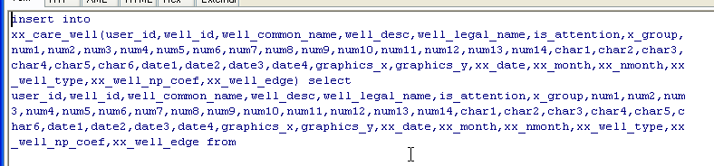

MARK：

此处开头增加一个表格列表

将所有常用方法编号，方便开发人员查看

## BQ的CHECKBOX单选框控件

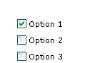

CheckBox1.GetCheck(0)=1

0 表示多个CHECK行的第几个行被勾选了。

1表示当前处于钩选状态。

## BQ操作TXT文件

1、逐行写入TXT

Dim inputStr As String,titleStr As String

Dim fileStr1 As String

Dim i As Long,cnt As Long

Dim flag As Integer

**‘每个字段间用TAB键分隔**

titleStr = "col1" & **vbTab** & "" _

& "col2"

fileStr1 ="C:/A.txt"

Open fileStr1 For Output As #1

**‘第一行输入内容为标题**

Print #1,titleStr

**‘循环写入N行记录。**

**注意最后一个字符不用在增加vbTab，否则TXT文件会多一列TAB内容**

For i = 1 To n

inputStr = "val1" & vbTab & "" _

& "val2" & vbTab & "" _

& "val3"

Print #1,inputStr

Next

Close #1

2、逐行读取TXT

Do Until EOF(1)

**‘str1为写入的内容**

Line Input #1, str1

If … Then

Exit Do

End If

Loop

Close #1

3、直接读取最后一行

Function GetFileLastLine(fName As String) As String

'fName 要处理的文件路径和名称

Dim hFile As Long

Dim recNumber1 As Long, recNumber2 As Long

Dim Char As String * 1

Dim strTmp As String

recNumber2 = FileLen(fName) '用于定位到最后一个字符

hFile = FreeFile

Open fName For Binary As hFile

'因为最后一行可能包含空格符回车符等

'所以要先找到最后一个有效字符

'有效字符条件要根据实际情况定，本示例定为字母和数字

Do

Get #hFile, recNumber2, Char

recNumber2 = recNumber2 - 1

Loop Until Char Like "[0-9a-zA-Z]"

'从最后一个有效字符起，再向前找最后一个换行符或回车符

recNumber1 = recNumber2

Do

Get #hFile, recNumber1, Char

recNumber1 = recNumber1 - 1

Loop Until Char = vbCr Or Char = vbLf

'读取最后一行

strTmp = Space(recNumber2 - recNumber1 + 1)

Get #hFile, recNumber1 + 1, strTmp

Close

GetFileLastLine = strTmp

End Function

4、判断指定路径文件是否存在

Dim fs As New FileSystemObject

If fs.FileExists(fileStr) = False Then

。。。

Exit Function

End If

## BQ定时器用法

只能在FORM里使用。

第一步、在触发定时程序的事件中启动定时器。

例如点击按钮时：

Const CHECK_DATA_FINISHED_EVENT = 1000

….

Public Sub SunButtonCtrl1_Click()

Form.SetTimer **CHECK_DATA_FINISHED_EVENT**, **200**

End Sub

CHECK_DATA_FINISHED_EVENT ：事件ID

200 ：定时器循环执行的时间间隔 200毫秒

第二步、在窗体事件FORM_TIMER中控制定时器

Public Sub Form_Timer(ByVal nIDEvent As Long)

On Error GoTo err_p

If nIDEvent = CHECK_DATA_FINISHED_EVENT Then

If checkFileFinish=True Then

**‘如果满足指定条件,结束循环执行定时器**

**Form.KillTimer CHECK_DATA_FINISHED_EVENT**

End If

End If

Exit Sub

**err_p:**

**‘注意需进行异常处理**

**If Err.Number <> 0 Then**

**MsgBox Err.Description**

**Form.KillTimer CHECK_DATA_FINISHED_EVENT**

**End If**

End Sub

## BQ任务计划设置

1、测试WINDOWS任务计划功能

1.1、打开WINDOWS任务计划

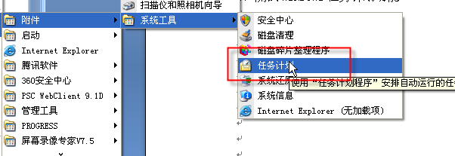

1.2、新建一个BAT文件（打开某个目录）

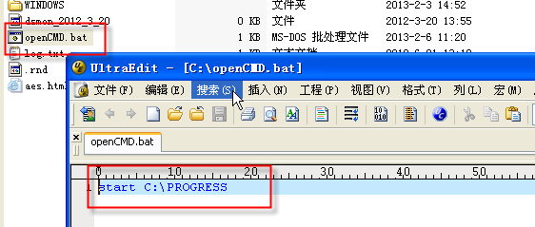

1.3、测试任务计划

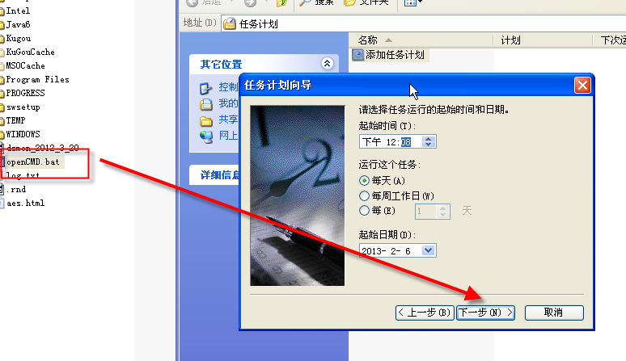

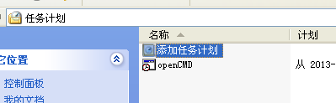

WINDOWS任务计划执行成功。打开目录。

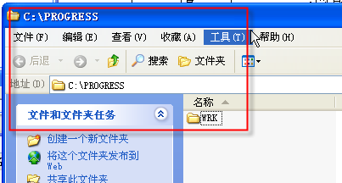

2、开启BQ任务计划

2.1、设置BQ系统桉树

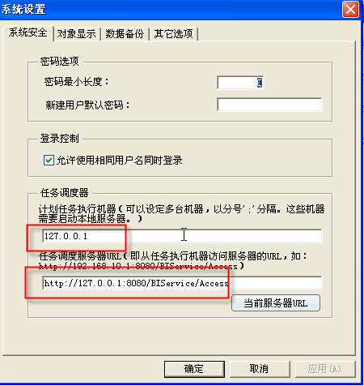

2.2、需要 “启用本地服务器”

**（注意：一定要开启。并且BQ服务器如果重启，需要重新设置该选项）**

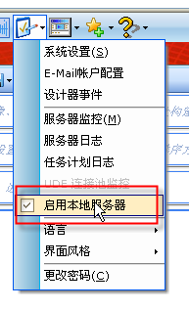

**3、（可选）利用BAT间接解决BQ任务计划执行失败**

**在WINDOWS新建BAT文件。输入以下命令：**

**C:\BI-Plug\CmdAgent.exe "run '$/a2dw/09DataTranslation/数据转换刷新脚本'" uid=admin pwd=jmhjmh svr="http://127.0.0.1/GPTDex/Access" /s**

[**http://127.0.0.1/GPTDex/Access**](http://127.0.0.1/GPTDex/Access) **为BQ的访问路径+Access**

也可以直接在BQ脚本直接该CMD，如下：

Dim cmdLine As String,hr As Long

cmdLine = "C:\BI-Plug\CmdAgent.exe ""run '$/TEST/EXEC_BY_ADMIN'"" uid=admin svr=""http://127.0.0.1:8080/BIService/Access"" /s"

App.ShowMsg 0,"cmdLine:" & cmdLine

hr = **App.RunAndWait**(cmdLine,False)

## 制作BQ模板

1、先制作好模板文件。

通常模板预置了公共用户常用，但不会自己实现的、或方便用户使用。

例如关注井分级查询：

将分级的字段预先定制在查询对象中。  
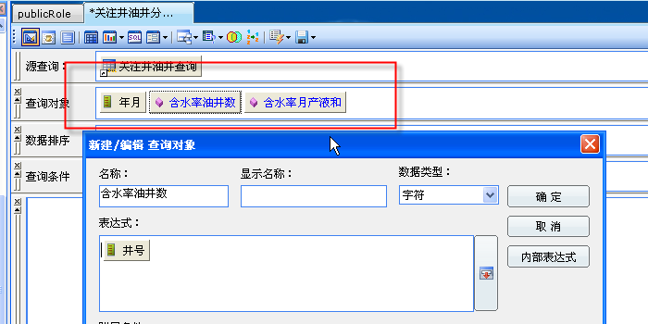

2、将模板原始文件拖入到BQ的模板文件夹

文件夹名称对应拖入的BQ对象。

例如智能查询放置智能查询。

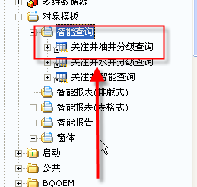

## 查找表中数据库字段的方法

1、找到信息域下对应分类，右击如下图

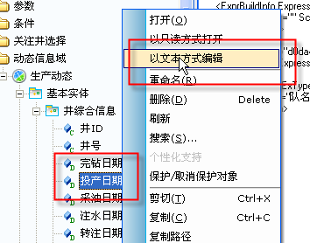

2、打开的XML中能找到数据库对应字段

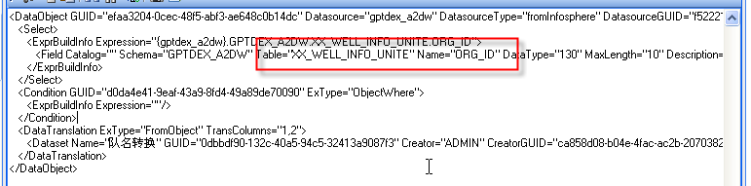

## BQ内部查询表达式

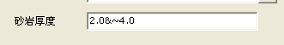

2.0&~4.0 表示 >2 <=4

& 为开区间

## 1、窗体内刷新查询控件

1) 引入控件

打开引用按钮的下拉菜单，选择引用，引入如图所示的脚本

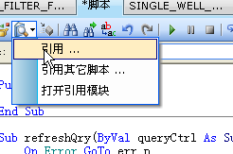

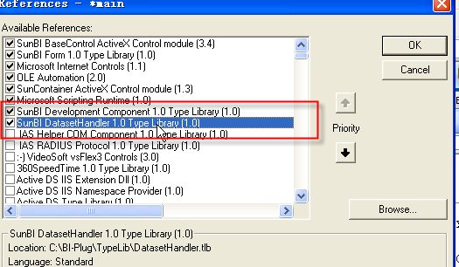

2)脚本

Const MSG1 = "发生错误.请联系管理员."

Const MSG2 = "正在刷新数据,请稍候..."

…..

Sub refreshQry(ByVal queryCtrl As SunContainer)

On Error GoTo err_p

Dim qry As Query

Set qry = queryCtrl.IObject

App.ShowWaitMsg MSG2,False

qry.RefreshData False,-1

App.HideWaitMsg

Exit Sub

err_p:

If Err.Number <> 0 Then

App.HideWaitMsg

MsgBox MSG1 & Err.Description

End If

End Sub

## 1.1、查询表格新增空白行/删除点中行

在窗体点击按钮，将窗体内的表格新增空白行单击插入新订单会自动插入一行

On Error GoTo ERR_P

Dim nRow As Long

Dim qry As Query

Set qry = QryCtrl.IObject

nRow = qry.MakeBlankRow() '新创建的行号

查找当前表中ID的最大值

If(nRow< 0) Then Err.RaisenRow

Dim ds As New SunDataset

Dim cmdSql As String

Dim curMaxOrderId As Integer

cmdSql = “SELECT MAX(OrderID) FROM {Northwind}.Orders“

ds.CreateDataset cmdSql,-1

curMaxOrderId = CInt(ds.CellData(1,1))

qry.CellData(nRow,2) = curMaxOrderId + 1

qry.ActiveRow = nRow

Exit Sub

ERR_P:

MsgBox "发生错误：" &App.Msg(Err.Number)

## 2、窗体控件实现全选和反选

1）调用脚本

'#Uses "*$/a2dw/19RandomTime/1905ModuleScript/GlobalFunction"

allHook全选

cancelHook反选

2）设置控件

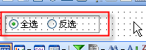

3) 控件的ITEM_CLICK方法调用脚本

Public Sub wellChk_ItemClick(ByVal nItem As Integer)

Select Case nItem

Case 0

allHook(QryCtrl)

Case 1

cancelHook(QryCtrl)

End Select

End Sub

QryCtrl为窗体中需要全选反选的查询表格

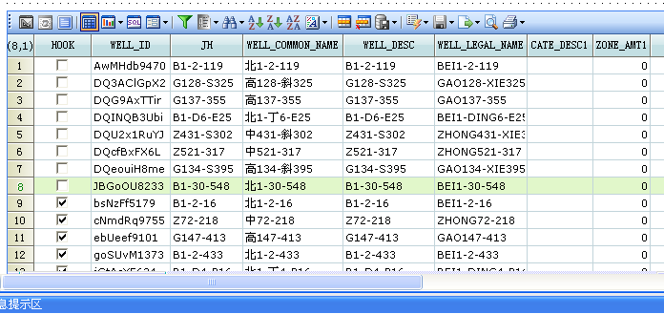

## 1、SQL实现行转列

1）静态递归N次的MAX(DECODE)

MY 增加样例代码说明

2）动态递归N次的MAX(DECODE)

Sub genHorExtSql(ByRef horExtStr As String)

On Error GoTo err_p

Dim ds As New SunDataset

Dim cmdStr As String

Dim i As Integer

Dim seqNoStr As String

Dim sqlStr1 As String

Dim defCnt As Integer,curCnt As Integer

'如果用户没有定义6个分级,默认放6个.保证SINGLE_WELL_QRY2查询字段不报错

defCnt = 6

sqlStr1 = ""

cmdStr = "select seq_no from " & DS1 & TAB1 & " where cate_type='" & CATE_COL & "' and user_id='" & App.CurrentUser & "' order by seq_no"

ds.CreateDataset cmdStr,-1

curCnt = ds.RowCount

App.ShowMsg 0,"******cmdStr:" & cmdStr & " ***curCnt:" & curCnt

'If curCnt<=defCnt Then curCnt = defCnt

For i = 1 To curCnt

seqNoStr = ds.CellData(i,1)

sqlStr1 = sqlStr1 & "max(decode(cate_lv," & seqNoStr & ",cate_desc)) cate_desc" & seqNoStr & "," _

& "max(decode(cate_lv," & seqNoStr & ",zone_amt)) zone_amt" & seqNoStr & "," _

& "max(decode(cate_lv," & seqNoStr & ",syhd)) syhd" & seqNoStr & "," _

& "max(decode(cate_lv," & seqNoStr & ",yxhd)) yxhd" & seqNoStr & ","

Next

horExtStr = sqlStr1

horExtStr = Mid(horExtStr,1,Len(horExtStr)-1)

App.ShowMsg 0,"maxdecode sql:" & sqlStr1

Exit Sub

err_p:

If Err.Number <> 0 Then

MsgBox "genHorExtSql:" & MSG1 & Err.Description

End If

End Sub

## BQ示警器的用法

一、"%Name%" 被触发，存在配注量或层数发生变化的水井。

详情请看"%ParentPathName%"。

"%Name%" ALERT名称

"%ParentPathName%" 触发查询的路径

二、示警器执行失败BQ会提示如下：

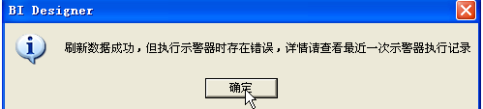

**在查询的工具按钮如下：**

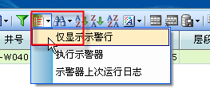

执行时间: 2012-11-08 03:08:06(UTC)

执行机器: 192.168.1.70

************************* 水井方案调整变化 ****************************

示警器 "水井方案调整变化" 执行错误: 指定的列不存在

[WELL_ID]

## 脚本的引用

使用query时需引用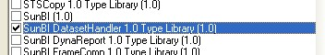

Dim qry As Query

Set qry = QryCtrl.IObject

qry.RefreshData False,-1

## 读取当地文件代码

Set ObjFSO = CreateObject("UserAccounts.CommonDialog")

ObjFSO.Filter = "DBF文件|*.dbf|Excel文件(97-2003)|*.xls|Excel文件(2007)|*.xlsx"

ObjFSO.FilterIndex = 1

ObjFSO.InitialDir = "C:\"

InitFSO = ObjFSO.ShowOpen

If InitFSO = False Then

MsgBox ("请选择正确格式文件",16,"警告")

Else

Set fso = CreateObject("Scripting.FileSystemObject")

jinghaolj.Text= Trim(ObjFSO.FileName)

TabName = Trim(fso.GetBaseName(ObjFSO.FileName))

spPath = Trim(fso.GetFile(ObjFSO.FileName).ParentFolder.Path)

Suffix_Name = UCase(Trim(fso.GetExtensionName(Trim(ObjFSO.FileName))))

newpath=Trim(ObjFSO.FileName)

## 文件写入到数据库代码

On Error Resume Next

If jinghaolj.Text<> "" Then

App.ShowWaitMsg "数据保存,请稍后...",False

If spPath<>"" Then

If Trim(Suffix_Name) ="DBF" Then

StrSql = "select JH,MQJB,QKM,CXDM,XQKDM from "&TabName

StrTitile ="WELL_ID"&Chr(9)&"WELL_DESC"&Chr(9)&"PATTTERN_FLAG"&Chr(9)&"PROJECT_ID"&Chr(9)&"OIL_REGION"&Chr(9)&"PROJECT_ASSOC_ID"&Chr(9)&"MQJB"&Chr(9)&"CM"&Chr(9)&"User_Name"

IntLen = 5

flag=0

Call queryDAA(StrSql,StrTitile,spPath,TabName,IntLen,flag)

Else

'EXCEL文件

StrSql="Select * from [Sheet1$]"

StrTitile ="WELL_ID"&Chr(9)&"WELL_DESC"&Chr(9)&"PATTTERN_FLAG"&Chr(9)&"PROJECT_ID"&Chr(9)&"OIL_REGION"&Chr(9)&"PROJECT_ASSOC_ID"&Chr(9)&"MQJB"&Chr(9)&"CM"&Chr(9)&"User_Name"

IntLen = 6

flag=2

Call excel(StrSql,StrTitile,spPath,TabName,newpath,IntLen,flag)

End If

End If

'删除数据库中的原有文件

scsql = "delete from OIL_PROD_WELL_ATTR_EXCEL_TAB where USER_NAME ='"&Trim(UCase(App.CurrentUser)) & "'"&" and CM ='" & SunComboBoxCtrl5.Text & "'"

Call shanchu(scsql)

'文本文件导入数据库

openpath="$/GPTDex/GPTDex/MY/导入数据/OIL_PROD_WELL_ATTR_EXCEL_TAB"

Call etlByD(spPath&"\"&TabName&".txt",openpath)

If Err.Number<> 0 Then

MsgBoxErr.Description

End If

App.HideWaitMsg

Else

MsgBox ("请选择正确格式文件",16,"警告")

End If

End Sub

## BQ调用EXECUTESQL公共方法写数据

Private Function doSave(Optional ByVal isAppend As Boolean = False) As Boolean

Dim i As Integer

Dim cmdstr As String , szErrMsg As String

Dim COL_GROUP As Long,xGroup As String

Dim qry As Query

Dim ds As New SunDataset

Dim fields(7) As String

Dim conditions(2) As String

Dim nUserID,nWellID As String

Dim checkCmdStr As String

App.ShowWaitMsg "正在提交数据，请稍候……",False

If isAppend=False Then

cmdstr = "DELETE FROM XX_CARE_WELL WHERE USER_ID='" & App.CurrentUser &"';"

If ExecuteSQL(cmdstr, szErrMsg)= False Then

MsgBox "清除关注井失败，更多信息：" & szErrMsg,vbCritical ,"提示信息"

doSave = False

Exit Function

End If

End If

Set qry = dsWellList.IObject

cmdstr = ""

For i = 1 To qry.RowCount

If qry.CellData(i,qry.ColumnIndex(HOOK)) = 1 Then

xGroup = Trim(qry.CellData(i,COL_GROUP))

If xGroup = "" Then xGroup = "默认"

fields(1) = "USER_ID:" & App.CurrentUser

fields(2) = "WELL_ID:" & qry.CellData(i,qry.ColumnIndex(COL_WELL_ID))

fields(3) = "WELL_COMMON_NAME:" & qry.CellData(i,qry.ColumnIndex(COL_WELL_COMMON_NAME))

fields(4) = "WELL_DESC:" & qry.CellData(i,qry.ColumnIndex(COL_WELL_DESC))

fields(5) = "WELL_LEGAL_NAME:" & qry.CellData(i,qry.ColumnIndex(COL_WELL_LEGAL_NAME))

fields(6) = "IS_ATTENTION:1:NUMBER"

fields(7) = "X_GROUP:" & xGroup

If isAppend Then

nUserID = App.CurrentUser

nWellID = Trim(qry.CellData(i,qry.ColumnIndex(COL_WELL_ID)))

checkCmdStr = "select 1 from " & DATA_SOURCE & XX_CARE_WELL & " where user_id ='" & nUserID & "' and well_id ='" & nWellID & "'"

ds.CreateDataset checkCmdStr,-1

App.ShowMsg 0,"checkCmdStr:" & checkCmdStr

'选择数据库的操作.当前记录已存在目标表,则Update,否则Insert

If ds.RowCount <= 0 Then

cmdstr = cmdstr & GetInsertSql(XX_CARE_WELL,fields)

App.ShowMsg 0,checkCmdStr

End If

Else

cmdstr = cmdstr & GetInsertSql(XX_CARE_WELL,fields)

End If

End If

Next

App.ShowMsg 0,UCase(cmdstr)

If InStr(1,UCase(cmdstr),"INSERT")>0 Then

If False = ExecuteSQL(cmdstr, szErrMsg) Then

MsgBox "提交关注井失败，更多信息：" & szErrMsg,vbCritical ,"提示信息"

doSave = False

Exit Function

End If

End If

doSave = True

App.HideWaitMsg

End Function

## BQ调用存储过程

On Error Resume Next

App.ShowWaitMsg "正在准备数据，请稍后...",False

Dim plsql As String

Dim db As New SunDatasource

plsql = "{call PRO_QUERY_TEMP_RPT_I('" & Trim(yearstr) & "'," &yearCnt& "," &statis_type& ")}"

db.OpenDB_NAME,dbReadWrite

db.Execute plsql,var11

db.Close

## 使用正则表达式对数字进行判断

'Function checkNum(ByValvalStr As String )

' checkNum = True

' valStr=Trim(valStr)

' Dim rex As RegExp

' Dim expr As String

' expr="^(([0-9]+\.[0-9]*[1-9][0-9]*)|([0-9]*[1-9][0-9]*\.[0-9]+)|([0-9]*[1-9][0-9]*))$"

' Set rex=New RegExp '建立正则表达式

' rex.Pattern = expr

' App.ShowMsg 0,"valStr:" &valStr

' If "" = valStr Then

' checkNum = False

' Exit Function

' End If

' If rex.Test(valStr)=False Then

' checkNum = False

' Exit Function

' End If

'End Function

## 链接及参数传递

**1.3 查询参数传递**

**查询脚本中获得参数**

**bef_mon=Query.Param("bef_mon")**

**aft_mon=Query.Param("aft_mon")**

**1.4 更改行的颜色**

**通过示警器来设置条件**

**1.5 表字段链接**

**Dim frm As New SunContainer**

**If nHitCol = Query.ColumnIndex ("井ID") Then**

**frm.EnvVar("?井") = Query.CellData (nHitRow,Query.ColumnIndex ("井ID") )**

**frm.ObjectFile = "$/a2dw/查询表/注入井月数据/水井单井月数据"**

**frm.PopupWindow True, Null, True**

**End If**

**bCancel = True**

**1.5 调入到界面后需要传递参数**

**Dim pathStr As String**

**Dim paramStr As String,paramVal As String**

**paramVal = "STIM_RPT"**

**paramStr = "?REPORT_ID=" &paramVal**

**pathStr = "../../WELL_GROUP_RPT_UI/UI/MAIN_UI" &paramStr**

**Form.DoLinkpathStr**

## 改query默认第一列显示

select 'grant select on '||table_name ||' to gptdex_a2dw;' from user_tables ;

Dim grid As New SunDataGrid

Dim cf As CellFormat

Set grid = Query.GridControl

Set cf = grid.CellFormat(1,1)

grid.RowHeader(1) = "含水率>90"

Dim i As Long

For i = 1 ToQuery.RowCount

App.ShowMsg 0,"i:" & i & " val:" &CDbl(Query.CellData(i,4)) & " org:" &Query.CellData(i,4)

If CDbl(Query.CellData(i,4)) >80 Then

App.ShowMsg 0,"i:" & i & " 含水率>80"

grid.RowHeader(i) = "含水率>90"

Else

grid.RowHeader(i) = CStr(i)

End If

Next

回车：

Query.CellData(i,1)= "含水差>2 and"&vbCrLf&" 生产时间差=0 "

## 数据库的写与改

Dim i As Integer

Dim qry As Query

Dim cmdSql As String

Set qry=SunContainerCtrl1.IObject

Dim db As New SunDatasource

Dim var As Variant

Set db=Nothing

For i=1 Toqry.RowCount

If qry.CellData(i,2)=1 Then

cmdSql="update affected_well_group set is_affected=1 where OFFSET_WELL_ID ='" &qry.CellData(i,3) &"'"

App.ShowMsg 0,"sql:" &cmdSql

db.OpenDB_NAME,dbReadWrite

db.ExecutecmdSql,var

End If

db.Close

Next

Set db = Nothing

Dim plsql As String

Dim var As Variant

Dim db As New SunDatasource

plsql = "{call public_pak.xx_care_well_prc('" & Trim(UCase(App.CurrentUser)) & "')}"

db.OpenDB_NAME,dbReadWrite

db.Executeplsql,var

db.Close

'*********************Mark Add May22th*********************

App.HideWaitMsg

## 按查询顺序输出

* **按查询顺序输出（常用）**

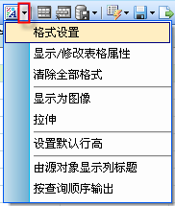新增查询对象“生产天数”，重排顺序后刷新后无效，如下图：

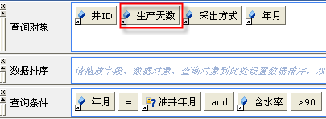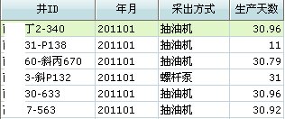

此时钩选“按查询顺序输出”，再次刷新后顺序生效。

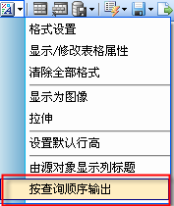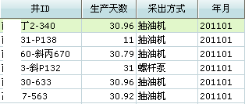

## 导出错误数据

Public Sub exportError_Click()

Dim filterUnhookStr As String

Dim strFile,tempFile As String

filterUnhookStr = "[措施年月].[flag] =0 or [措施年月].[flag]=2"

tempFile = "措施井错误记录"

qry.IObject.FilterfilterUnhookStr,False

qry.IObject.UpdateView

strFile= App.ShowFileDialog(False,tempFile,"Microsoft Excel (*.xls)|*.xls|Microsoft Excel(*.xlsx)|*.xlsx||")

If(strFile<>"" )Then

qry.IObject.Export strFile,0

End If

qry.IObject.Filter "",False

qry.IObject.UpdateView

End Sub

## 导出模板

Public Sub exportTemplate_Click()

Dim strFile,tempFile As String

tempFile = "措施井模板"

strFile= App.ShowFileDialog(False,tempFile,"Microsoft Excel (*.xls)|*.xls|Microsoft Excel(*.xlsx)|*.xlsx||")

If(strFile<>"" ) Then ExcelTemplateQryCtrl.IObject.Export strFile,0

End Sub

拖到窗体中的控件的ID

## 打开Excel文件

Sub File_Open()

Dim objDialog As Object

Dim tfile As Boolean

Set objDialog = CreateObject("UserAccounts.CommonDialog") 'UserAccounts.CommonDialog对象

objDialog.Filter = "2003 Excel File|*.xls|2010 Excel File|*.xlsx" '设定显示的文件格式

objDialog.InitialDir = "C:\" '设定打开时初始的目录

tfile=objDialog.ShowOpen '执行打开命令

If tfile Then

strLoadFile = objDialog.FileName '返回选中的文件路径

Else

strLoadFile=""

Exit Sub

End If

End Sub

strLoadFile = App.ShowFileDialog(True,"","Microsoft Excel (*.xls)|*.xls|Microsoft Excel(*.xlsx)|*.xlsx||")

## 读取Excel文件

Dim objExcel As Object '定义Excel应用程序对象

Dim objWorkbook As Object '打开EXCEL工作簿对象

Dim objImportSheet As Object '定义工作表对象

Dim intLastRowNum,i As Integer '一共多少行

Set objExcel= CreateObject("Excel.Application")

Set objWorkbook = objExcel.Workbooks.Open(strLoadFile)

Set objImportSheet = objWorkbook.Sheets(1)

intLastRowNum = objImportSheet.UsedRange.Rows.Count

If objExcel.Cells(1,1)="井号" And objExcel.Cells(1,2) ="年月" And objExcel.Cells(1,3) ="类别" Then

For i = 2 TointLastRowNum

fileds(1) = "well_desc:" & Trim(objExcel.Cells(i,1))

next

objWorkbook.Close

objExcel.Quit

Set objImportSheet =Nothing

Set objWorkbook=Nothing

Set objExcel = Nothing

取得数据库中的字段

Dim var As Variant

Dim ds As New SunDataset

yycode ="select type_code,type_desc from {" & DB_NAME & "}.well_group_type_code where type_desc ='" & Trim(objExcel.cells(i,3)) & "'"

ds.CreateDataset yycode,-1

If ds.RowCount>0 Then

fileds(5) = "x_group:" & ds.CellData(1,2)

Else

fileds(5) = "x_group:" & "未找到匹配项"

隐藏或显示某个控件

Form.ShowCtrl "qttype",True

## 基于查询的查询字段除法的结果无法保留小数

1、利用查询对象表达式

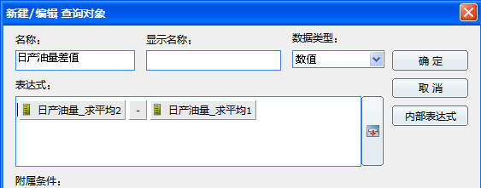

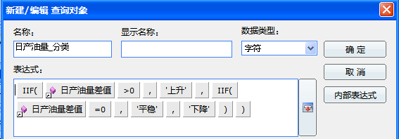

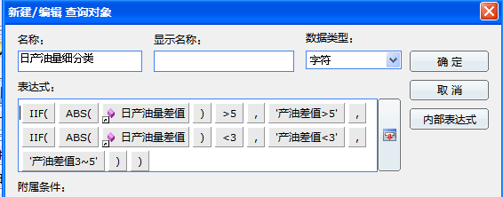

运行效果

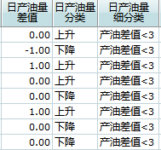

分析：差值缺失小数位。

2、利用脚本

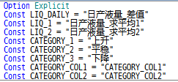

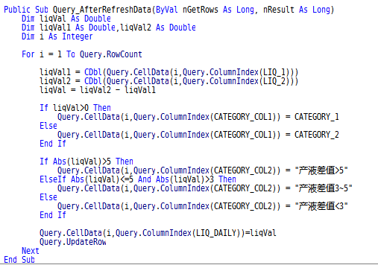

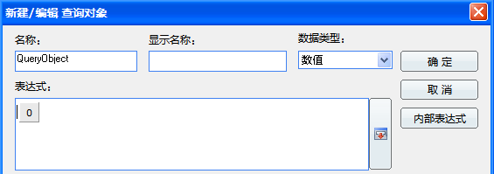

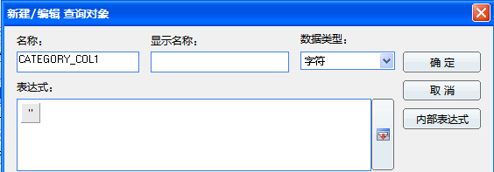

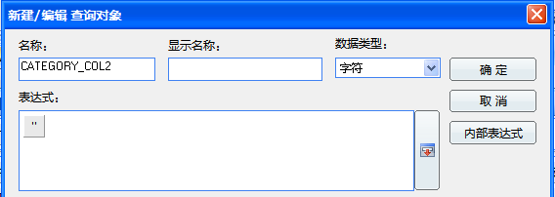

运行效果：

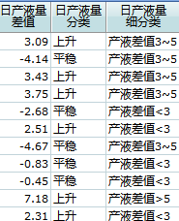

## 基于查询结果利用BQ内部SQL创建DATASET

MY 增加：

参考EXCEL设置关注井

提交的按钮事件中

createDatasetFromSelf

## 主窗体到弹出窗体

程序效果：

点击窗体的查询表格的某单元格，弹出一个子窗体，并将点击行的某列内容传递给子窗体。

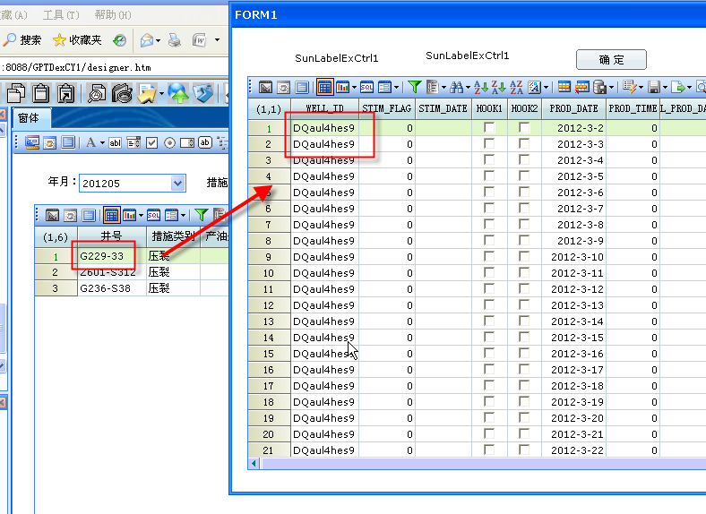

6）显示图表

将建立好的查询orders拖到窗体上会出现如下的提示框，选择“否”，即把查询对象作为可视查询控件放到窗体上了，然后调整图表的大小,更改图表的属性name值为QryCtrl即可。

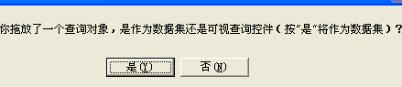

三、主页面点击表格弹出子页面（通过主窗体中的表格ordes链接到副窗体pop）

1)选中可进行链接的字段，如：货主国家，右键->连接到，连接目标#

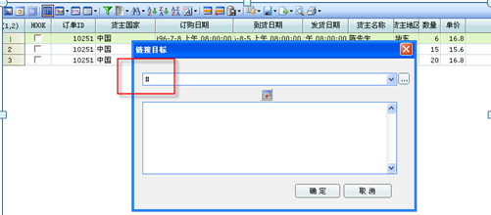

设置智能查询orsers的 linkTo事件

Const REGION_COL = “货主地区“定义一个全局变量REGION_COL值为货主地区

linkTo事件下的具体代码：

If nHitCol = 3 Then

Dim clickCellData As String

clickCellData = Query.CellData(nHitRow,Query.ColumnIndex(REGION_COL))

App.FireContainerEvent "LINKT0",clickCellData,nHitRow

将查询当前点击的行列抛出给窗体容器

事件名称

End If

注释：nHitRow，nHitCol是可变数组。

主窗体可以通过以下方式依次获得查询当前点击的行（nHitRow）列（nHitCol）的值

在窗体的查询控件选DO_EVENT事件，编写以下代码

If varID = "LINKT0" Then

Dim hitCellData As String

hitCellData = pvarParamArray(0)

App.ShowMsg 0,"form :" &hitCellData

End If

2）弹出子窗体并且把主窗体的参数传递到子窗体（ DO_EVENT事件）

Form.EnvVar("[orders].[订单ID]") = frm.EnvVar("?GET_REGION")

App.ShowMsg 0,"GET_REGION:" &Form.EnvVar("?GET_REGION")

3）子窗体获得主窗体传过来的参数并做出相应的动作（Form_Load事件）

Dim param As String

param = Form.EnvVar("?货主地区")

App.ShowMsg 0,"param:" &param

Call refreshQry

Sub refreshQry

App.ShowWaitMsg “正在刷洗数据”,False 子窗体查询刷新

Dim qry As Query

Set qry = QryCtrl.Iobject

第一个参数作用是否允许在位编辑，第二个参数-1 默认取回所有数据行

qry.RefreshData False,-1

App.HideWaitMsg

End Sub

四、子页面选择某个值，回写到首页

1、判断行是否打勾，取得打勾的行号

钩玄列的内容 = 1，没打勾的，都是等于0

Function getSelectedWell As Long

Dim iAs Integer

Dim nRow As Integer

Dim qry As Query

Set qry = QryCtrl.IObject

For i = 1 Toqry.RowCount

If qry.CellData(i,1) = 1 Then 钩玄列的内容 = 1

nRow = I 将勾选行的值赋给变量nRow

MsgBox “当前钩玄的是：” &i& “行！“ 输出选择的行数

Exit For

End If

Next

getSelectedWell = nRow返回勾选的行号

End Function

2、点击保存按钮将信息回写到主窗体

保存按钮下的脚本代码：

Dim iAs Integer

Dim hookCellData As String

Dim qry As Query

Set qry = QryCtrl.IObject

For i = 1 Toqry.RowCount

If qry.CellData(i,1) = 1 Then

hookCellData = qry.CellData(i,2)

Exit For

End If

Next

App.ShowMsg 0,"hookCellData:" &hookCellData

App.ShowMsg 0,"Close vbOK!!!"

Form.EnvVar("?GET_REGION") = hookCellData

Form.ClosevbOK

提示：

1）在主界面和弹出界面通过DEBUG打印出传递参数，方便调试

2个窗体的FORM环境变量都用同名，方便程序。

弹出窗体：

App.ShowMsg 0,"POP-UP PSTIM_DATE:"&Form.EnvVar("PRE_"& STIM_DATE)

主窗体：

App.ShowMsg 0,"MAINPSTIM_DATE:"&Form.EnvVar("PRE_"& STIM_DATE)

3、其他设置

1）页面关闭

Public Sub Form_Close(bCancel As Boolean)

Form.ClosevbCancel

End Sub

2）点击取消按钮页面关闭

Form.ClosevbCancel

五、父窗体的查询行获得子窗体返回的值，并保存到数据库

1、在窗体中引用别处的公共文件

1）引入文件名称及地址

'#Uses "*../../../a2dw/19RandomTime/1905ModuleScript/GlobalFunction"

$/a2dw/10BasicModule/1006GlobalComScript/ExecuteSql

2）引入方法（如下图所示）

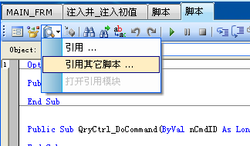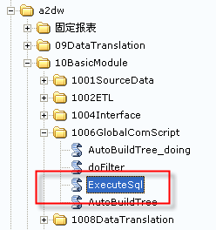

3）脚本说明

① ‘#Uses “*../../1905ModuleScript/GlobalFunction“

脚本中定义的方法getQryCtrlName获取窗体查询控件的实际名称

QryName = getQryCtrlName(Trim(QryCtrl.ObjectFile))

②Form.evvVar(“[查询名].[字段名]”) = VAL

这种方式来改变当前主窗体的查询控件中的活动行的对应字段内容

例如：

Form.EnvVar("[" &QryName& "].[初期干线压力]") = frm.EnvVar("[初期干线压力]")

2、保存到数据库（单击保存到数据库按钮，将数据保存到数据库中）

Dim qry As Query

Dim hrAs Long

Set qry = QryCtrl.IObject

hr = qry.SaveChangedDataToDB(False)

If(hr< 0) Then MsgBox "发生错误：" &App.Msg(hr)

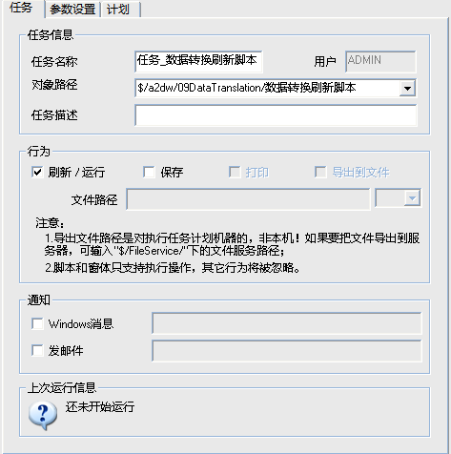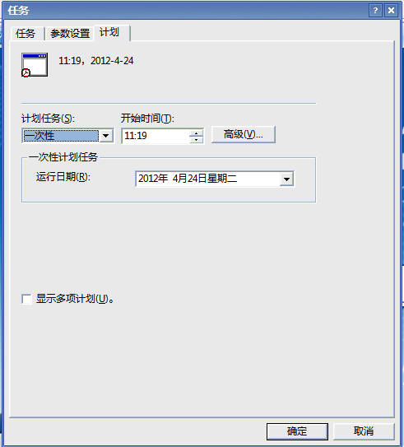

1、（主窗体的）查询定义事件

1)右键点击查询表格，选择“链接到”，输入“#”

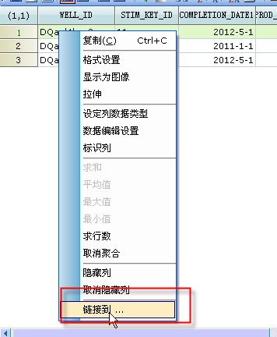

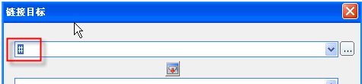

2) 在查询内部事件LinkTo定义FireContainerEvent操作，如下：

Public Sub Query_LinkTo(strLinkTo As String, ByVal nHitRow As Long, ByVal nHitCol As Long, bCancel As Boolean)

Dim wellIdStr As String,stimDateStr As String

Dim eventID As String

eventide = "LINK_TO"

wellIdStr = Query.CellData(nHitRow,Query.ColumnIndex(WELL_ID))

stimDateStr = Query.CellData(nHitRow,nHitCol)

App.FireContainerEventeventide,wellIdStr,stimDateStr

End Sub

2、主窗体内部脚本进行操作

3、主界面如需要接受子窗体回传的值（可选）

Dim frm As New SunContainer

frm.ObjectFile = "$/a2dw/YJY/FLOW_DIAGRAM/关注井工作流"

frm.PopupWindow(True,Null,False)

主界面查询回写需做的查询设置：

在菜单中点开保存修改到数据库的下拉菜单，选择写入数据库设置进行如图所示的设置后在刷新视图即可编辑行。

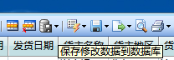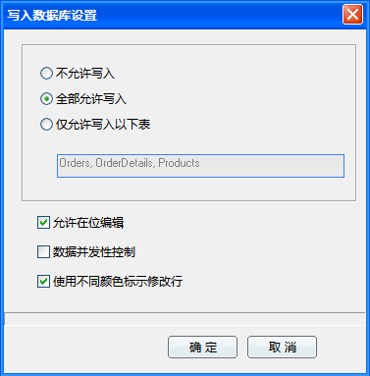

1）父容器点击行打开

Public Sub FReport_BeforeInputParams(bHideDefUI As Boolean, bCancel As Boolean)

Dim frm As New SunContainer

frm.ObjectFile = App.BaseUrl& "/PARAM_FRM"

If frm.PopupWindow(True,FReport,True) = vbOK Then

yearstr = frm.EnvVar("?YEAR")

If InStr(1,yearstr,",")>0 Then

var = Split(yearstr,",")

yearCnt = UBound(var)+1

Else

yearCnt = 1

End If

FReport.Param("YEAR_PARAM") = yearstr

FReport.Param("YEAR_CNT") = yearCnt

FReport.Param("OIL_REGION") = frm.EnvVar("?OIL_REGION")

FReport.Param("STATIS_TYPE") = frm.EnvVar("?STATIS_TYPE")

End If

End Sub

2）子窗体加载

2.1、FORM_LOAD

检查是否有环境变量传递

App.ShowMsg 0,"******get the env:" & Trim(Form.EnvVar("?" & START_YEAR_MON)) & " --> " &Trim(Form.EnvVar("?" & END_YEAR_MON))

If Trim(Form.EnvVar("?" & START_YEAR_MON))<>""

Or Trim(Form.EnvVar("?" & END_YEAR_MON))<>"" Then

执行其他操作…

End If

2.2、Form_Close

清除是否有环境变量传递

Form.EnvVar("?" & START_YEAR_MON) = ""

Form.EnvVar("?" & END_YEAR_MON) = ""

## BQ VBA处理字符串

Dim tempStr As String

tempStr = " Hello MARK welcomeOR"

MsgBox Mid(tempStr,1,Len(tempStr)-2)

## BQ设置自定义按钮

1、将工具栏视图切换到浏览者

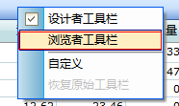

2、选择【自定义工具栏】来编辑浏览者工具栏

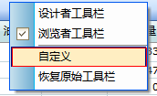

3、选择【新建按钮】，即可在工具栏上新建一个按钮，选择【编辑图标】即可在弹出的的画图工具中编辑图标。

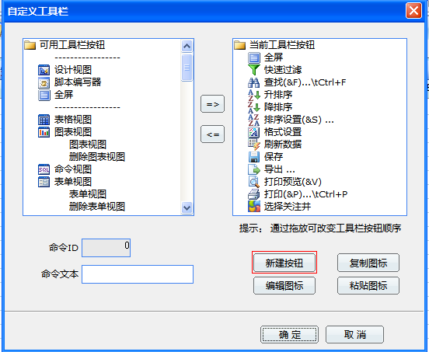

## SQL实现0值补齐的方法



参考：GPTDEX开发文档.doc

***XX_INJ_STIM_DAILY_SX_PRC***

## 查询列钩选

***1、新建名称叫HOOK的字段***

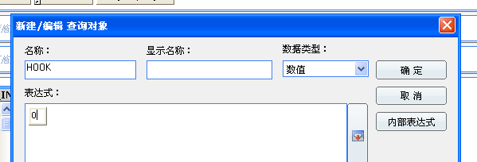

***2、刷新后在表格视图右键选中该列***

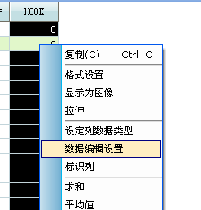

***设置如下：***

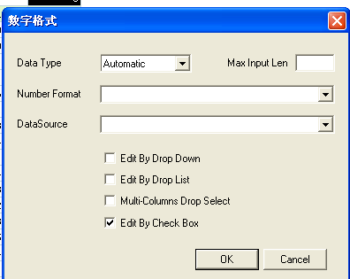

***3、设置可选***

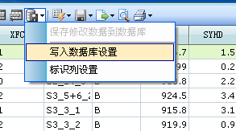

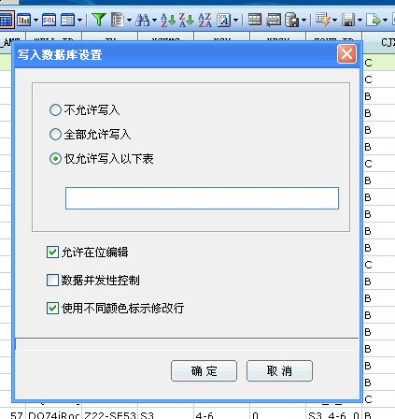

***4、再次刷新查询，后即可钩选***

***5、其他设置***

***1）每列只允许单选一条记录***

***注意在查询的内部脚本写（不是在窗体中写）：***

***1、定义过程singleHook***

***Sub singleHook(ByVal hookColStr As String,ByVal qryGrid As SunDataGrid)***

***Dim i As Long***

***Dim nClickedRow As Long,nClickedCol As Long,nMaxRow As Long***

***nClickedRow = qryGrid.ActiveRow***

***nClickedCol = qryGrid.ActiveCol***

***nMaxRow = qryGrid.MaxRow***

***If nClickedCol = Query.ColumnIndex(hookColStr) Then***

***For i =1 To qryGrid.MaxRow***

***If i<>nClickedRow And Query.CellData(i,Query.ColumnIndex(hookColStr)) = 1 Then***

***Query.CellData(i,Query.ColumnIndex(hookColStr)) = 0***

***Query.UpdateRow***

***Exit For***

***End If***

***Next i***

***End If***

***End Sub***

***2、在查询的DataGrid_CellChanged事件中写***

***HOOK1 为查询表的钩选列名***

***Public Sub DataGrid_CellChanged(ByVal nRow As Long, ByVal nCol As Long, ByVal lpszOldValue As String, ByVal lpszNewValue As String)***

***If nCol = Query.ColumnIndex(HOOK1) Then***

***Dim qryGrid As New SunDataGrid***

***Set qryGrid = Query.GridControl***

***Call singleHook(HOOK1,qryGrid)***

***End If***

***End Sub***

***2）将某个分组内所有行同时更新打勾***

如下图将所有井号Z22-E51的记录钩选或反选

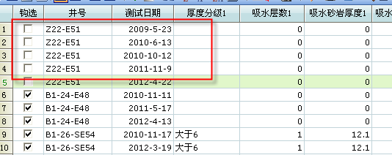

$/GPTDex/GPTDex/ADJUSTMENT_SCHEME_ANALYSIS/WELL_GROUP_RPT_UI/QUERY/MAIN_QRY

1）设置分组字段的排序

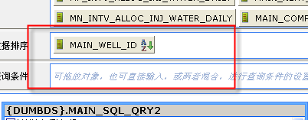

2）写脚本

'将主井的所有行的(主井原因)2个字段更新

Sub updateMainWellRows(ByVal wellId As Variant,ByVal updateCode As String,ByVal upateCodeDesc As String)

Dim startRow As Integer,i As Integer

Dim wellIdStr As String

wellIdStr = wellId

startRow = Query.FindRow(CInt(Query.ColumnIndex(MAIN_WELL_ID)),wellId,1)

App.ShowMsg 0," startRow fulfill row:" & startRow

For i = startRow To Query.RowCount

App.ShowMsg 0,"curWellId:" & Query.CellData(i,Query.ColumnIndex(MAIN_WELL_ID))

If Query.CellData(i,Query.ColumnIndex(MAIN_WELL_ID)) = wellIdStr Then

Query.CellData(i,Query.ColumnIndex(MAIN_TYPE)) = updateCode

Query.CellData(i,Query.ColumnIndex(MAIN_TYPE_DESC )) = upateCodeDesc

End If

If Query.CellData(i,Query.ColumnIndex(MAIN_WELL_ID))<>wellIdStr Then Exit For

Next

End Sub

***3）在查询内部的DataGrid_CellChanged事件调用过程2）***

Public Sub DataGrid_CellChanged(ByVal nRow As Long, ByVal nCol As Long, ByVal lpszOldValue As String, ByVal lpszNewValue As String)

If nCol = CLng(Query.ColumnIndex(HOOK_MAIN)) Then

**Call updateMainWellHookRows(mainWellId1,lpszNewValue)**

End If

End Sub

## 查询实现前后N个年月的方法

***调用ORACLE的ADD_MONTHS***

***参数NUM表示前后N（用户输入）***

***例如+1 表示参数（？年月）的前一个、-1表示后一个月***



***EXT1)***

***查询出用户输入日期的前N月开始日期、到后N月的结束日期***

***前N月的第一天：***

add_months(to_date('2012-1-31','yyyy-mm-dd'),-(N+1))+1

***后N月的最后一天：***

last_day(add_months(to_date('2012-1-31','yyyy-mm-dd'),N))

***然后通过 date_param between and来生成日期区间***

## 寻找连续区间，实现内容补充的方法

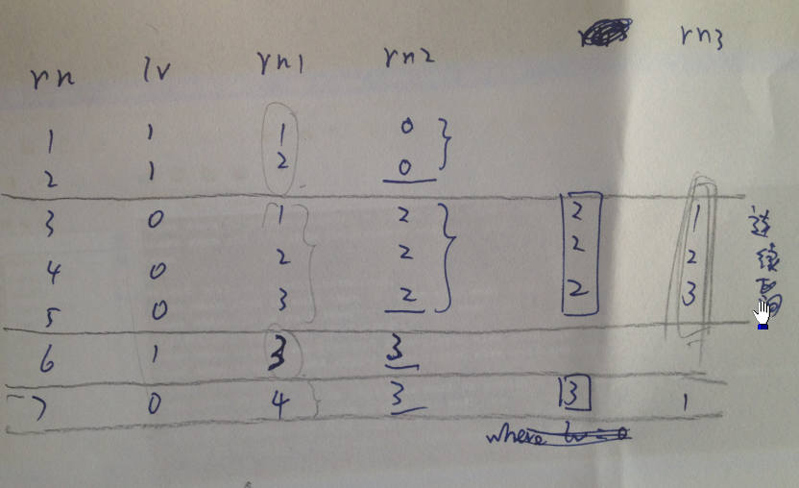

(**select**  
well_id,xcxh,jh,yczmc,xch,xfch,cjx,syhd,ylsyds,ylsyhd,yxhdds,yxhd,yxhdlb,jcs,skqk,stl,syds  
**from**  
(  
**select** well_id,xcxh,jh,yczmc,xch,xfch,cjx,  
syhd,ylsyds,ylsyhd,yxhdds,yxhd,yxhdlb,jcs,skqk,stl,  
(**casewhen** lv=1**then** lag(syds,rn3,**null**) over (**partitionby** well_id **orderby** rn) **else** syds **end**) syds  
**from**  
(  
**select**well_id,xcxh,jh,yczmc,xch,xfch,cjx,syds,syhd,ylsyds,ylsyhd,yxhdds,yxhd,yxhdlb,jcs,skqk,stl,  
row_number() over (**partitionby** well_id,lv,rn2 **orderby** rn) rn3,lv,rn  
**from**  
(  
**select** well_id,xcxh,jh,yczmc,xch,xfch,cjx,syds,syhd,ylsyds,ylsyhd,yxhdds,yxhd,yxhdlb,jcs,skqk,stl,  
rn-rn1 rn2,rn,lv   
**from**  
(  
**select** well_id,xcxh,jh,yczmc,xch,xfch,cjx,syds,syhd,ylsyds,ylsyhd,yxhdds,yxhd,yxhdlb,jcs,skqk,stl,  
lv,  
xcxh rn,  
row_number() over (**partitionby** well_id,lv **orderby** xcxh) rn1   
**from**  
(  
**select** a.well_id,to_number(a.xcxh) xcxh,a.jh,a.yczmc,a.xch,a.xfch,a.cjx,a.syds,a.syhd,a.ylsyds,a.ylsyhd,a.yxhdds,a.yxhd,a.yxhdlb,a.jcs,a.skqk,a.stl,  
(**casewhen** a.syds >0**then**0**else**1**end**) lv   
**from** daa05 a  
**where** well_id **isnotnull**  
)  
)   
)  
)  
)   
**orderby** well_id,xcxh  
)  
)   
) a

## 基于查询的查询做聚合报错

（MY）增加

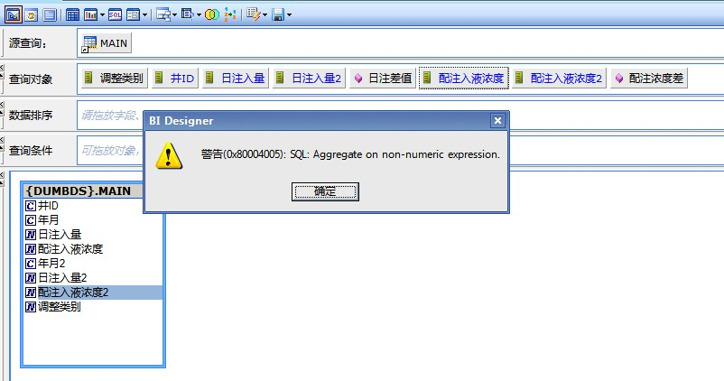

错误原因：某一个字段聚合求错，井ID为字符类型，应选择求数目

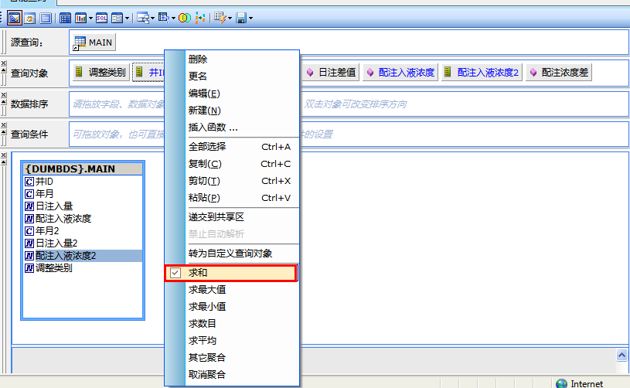

## 刷新前报表输入参数个数的检查的实现方法

示例路径：

$/GPTDex/GPTDex/CY1/ZONE_PLAN_WELL_STAT_RPT48/RPT1

1. 建立查询

将参数来源

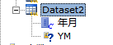

2、具体代码实现

Option Explicit

Const RESTRICT_PARAM_CNT = 3

Const MSG1 = "输入的参数范围需要保证在3个年月!请重新输入."

Dim bCancelRefresh As Boolean

Dim varYear As Variant

Public Sub FReport_AfterInputParams(bCancel As Boolean)

On Error GoTo err_p

bCancelRefresh = False

Dim ds As New SunDataset

ds.DatasetNode = FReport.DatasetNode("Dataset2")

ds.RefreshData -1

If ds.RowCount > 0 Then

If ds.RowCount <> RESTRICT_PARAM_CNT Then

bCancelRefresh = True

Else

Dim i As Integer

Dim yearMonArry(3) As String

For i = 1 To ds.RowCount

yearMonArry(i-1) = ds.CellData(i,1)

Next

varYear = yearMonArry

End If

Else

bCancelRefresh = True

End If

Exit Sub

err_p:

If Err.Number <> 0 Then

bCancelRefresh = True

End If

End Sub

Public Sub FReport_BeforeInputParams(bHideDefUI As Boolean, bCancel As Boolean)

bCancelRefresh = False

End Sub

Public Sub FReport_BeforeRefreshData(nMaxRows As Long, bCancel As Boolean)

bCancel = True

If bCancelRefresh Then

MsgBox MSG1

bCancel = True

Exit Sub

End If

Dim i As Long

For i = 1 To UBound(varYear)

MsgBox varYear(i-1)

Next

End Sub

Public Sub FReport_Command(ByVal nCmdID As Long, bCancel As Boolean)

If nCmdID = 1001 Then

App.OpenDocument "d27d3612-e241-46d5-b9af-9b133452dd5b",False

End If

End Sub

## SQL实现循环批量INSERT记录的操作

declare

v_trunc_str varchar2(100);

v_mind_str varchar2(100);

begin

v_trunc_str := 'truncate table xx_daa071_ext';

execute immediate v_trunc_str;

for mine_id in(select distinct nvl(x_km,'unknown') mine_id from xx_well_info_unite) loop

v_mind_str := mine_id.mine_id;

insert into xx_daa071_ext(well_id)

select well_id from xx_well_info_unite where x_km=v_mind_str;

commit;

end loop;

end;

## WINDOW日期格式可能导致BQ刷新报错

BQ刷新的日期格式显示如下：可能会导致日期作为查询条件刷新报错。

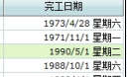

解决方法：

WINDOW日期格式设置修改

控制面板里日期和时间——

更改日期和时间——更改日历设置

——日期下面的日期格式，将

图片中的 dddd删掉然后点击确定

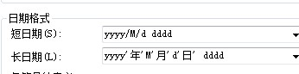

## 窗体格式要求 VERY IMPORTANT TO-DO

1、控件命名

2、控件布局

3、控件大小

## A2DW数据库常用表和字段来源说明

井名WELL_DESC 来源表 XX_WELL_INFO_UNITE

注意：所有代码井名、通用井名都用XX_WELL_INFO_UNITE，不要用XX_CARE_WELL表

## 运用BQ查询生成批量表注释的方法

查询路径：$/GPTDex/GPTDex/UTIL/添加注释

1、将智能查询导出

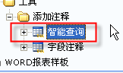

2、在导出文件填写上表、字段、中文注释

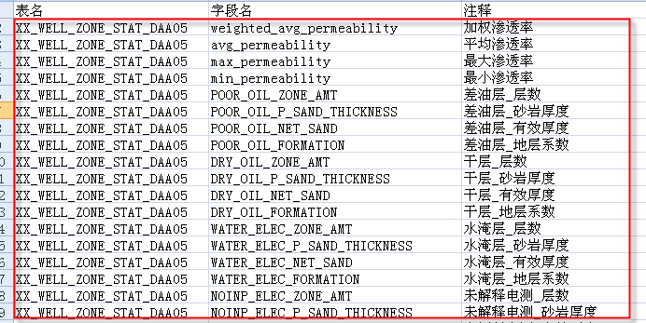

3、将修改好的EXCEL文件导入“智能查询”**刷新并保存**

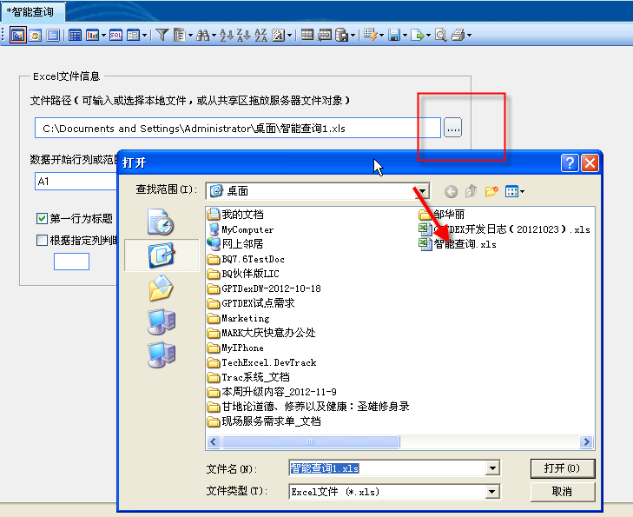

4、打开“字段注释”，直接刷新

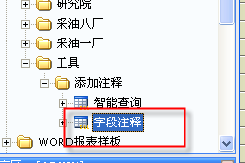

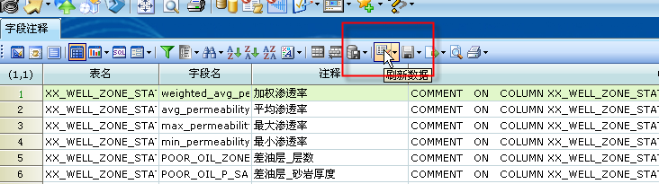

## SQL A表2个字段同时关联B表取值

select a.col1,a.col2,b.col3,a.col3,a.col4,c.col3

from tab1 a,tab2 b,tab2 c

where a.col1=b.col1 and a.col2=b.col2

and a.col1=c.col1 and a.col2=c.col2

## excel 导入关注井

关注井使用流程

1、主查询

$/a2dw/11BasicEntity/1103DataQuery/EXCEL_QRY

2、源查询

$/a2dw/11BasicEntity/1103DataQuery/EXCEL_SRC_QRY

* 写入目标表XX_CARE_WELL
* EXCEL_QRY内部脚本

1）WELL_ID翻译

2）数据校验

重复行checkDuplicateRows

井名正确 BQ字段翻译

checkSql = "select [WELL_ID],count([WELL_ID]) from [SELF] " & " group by [WELL_ID] having count([WELL_ID]) > 1"

ds.DatasetNode = Query.DatasetNode

ds.CreateDatasetFromSelf checkSql,-1

* ReDim well(ds.RowCount)
* VB定义变长数组
* identifyDuplicateRows
* 将查询表格中
* 重复的记录标记出来

**变量hookFirstRow的作用？**

SPLIT

先遍历模块列头字符串，获得数组

然后在遍历查询的所有列名

BYVAL 和BYREF的区别

excelFormatCheck

刷新了EXCEL_FROMAT_CHECK查询，

该查询内部如果有错误，会触发

App.fireContainerEvent

那么在父窗体的

ExcelChkQryCtrl_DoEvent中可以获取到该事件。

如何在窗体里面通过DS来刷新系统共享区的某个查询

dsExcel.Open dsUuid,False

dsExcel.Param("ExcelFile")=strFile

dsExcel.RefreshData -1

dsExcel.Save

通过查询的过滤器来导出数据

1、Query.Filter [错误记录的表示式]

2、导出的都是错误的记录

3、将原来的表示是清空

SAVEDB写数据库操作

1、xGroup 分组

2、processNumericNull 自定义函数

如果数字类型字段没有内容，我们填上一个0

3、客户端的机器格式或其他原因，导致如果

关注日期列用户没有填写内容，会自动天上一个

上午12：00：00 或0:00:00. 我们把这些内容处理掉。

Trim(ds.CellData(i,dsWellList.IObject.ColumnIndex("关注日期"))) = "0:00:00" Or ds.CellData(i,dsWellList.IObject.ColumnIndex("关注日期"))=""

$/a2dw/10BasicModule/1006GlobalComScript/ExecuteSql

* xx_care_well_prc方法的作用。
* 去xx_well_info_unite找到WELL_ID对应的中文井名和代码井名，补充到XX_CARE_WELL。
* **On Error GoTo Resume**
* **On Error GoTo err_p**

窗体通过BQ内部SQL进行XX_CARE_WELL表的写操作。

只需要字段名和DB表的字段名匹配即可，不用全部写上。

'************MARK****************

'改用EXCEL导入关注井DO_SAVE的模式.因为当前钩选的单井存在多条相同记录(见表格)

Private Function doSave(ByVal queryCtrl As SunContainer) As Boolean

On Error GoTo err_p

Dim i As Integer

Dim cmdStr As String , szErrMsg As String

Dim xGroup As String,delSql As String

App.ShowWaitMsg MSG4,False

cmdStr = "DELETE FROM XX_CARE_WELL WHERE USER_ID='" & App.CurrentUser & "';"

If ExecuteSQL(cmdStr, szErrMsg)= False Then

MsgBox MSG1 & szErrMsg

doSave = False

App.HideWaitMsg

Exit Function

Else

Dim ds As New SunDataset

Dim db As New SunDatasource

Dim defGroupStr As String

defGroupStr = "默认"

cmdStr = "select distinct '" & UCase(App.CurrentUser) & "' USER_ID," _

& "[WELL_ID] WELL_ID," _

& "[WELL_DESC] WELL_DESC," _

& "[WELL_COMMON_NAME] WELL_COMMON_NAME," _

& "[WELL_LEGAL_NAME] WELL_LEGAL_NAME," _

& "'" & defGroupStr & "' X_GROUP," _

& "1 IS_ATTENTION " _

& " from [SELF] where [HOOK]=1"

App.ShowMsg 0,"cmdStr:" & cmdStr

ds.DatasetNode = queryCtrl.IObject.DatasetNode

ds.CreateDatasetFromSelf cmdStr,-1

db.Open DB1,dbReadWrite

db.ImportDataFromDataset ds,TAB1,True,1

db.Close

End If

doSave = True

App.HideWaitMsg

Exit Function

err_p:

If Err.Number <> 0 Then

MsgBox MSG1 & Err.Number & Err.Description

doSave = False

App.HideWaitMsg

End If

End Function

## 基于查询的查询日期字段为空,自动处理成时间

父查询的日期字段如果没有值，基于查询的查询会将空自动变成时间

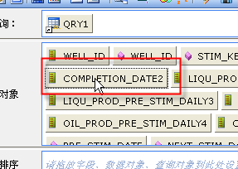

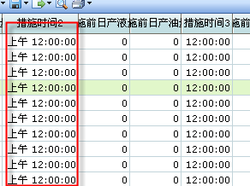

解决方案：

1、在查询内部脚本将0:00:00这种BQ自动转换的字符串清空

在Query_AfterRefreshData事件中，遍历表格每一行。

通过将非法的时间字符转换成年月格式，非法字符转换后内容<190001

For i = 1 To Query.RowCount

If ""<> Trim(dateStr) Then

dMonth = Format(dateStr,"yyyymm")

**If dMonth<"190001" Then**

'日期为(0:00:00 上午12:00:00 下午0:00 等)非法内容，需要清空日期内容

Query.CellData(k,Query.ColumnIndex(DATE_COL)) = ""

Else

…

End If

End If

End if

Next I

2、直接用普通查询来实现

## ORA树形操作

1、实现组内的树形递归

http://www.itpub.net/thread-1311153-2-1.html

**STARTWITH** rn2 = 1  
**CONNECTBY** rn1-1 = **PRIOR** rn1

(新增分组字段的下列判断条件，可保证树在分区内进行递归)  
**andpart_col1 = PRIORpart_col1  
andpart_col2 = PRIORpart_col2**

## ORA实现从某个日期往前或往后查找数据的方法

如何往前后找一个满足条件的值（where还要增加，不是简单的

往前找一个日期最近的算法）

…

2、往前查找SQL-SAMPLE：增加到开发技巧文档

A表从B表查找日期往前的日注>0(额外条件)的最近日期数据。

|  |  |
| --- | --- |
| **WELL_ID** | **XX_DATE** |
| A | 2011-2-1 |
| A | 2011-3-1 |

|  |  |  |  |
| --- | --- | --- | --- |
| **WELL_ID** | **COMPLETION_ID** | **INJ_DATE** | **INJ_VOL_DAILY** |
| A | a | 2011-1-5 | 1 |
| A | b | 2011-1-5 | 2 |
| A | a | 2011-1-15 | 2 |
| A | b | 2011-1-15 | 0 |
| A | a | 2011-1-25 | 0 |
| A | b | 2011-1-25 | 0 |

**select**  
a.*  
**from** test1 a,  
(**select** well_id,completion_id,inj_date **from** test2 **where** inj_vol_daily>0)

b  
**where** a.well_id = b.well_id **and** a.xx_date>b.inj_date  
**andnotexists**  
(**select**1**from** (**select** well_id,completion_id,inj_date **from** test2 **where** inj_vol_daily>0) c   
**where** c.well_id = a.well_id **and**

a.xx_date>c.inj_date **and** c.inj_date>b.inj_date);

## 树窗体代码说明

1. 需求背景：

研究院开发一按照DAA01小区快名称来确定其关注井的井号，所以，需要定做一个用户自定义区块单元名称的分组表，然后按照定义好的分组表去寻找用户所关心的井号。

1. 需求实现：

确保A2DW数据源下有DAA01数据表、GROUP_PLAN数据表，建立一个树窗体如下：

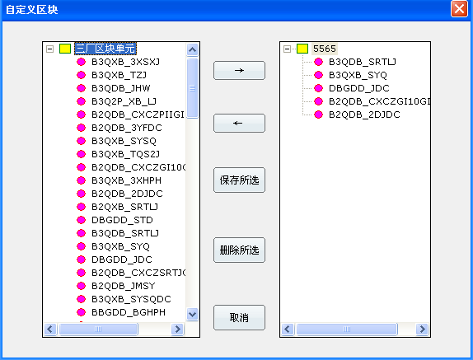

建立左边树控件为查找DAA01中的所有qkdy字段值：

nFirstImg = treetest.SetImageList("$/树窗体/图像", RGB(255,255,255))

nFirstImg1 = treetest1.SetImageList("$/树窗体/图像", RGB(255,255,255))

Dim ds As New SunDataset

Dim ds1 As New SunDataset

Dim sql,qkdy,lastqkdy As String

Dim cmItem,qkdyItem,row As Integer

sql = "select distinct {a2dw}.daa01.qkdy from {a2dw}.daa01"

ds.CreateDataset sql, -1

qkdy = "'

lastqkdy=""

cmItem = 0

qkdyItem = 0

recount = ds.RowCount

cmItem = treetest.InsertItem("三厂区块单元",nFirstImg,0,0)

For row = 1 To ds.RowCount

qkdy = ds.CellData(row,1)

If qkdy <> lastqkdy And qkdy<> "" Then

qkdyItem = treetest.InsertItem (qkdy,nFirstImg+1,cmItem,0)

lastqkdy = qkdy

End If

Next

右边树控件为读取A2DW下GROUP_PLAN表下内容，该表为用户存储自定义树结构表：

qkdy = "'

lastqkdy=""

cmItem = 0

qkdyItem = 0

sql = "select distinct {a2dw}.group_plan.Group_Name from {a2dw}.group_plan"

ds.CreateDataset sql, -1

recount = ds.RowCount

If recount > 0 Then

For row = 1 To ds.RowCount

qkdy = ds.CellData(row,1)

sql1 ="select * from {a2dw}.group_plan where {a2dw}.GROUP_PLAN.Group_Name = '" & qkdy & "'" & " And USER_NAME = '" & Trim(UCase(App.CurrentUser)) & "'"

ds1.CreateDataset sql1, -1

cmItem = treetest1.InsertItem(qkdy,nFirstImg1,0,0)

For row1 = 1 To ds1.RowCount

qkdy = ds1.CellData(row1,3)

If qkdy <> lastqkdy And qkdy<> "" Then

qkdyItem = treetest1.InsertItem (qkdy,nFirstImg1+1,cmItem,0)

lastqkdy = qkdy

End If

Next

Next

End If

ds.Close

Set ds = Nothing

保存所选按钮为保存右边树控件内容，保存GROUP_PLAN下Group_Name字段不等于树根节点名称的树结构。

删除所选为删除数据库内GROUP_PLAN下Group_Name等于所选根节点的名称。

Group.Sql

prompt PL/SQL Developer import file

prompt Created on 2012年5月8日 by dell

set feedback off

set define off

prompt Disabling triggers for GROUP_PLAN...

alter table GROUP_PLAN disable all triggers;

prompt Deleting GROUP_PLAN...

delete from GROUP_PLAN;

commit;

prompt Loading GROUP_PLAN...

insert into GROUP_PLAN (FACTORY_NAME, GROUP_NAME, PLAN_NAME, USER_NAME)

values ('采油三厂', '北三西层系', 'B3Q2P_XB_TZJ', 'ADMIN');

insert into GROUP_PLAN (FACTORY_NAME, GROUP_NAME, PLAN_NAME, USER_NAME)

values ('采油三厂', '北三西层系', 'B3Q2P_XB_LJ', 'ADMIN');

insert into GROUP_PLAN (FACTORY_NAME, GROUP_NAME, PLAN_NAME, USER_NAME)

values ('采油三厂', '北三西层系', 'B3QXB_3XHPH', 'ADMIN');

insert into GROUP_PLAN (FACTORY_NAME, GROUP_NAME, PLAN_NAME, USER_NAME)

values ('采油三厂', '北三西层系', 'B3QXB_3XSXJ', 'ADMIN');

insert into GROUP_PLAN (FACTORY_NAME, GROUP_NAME, PLAN_NAME, USER_NAME)

values ('采油三厂', '北三西层系', 'B3QXB_P2GXJ', 'ADMIN');

insert into GROUP_PLAN (FACTORY_NAME, GROUP_NAME, PLAN_NAME, USER_NAME)

values ('采油三厂', '北三西层系', 'B3QXB_PTHLJ', 'ADMIN');

insert into GROUP_PLAN (FACTORY_NAME, GROUP_NAME, PLAN_NAME, USER_NAME)

values ('采油三厂', '北三西层系', 'B3QXB_SRTLJ', 'ADMIN');

insert into GROUP_PLAN (FACTORY_NAME, GROUP_NAME, PLAN_NAME, USER_NAME)

values ('采油三厂', '北三西层系', 'B3QXB_TP2G1', 'ADMIN');

insert into GROUP_PLAN (FACTORY_NAME, GROUP_NAME, PLAN_NAME, USER_NAME)

values ('采油三厂', '北三西层系', 'B3QXB_TQG2J', 'ADMIN');

insert into GROUP_PLAN (FACTORY_NAME, GROUP_NAME, PLAN_NAME, USER_NAME)

values ('采油三厂', '北三西层系', 'B3QXB_TQP1J', 'ADMIN');

insert into GROUP_PLAN (FACTORY_NAME, GROUP_NAME, PLAN_NAME, USER_NAME)

values ('采油三厂', '北三西层系', 'B3QXB_TQS2J', 'ADMIN');

insert into GROUP_PLAN (FACTORY_NAME, GROUP_NAME, PLAN_NAME, USER_NAME)

values ('采油三厂', '北三西层系', 'B3QXB_TS1S2', 'ADMIN');

insert into GROUP_PLAN (FACTORY_NAME, GROUP_NAME, PLAN_NAME, USER_NAME)

values ('采油三厂', '北三西层系', 'B3QXB_TZJ', 'ADMIN');

commit;

prompt 13 records loaded

prompt Enabling triggers for GROUP_PLAN...

alter table GROUP_PLAN enable all triggers;

set feedback on

set define on

prompt Done.

地层压力变化

select

year_col,

year_well_qty,

year_ysdcyl,

case when year_static_pressure>0 then year_static_pressure-nvl(year_ysdcyl,0) else 0 end year_pressure_diff,

year_static_pressure,

max(decode(lv,1,single_pressure_diff)) single_pressure_diff_lv1,

max(decode(lv,1,well_qty)) well_qty_lv1,

max(decode(lv,2,single_pressure_diff)) single_pressure_diff_lv2,

max(decode(lv,2,well_qty)) well_qty_lv2,

max(decode(lv,3,single_pressure_diff)) single_pressure_diff_lv3,

max(decode(lv,3,well_qty)) well_qty_lv3,

max(decode(lv,4,single_pressure_diff)) single_pressure_diff_lv4,

max(decode(lv,4,well_qty)) well_qty_lv4,

max(decode(lv,5,single_pressure_diff)) single_pressure_diff_lv5,

max(decode(lv,5,well_qty)) well_qty_lv5

from

(

select

year_col,

year_well_qty,

year_ysdcyl,

year_static_pressure,

lv,

avg(single_pressure_diff) single_pressure_diff,

sum(well_qty) well_qty

from

(select

year_col,

count(well_id) over (partition by year_col) year_well_qty,

avg(case when ysdcyl<>0 then ysdcyl else null end) over (partition by year_col) year_ysdcyl,

avg(static_pressure) over (partition by year_col) year_static_pressure,

case

when single_pressure_diff>1.0 then 1

when single_pressure_diff<=1.0 and single_pressure_diff>0.5 then 2

when single_pressure_diff<=0.5 and single_pressure_diff>-0.5 then 3

when single_pressure_diff<=-0.5 and single_pressure_diff>-1.0 then 4

when single_pressure_diff<=-1.0 then 5 end lv,

single_pressure_diff,

1 well_qty

from

(

select

d.well_id,

d.year_col,

d.static_pressure,

g.ysdcyl,

/*单井压差,为分级LV所用*/

d.static_pressure-nvl(g.ysdcyl,0) single_pressure_diff

from

(/*step2)获取每年每口井的一年内满足静压条件的最后一个年月的记录*/

select distinct

well_id,

year_col,

max(year_mon) keep (dense_rank first order by year_mon desc) over (partition by well_id,year_col) year_mon,

max(static_pressure) keep (dense_rank first order by year_mon desc) over (partition by well_id,year_col) Static_Pressure

from

(select

a.well_id,

substr(a.year_mon,1,4) year_col,

a.year_mon,

a.static_pressure

from

xx_pc_well_pro_monthly a

where Static_Pressure>0 and Static_Pressure<20 /*此处接收用户输入范围值*/

) b

where b.year_col in ('2009')

and

((exists

/*step2)通过exists过滤出来N年都测试过静压(静压>0)的井*/

(select

c.well_id,

count(c.year_col)

from

/*在用户输入合理范围内的所有关注的测静压井中,列出用户输入的N个年份的井的统计字段

如果sum(静压)>0,则该井在该年份一定测试过静压*/

(select

a.well_id,

substr(a.year_mon,1,4) year_col,

sum(a.static_pressure)

from

xx_pc_well_pro_monthly a

where Static_Pressure>0 and Static_Pressure<20

and substr(a.year_mon,1,4) in ('2009')

group by a.well_id,substr(a.year_mon,1,4)

having sum(a.Static_Pressure)>0 /*过滤掉静压等于0的年份*/) c

where c.well_id = b.well_id

group by c.well_id

/*注意:

1)count(1)值等于用户输入年月个数

2)STATIC_TYPE用户输入参数选择相同井或不同井计算*/

having count(1)= 1) and 1=0) or 0=0)

) d

/*和DAA01关联,获取原始地层压力*/

inner join daa01 g

on d.well_id = g.well_id

where

g.qkdy in

('B3Q2P_XB_LJ',

'B3Q2P_XB_TZJ',

'B3QXB_3XHPH',

'B3QXB_3XSXJ',

'B3QXB_P2GXJ',

'B3QXB_PTHLJ',

'B3QXB_SRTLJ',

'B3QXB_TP2G',

'B3QXB_TQG2J',

'B3QXB_TQP1J',

'B3QXB_TQS2J',

'B3QXB_TS1S2',

'B3QXB_TZJ')

))

group by

year_col,

year_well_qty,

year_ysdcyl,

year_static_pressure,

lv

)

group by year_col,

year_well_qty,

year_ysdcyl,

case when year_static_pressure>0 then year_static_pressure-nvl(year_ysdcyl,0) else 0 end,

year_static_pressure

order by year_col;

累产油

select sum(leiji)aa from (

select sum(OIL_PROD_VOL_MON)/10000 leiji ,substr(year_mon,1,4)

from(

select * from(

select * from(

select a.well_id,a.OIL_PROD_VOL_MON,a.year_mon,a.prod_date,substr(year_mon,1,4)year

from

(select a.well_id,a.OIL_PROD_VOL_MON,a.year_mon,b.prod_date

from XX_PC_WELL_PRO_MONTHLY a

inner join xx_well_info_unite b

on a.well_id = b.well_id)a

inner join

(select * from daa01 a

inner join GROUP_PLAN b

on a.qkdy = b.plan_name where b.group_name = '北三西层系')b

on a.well_id = b.well_id ))

where year_mon <='200812')

group by substr(year_mon,1,4))

select sum(leiji) from(

select a.leiji,a.well_id from

(select sum(OIL_PROD_VOL_MON)/10000 leiji,well_id from XX_PC_WELL_PRO_MONTHLY where to_number(year_mon) <= 200812

group by well_id )a

inner join

(select * from daa01 a

inner join GROUP_PLAN b

on a.qkdy = b.plan_name where b.group_name = '北三西层系')b

on a.well_id = b.well_id )

select * from XX_PRO_CUM where well_id ='02rvrWtdJj' and year_mon ='200812'

压力分级

select

year_col,

year_well_qty,

year_ysdcyl,

case when year_static_pressure>0 then year_static_pressure-nvl(year_ysdcyl,0) else 0 end year_pressure_diff,

year_static_pressure,

max(decode(lv,1,single_pressure_diff)) single_pressure_diff_lv1,

max(decode(lv,1,well_qty)) well_qty_lv1,

max(decode(lv,2,single_pressure_diff)) single_pressure_diff_lv2,

max(decode(lv,2,well_qty)) well_qty_lv2,

max(decode(lv,3,single_pressure_diff)) single_pressure_diff_lv3,

max(decode(lv,3,well_qty)) well_qty_lv3,

max(decode(lv,4,single_pressure_diff)) single_pressure_diff_lv4,

max(decode(lv,4,well_qty)) well_qty_lv4,

max(decode(lv,5,single_pressure_diff)) single_pressure_diff_lv5,

max(decode(lv,5,well_qty)) well_qty_lv5

from

(

select

year_col,

year_well_qty,

year_ysdcyl,

year_static_pressure,

lv,

avg(single_pressure_diff) single_pressure_diff,

sum(well_qty) well_qty

from

(select

year_col,

count(well_id) over (partition by year_col) year_well_qty,

avg(case when ysdcyl<>0 then ysdcyl else null end) over (partition by year_col) year_ysdcyl,

avg(static_pressure) over (partition by year_col) year_static_pressure,

case

when single_pressure_diff>1.0 then 1

when single_pressure_diff<=1.0 and single_pressure_diff>0.5 then 2

when single_pressure_diff<=0.5 and single_pressure_diff>-0.5 then 3

when single_pressure_diff<=-0.5 and single_pressure_diff>-1.0 then 4

when single_pressure_diff<=-1.0 then 5 end lv,

single_pressure_diff,

1 well_qty

from

(

select

d.well_id,

d.year_col,

d.static_pressure,

g.ysdcyl,

/*单井压差,为分级LV所用*/

d.static_pressure-nvl(g.ysdcyl,0) single_pressure_diff

from

(/*step2)获取每年每口井的一年内满足静压条件的最后一个年月的记录*/

select distinct

well_id,

year_col,

max(year_mon) keep (dense_rank first order by year_mon desc) over (partition by well_id,year_col) year_mon,

max(static_pressure) keep (dense_rank first order by year_mon desc) over (partition by well_id,year_col) Static_Pressure

from

(select

a.well_id,

substr(a.year_mon,1,4) year_col,

a.year_mon,

a.static_pressure

from

xx_pc_well_pro_monthly a

where Static_Pressure>0 and Static_Pressure<20 /*此处接收用户输入范围值*/

) b

where b.year_col in ('2009')

and

((exists

/*step2)通过exists过滤出来N年都测试过静压(静压>0)的井*/

(select

c.well_id,

count(c.year_col)

from

/*在用户输入合理范围内的所有关注的测静压井中,列出用户输入的N个年份的井的统计字段

如果sum(静压)>0,则该井在该年份一定测试过静压*/

(select

a.well_id,

substr(a.year_mon,1,4) year_col,

sum(a.static_pressure)

from

xx_pc_well_pro_monthly a

where Static_Pressure>0 and Static_Pressure<20

and substr(a.year_mon,1,4) in ('2008','2009')

group by a.well_id,substr(a.year_mon,1,4)

having sum(a.Static_Pressure)>0 /*过滤掉静压等于0的年份*/) c

where c.well_id = b.well_id

group by c.well_id

/*注意:

1)count(1)值等于用户输入年月个数

2)STATIC_TYPE用户输入参数选择相同井或不同井计算*/

having count(1)= 2) and 1=0) or 0=0)

) d

/*和DAA01关联,获取原始地层压力*/

inner join daa01 g

on d.well_id = g.well_id

where

g.qkdy in

('B3Q2P_XB_LJ',

'B3Q2P_XB_TZJ',

'B3QXB_3XHPH',

'B3QXB_3XSXJ',

'B3QXB_P2GXJ',

'B3QXB_PTHLJ',

'B3QXB_SRTLJ',

'B3QXB_TP2G',

'B3QXB_TQG2J',

'B3QXB_TQP1J',

'B3QXB_TQS2J',

'B3QXB_TS1S2',

'B3QXB_TZJ')

))

group by

year_col,

year_well_qty,

year_ysdcyl,

year_static_pressure,

lv

)

group by year_col,

year_well_qty,

year_ysdcyl,

case when year_static_pressure>0 then year_static_pressure-nvl(year_ysdcyl,0) else 0 end,

year_static_pressure

order by year_col;

查找A2空格语句

select

table_name,column_name,data_type,data_length,data_precision,data_scale,nullable

from user_tab_columns

where data_type = 'CHAR';

Ora删除表空间

--删除空的表空间，但是不包含物理文件

drop tablespace tablespace_name;

--删除非空表空间，但是不包含物理文件

drop tablespace tablespace_name including contents;

--删除空表空间，包含物理文件

drop tablespace tablespace_name including datafiles;

--删除非空表空间，包含物理文件

drop tablespace tablespace_name including contents and datafiles;

--如果其他表空间中的表有外键等约束关联到了本表空间中的表的字段，就要加上CASCADE CONSTRAINTS

drop tablespace tablespace_name including contents and datafiles CASCADE CONSTRAINTS

--格式: create tablespace 表间名 datafile '数据文件名' size 表空间大小;

如：

SQL> create tablespace news_tablespace datafile 'F:\oracle\product\10.1.0\oradata\news\news_data.dbf'

size 500M;

oracle建表空间各种语句2009-11-27 10:08在创建用户之前，先要创建表空间：

其格式为：格式: create tablespace 表间名 datafile '数据文件名' size 表空间大小;

如：

SQL> create tablespace news_tablespace datafile 'F:\oracle\product\10.1.0\oradata\news\news_data.dbf' size 500M;

其中'news_tablespace'是你自定义的表空间名称，可以任意取名；'F:\oracle\product\10.1.0\oradata\news\news_data.dbf'是数据文件的存放位置，'news_data.dbf'文件名也是任意取；'size 500M'是指定该数据文件的大小，也就是表空间的大小。

现在建好了名为'news_tablespace'的表空间，下面就可以创建用户了：

其格式为：格式: create user 用户名 identified by 密码 default tablespace 表空间表;

如：

SQL> create user news identified by news default tablespace news_tablespace;

默认表空间'default tablespace'使用上面创建的表空间。

接着授权给新建的用户：

SQL> grant connect,resource to news; --表示把 connect,resource权限授予news用户

SQL> grant dba to news; --表示把 dba权限授予给news用户

授权成功。

ok! 数据库用户创建完成，现在你就可以使用该用户创建数据表了！

1．建表空间

create tablespace hoteldata datafile 'D:\java\Oracle\product\10.1.0\oradata\zznorcl\hoteldata.dbf'size 200m autoextend on next 10m maxsize unlimited;

2．建用户

create user hotel identified by hotel default tablespace hoteldata account unlock;//identified by 后面的是密码，前面的是用户名

3．用户授权

grant resource,connect,RECOVERY_CATALOG_OWNER to hotel ;

grant create table to hotel;

alter user hotel quota unlimited ON OSDB;

alter user hotel default tablespace hoteldata;

4．删除表空间

DROP TABLESPACE hoteldata INCLUDING CONTENTS AND DATAFILES;

5．删除用户

DROP USER hotel CASCADE

6．删除表的注意事项

在删除一个表中的全部数据时，须使用TRUNCATE TABLE 表名;因为用DROP TABLE，DELETE * FROM 表名时，TABLESPACE表空间该表的占用空间并未释放，反复几次DROP，DELETE操作后，该TABLESPACE上百兆的空间就被耗光了。

oracle sqlplus脚本建库总结(原创)

******************************************************************/

--查询表空间参数

select tablespace_name,min_extents,max_extents,pct_increase,status from dba_tablespaces;

--查询数据文件信息

--autoextensible数据库已满后是否自动扩展

select tablespace_name,bytes,autoextensible,file_name from dba_data_files;

/******************************************************************/

--创建表空间

-- 一般信息

-- DATAFILE：数据文件目录

-- 存储

-- AUTOEXTEND：数据文件满后自动扩展

-- ON NEXT：增量

-- MAXSIZE UNLIMITED：最大容量无限制

-- SIZE：文件大小

-- 存储

-- 启用事件记录：LOGGING为生成从做日志并可恢复，NOLOGGING为快速更新不生成日志且不可恢复

-- MANAGEMENT LOCAL：本地管理

-- 缺省：自动分配

-- UNIFORM SIZE：统一分配

-- MANAGEMENT DICTIONARY：在字典中管理

-- DEFAULT STORAGE：覆盖默认区值

-- INITIAL：初始大小

-- NEXT ：下一个大小

-- MINEXTENTS：最小数量

-- MAXEXTENTS UNLIMITED ：最大数量不限制

-- PCTINCREASE：增量，单位"%"

-- MINIMUM EXTENT：最小区大小

CREATE TABLESPACE "TEST"

NOLOGGING

DATAFILE 'G:\ORACLE\ORADATA\MYORACLE\TEST.ora' SIZE 5M REUSE

AUTOEXTEND ON NEXT 1M MAXSIZE UNLIMITED EXTENT

MANAGEMENT LOCAL UNIFORM SIZE 12K;

--最好写成相对路径，免得出错

CREATE TABLESPACE "TEST"

NOLOGGING

DATAFILE '../DATABASE/TEST.ora' SIZE 5M REUSE--建议用'../oradata/TEST.ora'

AUTOEXTEND ON NEXT 1M MAXSIZE UNLIMITED EXTENT

MANAGEMENT LOCAL UNIFORM SIZE 12K;

CREATE TABLESPACE "TEST"

LOGGING

DATAFILE 'G:\ORACLE\ORADATA\MYORACLE\TEST.ora' SIZE 5M EXTENT

MANAGEMENT DICTIONARY DEFAULT STORAGE ( INITIAL 1K NEXT 2K

MINEXTENTS 5 MAXEXTENTS 67 PCTINCREASE 4 ) MINIMUM EXTENT 3K;

/******************************************************************/

--增加表空间, 注意这里test.ora1不能与原表空间文件名称相同

--添加一个新的大小为5M数据库文件test.ora1

alter tablespace mytesttablespace add datafile 'c:\test\test.ora1' size 5M;

/******************************************************************/

--修改表空间数据库文件属性，myoracle为sid

--将test.ora1数据库文件改为3M，其中resize可以是ONLINE, OFFLINE, RESIZE, AUTOEXTEND 或 END/DROP

alter database myoracle datafile 'c:\test\test.ora1' resize 3M;

alter database myoracle datafile '$ORACLE_HOME/oradata/undo102.dbf' autoextend on next 10m maxsize 500M;

/******************************************************************/

/*删除表空间

语法：drop tablespace tablespace_name including contents and datafiles;

删除表空间时要系统不会删除表空间数据库文件，要彻底删除要手动删除

*/

drop tablespace mytesttablespace including contents and datafiles;

/******************************************************************/

--创建用户

--命令：

--CREATE USER 名称 IDENTIFIED BY 口令 DEFAULT TABLESPACE "默认表空间名" TEMPORARY TABLESPACE "TEMP" ACCOUNT UNLOCK

-- 一般属性

-- DEFAULT TABLESPACE ：默认表空间名

-- TEMPORARY TABLESPACE ：临时表空间名，默认TEMP

-- ACCOUNT ：用户状态，默认UNLOCK 未锁定；LOCK 锁定

CREATE USER "TEST" PROFILE "DEFAULT"

IDENTIFIED BY "test" DEFAULT TABLESPACE "TEST"

TEMPORARY TABLESPACE "TEMP"

ACCOUNT UNLOCK;

--可以写成

CREATE USER "TEST" PROFILE "DEFAULT"

IDENTIFIED BY "test" DEFAULT TABLESPACE "TEST" ;

/******************************************************************/

--用户授权

--grant "connect,resource,dba" to "someuser" with admin option;

-- WITH ADMIN OPTION ：管理选项

--授予usertest DBA权限

grant dba to "usertest" with admin option;

--取消授权

--REVOKE "RESOURCE" FROM "SCOTT";

/******************************************************************/

--建表

--在usertest方案下建表,注意表名不能用关键字，否则报错ORA-00903: 表名无效

--语法：

-- create table [schema.]<table_name>(

-- <column_name><data type>[default <expression>]<constraint>[,]

-- .......

-- )TABLESPACE TABLESPACE_NAME;

--schema:表示所属的用户名称或模式名称亦即方案

--table_name:表示新建表的名称

--column_name：表示字段名称

--data type：表示字段的数据类型

--default <expression>：表示字段的默认值

--constraint：表示约束条件

--TABLESPACE_NAME：所用表空间

CREATE TABLE "TEST"."TEST" (

"ID" NUMBER(10) DEFAULT 0 NOT NULL,

"NAME" VARCHAR2(20) NOT NULL,

"INFO" VARCHAR2(1000),

PRIMARY KEY("ID")

)TABLESPACE "TEST" ;

--也可以写成

CREATE TABLE "TEST"."TEST" (

"ID" NUMBER(10) DEFAULT 0 PRIMARY KEY,

"NAME" VARCHAR2(20) NOT NULL,

"INFO" VARCHAR2(1000)

)TABLESPACE "TEST" ;

/******************************************************************/

--插入数据

--语法：

-- INSERT INTO tablename (column1,column2,…) VALUES (expression1,expression2,…);

INSERT INTO "TEST"."TEST" ("ID" ,"NAME" ,"INFO" ) VALUES (1 ,'testname' ,'' );

--也可以写成

INSERT INTO "TEST"."TEST" VALUES (1 ,'testname' ,'' );

create tablespace aa datafile 'F:\A2data\news_data.dmp' size 500M;

--drop tablespace cy5 including contents and datafiles CASCADE CONSTRAINTS

create user cy6 identified by a2 default tablespace a;

触发器

触发器的定义就是说某个条件成立的时候，你触发器里面所定义的语句就会被自动的执行。因此触发器不需要人为的去调用，也不能调用

行级触发器和语句级触发器

简单的智能查询，报表，报告，窗体，信息域，经营地图

1.

update t

set logdate=to_date('2003-01-01','yyyy-mm-dd')

where logdate=to_date('2001-02-11','yyyy-mm-dd');

2.

select *

from t

where name in (select name from t group by name having coung(*)>1)

order by name;--没说清楚，到底是升序还是降序

3.

select ID，NAME，ADDRESS，PHONE，LOGDATE

from

(

select t.*,row_number() over(partition by name order by name) rn

from t

)

where rn = 1;

4.

update t

set (address,phone)=

(select address,phone from e where e.name= t.name);

5.

select *

from t

where rownum <=5

minus

select *

from t

where rownum <=2;

聚合函数：sum() avg() count()

group by 先于 order by

partition 划分

descode 解码

存储过程（Stored Procedure）是在大型数据库系统中，一组为了完成特定功能的SQL 语句集，经编译后存储在数据库中，用户通过指定存储过程的名字并给出参数（如果该存储过程带有参数）来执行它。

创建数据库

　　创建之前判断该数据库是否存在　　if exists (select * from sys.databases where name='databaseName') 　　drop database databaseName 　　go 　　Create DATABASE databasename

删除数据库

　　drop database dbname

备份sql server

　　--- 创建备份数据的 device 　　USE master 　　EXEC sp_addumpdevice 'disk', 'testBack', 'c:\mssql7backup\MyNwind_1.dat' 　　--- 开始备份　　BACKUP DATABASE pubs TO testBack

创建新表

　　create table tabname(col1 type1 [not null] [primary key],col2 type2 [not null],..) 　　根据已有的表创建新表：　　A：go 　　use 原数据库名　　go 　　select * into 目的数据库名.dbo.目的表名 from 原表名(使用旧表创建新表) 　　B：create table tab_new as select col1,col2… from tab_old definition only

创建序列

　　create sequence SIMON_SEQUENCE 　　minvalue 1 -- 最小值　　maxvalue 999999999999999999999999999 -- 最大值　　start with 1 -- 开始值　　increment by 1 -- 每次加几　　cache 20;

删除新表

　　drop table tabname

增加一个列

　　Alter table tabname add colname coltype

删除一个列

　　Alter table tabname drop column colname

添加主键

　　Alter table tabname add primary key(col) 　　说明：删除主键：Alter table tabname drop primary key(col)

创建索引

　　create [unique] index idxname on tabname(col…。) 　　删除索引：drop index idxname on tabname 　　注：索引是不可更改的，想更改必须删除重新建。

创建视图

　　create view viewname as select statement 　　删除视图：drop view viewname

简单基本的sql语句

　　(1) 数据记录筛选：　　sql="select * from 数据表 where 字段名=字段值 order by 字段名 [desc]" 　　sql="select * from 数据表 where 字段名 like '%字段值%' order by 字段名 [desc]" 　　sql="select top 10 * from 数据表 where 字段名=字段值 order by 字段名 [desc]" 　　sql="select top 10 * from 数据表 order by 字段名 [desc]" 　　sql="select * from 数据表 where 字段名 in ('值1','值2','值3')" 　　sql="select * from 数据表 where 字段名 between 值1 and 值2" 　　(2) 更新数据记录：　　sql="update 数据表 set 字段名=字段值 where 条件表达式" 　　sql="update 数据表 set 字段1=值1,字段2=值2 ……字段n=值n where 条件表达式" 　　(3) 删除数据记录：　　sql="delete from 数据表 where 条件表达式" 　　sql="delete from 数据表" (将数据表所有记录删除) 　　(4) 添加数据记录：　　sql="insert into 数据表 (字段1,字段2,字段3 …) values (值1,值2,值3 …)" 　　sql="insert into 目标数据表 select * from 源数据表" (把源数据表的记录添加到目标数据表) 　　(5) 数据记录统计函数：　　AVG(字段名) 得出一个表格栏平均值　　COUNT(*;字段名) 对数据行数的统计或对某一栏有值的数据行数统计　　MAX(字段名) 取得一个表格栏最大的值　　MIN(字段名) 取得一个表格栏最小的值　　SUM(字段名) 把数据栏的值相加　　引用以上函数的方法：　　sql="select sum(字段名) as 别名 from 数据表 where 条件表达式" 　　set rs=conn.excute(sql) 　　用 rs("别名") 获取统计的值，其它函数运用同上。　　查询去除重复值：select distinct * from table1 　　(5) 数据表的建立和删除：　　CREATE TABLE 数据表名称(字段1 类型1(长度),字段2 类型2(长度) …… )

几个高级查询运算词

　　A：UNION 运算符　　UNION 运算符通过组合其他两个结果表（例如TABLE1 和TABLE2）并消去表中任何重复行而派生出一个结果表。当 ALL 随UNION 一起使用时（即UNION ALL），不消除重复行。两种情况下，派生表的每一行不是来自TABLE1 就是来自TABLE2。　　B： EXCEPT 运算符　　EXCEPT 运算符通过包括所有在TABLE1 中但不在TABLE2 中的行并消除所有重复行而派生出一个结果表。当ALL 随EXCEPT 一起使用时(EXCEPT ALL)，不消除重复行。　　C：INTERSECT 运算符　　INTERSECT 运算符通过只包括TABLE1 和TABLE2 中都有的行并消除所有重复行而派生出一个结果表。当ALL 随INTERSECT 一起使用时(INTERSECT ALL)，不消除重复行。　　注：使用运算词的几个查询结果行必须是一致的。

使用外连接

　　A、left outer join：　　左外连接（左连接）：结果集既包括连接表的匹配行，也包括左连接表的所有行。　　SQL: select a.a, a.b, a.c, b.c, b.d, b.f from a LEFT OUT JOIN b ON a.a = b.c 　　B：right outer join: 　　右外连接(右连接)：结果集既包括连接表的匹配连接行，也包括右连接表的所有行。　　C：full outer join：　　全外连接：不仅包括符号连接表的匹配行，还包括两个连接表中的所有记录。

编辑本段判断对象是否存在

判断数据库是否存在

　　if exists (select* from sysdatabases where name= '数据库名') 　　dropdatabase[数据库名]

判断表是否存在

　　if not exists (select * from sysobjects where [name] = '表名' and xtype='U') 　　begin 　　--这里创建表　　end

判断存储过程是否存在

　　if exists (select* from sysobjects whereid = object_id(N'[存储过程名]') and OBJECTPROPERTY(id, N'IsProcedure') = 1) 　　dropprocedure[存储过程名]

判断临时表是否存在

　　if object_id('tempdb..#临时表名') isnot null 　　droptable#临时表名

判断视图是否存在

　　--SQL Server 2000 　　IF EXISTS (SELECT* FROM sysviews WHEREobject_id = '[dbo].[视图名]' 　　--SQL Server 2005 　　IF EXISTS (SELECT* FROM sys.views WHERE object_id = '[dbo].[视图名]'

判断函数是否存在

　　if exists (select* from dbo.sysobjects where id = object_id(N'[dbo].[函数名]') and xtype in (N'FN', N'IF', N'TF')) 　　dropfunction[dbo].[函数名]

获取创建信息

　　SELECT[name],[id],crdate FROM sysobjects where xtype='U' 　　/* 　　xtype 的表示参数类型，通常包括如下这些 C = CHECK约束 D = 默认值或DEFAULT约束 F = FOREIGNKEY约束 L = 日志 FN = 标量函数 IF = 内嵌表函数 P = 存储过程 PK = PRIMARYKEY约束（类型是K） RF = 复制筛选存储过程 S = 系统表 TF = 表函数 TR = 触发器U = 用户表 UQ = UNIQUE约束（类型是K） V = 视图 X = 扩展存储过程 */

判断列是否存在

　　if exists(select* from syscolumns whereid=object_id('表名') and name='列名') 　　altertable表名dropcolumn列名

判断列是否自增列

　　if columnproperty(object_id('table'),'col','IsIdentity')=1 　　print '自增列' 　　else 　　print '不是自增列' 　　SELECT* FROM sys.columns WHEREobject_id=OBJECT_ID('表名') 　　AND is_identity=1

判断表中是否存在索引

　　if exists(select* from sysindexes whereid=object_id('表名') and name='索引名') 　　print '存在' 　　else 　　print '不存在

查看数据库中对象

　　SELECT* FROM sysobjects WHEREname='对象名' 　　select * from table（所要查询的表名） where coloum(条件)

编辑本段提升

复制表

　　(只复制结构，源表名：a 新表名：b) (Access可用) 　　法一：select * into b from a where 1<>1 　　法二：select top 0 * into b from a

拷贝表

　　(拷贝数据,源表名：a 目标表名：b) (Access可用) 　　insert into b(x, y, z) select d,e,f from a;

跨数据库之间表的拷贝

　　(具体数据使用绝对路径) (Access可用) 　　insert into b(x, y, z) select d,e,f from a in ‘具体数据库’ where 条件　　例子：。.from b in '"&Server.MapPath("."&"\data.mdb" &"' where..

子查询

　　(表名1：a 表名2：b) 　　select a,b,c from a where a IN (select d from b 或者： select a,b,c from a where a IN (1,2,3)

显示文章最后时间

　　select a.title,a.username,b.adddate from table a,(select max(adddate) adddate from table where table.title=a.title) b

外连接查询

　　(表名1：a 表名2：b) 　　select a.a, a.b, a.c, b.c, b.d, b.f from a LEFT OUT JOIN b ON a.a = b.c

在线视图查询

　　(表名1：a 　　select * from (Select a,b,c FROM a) T where t.a > 1;

between的用法

　　between限制查询数据范围时包括了边界值，not between不包括　　select * from table1 where time between time1 and time2 　　select a,b,c, from table1 where a not between 数值1 and 数值2

in 的使用方法

　　select * from table1 where a [not] in (‘值1’，’值2’,’值4’，’值6’)

删除主表没有的信息

　　两张关联表delete from table1 where not exists ( select * from table2 where table1.field1=table2.field1

四表联查问题

　　select * from a left inner join b on a.a=b.b right inner join c on a.a=c.c inner join d on a.a=d.d where .....

日程安排提前五分钟

　　SQL: select * from 日程安排 where datediff('minute',f开始时间，getdate())>5

一条sql 搞定数据库页

　　select top 10 b.* from (select top 20 主键字段,排序字段 from 表名 order by 排序字段 desc) a,表名 b where b.主键字段= a.主键字段 order by a.排序字段

前10条记录

　　select top 10 * from table1 where 范围

选择排名

　　选择在每一组b值相同的数据中对应的a最大的记录的所有信息(类似这样的用法可以用于论坛每月排行榜，每月热销产品分析,按科目成绩排名，等等。) 　　select a,b,c from tablename ta where a=(select max(a) from tablename tb where tb.b=ta.b)

派生结果表

　　包括所有在TableA 中但不在TableB和TableC 中的行并消除所有重复行而派生出一个结果表　　(select a from tableA except (select a from tableB) except (select a from tableC)

随机取出10条数据

　　select top 10 * from tablename order by newid()

随机选择记录

　　select newid()

删除重复记录

　　Delete from tablename where id not in (select max(id) from tablename group by col1,col2,...)

列出数据库里的表名

　　select name from sysobjects where type='U'

列出表里的所有的

　　select name from syscolumns where id=object_id('TableName')

列示排列

　　列示type、vender、pcs字段，以type字段排列，case可以方便地实现多重选择，类似select 中的case。　　select type,sum(case vender when 'A' then pcs else 0 end),sum(case vender when 'C' then pcs else 0 end),sum(case vender when 'B' then pcs else 0 end) FROM tablename group by type 　　显示结果：　　type vender pcs 　　电脑A 1 　　电脑A 1 　　光盘B 2 　　光盘A 2 　　手机B 3 　　手机C 3

初始化表table1

　　TRUNCATE TABLE table1

选择从10到15的记录

　　select top 5 * from (select top10 * from (select top 15 * from table order by id asc) table_别名 order by id desc) table_2 order by id

数据类型转换

　　declare @numid int 　　declare @id varchar(50) 　　set @numid=2005 　　set @id=convert(varchar,@numid) 　　通过上述语句完成数据类型Int转换成varchar，其他转换类似，可参看convert函数

编辑本段技巧

1=1，1=2的使用

　　在SQL语句组合时用的较多　　“where 1=1”是表示选择全部“where 1=2”全部不选，　　如：　　if @strWhere !=' 　　begin 　　set @strSQL = 'select count(*) as Total from [' + @tblName + '] where ' + @strWhere 　　end 　　else 　　begin 　　set @strSQL = 'select count(*) as Total from [' + @tblName + ']' 　　end 　　我们可以直接写成　　set @strSQL = 'select count(*) as Total from [' + @tblName + '] where 1=1 and '+ @strWhere

收缩数据库

　　--重建索引　　DBCC REINDEX 　　DBCC INDEXDEFRAG 　　--收缩数据和日志　　DBCC SHRINKDB 　　DBCC SHRINKFILE

压缩数据库

　　dbcc shrinkdatabase(dbname) 　　转移数据库给新用户以已存在用户权限　　exec sp_change_users_login 'update_one','newname','oldname' 　　go

检查备份集

　　RESTORE VERIFYONLY from disk='E:\dvbbs.bak'

修复数据库

　　Alter DATABASE [dvbbs] SET SINGLE_USER 　　GO 　　DBCC CHECKDB('dvbbs',repair_allow_data_loss) WITH TABLOCK 　　GO 　　Alter DATABASE [dvbbs] SET MULTI_USER 　　GO

日志清除

　　SET NOCOUNT ON 　　DECLARE @LogicalFileName sysname, 　　@MaxMinutes INT, 　　@NewSize INT 　　USE tablename -- 要操作的数据库名　　Select @LogicalFileName = 'tablename_log', -- 日志文件名　　@MaxMinutes = 10, -- Limit on time allowed to wrap log. 　　@NewSize = 1 -- 你想设定的日志文件的大小(M) 　　-- Setup / initialize 　　DECLARE @OriginalSize int 　　Select @OriginalSize = size 　　FROM sysfiles 　　Where name = @LogicalFileName 　　Select 'Original Size of ' + db_name() + ' LOG is ' + 　　CONVERT(VARCHAR(30),@OriginalSize) + ' 8K pages or ' + 　　CONVERT(VARCHAR(30),(@OriginalSize*8/1024)) + 'MB' 　　FROM sysfiles 　　Where name = @LogicalFileName 　　Create TABLE DummyTrans 　　(DummyColumn char (8000) not null) 　　DECLARE @Counter INT, 　　@StartTime DATETIME, 　　@TruncLog VARCHAR(255) 　　Select @StartTime = GETDATE(), 　　@TruncLog = 'BACKUP LOG ' + db_name() + ' WITH TRUNCATE_ONLY' 　　DBCC SHRINKFILE (@LogicalFileName, @NewSize) 　　EXEC (@TruncLog) 　　-- Wrap the log if necessary. 　　WHILE @MaxMinutes > DATEDIFF (mi, @StartTime, GETDATE()) -- time has not expired 　　AND @OriginalSize = (Select size FROM sysfiles Where name = @LogicalFileName) 　　AND (@OriginalSize * 8 /1024) > @NewSize 　　BEGIN -- Outer loop. 　　Select @Counter = 0 　　WHILE ((@Counter < @OriginalSize / 16) AND (@Counter < 50000)) 　　BEGIN -- update 　　Insert DummyTrans VALUES ('Fill Log') 　　Delete DummyTrans 　　Select @Counter = @Counter + 1 　　END 　　EXEC (@TruncLog) 　　END 　　Select 'Final Size of ' + db_name() + ' LOG is ' + 　　CONVERT(VARCHAR(30),size) + ' 8K pages or ' + 　　CONVERT(VARCHAR(30),(size*8/1024)) + 'MB' 　　FROM sysfiles 　　Where name = @LogicalFileName 　　Drop TABLE DummyTrans 　　SET NOCOUNT OFF

更改某个表

　　exec sp_changeobjectowner 'tablename','dbo'

存储更改全部表

　　Create PROCEDURE dbo.User_ChangeObjectOwnerBatch 　　@OldOwner as NVARCHAR(128), 　　@NewOwner as NVARCHAR(128) 　　AS 　　DECLARE @Name as NVARCHAR(128) 　　DECLARE @Owner as NVARCHAR(128) 　　DECLARE @OwnerName as NVARCHAR(128) 　　DECLARE curObject CURSOR FOR 　　select 'Name' = name, 　　'Owner' = user_name(uid) 　　from sysobjects 　　where user_name(uid)=@OldOwner 　　order by name 　　OPEN curObject 　　FETCH NEXT FROM curObject INTO @Name, @Owner 　　WHILE(@@FETCH_STATUS=0) 　　BEGIN 　　if @Owner=@OldOwner 　　begin 　　set @OwnerName = @OldOwner + '.' + rtrim(@Name) 　　exec sp_changeobjectowner @OwnerName, @NewOwner 　　end 　　-- select @name,@NewOwner,@OldOwner 　　FETCH NEXT FROM curObject INTO @Name, @Owner 　　END 　　close curObject 　　deallocate curObject 　　GO

SERVER中循环写入数据

　　declare @i int 　　set @i=1 　　while @i<30 　　begin 　　insert into test (userid) values(@i) 　　set @i=@i+1 　　end

部署环境执行语句

-- CY1、CY3、CY6、CY7、CY10

/*PCEDM_A2_I =

(DESCRIPTION =

(ADDRESS = (PROTOCOL = TCP)(HOST = 10.65.11.187)(PORT = 1521))

(CONNECT_DATA =

(SERVER = DEDICATED)

(SERVICE_NAME = a2dbcent)

)

)*/

-- CY2、CY4、CY5、CY8、CY9、CY11、CY12

/*

PCEDM_A2_II =

(DESCRIPTION =

(ADDRESS_LIST =

(ADDRESS = (PROTOCOL = TCP)(HOST = 10.65.11.185)(PORT = 1521))

)

(CONNECT_DATA =

(SERVICE_NAME = a2dbcent1)

)

)

*/

--Connect by SYS/SYS

--创建用户

create user CY3

identified by CY3

default tablespace USERS

temporary tablespace TEMP

profile DEFAULT;

-- Grant/Revoke object privileges

grant read,write on directory DUMP_DIR to CY3;

-- Grant/Revoke role privileges

grant connect to CY3;

grant resource to CY3;

-- Grant/Revoke system privileges

grant alter any sequence to CY3;

grant alter any table to CY3;

grant alter any trigger to CY3;

grant alter any type to CY3;

grant create any index to CY3;

grant create any job to CY3;

grant create any procedure to CY3;

grant create any synonym to CY3;

grant create any view to CY3;

grant create public database link to CY3;

grant debug any procedure to CY3;

grant debug connect session to CY3;

grant drop public database link to CY3;

grant select any table to CY3;

grant unlimited tablespace to CY3 with admin option;

--创建数据链

create public database link LINKA2_I

connect to CY3A2ADMIN identified by a2landmark

using 'PCEDM_A2_I';

create public database link LINKA2_II

connect to CY8A2ADMIN identified by a2landmark

using 'PCEDM_A2_II';

--Connect by Local schema such as CY3/CY3

--执行建表语句

--导出命令

expdp cy12/cy12 schemas=cy12 dumpfile=cy12.dmp directory=DUMP_DIR content=all parallel=4

--导入命令

impdp cy6/cy6@orcl directory=dump_dir dumpfile=cy6.DMP table_exists_action=truncate/skip/append parallel=4

impdp cy6/cy6@orcl directory=dump_dir dumpfile=cy6.DMP table_exists_action=truncate parallel=4

impdp cy3/a2@orcl directory=dump_dir dumpfile=cy3.DMP parallel=4

查找a2空格语句

select

table_name,column_name,data_type,data_length,data_precision,data_scale,nullable

from user_tab_columns

where data_type = 'CHAR';

创建用户

expdp impdp

-- Create the user

create user CY11

identified by a2

profile DEFAULT;

-- Grant/Revoke object privileges

grant read on directory DUMP_DIR to CY11;

-- Grant/Revoke role privileges

grant connect to CY11;

grant resource to CY11;

-- Grant/Revoke system privileges

grant alter any sequence to CY11;

grant alter any table to CY11;

grant alter any trigger to CY11;

grant alter any type to CY11;

grant create any index to CY11;

grant create any job to CY11;

grant create any procedure to CY11;

grant create any synonym to CY11;

grant create any view to CY11;

grant create public database link to CY11;

grant debug any procedure to CY11;

grant debug connect session to CY11;

grant drop public database link to CY11;

grant unlimited tablespace to CY11 with admin option;

导入数据过程代码

1.grant read,write on directory DUMP_DIR to CY3;

2.impdp cy5/a2@orcl directory=dump_dir dumpfile=cy5.DMP parallel=4

3.select * from pc_organization_t

采出井_投产初值

1、查询目录



目标：

1)主页面试用一个查询即可。

查询的字段参考.



2) 弹出页面的查询

$/a2dw/19RandomTime/1901SourceData/采出井_月数据初值/CARE_WELL_PRO_MONTHLY

2、页面路径：



3、公共脚本的两种方式：

getInsertSql新增

GetUpdateSql更新

多一个参数 condition数值  
Update tab set col=val where col1=val1,col2=val2;

因为用UPDATE 操作，不用INSERT？》

一、For循环将勾选的记录拼接出来。

UPDATE XX_PRO_EARLY_DATA SET YEAR_MON = '200311',OIL_PROD_DAILY = '27.1'

WHERE WELL_ID = 'KWHmwozo5y';

UPDATE XX_PRO_EARLY_DATA SET YEAR_MON = '200608',OIL_PROD_DAILY = '8.4' WHERE WELL_ID = 'GT0KTKAsQr';

二、将上面拼接出来的SQL语句传给下面的方法（发送到DB执行）

ExecuteSQL(transactionSql, szErrMsg)

公共脚本：

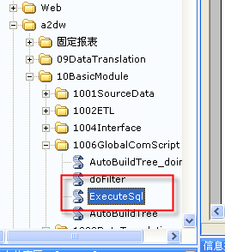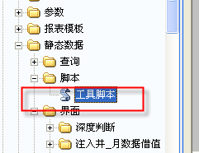

查看保存结果，试用下面SQL：

selectb.well_common_name,a.* fromxx_pro_early_dataa

innerjoinxx_care_wellb

ona.well_id = b.well_id

whereb.user_id = 'ADMIN';

各厂表缺少的字段

以A2DW用户为例子

第一步：登录到a2dw中，删除table文件夹下以字母D开头的所有表，创建标准表

第二步：创建数据链以连接到CY1为例，新建SQL WINDOW输入代码如下：

createpublicdatabaselinkLINKCY

connecttoCY1identifiedbya2

using'PCEDM_A2';然后点击运行

第三步：以表daa05为例，查出daa05中的所有表字段，代码如下：

selectpublic_pak.insert_select_clause_func('DAA05') fromdual;

然后点击运行，会出现如下图所示：

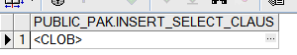

点击

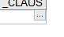

显示结果

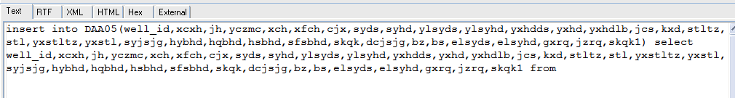

第四步：运行如下代码：

insertintoDAA05(well_id,xcxh,jh,yczmc,xch,xfch,cjx,syds,syhd,ylsyds,ylsyhd,yxhdds,yxhd,yxhdlb,jcs,kxd,stltz,stl,yxstltz,yxstl,syjsjg,hybhd,hqbhd,hsbhd,sfsbhd,skqk,dcjsjg,bz,bs,elsyds,elsyhd,gxrq,jzrq,skqk1)

selectnullwell_id,xcxh,jh,yczmc,xch,xfch,cjx,syds,syhd,ylsyds,ylsyhd,yxhdds,yxhd,yxhdlb,jcs,kxd,stltz,stl,yxstltz,yxstl,syjsjg,hybhd,hqbhd,hsbhd,sfsbhd,skqk,dcjsjg,bz,bs,elsyds,nullelsyhd,gxrq,jzrq,nullskqk1from

(SELECT * FROMDAA05@linkcy)

点击运行，如果出现报错，即可找到cy1中daa05与标准表的差异，

最后：在execel表中记录所缺字段

开发调整报表规格

二、地层压力变化

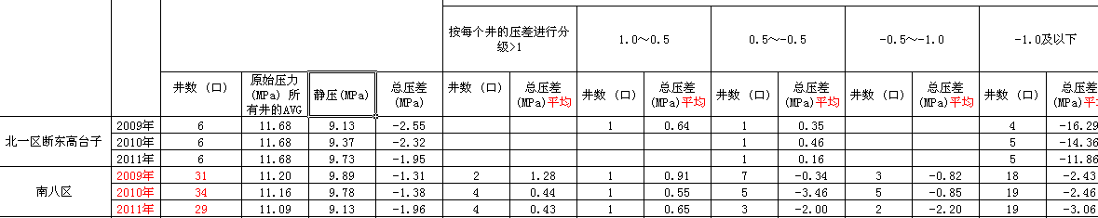

实现步骤

**UNDO 缺少区块关联的条件？**

改用基于源表xx_pc_well_pro_monthly月数据的流静压数据。

暂时不使用油田监测的TEMP_WELL_MECH_PRESSURE表。

因为该表数据不太合理。

第一步：从油井月数据表xx_pc_well_pro_monthly中，筛选出用户输入N年(2007、2008、2009)都存在静压的井（并且在静压合理范围内）。

获取用户在BQ界面输入静压的合理范围值，做为过滤条件。

**Static_Pressure> MIN and Static_Pressure< MAX**

N年都存在静压的井

having count(1)=N

第二步：将每年的最后一个年月记录作为井该年的记录。

第三步：和DAA01关联，取出原始地层压力。

井的静压-原始地层压力=单井压差

第四步：将全年的字段进行统计。

1）全年原始地层压力year_ysdcyl

所有井的原始地层压力非零平均

avg(case when ysdcyl<>0 then ysdcyl else null end) over (partition by year_col)

2）全年测静压总井数year_well_qty

3）全年静压平均year_static_pressure

同时将单井的压差进行分级，增加分级标准LV。

第五步：按LV分区，统计各分级进行统计。

1）单井压差single_pressure_diff非零平均

2）测静压的井数求和

第六步：将5个分级进行横向扩展。

同时计算全年的总压差year_pressure_diff

= 全年静压year_static_pressure-全年原始地层压力year_ysdcyl

问题

增加相同井或不同井的选择

答：已增加

三、示范区月数据

**实现步骤**

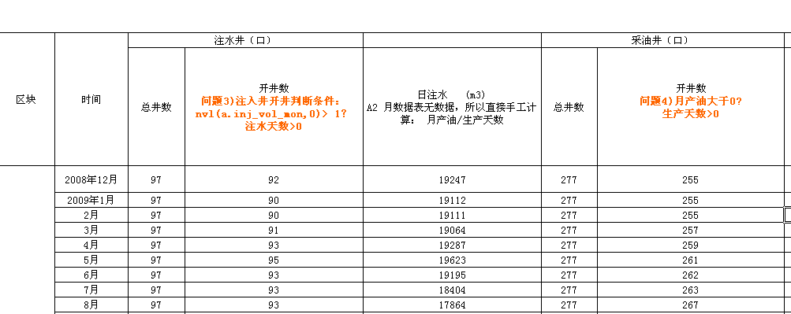

第一步：基于油井月数据表xx_pc_well_pro_monthly，求采出井部分

日产油求和 oil_prod_daily

日产水求和 water_prod_daily

核实日产油求和 veri_oil_prod_daily

核实日产水求和 veri_water_prod_daily

核实日产液求和 veri_liq_prod_daily

总井数求数目 pro_well_qty

开井数求数目 pro_prod_well_qty

生产天数大于0且月产油大于0

a.prod_days>0 or a.oil_prod_vol_mon>0

新井月产油 new_well_oil_prod_vol_mon

井的投产日期所在年份=当前年份

沉没度 cmd

(PUMP_DEPTH泵深-DYNAMIC_LIQ_LEVEL动液面) 进行非0平均

动液面非0平均 dynamic_liq_level

测试井数 测过动液面的井数目

测流压井数 flow_pres_well_qty

流压 Flow_Pres

注意：流压直接从月数据取，进行非零平均

注意：

1）获取半年标志half_year_col和每半年内的最大年月half_year_mon

max(year_mon) keep (dense_rank first order by year_mon desc) over(partition by half_year_col) half_year_mon

2）如果当前年月是半年内最大年月，例如当前年月201110等于2010上半年的最大年月201110（可能月数据只有2011年10月），则half_year_col保留20102，否则置为null字符串。

该half_year_col和第三步按半年统计静压的结果关联。

第二步：基于水井月数据xx_pc_well_inj_monthly，求注入井部分

日注入inj_vol_daily

月产油/生产天数

开井数inj_prod_well_qty

生产天数大于0且月注入大于1

a.prod_days>0 or nvl(a.inj_vol_mon,0)>1

第三步：求出静压部分

注意：静压为半年一次累计。即1-6月的结果统计到6月，7-12月的结果统计到12月。

1、对xx_pc_well_pro_monthly表，将每个月满足用户输入

满足（流压合理范围值）的年月做标记flow_pres_flag。

2、按井、半年分区，将满足用户输入流压条件的最大年月的流压做为该井半年的流压值。

例如用户输入流压范围>0.5 &< 50

2010上半年的流压为201004的1.2

2010下半年的流压为201011的1

|  |  |  |
| --- | --- | --- |
| **WELL_ID** | **YEAR_MON** | **FLOW_PRES** |
| A | 201001 | 0.5 |
| A | 201002 | 0 |
| A | 201003 | 0 |
| **A** | **201004** | **1.2** |
| A | 201005 | 0.5 |
| A | 201006 | 0.3 |
| A | 201007 | 1.2 |
| A | 201008 | 0 |
| A | 201009 | 0 |
| A | 201010 | 0.5 |
| **A** | **201011** | **1** |
| A | 201012 | 0 |

注意：如果半年内没有满足条件的流压，则置为NULL。然后进行AVG(非零)

3、得出每半年的静压和流压。

注意：

1)应该不能直接筛选6、12月的记录。如果半年的结束年月是5月，则可能出现BUG

2)如果半年内结束年月是5月，则下半年的静压结果是放在5月.

以井、半年分区，半年内最后一个年月的静压作为该半年的静压。

|  |  |  |  |
| --- | --- | --- | --- |
| WELL_ID | YEAR_MON | STATIC_PRES | FLOW_PRES |
| B | 201001 | 3 | 3 |
| B | 201002 | 4 | 2 |
| B | 201003 | 5 | 1 |
| B | 201004 | 1 | 8 |
| B | 201005 | 3 | 9 |
| B | 201006 | 4 | 10 |
| B | 201007 | 2 | 1 |
| B | 201008 | 0 | 2 |
| B | 201009 | 1 | 5 |
| B | 201010 | 2 | 6 |
| B | 201011 | 3 | 8 |
| B | 201012 | 8 | 2 |
| B | 201101 | 1 | 6 |
| B | 201102 | 2 | 0 |

**井、半年区间的结果**

**保证如过只有201001、201002两个月记录，该半年也不会被过滤掉。**

|  |  |  |  |
| --- | --- | --- | --- |
| **WELL_ID** | **HALF_YEAR_MON** | **YEAR_MON** | **STATIC_PRES** |
| B | 20101 | 201006 | 4 |
| B | 20102 | 201012 | 8 |
| B | 20111 | 201102 | 2 |

将3结果中，不满足用户输入的静压的单井记录过滤掉。

同时从DAA01取出单井的原始地层压力ysdcyl

按半年的结束年月分区，统计该年月所有井的字段。

Static_Pressure_well_qty测静压的井数目

Static_Pressure 静压求平均

Flow_Pres 流压求平均

Ysdcyl 原始地层压力求平均

基于5结果，计算总压差pressure_diff_sum和生产压差pressure_diff_prod

如静压>0，则总压差等于静压Static_Pressure-原始地层压力nvl(ysdcyl,0)

如静压>0，则总压差等于静压Static_Pressure-流压Flow_Pres

第四步：将第一步采出井、第二步注入井、第三步流静压合并

注意：一和三合并时，三只有6月和12月的记录，

如果采出井在2012年

问题

**所有平均字段都需要非0平均吗？**

**AVG(CASE WHEN COL >0 THEN COL ELSE NULL END)**

**开井数判断条件？**

**四、示范区年数据**

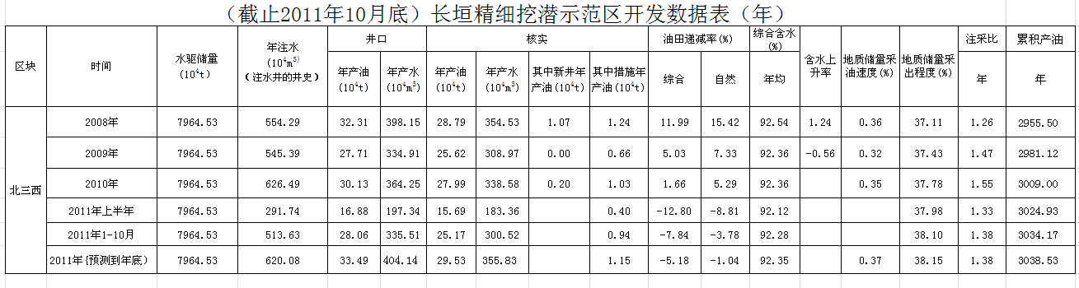

1.从DAA01中确定井数，按照DAA01中的qkdy判断取出区块所有的jh,并与cd_well_source中的well_desc相关联取的区块井的well_id;

**其中水驱储量需要用户参数设定；**

**年注水为用户输入年月的井的注水累加和：**

从XX_PC_WELL_INJ_MONTHLY中INJ_VOL_MON按年累加；

**井口中的年产油以及年产水为用户输入年月的井的累加和：**

从XX_PC_WELL_PRO_MONTHLY

核实同理，新井产油，在井基础信息表里找到产出井的开采年月，开采年月等于用户输入的年月即为新井，累加其产油量。措施产量为采出井的措施效果月数据中累加得到。

综合递减率=(上年产油/上年日历天数)/((今年产油-新井产油)/今年日历天数)

自然递减率=（本年产油-上年产油-措施增油)/(上年产油)

综合含水为油井月数据中找到年的含水平均。

含水上升率=（今年产油-去年产油)/(累计核实产油/水驱储量)

地质储量采油速度=核实产油/水驱储量

地质储量采出程度=核实累产油/水驱储量

注采比=年注水/(年产油*体积系数+年产水)

累积产油即为用户输入年月内的最大年月的累积产油的井累加和。

2.先从采出井月数据表中求出新井月产油：代码如下：

Selecta.OIL_PROD_VOL_MON,a.WATER_PROD_VOL_MON,a.VERI_OIL_PROD_MON,a.VERI_WATER_PROD_MON,

/*按照投产日期判断井是否本年度投产，如果是新井，查出产油量*/

(Case when(to_char(b.prod_date,'yyyy')=substr(a.year_mon,1,4) and b.prod_date is not null) then a.oil_prod_vol_mon else 0 end)new_well_oil_prod_vol_mon,

substr(a.year_mon,1,4)year_col_OIL,OIL_PROD_CUM,VERI_OIL_PROD_CUM

from XX_PC_WELL_PRO_MONTHLY a

inner join xx_well_info_unite b

on a.well_id = b.well_id

inner join xx_care_well c

on b.well_id = c.well_id

3.按年份累加成年产量：

select sum(OIL_PROD_VOL_MON)/10000 OIL_PROD_YEAR,sum(WATER_PROD_VOL_MON)/10000 WATER_PROD_YEAR,

sum(VERI_OIL_PROD_MON)/10000 VERI_OIL_PROD_YEAR,sum(VERI_WATER_PROD_MON)/10000 VERI_WATER_PROD_YEAR,

sum(new_well_oil_prod_vol_mon)/10000 new_well_oil_prod_vol_Year,year_col_OIL,

sum(OIL_PROD_CUM)OIL_PROD_CUM_year,sum(VERI_OIL_PROD_CUM)VERI_OIL_PROD_CUM_year

from(select a.OIL_PROD_VOL_MON,a.WATER_PROD_VOL_MON,a.VERI_OIL_PROD_MON,a.VERI_WATER_PROD_MON,

/*按照投产日期判断井是否本年度投产，如果是新井，查出产油量*/

(Case when(to_char(b.prod_date,'yyyy')=substr(a.year_mon,1,4) and b.prod_date is not null) then a.oil_prod_vol_mon else 0 end)new_well_oil_prod_vol_mon,

substr(a.year_mon,1,4)year_col_OIL,OIL_PROD_CUM,VERI_OIL_PROD_CUM

from XX_PC_WELL_PRO_MONTHLY a

inner join xx_well_info_unite b

on a.well_id = b.well_id

inner join xx_care_well c

on b.well_id = c.well_id

where c.x_group ='基础' and b.x_dqjb = '油井')group by year_col_OIL

4.左连接注入井数据的月注量累成的年注量、采出井的年日历天数、措施效果月数据累加的措施效果数据和。

5.按照公式计算出最后结果：

Selectyear_col_OIL,*/*年月*/*

INJ_VOL_YEAR,*/*年注入量*/*

OIL_PROD_YEAR,*/*年产油量*/*

WATER_PROD_YEAR,*/*年产水量*/*

VERI_OIL_PROD_YEAR,*/*核实年产油量*/*

VERI_WATER_PROD_YEAR,*/*核实年产水量*/*

new_well_oil_prod_vol_Year,*/*其中新井年产油量*/*

OIL_PROD_INCR_Year,*/*措施年增油*/*

*/*综合递减率,(上年产油/上年日历天数)/((今年产油-新井产油)/今年日历天数) */*

round((CaseWhensnrlts>0andrecord_OIL_PROD_YEAR>0then(record_OIL_PROD_YEAR/snrlts)/((OIL_PROD_YEAR - new_well_oil_prod_vol_Year)/dnrlts) else0end),2)zhdjl,

*/*自然递减率,(本年产油-上年产油-措施增油)/(上年产油)*/*

round((CaseWhenrecord_OIL_PROD_YEAR>0then ((OIL_PROD_YEAR-record_OIL_PROD_YEAR-OIL_PROD_INCR_Year)/record_OIL_PROD_YEAR) else0end),2)zrdjl,

WATER_CUT_RATIO*/*年均综合含水*/*

向数据库导入表

第一步:创建目录

用sys登录plsql 密码是sys



在my objects 的directories文件夹上点击右键🡪new



建立如下图所示的文件名称和路径：



点击左下方的apply 然后点击close如图



文件名称(name)可以自定义，文件路径（path）是要导入数据库的文件在本机存放的路径

文件格式为.dmp如右图

第二步：创建用户

新建SQL window 输入以下代码

-- Create the user

create user CY6

identified by a2

profile DEFAULT;

-- Grant/Revoke object privileges

-- Grant/Revoke role privileges

grant connect to CY6;

grant resource to CY6;

-- Grant/Revoke system privileges

grant alter any sequence to CY6;

grant alter any table to CY6;

grant alter any trigger to CY6;

grant alter any type to CY6;

grant create any index to CY6;

grant create any job to CY6;

grant create any procedure to CY6;

grant create any synonym to CY6;

grant create any view to CY6;

grant create public database link to CY6

grant debug any procedure to CY6;

grant debug connect session to CY6;

grant drop public database link to CY6;

grant unlimited tablespace to CY6with admin option;

然后执行如下图



第三步：在sys中给新创建的用户授权目录读写权限

grant read,write on directory DUMP_DIR to +用户名;

如下图



查看创建的用户，看是否有读写权限

以CY6为例子见下图

如果读写权限已经被写入会出现下图所示的read和write 注：如果缺少写权限，导入时会报错

**

*第三步：开始导入数据*

过程如下：开始🡪运行🡪cmd🡪impdp 用户名/密码@orcl directory=创建的目录名称 dumpfile=表名.DMP parallel=4—>回车

出现如下图：



成功导入

最后检查下是否导入成功

进入你创建的用户：新建sql窗体

输入代码：select * from pc_organization_t

如果出现表，证明已经导入成功

如下图:

**注:1.在**IMPDP**导入数据中出现的错误如下图**



**解决方法:重新复制表到根目录下,把原来的表删除**

**2.**

**有可能是系统表空间不足：暂未解决**